**Round 2 Phase 2 - Proof Of Concept**

Title: Stats Paper

Team: KIIT_BHUBANESWAR_Glitch

Bussiness Case:

* The real time analysis of news and prediction of stocks will change how readers take information and understand it.
* The readers invest less time in understanding the information and more in taking action with the results that are already processed for them.
* For a subscription fee, readers can avail a much more intensive analysis.
* This will help reform the current format of digital media making data analytics a common-man friendly and accessible tool.

Solution Design and Architecture:

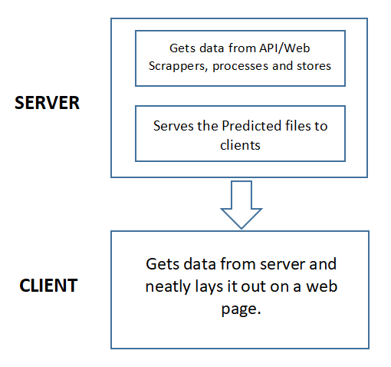

Fig: Solution Architecture

Webpage ScreenShot:

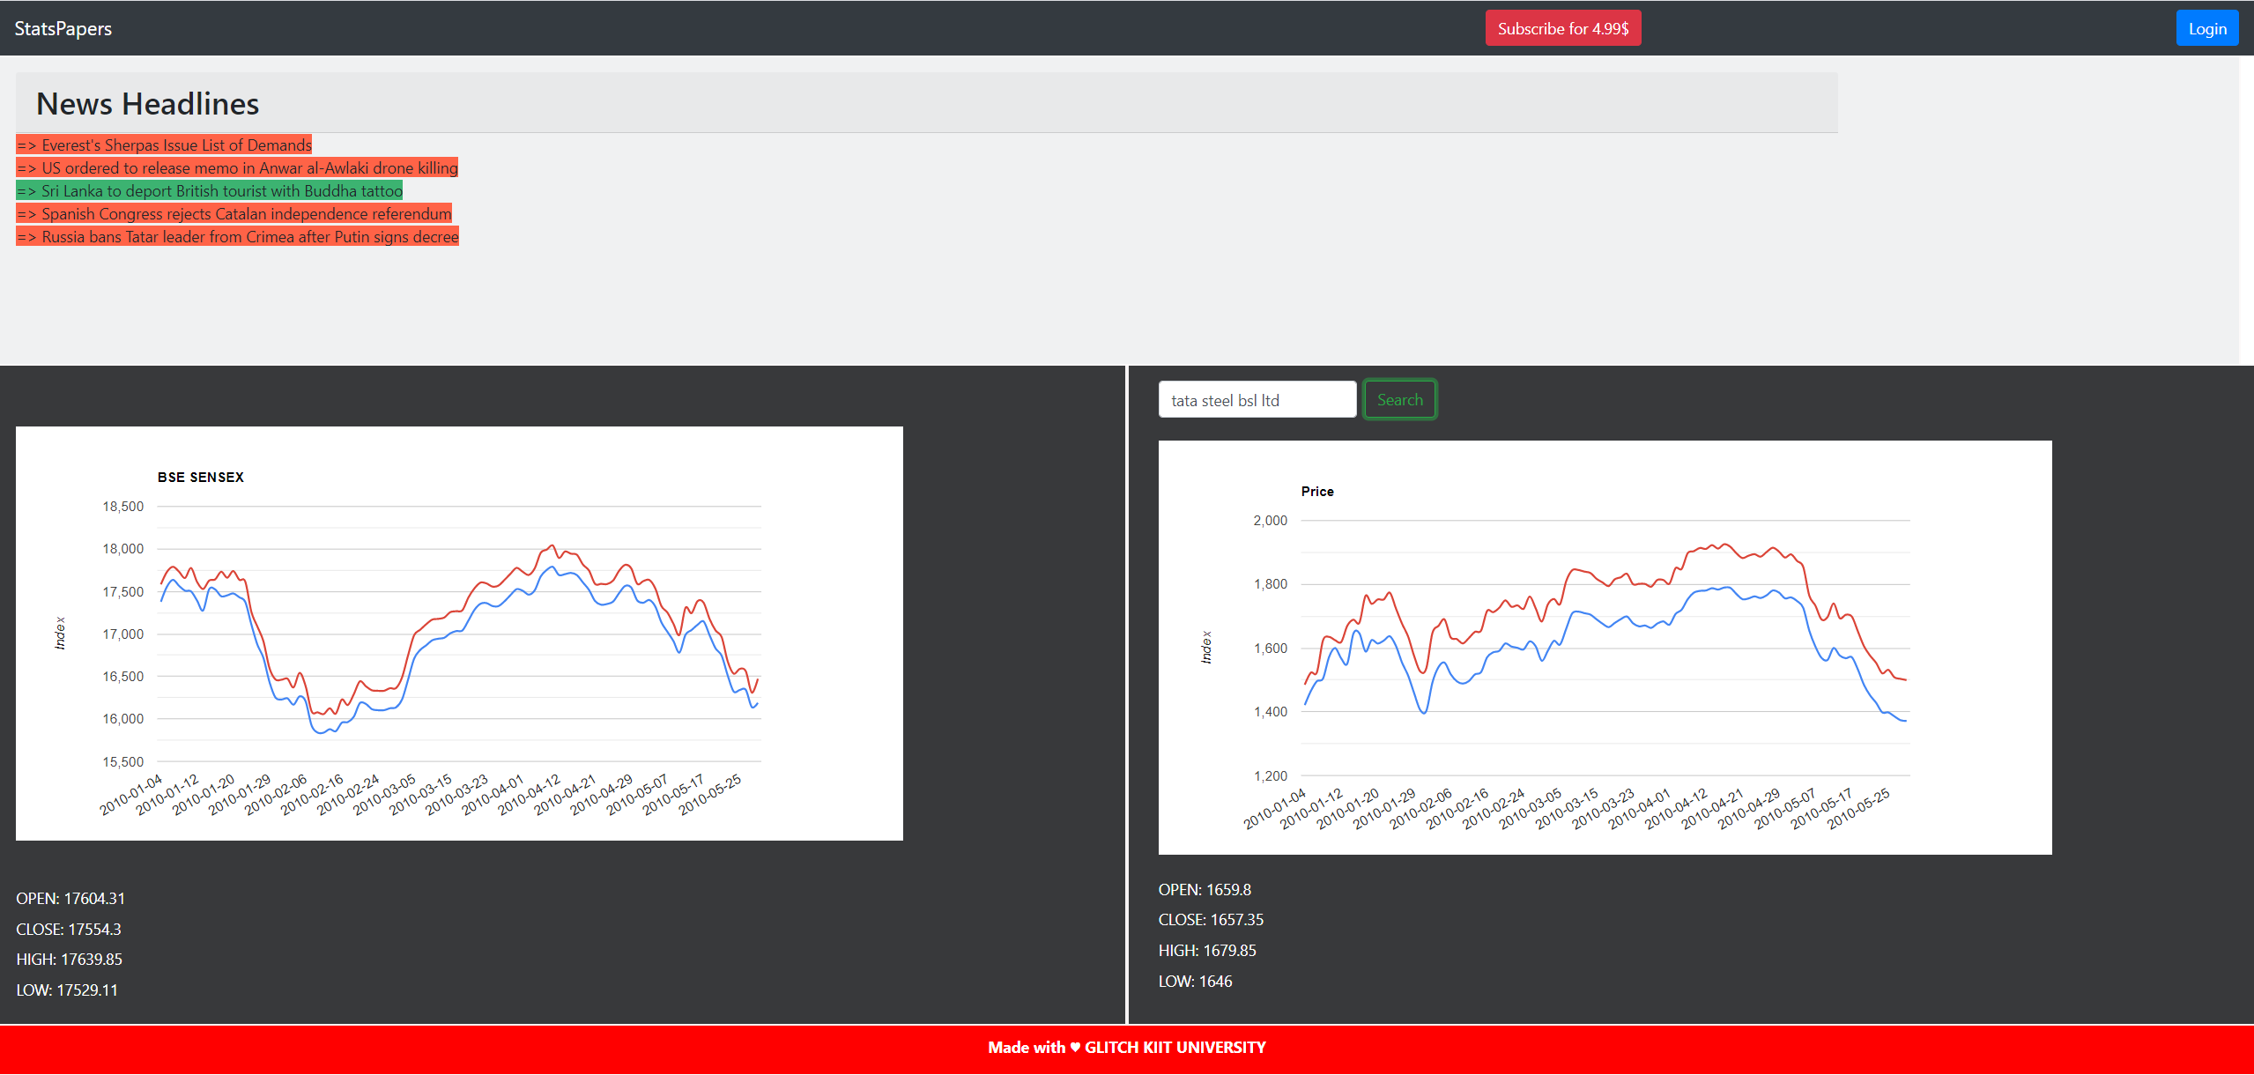

* Easy and interactive graphs with current open, high, low, close prices along with predictions upto 100 days.
* Search bar to get the stats of the company of choice.
* Current Top News Headlines with their sentiment analysis. Red highlights for negative news and green for positive/neutral.
* Simple Layout with subscription and login options. Also has potential to develop further.