SOFTWARE TRAINING REPORT

on JAVA

***submitted in partial fulfillment for the award of the degree***

***of***

***BACHELOR OF TECHNOLOGY***

## in INFORMATION TECHNOLOGY

***Submitted by***

**GURDEV SINGH (1808469)**

**Kuljit Singh (1808474)**

**under the supervision of**

***JAYATI MUNOT***



**Department of Information Technology**

**Rayat-Bahra Institute of Engineering & Nanotechnology, Hoshiarpur**

June & 2022

**Table of Contents**

ACKNOWLEDGEMENT i

TABLE OF FIGURES ii

INTRODUCTION ABOUT TOOLS USED 1

* 1. Git 1
     1. Features of Git 1
     2. Advantages of Git 3
     3. Disadvantages of Git 4
  2. Github 4
     1. Features of Github 5
     2. Advantages of Github 6
  3. SQL 8
     1. Different types of SQL commands 8
     2. Advantages of SQL 12
     3. Disdvantages of SQL 13
  4. Object Oriented Programming 14

BIBLIOGRAPHY 18

# ACKNOWLEDGEMENT

I express my sincere gratitude to my respected guide Er Kanchan Sharma, Assistant Professor, Rayat-Bahra Institute of Engineering & Nanotechnology, Hoshiarpur, for giving me stimulating guidance, continuous support and supervision throughout the course of present work.

I would like to place on record my deep sense of thankfulness to Er. Prince Rana, Assistant Professor & Head of the Department, Department CSE & IT, Rayat-Bahra Institute of Engineering & Nanotechnology, Hoshiarpur, for his generous guidance, help and useful suggestions.

I express my sincere gratitude to my respected guide Dr. H.P.S. Dhami, Director Principal, Rayat- Bahra Institute of Engineering & Nanotechnology, Hoshiarpur, for giving me stimulating guidance, continuous support and supervision throughout the course of present work.

I also wish to extend my thanks to all faculty members, Rayat-Bahra Institute of Engineering & Nanotechnology, Hoshiarpur, their insightful comments and constructive suggestions to improve the quality of this research work.

I am extremely thankful to Dr. Chander Mohan, Campus-Director, Rayat-Bahra Institute of Engineering & Nanotechnology, Hoshiarpur, for providing me infrastructural facilities to work in, without which this work would not have been possible.

**GURDEV SINGH (1808469)**

# LIST OF FIGURES

|  |  |  |
| --- | --- | --- |
| **FIGURE NO.** | **TITLE** | **PAGENO.** |
| 1.1 | Google Chrome |  |
| 1.2 | Git workflow | 2 |
| 1.3 | Three Stages | 2 |
| 1.4 | Github | 4 |
| 1.5 | Github Developer | 6 |
| 1.6 | SQL | 11 |
| 1.7 | Eclipse IDE |  |
| 1.8 | JDK Download interface |  |
| 1.9 | JDK Download Complete |  |
| 1.0 | JDK variable Setup Interface |  |
| 2.1 | OOPs Type |  |
| 2.2 | Java |  |
| 2.3 | Feature Of Java |  |
| 2.4 | Exception Handling |  |
| 2.5 | Database Connectivity |  |
| 2.6 | Spring |  |
| 2.7 | Salesforce |  |
|  |  |  |
|  |  |  |
|  |  |  |
|  |  |  |

**INTRODUCTION ABOUT TOOLS USED**

* 1. **GOOGLE CHROME**

Google Chrome is an open-source and the most popular internet browser that is used for accessing the information available on the World Wide Web. It was developed by Google on 11 December 2008 for Windows, Linux, Mac OS X, Android, and iOS operating systems. It uses sandboxing-based approach to provide Web security. Furthermore, it also supports web standards like HTML5 and CSS (cascading style sheet). Google Chrome was the first web browser that has a feature to combine the search box and address bar, that was adopted by most competitors. In 2010, Google introduced the Chrome Web Store, where users can buy and install Web-based applications. Chrome's features

Chrome has several features that make it easy to browse the web. Learn more about some of Chrome's features below.

* Speed: Because Chrome was designed with web applications in mind, performance with websites like Gmail and Facebook is especially fast and reliable.
* Security: Chrome has a variety of tools to help keep you safe online. It is constantly updating, so you're always protected from the latest malware and phishing scams. For example, Chrome will show you a warning whenever you visit a page that is potentially dangerous.
* Customization: While Chrome's design is simple, the Chrome Web Store makes it easy to customize Chrome with web apps, themes, and extensions.
* Translation: Whenever you visit a website that's in a foreign language, Chrome will automatically offer to translate the page to your native language. This feature isn't always perfect, but it opens the door to millions of websites you might never have visited otherwise.



**Fig 1.1 Google Chrome**

* + 1. **ADVANTAGES OF GOOGLE CHROME**

There are so many advantages of Google Chrome that make it easier to use, which are as follows:

* **Modern Layout**: The Chrome browser has a simple user-interface that includes frequently-used buttons such as forward, backward, refresh, etc. It also has a search bar or an Omnibox; that allows users to input the web address for searching anything.
* **Speedy Performance**: There are many websites (like news and online commerce sites) that are developed by using sophisticated programming that can be a cause for the slow browsing.
* **Safe and Secure**: The Chrome browser is updated regularly by Google to keep it safe and secure. It has the ability to get updated automatically when you connect the internet. Furthermore, Chrome provides the following protection:
* It can block harmful and malicious websites.
* It helps to identify and remove the malware that affects the browser with the help of the Chrome cleanup tool.
* **Integration with Google Apps:** Chrome has become a popular browser in the world as it can be integrated with other Google products like Gmail.
* **Cross-Platform Browser:** Google provides a cross-platform browser. As Edge and Safari browsers cannot run on all operating systems, but Chrome can be used on Windows, Linux, and Mac platforms.
  + 1. **DISADVANTAGES OF GOOGLE CHROME**

The Google Chrome also has some limitations, which are as follows:

* **High amount of memory (RAM) usage**: The Google Chrome browser utilizes more RAM (Random Access Memory) and CPU as compared to other browsers. Although the browser is lightweight, high consumption of memory can impact the other applications running simultaneously on your computer
* **Limited Customization and Options**: The Chrome browser does not offer certain customization and options like other browsers. For example, when you close the chrome browser window with multiple open tabs, it does not ask you whether to close all tabs or not. It will close all the tabs and windows directly.

### Git

Git is a version control system used for tracking changes in computer files. It is generally used for source code management in software development.

* + - Git is used to tracking changes in the source code
    - The distributed version control tool is used for source code management
    - It allows multiple developers to work together
    - It supports non-linear development through its thousands of parallel branches.

### Features of Git

* + - * Tracks history
      * Free and open source
      * Supports non-linear development
      * Creates backups
      * Scalable
      * Supports collaboration
      * Branching is easier

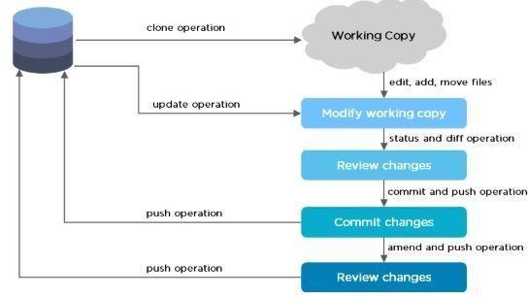

**Fig1.2 Git workflow**

The Git workflow is divided into three states:

* + - * Working directory – Modify files in your working directory
      * Staging area (Index) – Stage the files and add snapshots of them to your staging area
      * Git directory (Repository) – Perform a commit that stores the snapshots permanently to your Git directory. Checkout any existing version, make changes, stage them and commit.

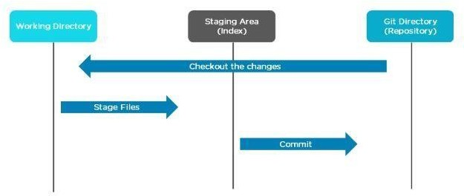

**Fig 1.3 Three Stages**

### Advantage of git

1. Performance

Git performs very strongly and reliably when compared to other version control systems. New code changes can be easily committed, version branches can be effortlessly compared and merged, and code can also be optimized to perform better. Algorithms used in developing Git take the full advantage of the deep knowledge stored within, with regards to the attributes used to create real source code file trees, how files are modified over time and what kind of file access patterns are used to recall code files as and when needed by developers. Git primarily focuses upon the file content itself rather than file names while determining the storage and file version history. Object formats of Git repository files use several combinations of delta encoding and compression techniques to store metadata objects and directory contents.

1. Security

Git is designed specially to maintain the integrity of source code. File contents as well as the relationship between file and directories, tags, commits, versions etc. are secured cryptographically using an algorithm called SHA1 which protects the code and change history against accidental as well as malicious damage. You can be sure to have an authentic content history for your source code with Git.

1. Flexibility

A key design objective of Git is the kind of flexibility it offers to support several kinds of nonlinear development workflows and its efficiency in handling both small scale and large scale projects as well as protocols. It is uniquely designed to support tagging and branching operations and store each and every activity carried out by the user as an integral part of “change” history. Not all VCSs support this feature.

1. Wide acceptance

Git offers the type of performance, functionality, security, and flexibility that most developers and teams need to develop their projects. When compared to other VCS Git is the most widely.

### Disadvantages of Git

* + - * GIT requires technical excellence and it is slower on windows. They have tedious command lines to input and don’t track renames.
      * They have poor GUI and usability. And also, they take a lot of resources which slows down the performance.
      * GIT doesn’t support checking out sub-trees. For each project, the central service would need to be set up for multiple package repositories.
      * It lacks window support and doesn’t track empty folders.
      * GIT needs multiple branches to support parallel developments used by the developers.
      * There is no built-in access control and doesn’t support binary files.
      * They do not provide access control mechanisms in case of security.
      * The process of Packing is very expensive completely.

### Github :

Development of the GitHub.com platform began on October 19, 2007. The site was launched in April 2008 by Tom Preston-Werner, Chris Wanstrath, P. J. Hyett and Scott Chacon after it had been made available for a few months prior as a beta release. GitHub has an annual [keynote](https://en.wikipedia.org/wiki/Keynote) called GitHub Universe.

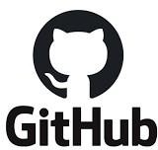

**Fig 1.4 Git Hub**

### Features of Github :

**Drag and Drop Gist Code**

[Gist](https://gist.github.com/) is Github’s very own facility that allows you to host code snippets. You can also browse and find a large number of code snippets of a variety of languages. Using Gist is downright easy and should be intuitive. But, did you know that you can add codes directly from files**?** Simply drag and drop the files on the Gist, the codes within the files will be immediately copied. It’s quick and saves you a lot of time!

### Creating a folder via the Web Interface

While many of us may manage Github repositories through the free Github app, Github has also built what they called WebFlow. It allows us to manage repositories through Github’s web interface.

And this is how you create new folders or files in directly in Github. End each new input with a

/ to create a new folder. Or, specify a file extension and hit Commit a New File to create a new file.

### Using Git URL Shortener

These days people like sharing things from their photos, statuses, and news in Twitter. If you are a Github user, you might also want to share your Github repository. Yet, the repository URL is sometimes too long to be shared in Twitter, which only accepts 140 characters.

### Using Github Command Line Interface

Whilst most people like working using a GUI, there are still some who prefer using CLI (Command Line Interface). This is where [Github CLI](https://github.com/github/hub) comes in. Github CLI is initiated with hub. It brings extra commands that can be used along with the git commands. The full list of the features can be found in [the Hub repository page.](https://github.com/github/hub)

### Linking Lines

Sometimes, you might want to share and point out specific lines within the file of your repository. Github allows you to do this by adding #L followed by the line number at the end of file URL (take a look at the example below).

You can also select a range of lines by specifying the starting and end lines within the #L parameter. The #L10-15, as an example, selects line 10 to 15.

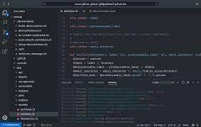

### Fig 1.5 Git hub developer

* + 1. **Advantage of Git hub:**

### Markdown

Basically, Markdown allows you to use a simple text editor to write formatted documents. GitHub, like many online repo services, supports Markdown for the issue tracker, user comments, wikis – everything. With so many other programming languages to learn for setting up projects, it’s really a big benefit to have your content inputted in a format without having to learn yet another system. In addition, there is also what is known as the GitHub flavored markdown – a feature that adds changes to the usual markdown in order to make it more useful in programming environments.

### GitHub has some of the best documentation around

You won’t run out of content when you use GitHub, thanks to a well-padded guide and help section for articles that you can pull up for practically any topic on earth, for as long as it is related to a git. It’s got content for helping you learn about generating SSH keys. A guide for the best git workflow is available. Samples on gitignore (and more) are abound for your next planned project, among other things. You would not need to look elsewhere for all the information that you need.

### GitHub has Gists and GitHub Pages, too

A while back, GitHub rolled out a feature called Gists, which lets you convert one or several files into a working git repository. This new feature converted sharing and tracking changes made to configuration files and even simple scripts into a whole new level of easy. While they aren’t as rich in features like a full-blown GitHub repository, they really work well even if you are without a paid account. GitHub pages, on the other hand, lets you host static websites by simple assigning HTML pages onto another, separate repository – the way you would any other type of git repository. With this, blogging can be done off the bat as well as updating with additional documentation or bumping up its web presence.

### Collaboration

For those who are not in the same physical location, an online Git is an easy solution requiring no setup for new users. With no need to connect to the company’s VPN, it may be easier to dump everything on a private repository on GitHub.

This benefit is much greater to those working collaboratively on a project that are not part of a professional environment – particularly open source projects. Most programmers are already familiar with how to use GitHub, and it’s easy to point people to a GitHub page if they want to make contributions. Online repositories are essential for open source projects, and the only reason some may avoid GitHub was acquired by Microsoft some time ago, which resulted in many switching to alternative like [GitLab.](https://about.gitlab.com/) While there’s no current reason in particular for this switch, many do not trust Microsoft’s track record of attacking the open source community in the past.

### Backup

Using an online repository should never be considered infallible, but it provides a nice and simple way to have their code and version history available online, regardless of what happens to their local machine. For some people, this is enough, but we stress that a multi solution backup plan is always the best.

### SQL :

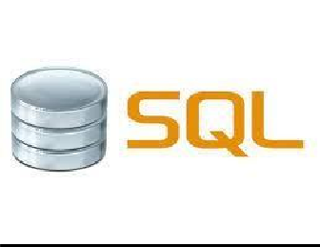SQL stands for Structured Query Language. SQL is used to create, remove, alter the database and database objects in a database management system and to store, retrieve, update the data in a database. SQL is a standard language for creating, accessing, manipulating database management system. SQL works for all modern relational database management systems, like SQL Server, Oracle, MySQL, etc.

### Fig 1.6 SQL

### Different types of SQL commands :

SQL commands can be categorized into five categories based on their functionality.

### DDL

DDL stands for data definition language. DDL commands are used for creating and altering the database and database object in the relational database management system, like CREATE

DATABASE, CREATE TABLE, ALTER TABLE, etc. The most used DDL commands are CREATE, DROP, ALTER, and TRUNCATE.

### CREATE

CREATE command is used to create a database and database object like a table, index, view, trigger, stored procedure, etc.

### Syntax

CREATE TABLE Employee (Id INT, Name VARHCAR(50), Address VARCHAR (100));

### ALTER

ALTER command is used to restructure the database object and the settings in the database.

### Syntax

ALTER TABLE Employee ADD Salary INT;

### TRUNCATE

The TRUNCATE command is used to remove all the data from the table. TRUNCATE command empties a table.

### Syntax

TRUNCATE TABLE Employee;

### DROP

DROP command is used to remove the database and database object.

### Syntax

DROP TABLE Employee;

### DML

DML stands for data manipulation language. DML commands are used for manipulating data in a relational database management system. DML commands are used for adding, removing, updating data in the database system, like INSERT INTO TableName, DELETE FROM TableName, UPDATE tableName set data, etc. The most used DML commands are INSERT INTO, DELETE FROM, UPDATE. •

* **INSERT INTO**

INSERT INTO command is used to add data to the database table.

### Syntax

INSERT INTO Employee (Id, Name, Address, Salary) VALUES (1, ‘Arvind Singh’, ‘Pune’, 1000);

### UPDATE

UPDATE command is used to update data in the database table. A condition can be added using the WHERE clause to update a specific row.

### Syntax

UPDATE Employee SET Address = ‘Pune India’, Salary = 100 WHERE Id =1;

### DELETE

DELETE command is used to remove data from the database table. A condition can be added using the WHERE clause to remove a specific row which meets the condition.

### Syntax

DELETE FROM Employee WHERE Id =1;

### DQL

DQL stands for the data query language. DQL command is used for fetching the data. DQL command is used for selecting data from the table, view, temp table, table variable, etc. There is only one command under DQL which is the SELECT command

### Syntax

SELECT * FROM Employee;

### DCL

DCL stands for data control language. DCL commands are used for providing and taking back the access rights on the database and database objects. DCL command used for controlling user’s access on the data. Most used DCL commands are GRANT and REVOKE.

### GRANT

GRANT is used to provide access right to the user.

### Syntax

GRANT INSERT, DELETE ON Employee TO user;

### REVOKE

REVOKE command is used to take back access right from the user, it cancels access right of the user from the database object.

### Syntax

REVOKE ALL ON Employee FROM user;

### TCL

TCL stands for transaction control language. TCL commands are used for handling transactions in the database. Transactions ensure data integrity in the multi-user environment. TCL commands can rollback and commit data modification in the database. The most used TCL commands are COMMIT, ROLLBACK, SAVEPOINT, and SET TRANSACTION.

### COMMIT

COMMIT command is used to save or apply the modification in the database..

### ROLLBACK

ROLLBACK command is used to undo the modification

### Syntax

Just write COMMIT or ROLLBACK or SAVEPOINT;

### Advantage of SQL

* + - * **High Performance**

SQL provides high-performance programming capability for highly transactional, heavy workload, and high usage [database systems.](https://intellipaat.com/blog/what-is-database/) SQL programming gives various ways to describe the data more analytically.

### High Availability

SQL is compatible with databases like MS Access, Microsoft SQL Server, MySQL, Oracle Database, SAP HANA, SAP Adaptive Server, etc. All of these [relational database management systems](https://intellipaat.com/blog/tutorial/sql-tutorial/rdbms/) support SQL and it is easy to create an application extension for procedural programming and various other [SQL](https://intellipaat.com/blog/tutorial/sql-tutorial/sql-functions/) [functions](https://intellipaat.com/blog/tutorial/sql-tutorial/sql-functions/) which are additional features thus converting SQL into a powerful tool.

### Scalability and Flexibility

[SQL](https://intellipaat.com/blog/tutorial/sql-tutorial/introduction-to-sql/) provides Scalability and Flexibility. It is very easy to create new tables and previously created or not used tables can be dropped or deleted in a database.

### Robust Transactional Support

SQL programming can handle large records and manage numerous transactions.

### Comprehensive Application Development

SQL is used by many programmers to program apps to access a database. No matter what the size of an organization, SQL works for every small or large organization.

### Management Ease

SQL is used in almost every Relational Database Management System. “[Select“](https://intellipaat.com/blog/tutorial/sql-tutorial/select-statement/), “Create”, “Insert”, “Drop”, “Update”, and “[Delete”](https://intellipaat.com/blog/tutorial/sql-tutorial/delete-query/) are the standard and common SQL commands that help us to manage large amounts of data from a database very quickly and efficiently.

### Open Source

SQL is an open-source programming language for building relational database management system.

### Disadvantage of SQL

* **Poor Interface**

SQL has a poor interface as it makes look everything very complex even when it’s not! Due to its difficult interfacing, users find it difficult to deal with the databases.

### Cost Inefficient

SQL Server Standard costs around $1,418/year. The high cost makes it difficult for some programmers to use it.

### Partial Control

SQL doesn’t grant the complete control over databases to its users. This is due to some hidden business rules.

### Security

Regardless of the SQL version, databases in SQL is constantly under threat as it holds huge amounts of sensitive data.

* 1. [**Ellipses**](https://www.bing.com/ck/a?!&&p=33691eaf3432d92dd755a219aa9d8dcd378f67de3286525f770e822d832e2500JmltdHM9MTY1NDIzNjIzMSZpZ3VpZD0xZDJmNDhiNi1kMzlmLTRkNTYtOWMzYy1iYmE2ZWEyYTcxOGImaW5zaWQ9NTE2OQ&ptn=3&fclid=f079991b-e302-11ec-9ffc-20a55f43c72b&u=a1aHR0cHM6Ly93d3cudGhlcHVuY3R1YXRpb25ndWlkZS5jb20vZWxsaXBzZXMuaHRtbA&ntb=1)

The Eclipse Foundation allows development by providing the infrastructure, and a structured process of development. The Eclipse Foundation has built its open source community and ecosystem of products and services since 2001.

Eclipse IDE (integrated development environment) for Java has been the leading development environment with a market share of 65% as of today. It can be extended with an additional software component. Eclipse calls these software components as plugins, which can grouped into features. Many companies have extended Eclipse IDE on top of the Eclipse framework. It is also available as IDE for other languages.

### 1.41 Features Of Eclipse IDE

* Almost everything in Eclipse is a plugin.
* We can extend the functionality of Eclipse IDE by adding plugins to the IDE, maybe for additional programming language or version control system or UML.
* Supports various source knowledge tools like folding and hyperlink navigation, grading, macro definition browser, code editing with syntax highlighting.
* Provides excellent visual code debugging tool to debug the code.
* Eclipse has a wonderful user interface with drag and drop facility for UI designing.
* Supports project development and administered framework for different toolchains, classic make framework, and source navigation.
* Java Eclipse IDE has a JavaDoc facility using which we can automatically create documentation for classes in our application.

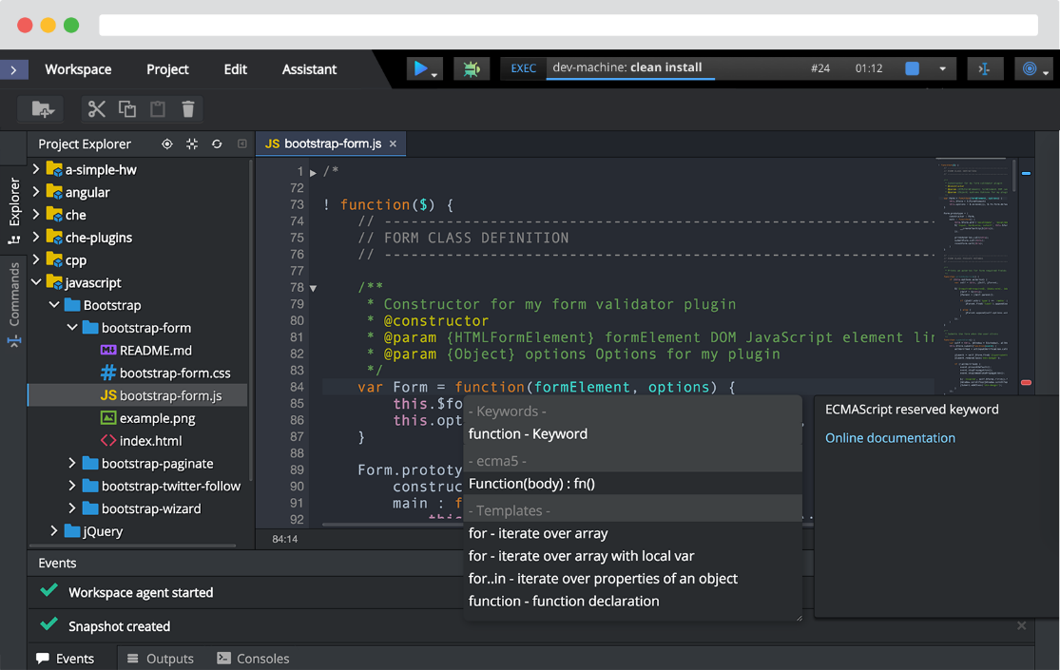

**Fig 1.7 Eclipse IDE**

**1.42 Advantages of Eclipse:**

* Using IDE will cost you less time and effort .
* Navigation is made easier.
* Auto completion- one of the best features , you don’t have to remember all.
* Refactoring
* Error debugging is easy , you can easily navigate to Error line.
* All files can be viewed and managed at same screen.
* Organizing you imports.
* Downloading requires packages at ease.
* It is free and open source.
* Industrial level of development
* It supports many other languages other than JAVA.
  1. **Disadvantage Of Eclipse:**
* Auto-completion of the keywords like the variable name, function name… obstacles your learning. When the line of code gets autocompleted, you did not think about it.
* You will be distracted seeing cumbersome menu options on IDE, icons, and dozens of toolbars which you don’t require now.
* You will not understand the compilation and procedure involved to execute the program when you do it by simply clicking on “Execute” button.
  1. **Installation the JDK in windows**
* **Download JDK From the Site**

Go to the Oracle site and open the Java SE download page. Under the latest version of Java Platform, Standard Edition, click on the JDK download button. Next, click on the Accept License Agreement button and choose your version of Java for Windows (32-bit or 64-bit

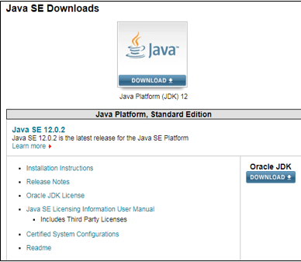

**Fig 1.8 JDK Download interface**

* **Install The JDK exe File**
* In this step, we will be running the executable JDK file (It will be a file with .exe as an extension) once the download is done. This installs JDK as well as JRE. For running this file on Windows, we will need Administrator rights.
* To begin the installation, we need to double-click on the downloaded file, and we will be presented with the below window.
* Click on Next to proceed with the installation, and follow the Installation guide provided for any queries.
* Click on the Close button once the installation has finished.

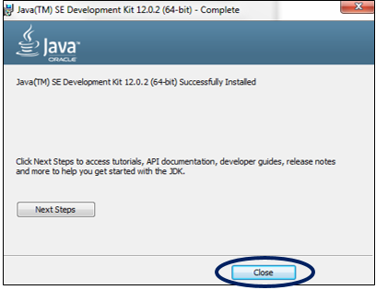

**Fig 1.9 JDK Download Complete**

* **Check The Directory**

JDK gets installed in the C directory of our system by default having the path “C:\Program Files\Java\jdk-11.0”. If we make any change to this path at all, we need to make a note of it as it will be required in the upcoming steps.

* **Update the Environment Variable**
* We will need to update our system’s Environment variables with our installed JDK bin path to run the Java programs because while executing the programs, the command prompt will look for the complete JDK bin path.
* The PATH variable in our system provides the exact location of executables that will be used for running Java programs, such as javac and java. The CLASSPATH variable provides us with the library files location.
* If we do not set the PATH variable, we will specify the full path to the JDK bin every time we run a program.

**For Example:** C:\> “C:\Program Files\Java\jdk-11.0\bin\javac” TestClass.java

* So to set these variables, first right-click on My PC and select Properties.
* Inside Properties, in the left-side panel, select Advanced System Settings, and here choose the option Environment Variables.
* Click on New, and type PATH in the Variable Name, and enter the path of the bin of installed JDK in the Variable Value field.

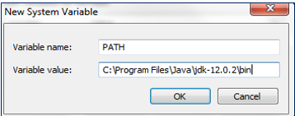

**Fig 1.0 JDK variable Setup Interface**

* If we already have the PATH variable, we can edit it by adding it to the existing values.
* Click on the OK button to apply the changes.
* **Verify the Java Installation**
* Open the command prompt and enter the command “java –version”, and if it runs successfully, Java has been successfully installed.
* Now that we have seen the steps to install JDK, let the programming fun begin!

**INTRODUCTION ABOUT THE TECHNOLOGY**

### 2.1 Object Oriented Programming (OOPs)

### Object Oriented programming or OOPs refers to languages that uses objects in programming. Object-oriented programming aims to implement real-world entities like inheritance, hiding, polymorphism etc in programming. The main aim of OOP is to bind together the data and the functions that operate on them so that no other part of the code can access this data except that function.

### Access Modifier:

Defines access type of the method i.e. from where it can be accessed in your application. In Java, there 4 type of the access specifiers.

* public: accessible in all class in your application.
* protected: accessible within the package in which it is defined and in its subclass(es)(including subclasses declared outside the package)
* private: accessible only within the class in which it is defined.
* default (declared/defined without using any modifier): accessible within same class and package within which its class is defined.
* The return type: The data type of the value returned by the method or void if does not return a value.
* Method Name: the rules for field names apply to method names as well, but the convention is a little different.
* Parameter list: Comma separated list of the input parameters are defined, preceded with their data type, within the enclosed parenthesis. If there are no parameters, you must use empty parentheses ().
* Method body: it is enclosed between braces. The code you need to be executed to perform your intended operations.

**OOPs Concepts are as follows:**

A [**Class** i](https://www.geeksforgeeks.org/classes-objects-java/)s a user defined blueprint or prototype from which objects are created. It represents the set of properties or methods that are common to all objects of one type. In general, class declarations can include these components, in order:

1. Modifiers: A class can be public or has default access (Refer [this](https://www.geeksforgeeks.org/access-specifiers-for-classes-or-interfaces-in-java/) for details).
2. Class name: The name should begin with a initial letter (capitalized by convention).
3. Superclass(if any): The name of the class’s parent (superclass), if any, preceded by the keyword extends. A class can only extend (subclass) one parent.
4. Interfaces(if any): A comma-separated list of interfaces implemented by the class, if any, preceded by the keyword implements. A class can implement more than one interface.
5. Body: The class body surrounded by braces, { }.

[**Object**](https://www.geeksforgeeks.org/classes-objects-java/) is a basic unit of Object Oriented Programming and represents the real life entities. A typical Java program creates many objects, which as you know, interact by invoking methods. An object consists of:

1. State : It is represented by attributes of an object. It also reflects the properties of an object.
2. Behavior : It is represented by methods of an object. It also reflects the response of an object with other objects.
3. Identity : It gives a unique name to an object and enables one object to interact with other objects.

A **Method** is a collection of statements that perform some specific task and return result to the caller. A method can perform some specific task without returning anything. Methods allow us to reuse the code without retyping the code. In Java, every method must be part of some class which is different from languages like C, C++ and Python.

Methods are time savers and help us to reuse the code without retyping the code. Let us now discuss 4 pillars of OOPS:

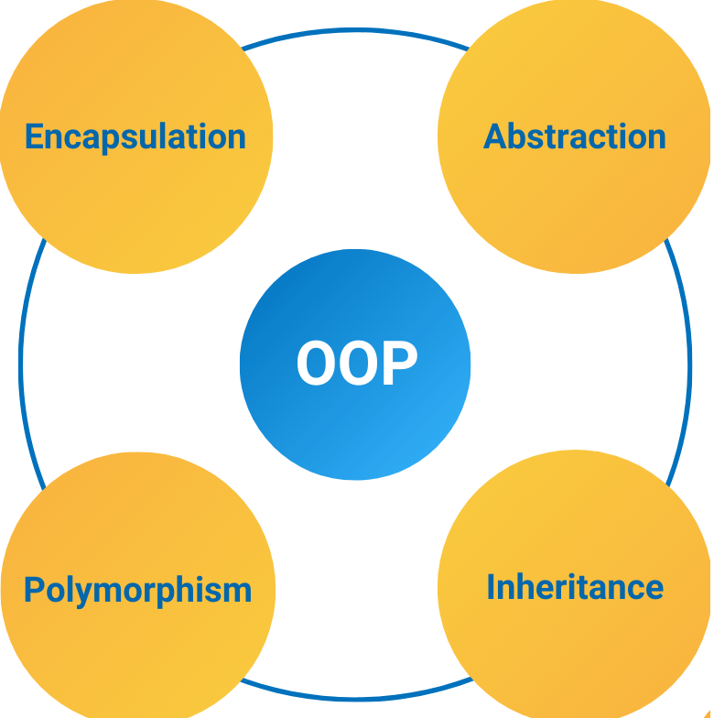

**Fig 2.1 OOP Type**

### Pillar 1: [Abstraction](https://www.geeksforgeeks.org/abstraction-in-java-2/)

Data Abstraction is the property by virtue of which only the essential details are displayed to the user.The trivial or the non-essentials units are not displayed to the user. Ex: A car is viewed as a car rather than its individual components.

Data Abstraction may also be defined as the process of identifying only the required characteristics of an object ignoring the irrelevant details. The properties and behaviours of an object differentiate it from other objects of similar type and also help in classifying/grouping the objects.

Consider a real-life example of a man driving a car. The man only knows that pressing the accelerators will increase the speed of car or applying brakes will stop the car but he does not know about how on pressing the accelerator the speed is actually increasing, he does not know about the inner mechanism of the car or the implementation of accelerator, brakes etc in the car. This is what abstraction is. In java, abstraction is achieved by [interfaces](https://www.geeksforgeeks.org/interfaces-in-java/) and [abstract classes.](https://www.geeksforgeeks.org/abstract-classes-in-java/) We can achieve 100% abstraction using interfaces.

### Pillar 2: [Encapsulation](https://www.geeksforgeeks.org/encapsulation-in-java/)

It is defined as the wrapping up of data under a single unit. It is the mechanism that binds together code and the data it manipulates. Another way to think about encapsulation is, it is a protective shield that prevents the data from being accessed by the code outside this shield.

* Technically in encapsulation, the variables or data of a class is hidden from any other class and can be accessed only through any member function of own class in which they are declared.
* As in encapsulation, the data in a class is hidden from other classes, so it is also known as data-hiding.
* Encapsulation can be achieved by Declaring all the variables in the class as private and writing public methods in the class to set and get the values of variables.

### Pillar 3: [Inheritence](https://www.geeksforgeeks.org/inheritance-in-java/)

Inheritance is an important pillar of OOP(Object Oriented Programming). It is the mechanism in java by which one class is allow to inherit the features(fields and methods) of another class.

Let us discuss some of frequent used important terminologies:

* Super Class: The class whose features are inherited is known as superclass(or a base class or a parent class).
* Sub Class: The class that inherits the other class is known as subclass(or a derived class, extended class, or child class). The subclass can add its own fields and methods in addition to the superclass fields and methods.
* Reusability: Inheritance supports the concept of “reusability”, i.e. when we want to create a new class and there is already a class that includes some of the code that we want, we can derive our new class from the existing class. By doing this, we are reusing the fields and methods of the existing class.

### Pillar 4: [Polymorphism](https://www.geeksforgeeks.org/polymorphism-in-java/)

It refers to the ability of OOPs programming languages to differentiate between entities with the same name efficiently. This is done by Java with the help of the signature and declaration of these entities.

**2.2 Java:**

**JAVA** was developed by James Gosling at **Sun Microsystems** Inc in the year **1995**, later acquired by Oracle Corporation. It is a simple programming language. Java makes writing, compiling, and debugging programming easy. It helps to create reusable code and modular programs.

[Java](https://www.geeksforgeeks.org/java/) is a class-based, object-oriented programming language and is designed to have as few implementation dependencies as possible. A general-purpose programming language made for developers to *write once run anywhere* that is compiled Java code can run on all platforms that support Java. Java applications are compiled to byte code that can run on any Java Virtual Machine. The syntax of Java is similar to c/c++.

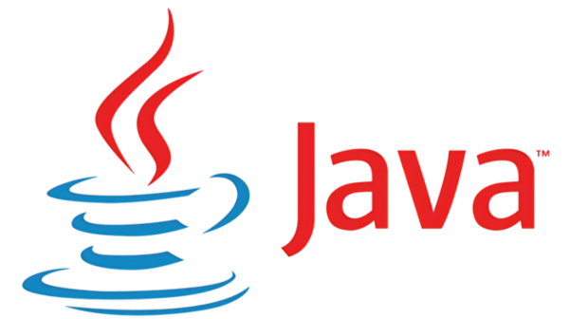

**Fig 2.2 Java**

# 2.2.1 Features/Characteristics of Java:

# Java has many important features that makes java one of the most useful programming language today. As the time passes, java has emerged as one of the most preferable programming language for different types of need.

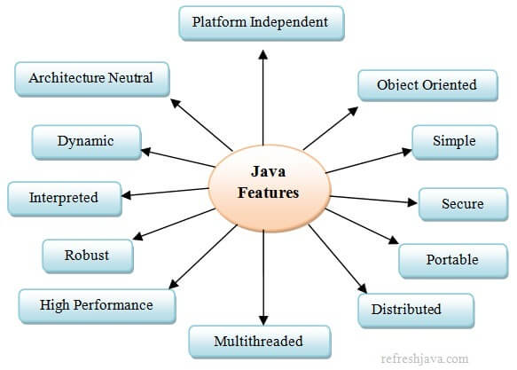

**Fig 2.3 Feature of java**

* **Java Is A Platform Independent**

Java is a platform independent language. In java you can write and compile your program on one machine(eg. Windows) and then you can run the compiled code(.class file) on any other machine(eg. Linux or macos). That is what the platform independent means in java, program written and compiled on one machine can be run on any other machine.

In order to run your program on new machine, all you need is, a [JVM](https://refreshjava.com/java/jdk-jre-jvm)(Included in JRE software) installed on new machine as per it’s operating system and the generated .class file from previous machine. This is why we also say java is a **“Write Once – Run Anywhere”**(WORA also known as Platform Independent) language.

* **Java is Object Oriented**

Java is an object oriented programming language because java supports the principles of Object Oriented Programming(OOPs) like *Encapsulation*, *Inheritance*, *Abstraction* *Polymorphism* etc. Everything in java plays around objects, we create variables, methods etc for objects in a program. Programming languages like C, FORTRAN, PASCAL etc focuses on logics while java focuses on objects. An object contains data in the form of fields([instance variable](https://refreshjava.com/java/variable-type-in-java)) and code/logic in the form of methods.

* **Java is Simple**

Java is a simple language because it’s syntaxes are very similar to C++ syntaxes, it also provides automatic memory management through garbage collection, programmers don’t have to focus on complex memory management. Apart from this java contains a lot of predefined class libraries to support different needs in a program. Java doesn’t support some of the complex features like operator overloading, multiple inheritance etc. Also there is no concept of pointers in java that confuses programmers a lot. All these things makes java a simple language.

* **Java is Secure**

Java is secure because it has features like automatic memory management, no explicit pointer, bytecode verifier etc that enhances the security of java programs. As java does not have concept of pointer and provides the automatic memory management, it reduces the chances of memory leak. Bytecode verifier ensures that .class files are not edited explicitly, any external edit fails the program to run. Also java program runs in a separate java virtual machine which enhances it’s security. These features together makes java one of the most secured language.

* **Java is Portable**

Java is portable because the bytecode(.class file) of a program can be run on different machines without any change in it. If the machine changes or the configuration(hardware, operating system or both) of existing machine changes, same bytecode can be executed on new machine/configuration as well. Java’s **Write once – Run anywhere** feature makes java a portable language. Java was designed with a goal that if new architectures are developed, the java environment could be ported easily. While porting all you need to have is the .class files of application on existing machine. Just copy these .class file on new machine and run your application by installing(if not already installed) the [java virtual machine](https://refreshjava.com/java/jdk-jre-jvm) on new machine.

* **Java is Distributed**

Java is also called a distributed language. This means java programs running on one machine can easily access the resources(files, java objects etc) of other machine on internet/network. Java provides class libraries for high-level support of networking. The java’s remote method invocation(RMI) API’s allow java programs to call methods of remote java objects, as if they were local objects. We can also say, same or different applications running on different [JVM](https://refreshjava.com/java/jdk-jre-jvm) on different machines can interact with each other for sharing data over the internet. RMI and EJB are mostly used for distributed programming.

* **Java is Multithreading**

Java is a multithreaded programming language. In multithreaded programming two or more than two parts of a program can execute simultaneously inside a machine. That means a single program can do two or more than two tasks simultaneously. Each part of such program is called a thread and each thread starts a separate path of execution. Multithreading is a special form of multitasking. For example in a multithreaded program you can read a file in one thread and can write into a different file in other thread simultaneously.

* **Java is Robust**

A language is called robust if it is reliable. The reliability comes because java strongly checks for error in program at compile and runtime both, to eliminate error-prone situations. The reliability also comes because java also has the strong memory allocation and automatic garbage collection mechanism which reduces the probability of crashing a program at runtime.

* **Dynamic**

A language is dynamic if it is adaptable to changing environments or the code is executed/loaded as and when required at runtime. Classes in java are linked/loaded only when needed. The code can be downloaded dynamically from anywhere on the network. The runtime features like memory management, dynamic binding etc makes java a dynamic language.

### Java Terminology

1. **Java Virtual Machine(JVM):**  This is generally referred to as [JVM](https://www.geeksforgeeks.org/jvm-works-jvm-architecture/#:~:text=JVM(Java%20Virtual%20Machine)%20acts,(Write%20Once%20Run%20Anywhere).). There are three execution phases of a program. They are written, compile and run the program.

* Writing a program is done by a java programmer like you and me.
* The compilation is done by the JAVAC compiler which is a primary Java compiler included in the Java development kit (JDK). It takes the Java program as input and generates bytecode as output.
* In the Running phase of a program, JVM executes the bytecode generated by the compiler.

Now, we understood that the function of Java Virtual Machine is to execute the bytecode produced by the compiler. Every Operating System has a different JVM but the output they produce after the execution of bytecode is the same across all the operating systems. This is why Java is known as a platform-independent language.

1. **Bytecode in the Development process:**  As discussed, the Javac compiler of JDK compiles the java source code into bytecode so that it can be executed by JVM. It is saved as .class file by the compiler. To view the bytecode, a disassembler like [javap](https://www.geeksforgeeks.org/javap-tool-in-java-with-examples/) can be used.
2. **Java Development Kit(JDK):** While we were using the term JDK when we learn about bytecode and JVM. So, as the name suggests, it is a complete Java development kit that includes everything including compiler, Java Runtime Environment (JRE), java debuggers, java docs, etc. For the program to execute in java, we need to install JDK on our computer in order to create, compile and run the java program.
3. **Java Runtime Environment (JRE):** JDK includes JRE. JRE installation on our computers allows the java program to run, however, we cannot compile it. JRE includes a browser, JVM, applet supports, and plugins. For running the java program, a computer needs JRE.
4. **Garbage Collector:** In Java, programmers can’t delete the objects. To delete or recollect that memory JVM has a program called [Garbage Collector](https://www.geeksforgeeks.org/garbage-collection-java/). Garbage Collectors can recollect the objects that are not referenced. So Java makes the life of a programmer easy by handling memory management. However, programmers should be careful about their code whether they are using objects that have been used for a long time. Because Garbage cannot recover the memory of objects being referenced.
5. **ClassPath**: The [classpath](https://www.geeksforgeeks.org/classpath-in-java/) is the file path where the java runtime and Java compiler look for .class files to load. By default, JDK provides many libraries. If you want to include external libraries they should be added to the classpath.

# Java Basic Syntax

# A Java program is a collection of objects, and these objects communicate through method calls to each other to work together. Here is a brief discussion on the [Classes and Objects](https://www.geeksforgeeks.org/classes-objects-java/), [Method](https://www.geeksforgeeks.org/methods-in-java/), [Instance variables](https://www.geeksforgeeks.org/variables-in-java/), syntax, and semantics of Java.

1. Class: The class is a blueprint (plan) of the instance of a class (object). It can be defined as a template which describes the data and behaviour associated with its instance.

* Example: Blueprint of the house is class.

1. Object: The object is an instance of a class. It is an entity which has behaviour and state.

* Example: A car is an object whose states are: brand, colour, number-plate.
* Behaviour: Running on the road.

1. Method: The behaviour of an object is the method.

* Example: The fuel indicator indicates the amount of fuel left in the car.

1. Instance variables: Every object has its own unique set of instance variables. The state of an object is generally created by the values that are assigned to these instance variables.
2. Comments in Java

There are three types of comments in Java.

* Single line Comment

// System.out.println(“GFG!”);

* Multi-line Comment

/*

System.out.println(“GFG!”);

System.out.println(“Alice!”);

*/

* Documentation Comment. Also called a doc comment.

/** documentation */

1. Source File Name

The name of a source file should exactly match the public class name with the extension

The name of the file can be a different name if it does not have any public class.

Assume you have a public class GFG.

GFG.java // valid syntax

*gfg*.java // invalid syntax

1. Case Sensitivity

Java is a case-sensitive language, which means that the identifiers *AB, Ab, aB*,and *ab*are different in Java.

System.out.println(“Alice”); // valid syntax

*s*ystem.out.println(“Alice”); // invalid syntax

* + 1. **Java String**

String is basically an object that represents sequence of char values. An [array](https://www.javatpoint.com/array-in-java)

of characters works same as Java string. For example:

* + **char**[] ch={‘j’,’a’,’v’,’a’,’t’,’p’,’o’,’€’,’n’,’t’};
  + String s=**new** String(ch);
  + String s=”javatpoint”;

**Java String** class provides a lot of methods to perform operations on strings such as compare(), concat(), equals(), split(), length(), replace(), compareTo(), intern(), substring() etc.

### Java String class methods

|  |  |  |
| --- | --- | --- |
| **No.** | **Method** | **Description** |
| 1 | [char charAt(int index)](https://www.javatpoint.com/java-string-charat) | It returns char value for the particular index |
| 2 | [int length()](https://www.javatpoint.com/java-string-length) | It returns string length |
| 3 | [static String format(String format, Object... args)](https://www.javatpoint.com/java-string-format) | It returns a formatted string. |
| 4 | [static String format(Locale l, String format, Object... args)](https://www.javatpoint.com/java-string-format) | It returns formatted string with given locale. |
| 5 | [String substring(int beginIndex)](https://www.javatpoint.com/java-string-substring) | It returns substring for given begin index. |
| 6 | [String substring(int beginIndex, int endIndex)](https://www.javatpoint.com/java-string-substring) | It returns substring for given begin index and end index. |
| 7 | [boolean contains(CharSequence s)](https://www.javatpoint.com/java-string-contains) | It returns true or false after matching the sequence of char value. |
| 8 | [static String join(CharSequence delimiter, CharSequence... elements)](https://www.javatpoint.com/java-string-join) | It returns a joined string. |
| 9 | [static String join(CharSequence delimiter, Iterable<? Extends CharSequence> elements)](https://www.javatpoint.com/java-string-join) | It returns a joined string. |
| 10 | [boolean equals(Object another)](https://www.javatpoint.com/java-string-equals) | It checks the equality of string with the given object. |
| 11 | [boolean isEmpty()](https://www.javatpoint.com/java-string-isempty) | It checks if string is empty. |
| 12 | [String concat(String str)](https://www.javatpoint.com/java-string-concat) | It concatenates the specified string. |
| 13 | [String replace(char old, char new)](https://www.javatpoint.com/java-string-replace) | It replaces all occurrences of the specified char value. |
| 14 | [String replace(CharSequence old, CharSequence new)](https://www.javatpoint.com/java-string-replace) | It replaces all occurrences of the specified CharSequence. |

# Exception Handling in Java

# The **Exception Handling in Java** is one of the powerful mechanism to handle the runtime errors so that the normal flow of the application can be maintained.

# hierarchy of exception handling

# Fig 2.4 Exception Handling

# Java Exception Keyword

|  |  |
| --- | --- |
| **Keyword** | **Description** |
| try | The “try” keyword is used to specify a block where we should place an exception code. It means we can’t use try block alone. The try block must be followed by either catch or finally. |
| Catch | The “catch” block is used to handle the exception. It must be preceded by try block which means we can’t use catch block alone. It can be followed by finally block later. |
| Finally | The “finally” block is used to execute the necessary code of the program. It is executed whether an exception is handled or not. |
| Throw | The “throw” keyword is used to throw an exception. |
| Throws | The “throws” keyword is used to declare exceptions. It specifies that there may occur an exception in the method. It doesn’t throw an exception. It is always used with method signature. |

* + 1. **Java JDBC**

JDBC stands for Java Database Connectivity. JDBC is a Java API to connect and execute the query with the database. It is a part of JavaSE (Java Standard Edition). JDBC API uses JDBC drivers to connect with the database. There are four types of JDBC drivers:

* JDBC-ODBC Bridge Driver,
* Native Driver,
* Network Protocol Driver, and
* Thin Driver
* Java DataBase Connectivity With MySql

To connect Java application with the MySQL database, we need to follow 5 following steps.

In this example we are using MySql as the database. So we need to know following informations for the mysql database:

1. **Driver class:**The driver class for the mysql database is **com.mysql.jdbc.Driver**.
2. **Connection URL:**The connection URL for the mysql database is **jdbc:mysql://localhost:3306/sonoo** where jdbc is the API, mysql is the database, localhost is the server name on which mysql is running, we may also use IP address, 3306 is the port number and sonoo is the database name. We may use any database, in such case, we need to replace the sonoo with our database name.
3. **Username:**The default username for the mysql database is **root**.
4. **Password:**It is the password given by the user at the time of installing the mysql database. In this example, we are going to use root as the password.

**Example :**

**import** java.sql.*;

**class** MysqlCon{

**public** **static** **void** main(String args[]){

**try**{

Class.forName(“com.mysql.jdbc.Driver”);

Connection con=DriverManager.getConnection(

“jdbc:mysql://localhost:3306/sonoo”,”root”,”root”);

//here sonoo is database name, root is username and password

Statement stmt=con.createStatement();

ResultSet rs=stmt.executeQuery(“select * from emp”);

**while**(rs.next())

System.out.println(rs.getInt(1)+”  “+rs.getString(2)+”  “+rs.getString(3));

con.close();

}**catch**(Exception e){ System.out.println€;}

}

}

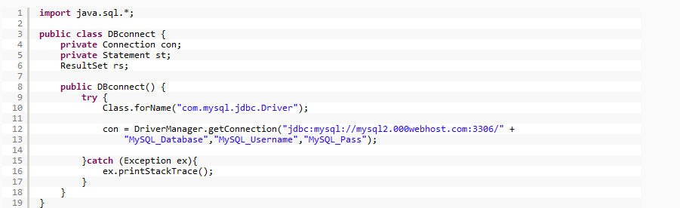

Fig 2.5 Database Connectivity

* + 1. **Disadvantage of java**

1. **Performance**

Java needs to be interpreted during runtime, which allows it to run on every operating system, but it also makes it perform slower than the languages like [C](https://www.javatpoint.com/c-programming-language-tutorial)

On the other hand, the C++ program needs to be compiled on each operating system,

1. **Memory consumption**

Java program consumes more memory since it runs on top of Java virtual machine.

1. **Cost**

Java programming language is a bit costly due to its higher processing and memory requirements. We need better hardware to run the Java program.

1. **Less machine interactive**

Java lacks when it comes to interacting directly with machines, making it less viable for the software that needs to run quickly and run directly with the machine, as explicit pointers are also missing in Java.

* 1. **Spring Framework**

Spring is a lightweight framework. It can be thought of as a framework of frameworks because it provides support to various frameworks such as [Struts](https://www.javatpoint.com/struts-2-tutorial), [Hibernate](https://www.javatpoint.com/hibernate-tutorial), Tapestry, [EJB](https://www.javatpoint.com/ejb-tutorial), [JSF](https://www.javatpoint.com/jsf-tutorial), etc. The framework, in broader sense, can be defined as a structure where we find solution of the various technical problems. The Spring framework comprises several modules such as IOC, AOP, DAO, Context, ORM, WEB MVC etc.



**Fig 2.6 Spring**

* + 1. **Features of Spring Framework**

1. **IoC Container**

During runtime, an object needs to be referenced implicitly and the task is taken up by IoC container. This container consists of assembler code that takes care of configuration management. For reference, the packages used are org.springframework.beans and org.springframework.context

#### **Data Access Framework**

#### This feature enables the developer to use persistence APIs. For storing persistence data in the database using JDBC or Hibernate. Persistence data is that type of data that has its previous version stored even if modified. Way of connection to the database, making sure that the connection is closed, dealing with exceptions, implementation of a transaction management system are some of the other tasks which are under this feature’s umbrella.

#### **Spring MVC Framework**

#### This framework feature helps developers in building web applications on the basis of MVC architecture.

#### **Transaction Management**

#### As the name suggests this framework helps in building a transaction management system without intervening with the code. The Java Transaction API is provided in this framework to the global transaction.

#### **JDBC Abstraction Layer**

#### This feature helps the developer in handling errors in an easy and efficient manner. The abstraction layer here helps in reducing the JDBC programming code.

#### **Spring Test Context Framework**

#### Last but not least, this feature provides the developer with the unit and integration testing frameworks for Spring applications. Particular and specific integration testing functionalities are also provided as a part of this feature.

## **Advantages of Spring Framework**

* + 1. Spring enables the developers to develop enterprise applications using POJOs (Plain Old Java Object). The benefit of developing the applications using POJO is, that we do not need to have an enterprise container such as an application server but we have the option of using a robust servlet container.
    2. Spring provides an abstraction layer on existing technologies like servlets, jsps, jdbc, jndi, rmi, jms and Java mail etc., to simplify the develpment process.
    3. Spring comes with some of the existing technologies like ORM framework, logging framework, J2EE and JDK Timers etc, Hence we don’t need to integrate explicitly those technologies.
    4. Spring WEB framework has a well-designed  web MVC framework, which provides a great alternate to lagacy web framework.
    5. Spring can eliminate the creation of the singleton and factory classes.
    6. Spring provides a consistent transaction management interface that can scale down to a local transaction and scale up to global transactions (using JTA).
    7. Spring framework includes support for managing business objects and exposing their services to the presentation tier components, so that the web and desktop applications can access the same objects.
    8. Spring framework has taken the best practice that have been proven over the years in several applications and formalized as design patterns.
    9. Spring application can be used for the development of different kind of applications, like standalone applications, standalone GUI applications, Web applications and applets as well.
    10. Spring supports both xml and anotation configurations.
    11. Spring Framework allows to develop standalone, desktop, 2 tire – n-tire architecture and distributed applications.
    12. Spring gives built in middleware services like Connection pooling, Transaction management and etc.,
    13. Spring provides a light weight container which can be activaed without using webserver or application server.
    14. **Disadvantage of Spring**
  1. Complex: One of the major problem faced by the Spring framework is that it is complex! No so clear focus, more than 3000 classes, 49 other tools and tons of the other things make it complicated for the developers.
  2. Longer Configuration: If you are a fresher developer, it would be quite difficult for you to learn Spring framework. The main reason behind this is a whole host of new programming methods and detailing require understanding how to set up the Spring XML configuration file.
  3. Require a lot of XML: If you have ever worked with Spring framework, you might be knowing that applications developed using Spring framework often require a huge amount of XML. So, if you are considering Spring for your next development, be prepared to spare a lot of time coding in XML.
  4. Parallel mechanisms frustrate developers: Parallel mechanisms are useful to perform the same task in different ways. However, when we talk about Spring framework, you will find multiple parallel mechanisms, which at the end confuses developers. It makes developers to spend lots of understanding each of them and choose the best one among them.
  5. Lack of Guidelines: No clear guidance on cross-site scripting attacks and cross-site request attacks in Spring MVC documentation. Also, it suffers from a several security holes.
  6. **SalesForce**

Salesforce started as a cloud based solution for CRM. CRM stands for Customer Relationship Management. It involves managing all aspects of relationship between an organization and its customers. For example, the contact details of the customer, the deals that are in progress or already completed, the support requests from a customer or a new lead from a new customer. Beyond the customer related information, it also involves storing and managing the details of the people and the concerned department from the seller organization that is managing the customer’s account and needs. This makes it easy to manage and enhance the relationship with the customer and hence better growth for the organization.

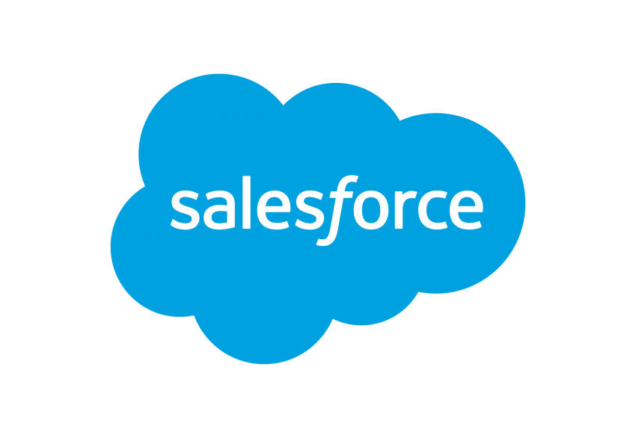

**Fig 2.7 Salesforce**

* + 1. **Following are the different features of the Salesforce platform −**

## **Contact Management**

## To view customer contact details, activity history, customer communications, and internal account discussions, etc. In short, it manages all the data pertaining to the contact with a customer.

## **Opportunity Management**

## It provides the details of the stage a deal is in, the products involved in the deal, the quotation for the deal etc. In short it manages all the data that helps in identifying, progressing and closing a deal.

## **Salesforce Engage**

## This feature is focused on making personalized contact with a customer for various campaigns designed by the marketing team. It also provides real-time sales alerts based on the level of engagement with a customer.

## **Sales Collaboration**

## This feature helps in quickly finding experts who can help in closing a deal based on customer queries and feedback. In short, it helps in bringing in a collaborative effort to engage an entire team in the deal and make the deal happen.

## **Sales Performance Management**

## It provides a metric-based goal setting, and also continuous feedback and rewards and recognition for the sales team. This helps in enhancing the performance of the sales team.

## **Lead Management**

## This feature initiates and tracks the leads that are in progress. It also helps in continually optimizing campaigns across every channel.

## **Partner Management**

## This feature helps in building a community with partners. It also helps in connecting directly with channel partners to share goals, objectives, and activities.

## **Salesforce Mobile App**

## This is the mobile platform to carry out all the above activities on a mobile platform.

## **Workflow and Approvals**

## It is a visual design to automate the business processes. The interface provides simple drag and drop options to make this design. It helps in creating a flexible approval process with deal discounts and expense management etc.

## **Email Integration**

## Salesforce can integrate to an existing email platform. This helps in providing flexibility to the existing team with no additional learning curve.

## **Files Sync and Share**

## This feature provides the sales team the power to easily share various files, discuss them and update them as needed. Also receive alerts when something in the file changes.

## **Reports and Dashboards**

## Dashboards offer a real-time picture of the business at a glance. With this, anyone can create detailed reports which can be accessed from anywhere.

## **Sales Forecasting**

## This feature helps in getting a real time view of the forecast of a sales team. It provides multi-currency support and an in-line editing mode to manage the sales forecast well.

## **Territory Management**

## This feature is used to create multiple territory models, preview them before rollout, and continually optimize and balance territories throughout the year.

## **Salesforce Environment**

## As Salesforce is a cloud based system it does not need any software installation on your part. All you have to do is signup for a free trial and get started. The free trial account provides nearly all features which you need to learn to understand the basics of Salesforce platform.

## **Step 1**

Go to the link [Salesforce](https://www.salesforce.com/in/?ir=1) and click on Free Trial.

It takes you to a window where you have to fill in some details about you and sign up.

## **Step 2**

You will receive an activation mail for your account which also contains the details of your account and the duration of the trial period. Click on the link in the email to verify your email ID and activate the account.

## **Step 3**

Again visit the link [Salesforce](https://www.salesforce.com/in/?ir=1) and click on login. Give the login credentials which you just created. You will be directed to the following screen.

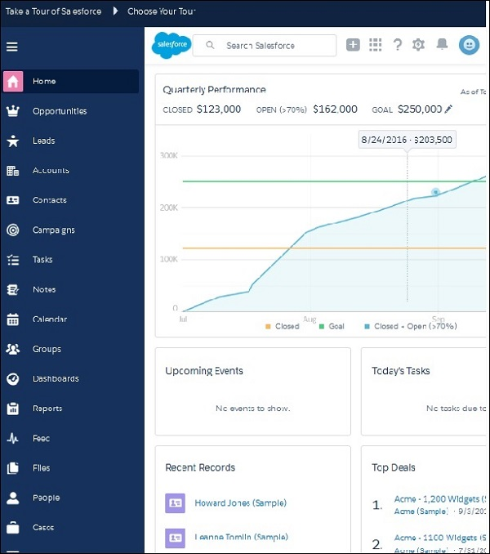

**Fir 2.7 Salesforce login**

## **Advantage of Salesforce**

* 1. Firstly, there is little to no risk when using Salesforce. Due to its low acquiring costs and low-risk management as an organization tool, there is very little to lose and a lot to benefit from.
  2. The database that Salesforce uses is also helpful in digitizing and organizing company sale records. Thus, improving the overall organization of a company.
  3. Salesforce and good customer service comes hand in hand.  It allows customization of profiles for individual customers as well as quick, organized access to individual records.
  4. There is also no need to purchase software and hardware systems to help maintain and keep the application running.  Therefore, unlike most software, Salesforce requires no capital investment.
  5. The integrated solutions allow users to work more efficiently and increase the value of each part of the customer life cycle.  Moreover, Saleforce analytics and its reporting function gives its users the ability to expand their campaign capacity.  As a result, overall productivity can be increased and profit can be maximized.
  6. Since Salesforce is an application and no software is required, there is no need for constant updates as Salesforce will update automatically.
     1. **Disadvantage of salesforce**

1. At times, there can be too much customization and the interface can be filled with undersome and tedious tools which can be seen as repetitive or distracting.
2. Some users face difficulties in the transition between transactions.  Some have to go through multiple screens to process transactions.
3. Salesforce has its own maintenance schedule since runs on its own cloud server.  As a result, there are times that the application will not be accessible.
4. Users can also lose a personal touch as in the process of automation
5. Salesforce contains barriers to adoption.  This means that even though Salesforce is cheap, the cost to integrate the application and redesigning their IT to incorporate it into a company is not the same as the cost of acquiring Salesforce. It is possible that the cost of integrating it can exceed the costs of the software itself.

### BIBLIOGRAPHY

[Git - Downloads (git-scm.com)](https://git-scm.com/downloads)

[Git - Documentation (git-scm.com)](https://git-scm.com/doc)

[Persistent Systems (udemy.com)](https://persistent.udemy.com/learning-paths/2414796/) (Git)

[Persistent Systems (udemy.com)](https://persistent.udemy.com/learning-paths/2273018/) (SQL)

[OOPS-Concepts-01-Introduction - YouTube](https://www.youtube.com/watch?v=J-Ft0FClvoA)

### 

### 