# Layouting

**TopTabNavigation**

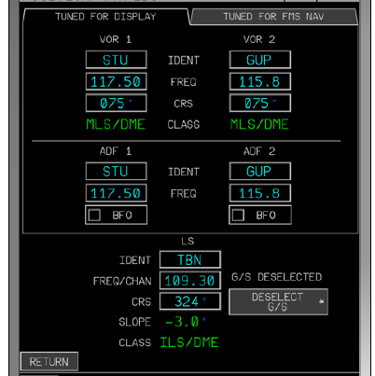

# UI Elements

**Systems selector**

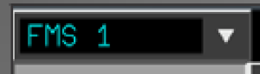

**Top Bar Dropdown Menu**

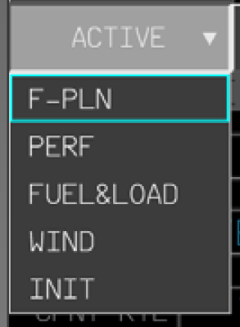

Dropdown is optional (single option also allowable)

**Button**



**IconButton**



Possible different styling than Button

**RadioButton**

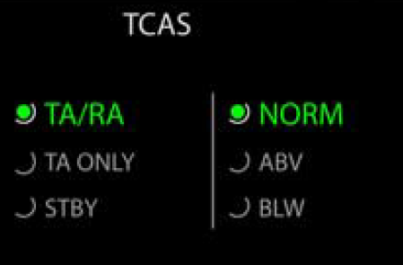

Dots can be colored, as well as text

**TextInput**

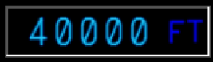

Two different styles of missing input: Orange rectangles or blue lines:



Add option to include leading or trailing JSX object (for units etc.)

**Label**



**ContextMenu**

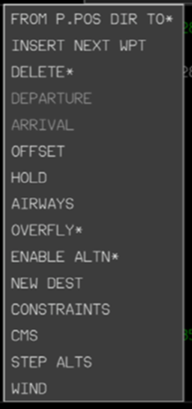

**FCUButton**

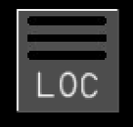 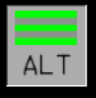

**SURVButton**

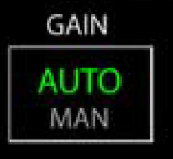

# Example pages

**INIT**



**FUEL&LOAD**



**F-PLN**



**PERF**

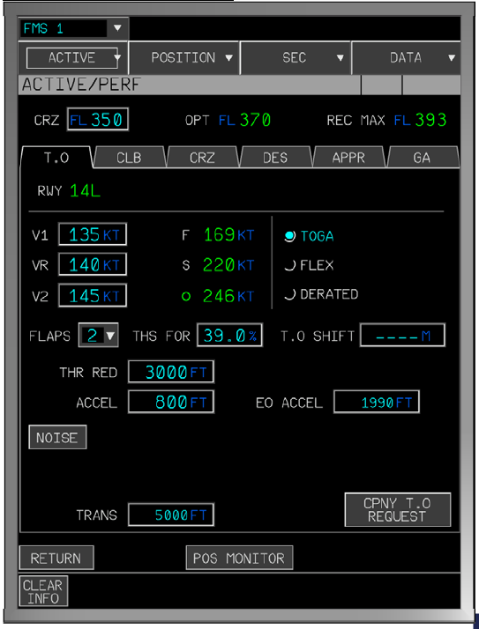

**SURV:**

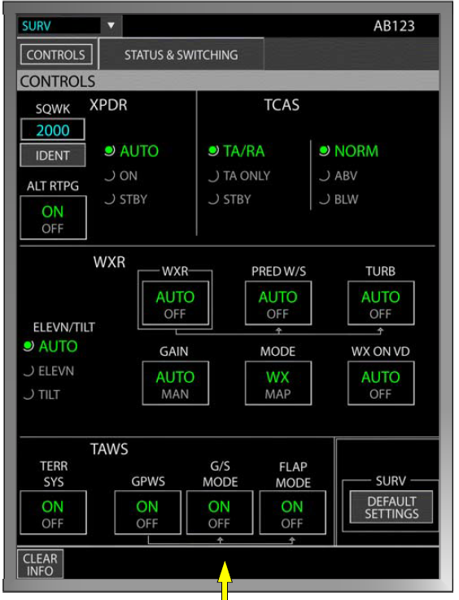

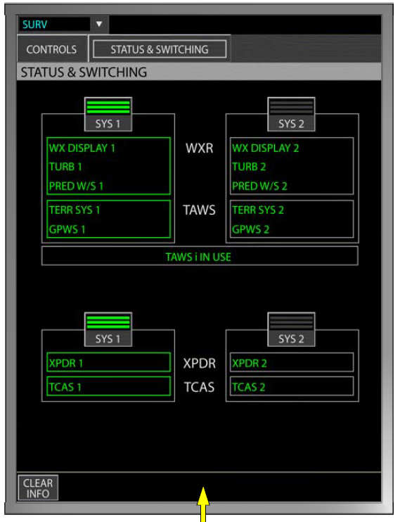

**OANS:**

