**Week 9 Homework**

Name: Gurgobind Singh Student ID: 33524769 Lab: 7 Tutor Name: Dr Chai Wen Ting

**URL for HTML (Map):** <https://gurgobindsingh.github.io/FIT3179_Homework9/>

**GitHub Link:** <https://github.com/GurgobindSingh/FIT3179_Homework9.git>

**Map:**

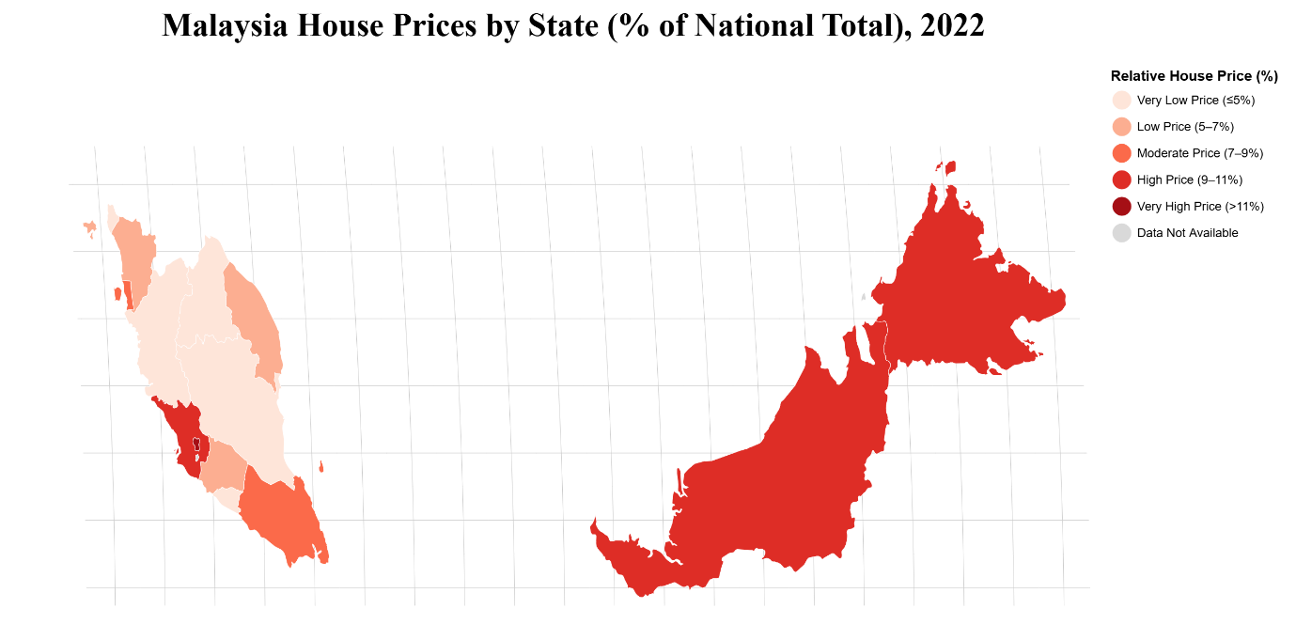**Domain:**

The visualisation focuses on house prices across Malaysian states in 2022, showing the relative contribution of each state’s house prices to the national total.

**Visualised Dataset:**

* Source:
* National Property Information Centre: <https://napic2.jpph.gov.my/en/data-visualization?category=18&id=64>
* OpenDOSM: <https://open.dosm.gov.my/data-catalogue/hh_income_state>
* Author of datasets: National Property Information Centre, Department of Statistics Malaysia
* Author of map: Gurgobind Singh
* Attribute Types: State (categorical nominal), Relative House Price % (quantitative)

**Data Transformation:**

The house prices were normalized to obtain the Relative House Price (%) for each state. This expresses each state’s house price as a percentage of the total house price across all states. The formula used is:

$Relative House Price \left(\%\right)=\frac{House Price of a State}{Total House Price of all State}× 100$

**Justification:**

A choropleth map was chosen because it effectively communicates relative values per geographic area. The data was normalised by calculating the relative house price as a percentage of the national total for each state. This ensures fair comparison across states of different sizes and total values. Each state is color-coded based on its percentage of contribution to the national total of house prices thus, allowing viewers to quickly identify regions with higher or lower house prices. A sequential colour scheme with colour luminance was applied, where darker shades indicate states with higher house prices and lighter shades indicate states with lower house prices. Therefore, this makes the differences across states more intuitive and visually clear. Besides that, alternative map idioms such as proportional symbol maps or dot maps were not chosen, as they are less effective at representing relative percentages by area and may cause visual clutter, particularly in smaller states such as Kuala Lumpur and Perlis.