**INDUSTRIAL TRAINING REPORT**

**City Weather & Map**

**And**

**Word Dictionary**

**Submitted in partial fulfillment of the**

**Requirements for the Award of the degree of**

**B.Tech in Computer Science & Engineering**

**SUBMITTED BY**

Name: GURJANT SINGH

University Roll No. 1629687

**SUBMITTED TO**

**Department of Computer Science & Engineering**



**CGC TECHNICAL CAMPUS, JHANJERI, MOHALI**



**Affiliated to I.K Gujral Punjab Technical University, Jalandhar**

**(Batch: 2016-2020)**

**CONTENTS**

|  |  |
| --- | --- |
| ***Contents*** | ***Page No.*** |
| *Certificate* | *I* |
| *Declaration* | *III* |
| *Abstract* | *IV* |
| *Acknowledgement* | *V* |
| *Company Profile* | *VI* |

**Chapter1: PRESENT WORK** 12-14

1.1 Methodology

1.2 Requirements

1.2.1 Hardware Requirements

1.2.2 Software Requirements

1.3. Project Module

1.3.1 Admin Module

1.3.2 Student Module

**Chapter2: TECHNOLOGY OVERVIEW** 15-17

2.1 Html, CSS

2.2 Python Django

2.3 IDE

**Chapter3: FEASIBILITY STUDY** 18-20

3.1 Economical study

3.2 Technical study

3.3 Operational study

3.4 Behavioral study

**Chapter 4: ANALYSIS** 21-24

4.1 Data Flow Diagram (DFD)

**Chapter 5: SYSTEM TESTING** 25-26

5.1 Unit testing

5.2 Integration testing

**Chapter 6: PROJECT DESIGN** 27-29

6.1 Database design

6.2 Front-end design

6.3 Front-end design

**Chapter 7: CONCLUSIONS AND FUTURE SCOPE** 30

**CERTIFICATE**

**DECLARATION**

Ihereby declare that the project entitled “**City Weather & Map**” and “**Word Dictionary**” which have to be submitted in the partial fulfillment of the requirements for the awards of **B.tech CSE** in **CGCTC, Jhanjeri**, **Mohali** is an own record carried out by me under the supervision of my teacher Ms. Amandeep Kaur (Python Developer SachTech Solutions Mohali). The matter embodied in this project has not been submitted so far for the award of any degree.

**(Signature of student)**

**GURJANT SINGH**

**1629687**

**Date: ____________________**

This is to certify that the above statement made by the student is correct to the best of my knowledge and belief.

**Head of Department**

**(Singature and Seal)**

**ABSTRACT**

The project is concerned with developing a websites for Public to Search “City Weather and Map” and “Meaning of English Word”.

The website (City Weather and Map) is basically meant for getting all the weather information and map of city online. The website gives detailed information about the temperature, humidity , pressure, geographical locations etc., so that the person can get full knowledge about the weather of city. It also provides the feature of Map of City. It provides information about various cities that are present in database. 

The website (Word Dictionary) is for getting meaning of word. The website gives detailed definition of the word in English with example also. User can easily search word and get the result in one click.

Both websites are gives knowledge to user in easy way.

**ACKNOWLEDGEMENT**

A formal statement of acknowledgement is hardly sufficient to express my gratitude towards the personalities who have helped me to undertake and carry out this project. I hereby convey my thankfulness and obligation to all those who provided me valuable help, support and guidance to carry on this project. It gives me great pleasure in bringing out the report titled **“City Weather and Map”** and **“Word Dictionary”**.

First and foremost, I express my gratitude towards **Ms. Amandeep Kaur(**Python Developer SachTech Solutions Mohali**)**  **& Er. Simran Singh(**PHP Developer SachTech Solutions Mohali**).** Their keen interest and encouragement has been of immense help to me. They gave me unending support and helped me in numerous ways from the stage when the idea of the project was conceived. They were always there to hear me and to give advice. They are responsible for involving me in this project. They taught me how to ask questions and express my ideas. They showed me different ways to approach a research problem and the need to be persistent to accomplish any goal. They had taken pain to go through the project and make necessary correction as and when needed. I express our thanks to the principal our college **Chandigarh Group of Colleges (Jhanjeri)** for extending his support. I owe everything to my parents who worked very hard to provide me everything in life. Finally, I am indebted to my friends who showed tolerance and maturity when I was preoccupied with composition of the project cannot be expressed in words.

**ABOUT THE TRAINING**

|  |  |
| --- | --- |
| Student Name | Gurjant Singh, Gagandeep Singh |
| Organization Name & Address | SachTech Solution Pvt. Ltd.  C-86,Industrial Area Phase-7, Mohali |
| External Supervisor Name & Designation | Er. Simran Singh  PHP Developer (SachTech Mohali) |
| Internal Supervisor Name & Designation | Er. Amandeep Kaur  Python Developer (SachTech Mohali) |
| Project Title | City Weather and Map  Word Dictionary |
| Duration | 6 Weeks |



**Foundation**

STS has been founded by group of senior IT Professional. Right from the inception of this start up, STS has prospered by Leaps and bounds in technology products and critical solutions. Our technologies are acknowledged by leading names of the industry such as Sun Microsystems, Oracle, and Computer Associates etc.

Within the span of four years, STS is the strong team of more than 40 members having its operations based in New York, Israel and Mohali.

**Achievements**

STS believes in Quality and it is evident from various technology breaks through like from fastest development systems to Desktop Retail Applications integrated with highly innovative data center services which STS has achieved in a short span. Our achievements represent our capabilities and expertise in catering directly to the problematic area of a business enterprise.

STS works along with the client to improve its business outcomes by exploring new business opportunities, deriving cost takeout, and increasing process efficiency without any major change. From innovative ideas to their implementation and thereafter, STS offers all business transformation outsourcing services to clients under one flagship in four different phases of consulting, developing, outsourcing and training.

**Business Domains**

(1) Consulting -: STS has 360-degree approach including each business process through a panel of various domain experts, who work hard along with the client to identify the requirements to achieve client's goal while respecting its value. STS has devised ready to opt industry vertical consulting solutions for various processes like Business Case Analysis, Business process re-engineering and Management product, Development and Management, IT Strategy Formulation, Technology Support Development, Internal Marketing, Product Testing, Performance Management etc.

(2) Developing-: STS has the honor of developing innovative technologies and the growth of cloud, mobile computing and social media have put additional burdens on staff looking to quickly provide modern solutions. We also offer bouquet of various enterprise solutions, Android applications, Desktop applications, Web & Device Applications.

Our Team can develop any solution with much more customization and with minimum efforts. Solutions develop by us come with round the clock automatic technical support throughout its life time.

(3) Outsourcing-: Besides various readymade STS business process outsourcing solutions for various processes like collocation services, Onsite Database Administration Services, Online Counter etc., we have specialization in various industrial critical, technical and general processes. Our man resources are trained for client processes and work as client’s integral part and are fully accessible by client directly.

(4) Training-: From corporate training to end user training and technical Trainings like System Administration, Enterprise Architecture, Enterprise Network etc., STS has client based dedicated training programs to ensure client can take maximum advantage of our system, services and solutions. Apart from in-house trainers, we have ever-growing team of our training partners offering customized professional training modules to enterprising and up comings professionals.

**CHAPTER 1. PRESENT WORK:**

**1.1. METHODOLOGY:**

In our project we have used the iterative waterfall model. The Iterative Waterfall Model is a popular version of the Systems Development Life Cycle Model for software engineering. Often considered the iterative approach to the systems development life cycle, the iterative waterfall model describes a development method that is linear and sequential. Iterative Waterfall development has distinct goals for each phase of development.

In iterative waterfall modal when we work **iteratively** we create rough product or product piece in one iteration, then review it and improve it in next iteration and so on until it’s finished. In this below given diagram the iterative waterfall modal is shown.

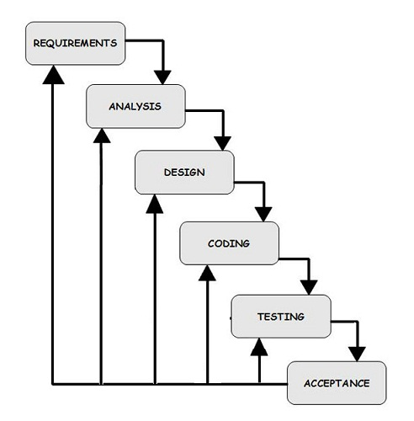

Diagram no- 1

Advantages of Iterative model

* In iterative model we can only create a high-level design of the application before we actually begin to build the product and define the design solution for the entire product. Later on we can design and built a skeleton version of that, and then evolved the design based on what had been built.
* In iterative model we are building and improving the product step by step. Hence we can track the defects at early stages. This avoids the downward flow of the defects.
* In iterative model we can get the reliable user feedback. When presenting sketches and blueprints of the product to users for their feedback, we are effectively asking them to imagine how the product will work.
* In iterative model less time is spent on documenting and more time is given for designing.

Due to these advantages, I opted Iterative Waterfall Model for the development of my project.

**1.2. REQUIREMENTS:**

**1.2.1. Hardware Requirement**

**Processor** : Pentium 4 or above

**Processor Speed** : 2.00 GHz CPU

**RAM** : 1 GB or above

**Hard disk utilization** : 300 MB or above

**1.2.2. Software Requirement**

**Front End** : HTML, CSS

**Back End**  : Django

**Application Server** : Django Server

**Operation System** : Windows or any equivalent

**1.3 PROJECT MODULES:**

**1.3.2 Admin Module**

**City Weather and Map**

* Admin can add the new city.
* Admin can delete the city.

**Word Dictionary**

* Website has not any Admin Module

**1.3.3 User module**

**City Weather and Map**

* User can add the city
* User can delete the city
* User can see the weather information and map of city

**Word Dictionary**

* User can search the word and see the meaning of word

**CHAPTER 2. TECHNOLOGY OVERVIEW:**

**2.1. Front End: HTML, CSS**

When you write a normal document using a word processor like Microsoft Word/Office, your text is saved in a file with a special format. It is not simply saved as the string of words you typed since the document needs to preserve things like the font you chose, the size of the text, which words are in bold, which italics, and so on. The special format includes not only your words, but all these extra information so that the next time Word opens your document, it can display the document with the exact appearance you created earlier.

In the same way, web pages are simply strings of words put in a special format that web browsers are able to display. While the format of Word documents is simply called "Word format" (or "doc format"), loosely speaking, one might say that web pages are formatted using "HTML". Take the paragraph of text in the box below for example:

This is an example paragraph to illustrate what HTML is, for the purpose of [explaining common terms like HTML, JavaScript and PHP](https://www.thesitewizard.com/html-tutorial/what-is-html.shtml).

If you were to peek into the raw code for the above words, you will see the following:

This is an example paragraph to illustrate what HTML is, for the purpose of <a href="https://www.thesitewizard.com/html-tutorial/what-is-html.shtml">explaining common terms like HTML, JavaScript and PHP</a>.

Notice that it is more or less like the text given earlier, except that there is additional information embedded. For example, the portion that says <a href="https://www.thesitewizard.com/html-tutorial/what-is-html.shtml"> (which I placed in a different font above to make it easier to spot) tells the web browser that what follows, until </a> is reached, is to be regarded as a link pointing at the web address https://www.thesitewizard.com/html-tutorial/what-is-html.shtml

When the web browser sees this information, it makes the words "explaining common terms like... [etc]" appear as the blue underlined text that represents a clickable link. The rest of the text is just displayed as-is.

Cascading Style Sheets, or CSS, allow you to specify things like the font you want on your page, the size of your text, whether the page is to have 2 columns, whether your text is to be in bold or italics, and so on. In other words, it is the part that lets you control the appearance of your web page.

You may be used to the Microsoft Word "doc" format, where everything from the text you type to the appearance of the document is specified in a single file, transparent to you. On the web, the raw information is specified in HTML and most of the appearance is determined by the CSS.

If you use a web editor like those I [mentioned above](https://www.thesitewizard.com/html-tutorial/what-is-html.shtml#editors), you won't have to bother with which parts goes into the HTML portion and which parts goes into the CSS portion. Everything will be taken care of by the editor.

For those who want to accomplish specific effects using CSS, you can check out my [list of CSS tutorials](https://www.thesitewizard.com/css/index.shtml). However, if you are using a web editor, you probably don't need to read those articles, since you can usually accomplish the same thing using the editor's built-in facilities, and it will generate the appropriate CSS code for you.

**2.2. Back End: Django**

With Django, you can take Web applications from concept to launch in a matter of hours. Django takes care of much of the hassle of Web development, so you can focus on writing your app without needing to reinvent the wheel. It’s free and open source.

**Ridiculously fast.**

Django was designed to help developers take applications from concept to completion as quickly as possible.

**Fully loaded.**

Django includes dozens of extras you can use to handle common Web development tasks. Django takes care of user authentication, content administration, site maps, RSS feeds, and many more tasks — right out of the box.

**Reassuringly secure.**

Django takes security seriously and helps developers avoid many common security mistakes, such as SQL injection, cross-site scripting, cross-site request forgery and clickjacking. Its user authentication system provides a secure way to manage user accounts and passwords.

**Exceedingly scalable.**

Some of the busiest sites on the planet use Django’s ability to quickly and flexibly scale to meet the heaviest traffic demands.

**Incredibly versatile.**

Companies, organizations and governments have used Django to build all sorts of things — from content management systems to social networks to scientific computing platforms.

**2.3. IDE: (Integrated Development Environment)**

An integrated development environment (IDE) (also known as integrated design environment, integrated debugging environment or interactive development environment) is a [software application](http://application/) that provides comprehensive facilities to [computer programmers](http://programmer/) for [software development](http://development/). An IDE normally consists of:

* a [source code editor](http://editor/)
* a [compiler](http://compiler/) and/or an interpreter
* [build automation](http://automation/) tools
* a [debugger](http://debugger/)

The boundary between an integrated development environment and other parts of the broader software development environment is not well-defined. Sometimes a [version control system](http://system/) and various tools are integrated to simplify the construction of a [GUI](http://gui/). Many modern IDEs also have a [class browser](http://browser/), an object inspector, and a hierarchydiagram, for use with [object-oriented software development](http://programming/).

**CHAPTER 3. FEASIBILITY STUDY:**

A feasibility study is conducted to select the best system that meets performance requirement. This entails an identification description, an evaluation of candidate system and the selection of best system for the job. The system required performance is defined by a statement of constraints, the identification of specific system objective and a description of outputs.

The key consideration in feasibility analysis are-

* Economic Feasibility
* Technical Feasibility
* Operational Feasibility
* Behavioral Feasibility

**3.1. Economic Feasibility**

Economic analysis determines the benefits and the saving that are expressed from a candidate system and compare those costs. If benefits outweigh costs. Otherwise, further justification or alterations in the proposed system will have to be made if it is to have a chance of being approved. This is an ongoing effort that improves in accuracy at each phase of the system life cycle.It looks at the financial aspects of the project. It determines whether the management has enough resources and budget to invest in the proposed system and the estimated time for the recovery of cost incurred. It also determines whether it is worthwhile to invest the money in the proposed project. Economic feasibility is determines by the means of cost benefit analysis.

**3.2. Technical Feasibility**

It is a measure of the practically of a specific technical solution and the availability of technical resources and expertise

* The proposed system uses css as front-end and django framwork as back-end tool.
* Django is a popular tool used to design and develop database objects such as table views, indexes.
* The above tools are readily available, easy to work with and widely used for developing commercial application.

Hardware used in this project are I 3 processor 2.4GHz, 2GB DDR3 memory, 500 GB hard disk. These hardware were already available on the existing computer system. The software like Atom and operating system WINDOWS 10 used were already installed on the existing computer system. So no additional hardware and software were required to purchase and it is technically feasible.

**3.3. Operational Feasibility**

It is common knowledge that computer installations have something to do with turnover, transfers, retraining and changes in employee job status. Therefore, it is understandable that the introduction of a candidate system requires special efforts to educate, sell, and train the staff on new ways of conducting business.

* No major training and new skills are required as it is based on DBMS model.
* It will help in the time saving and fast processing and dispersal of user request and applications.
* New product will provide all the benefits of present system with better performance.
* Improved information, better management and collection of the reports.
* User support.

From there points our project is operationally feasible too.

**3.4. Behavioral Feasibility**

People are inherent to change. In this type of feasibility check, we come to know if the newly developed system will be taken and accepted by the working force i.e. the people who will use it.

**CHAPTER 4. ANALYSIS:**

**4.1. Data flow diagrams (DFD)**

DFD is an important tool used by system analysts. The main merit of DFD is that it can provide an over view of what a system would process, what transformation of data are done, what files are used and where the result flows. The grphical representation of the system makes it a user and analyst. DFD is structural in such a way that starting from a simple diagram which provides a board overview at a glance, there can be expanded to a hierarchy of diagram giving top more and more details.

* Square: - Source or destination of data (External or Internal) as the name suggested does not fall with system boundary hence are defined as source/destination of data.
* Rounded rectangle/Circle: Process can be defined at place where transfer of data takes place; this transformation includes additional modification deletion or accumulation of data.
* Open ended rectangle/parallel lines, data store- This symbolically represents place where data is stored the data can be stored for future procession (or) it can be processed for future return any place where data is stored is called data stored.

### **Data flow can take place:**

* Between process
* File to process
* External entity to process
* Process to external entity
* Process to file.

DFD’s of Different-2 levels of Hostel Management System:-

**LEVEL 0 DFD**

User

**Level 1 DFD**

Main Page

Website

User

**City Weather and Map**

User

Admin

Add new City

Add/Delete City

Delete City

Open map

Switch to Word Dictionary website

**Word Dictionary**

User

Search Words

Switch to City Weather website

**CHAPTER 5. SYSTEM TESTING:**

Quality assurance is an important step in software engineering. This overlaps with all the phases of development right from the requirement analysis. This quality requirement of the software system must be clearly extracted during the requirement analysis and all the subsequent phases should be made biased to that, the final testing will become trivial and less expensive.

There are number of quality parameters like correctness, accuracy, reliability, robustness, efficiency, effectiveness, reusability, maintainability etc.. The state of requirement of each of these parameters will vary depending upon the name and domain of the application. The testing should be done at the end of all development steps. Even though the final testing and verification are inevitable for better life and functionality of the software.

The different software testing approaches and methods like white box testing and black box testing. The major phases in testing are design of test plan, setting up test case and test candidate and test procedure, testing and correction. This is a cycle process and the software will circulate through all the steps till it attends the required quality. The testing is carried in the following steps.

**5.1 Unit testing**

Unit testing focuses verification effort on the smallest unit of software design the module. Using the details design description as a guide, important control paths are tested to uncover errors within boundary of the boundary of the module. The relative complexity of tests and the errors detected as a result is limited by the constrained scope established for unit testing.

Unit testing is normally considered an adjacent to coding steps. After source level code has been developed, reviewed, and verified for correct syntax, unit test case design begins. A review of design information provides guidance for establishing test cases that are likely to uncover error in each case of the categories discussed above. Each test case should be coupled with a set of expected results.

**5.2 Integration testing**

Integration testing is systematic technique for constructing the program structure while at the same time conducting test to uncover error associated with interfacing .The objective is to take unit tested modules and build a program structure that has been dictated by design.

There is often a tendency to attempt no incremental integration; that is to construct the program using a “big bang “approach. The entire modules are combined in advance. The entire program is tested as whole and chaos usually result! A set of error is encountered. Correction is difficult because the isolation of cause is complicated by the vast expanse of entire program. Once errors are corrected, new ones appear and process continues in a seemingly endless loop.

**6. PROJECT DESIGN**

**City Weather and Map**

**6.1. Database Design**

In our project we use Django administration for making the back end database there table are given with its description.

Description: Represent the name of cities

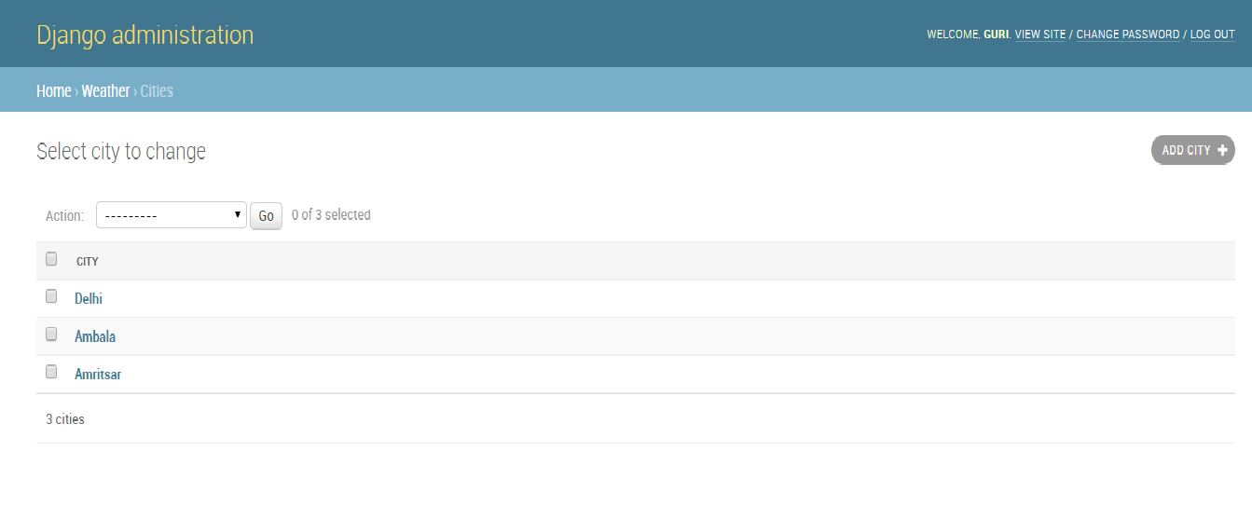

**6.2. Front-end Design**

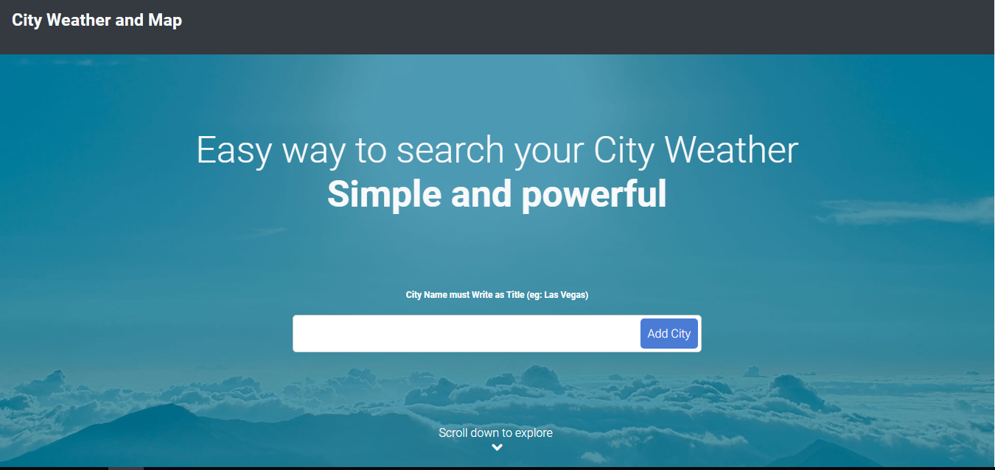

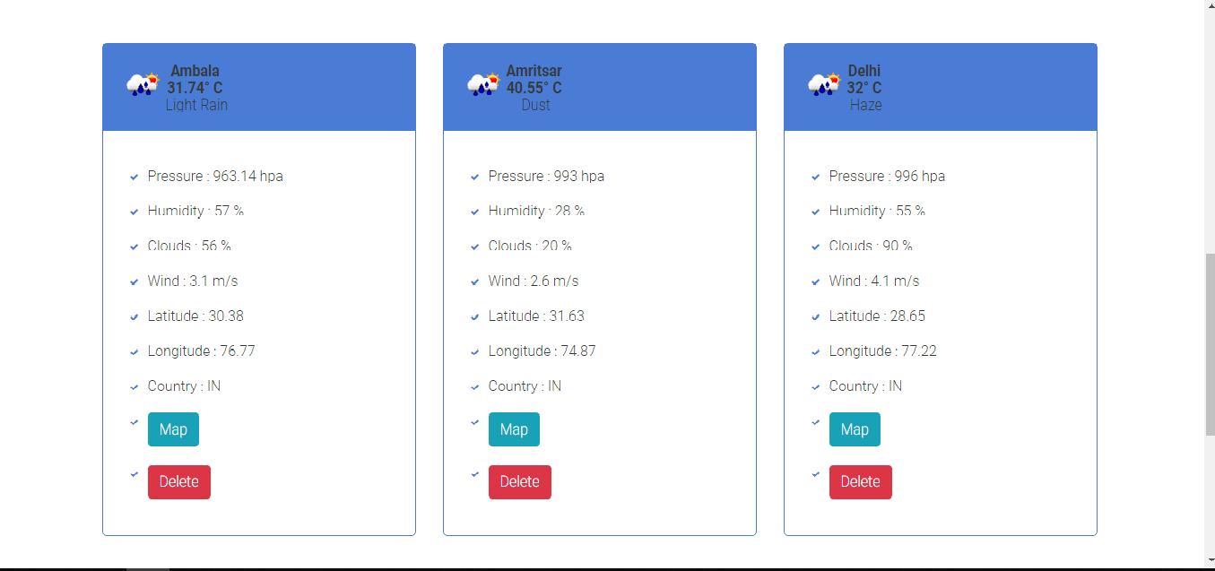

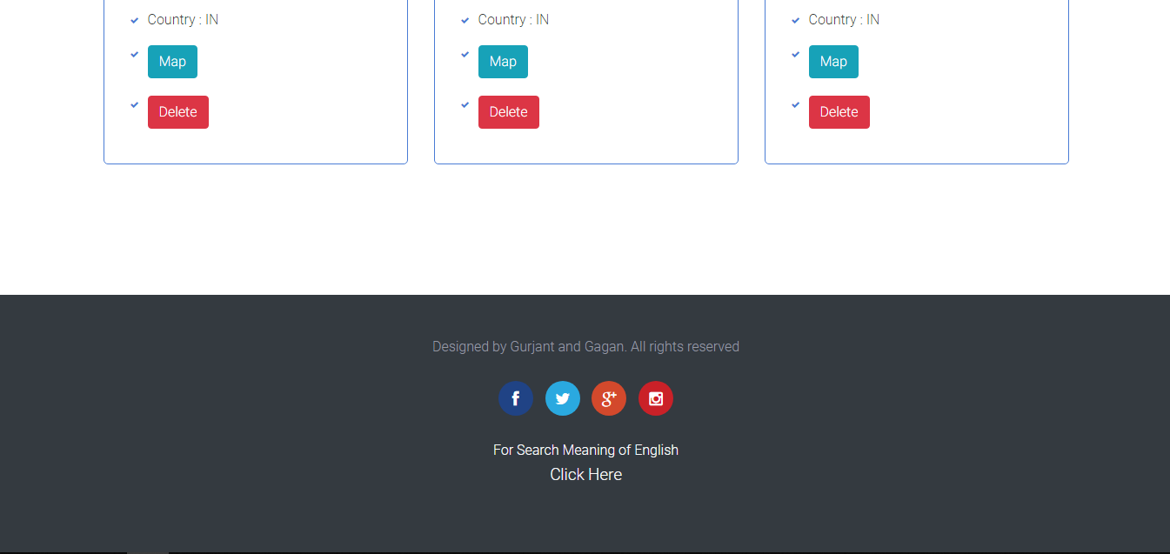

**Word Dictionary**

**6.3. Front-end Design**

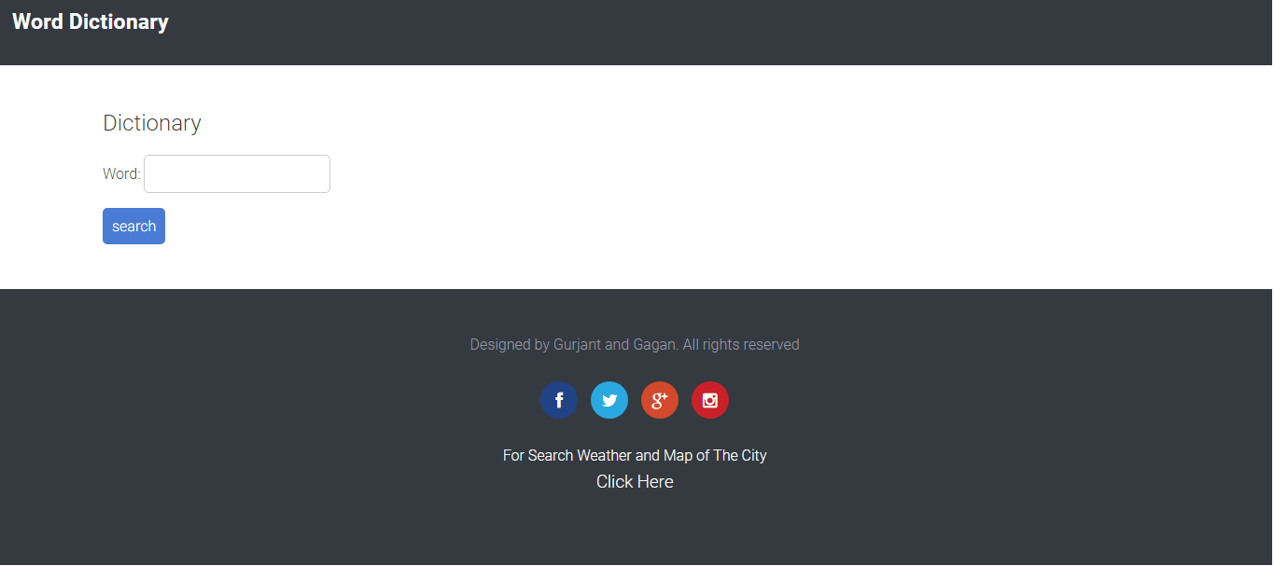

**CHAPTER 7. CONCLUSIONS AND FUTURE SCOPE:**

**CONCLUSION:**

City Weather and Map is an application that can help weather activity of the city every day and Word Dictionary helps to find meaning of the English words. These applications will help reduce

time to getting information regarding city weather and word meaning. Furthermore, it is hope that the applications can fulfill the public requirement in the future.

**FUTURE SCOPE:**

More features could be added like online weather forecast, map directions in City Weather and Map and offline dictionary, more knowledge about words.