AMONG US: My Summer Vacation — Printable Cards
Junior Sunshine 6, Lesson 4 · Print, cut along the lines, and sort into decks for each station.

Role Cards
24 Crewmate cards + 6 Impostor cards shown — print enough copies for your class size, keeping roughly a 6:1 to 8:1 Crewmate-to-Impostor ratio.
CREWMATE | CREWMATE
CREWMATE | CREWMATE
CREWMATE | CREWMATE
CREWMATE | CREWMATE
CREWMATE | CREWMATE
CREWMATE | CREWMATE
CREWMATE | CREWMATE
CREWMATE | CREWMATE
CREWMATE | CREWMATE
CREWMATE | CREWMATE
CREWMATE | CREWMATE
CREWMATE | CREWMATE
IMPOSTOR | IMPOSTOR
IMPOSTOR | IMPOSTOR
IMPOSTOR | IMPOSTOR

"OUT!" Cards (for Impostors to show a Crewmate)
OUT!  You are eliminated. | OUT!  You are eliminated.
OUT!  You are eliminated. | OUT!  You are eliminated.
OUT!  You are eliminated. | OUT!  You are eliminated.

Station 1 — Photo Match
Deck A: Picture cards. Deck B: Sentence cards. Shuffle each deck separately, then have students match Deck A to Deck B.

Deck A — Picture Cards
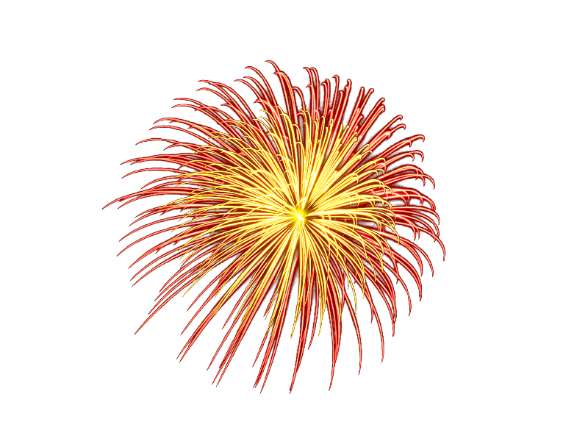 | 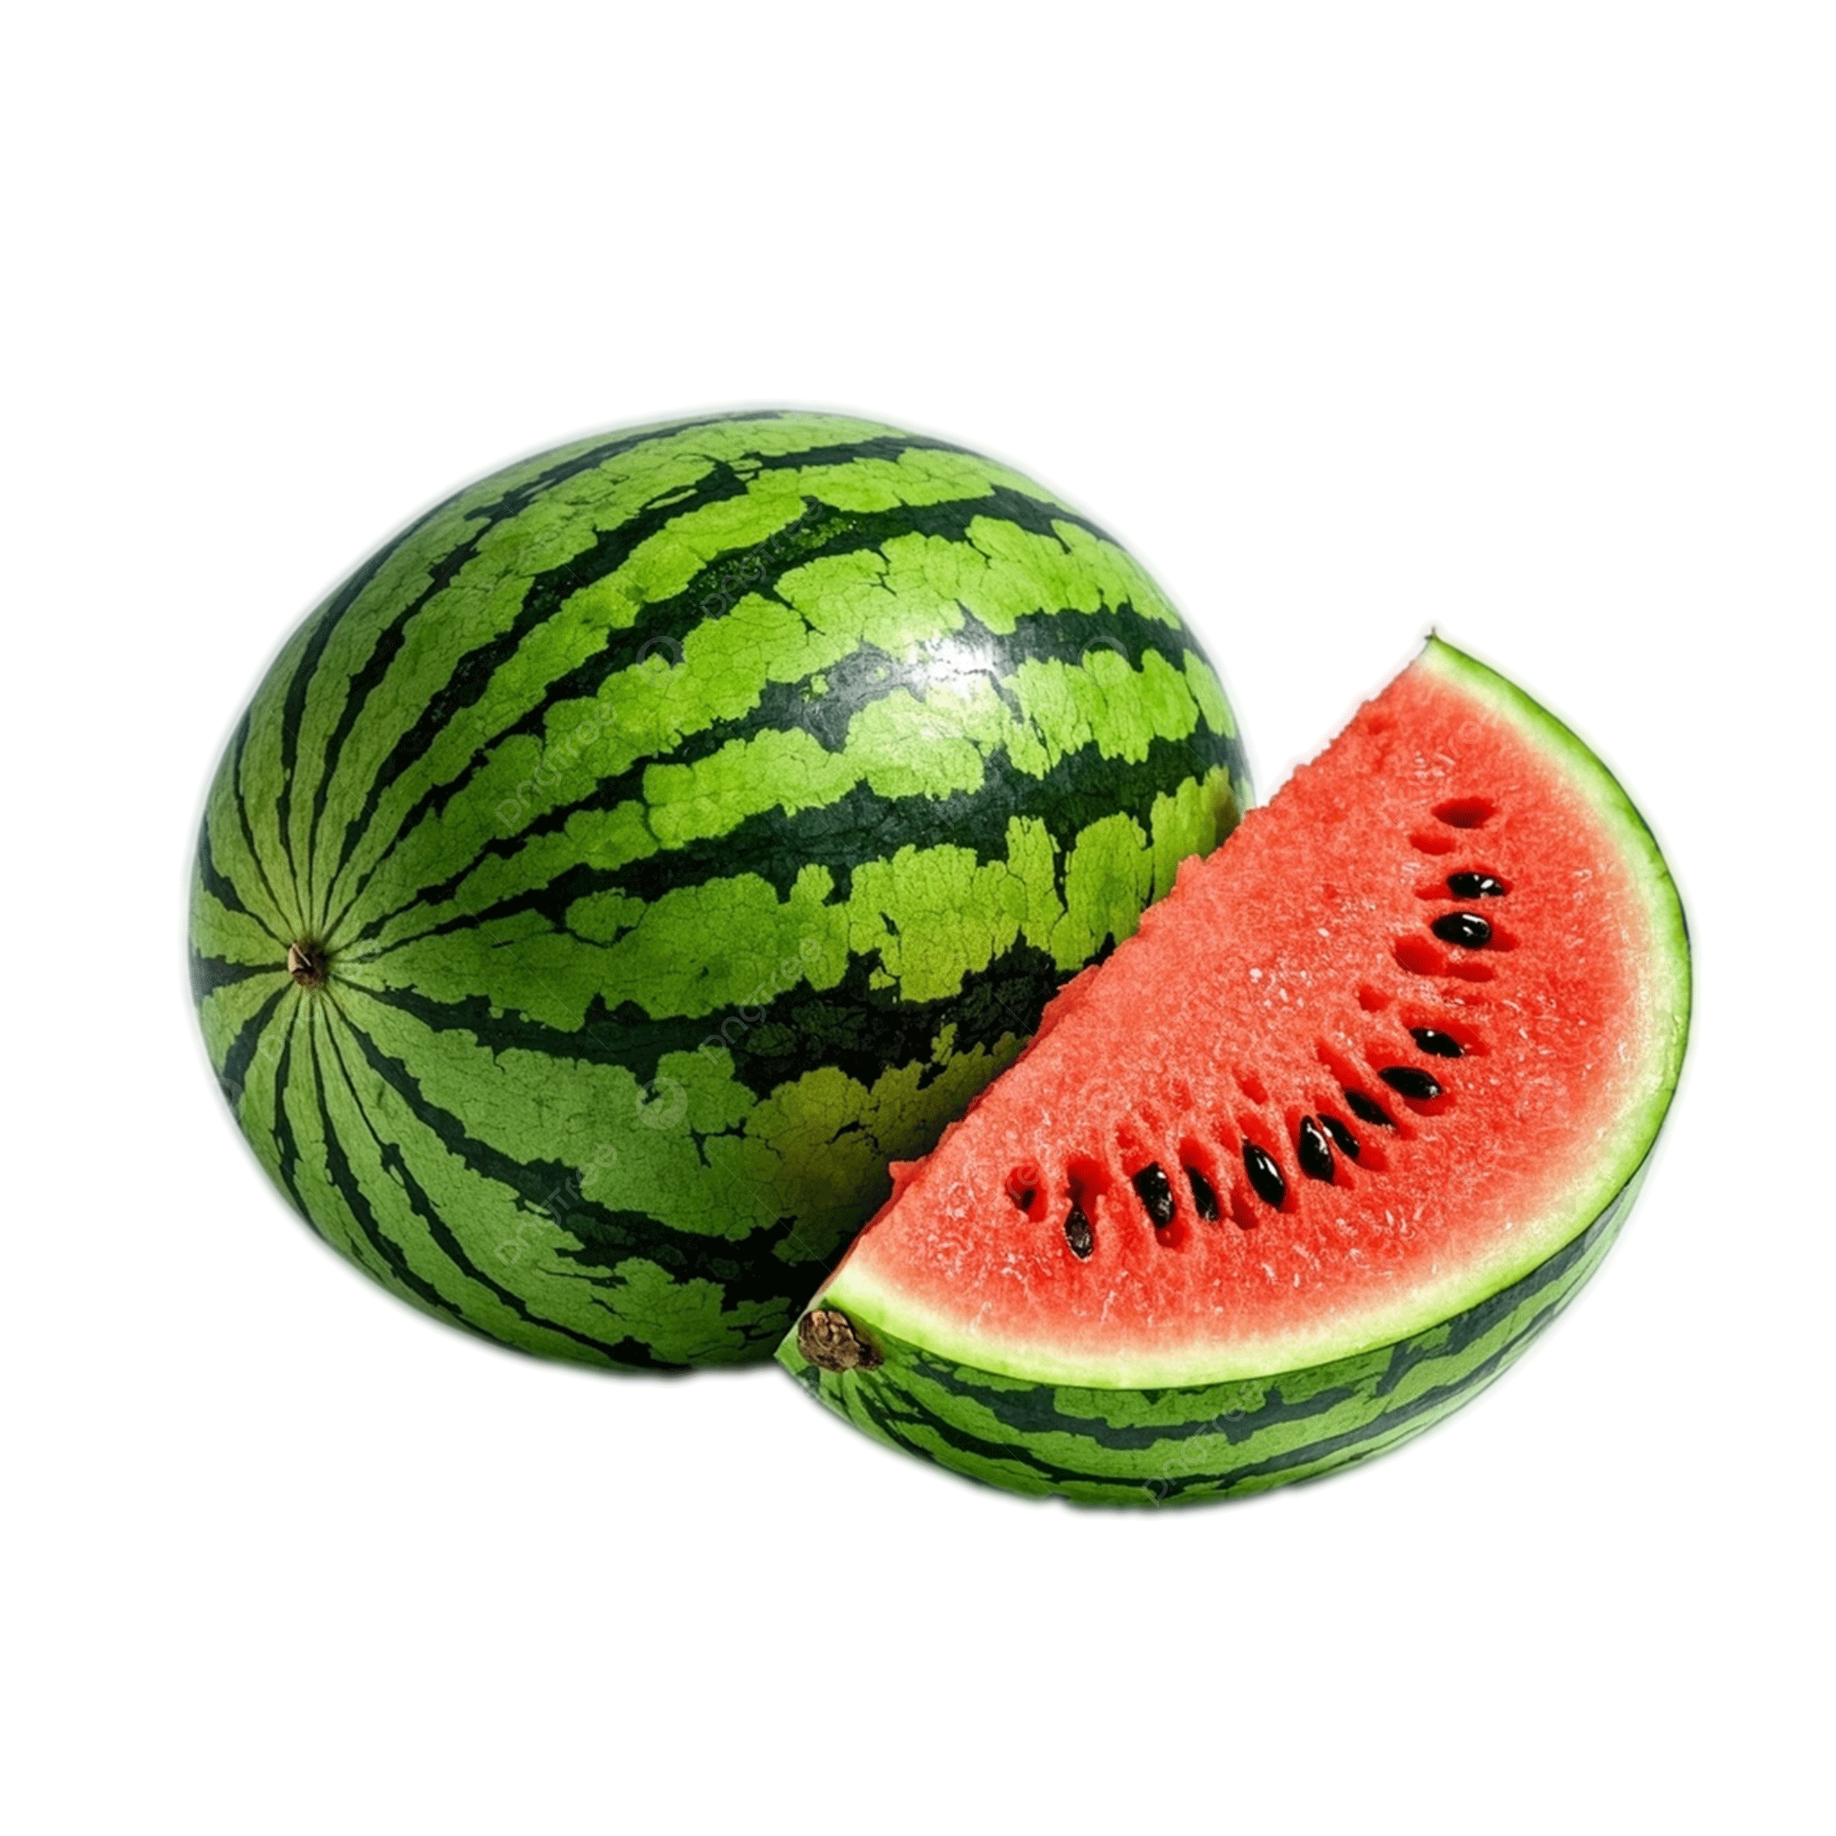 | 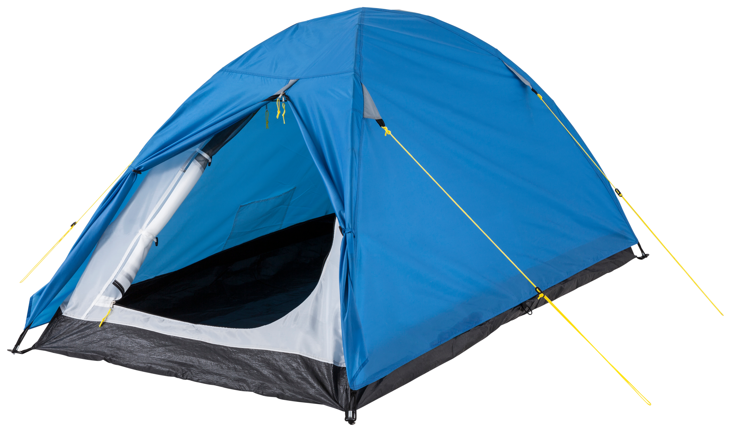
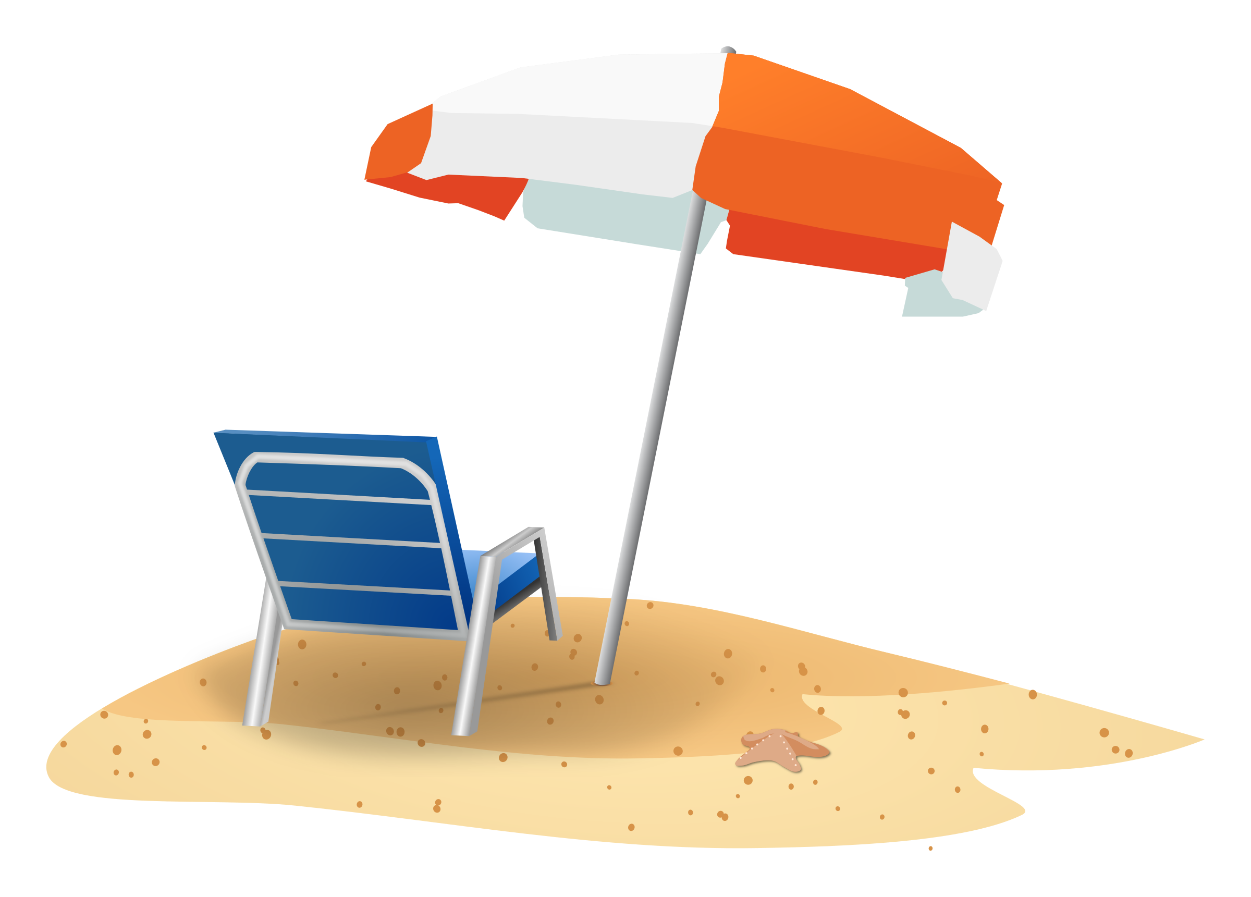 |  | 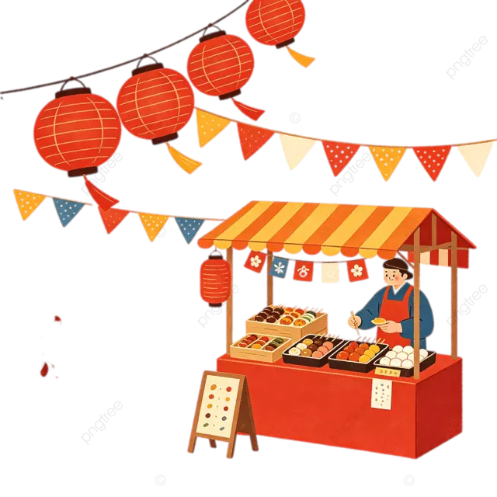
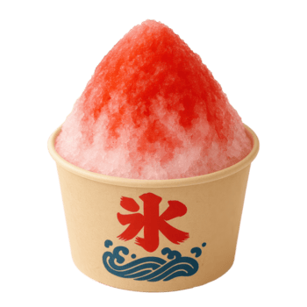 |  | 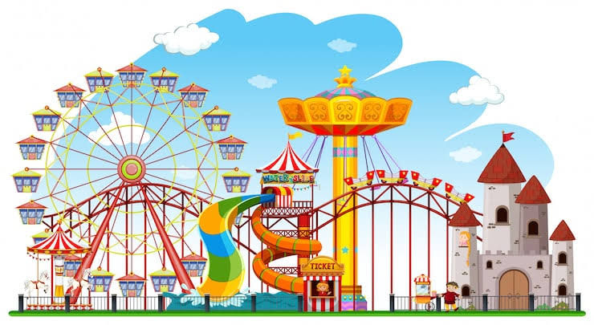
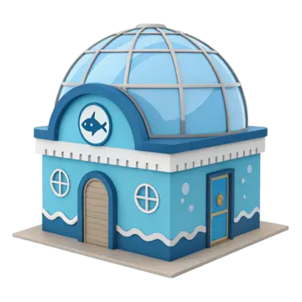 | 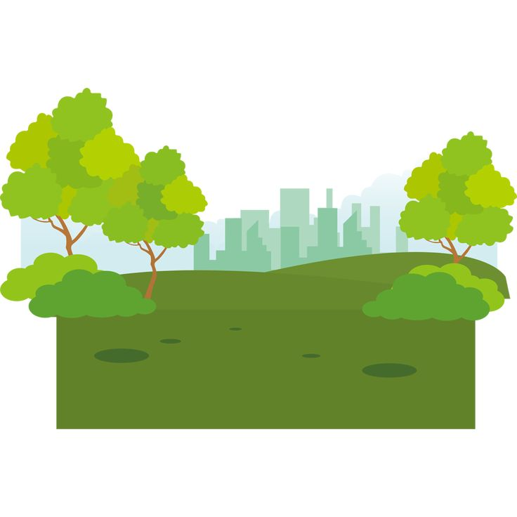 | 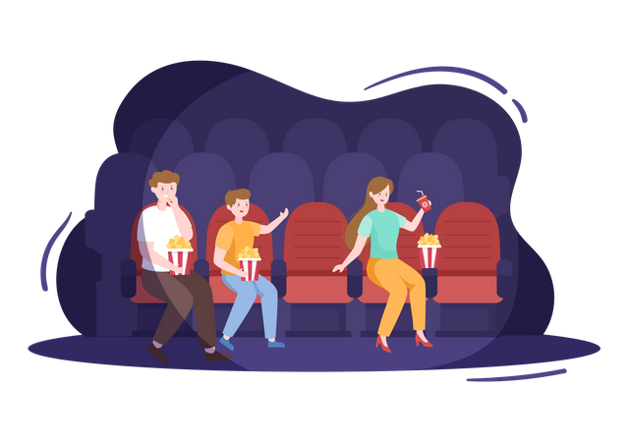
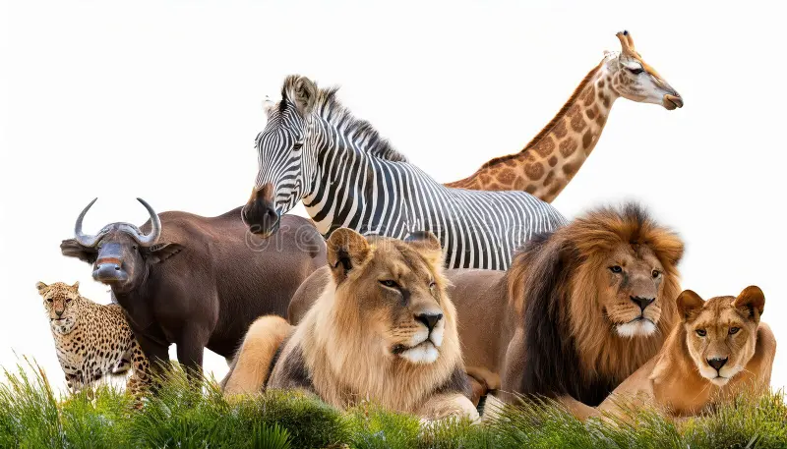 | 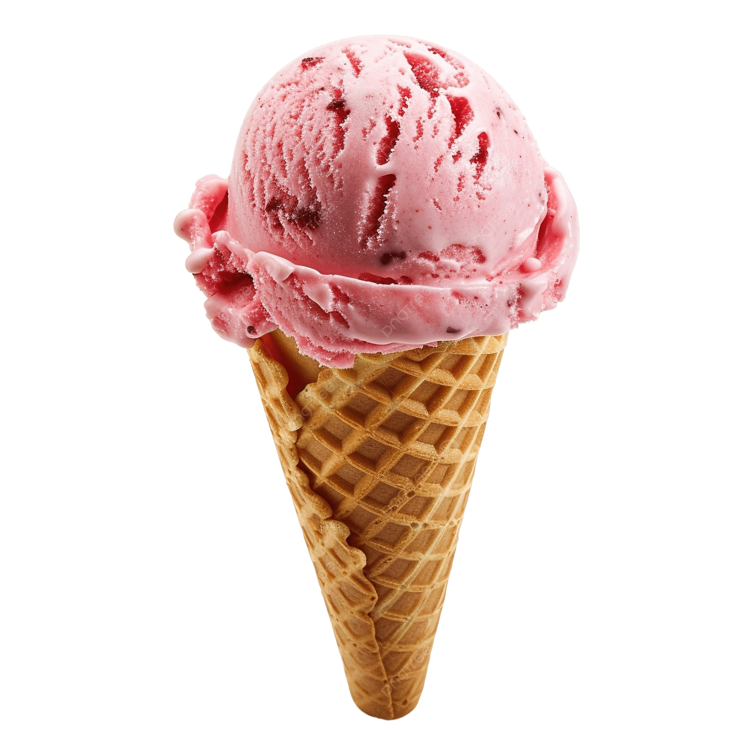 | 
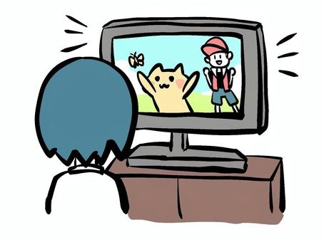

Deck B — Sentence Cards
I saw fireworks. | I ate watermelon.
I went camping. | I went to the beach.
I enjoyed swimming. | I saw a festival.
I ate shaved ice. | I went to the mountains.
I went to an amusement park. | I saw fish at the aquarium.
I went to the park. | I saw a movie.
I went to the zoo. | I ate ice cream.
I went to Tokyo by train. | I enjoyed watching TV.

Station 2 — Wire Connect
One combined deck of 20 verb pairs — all used together.

Base Form Deck
go | eat | see
have | enjoy | am/is/are
play | watch | swim
make | do | get
buy | read | ride
take | come | drink
write | run

Past Form Deck
went | ate | saw
had | enjoyed | was/were
played | watched | swam
made | did | got
bought | read | rode
took | came | drank
wrote | ran

Station 3 — Scan Task Topic Cards
Student draws a card and says a true sentence about their summer using the topic. Helper checks/stamps the checklist.
Talk about:  Where you went | Talk about:  What you ate
Talk about:  What you saw | Talk about:  Who you went with
Talk about:  How many days you stayed | Talk about:  What you enjoyed most
Talk about:  The weather | Talk about:  A funny thing that happened
Talk about:  Something you bought | Talk about:  A picture you took
Talk about:  Your favorite food there | Talk about:  A place you want to go next
Talk about:  Something new you tried | Talk about:  An animal you saw
Talk about:  A game you played | Talk about:  A festival you went to
Talk about:  Something you got as a present | Talk about:  Your favorite memory
Talk about:  How you felt (fun? exciting? tired?) | Talk about:  Something you did every day

Station 4 — Question Cards
Student draws a card and answers it aloud (or writes the answer on their worksheet).
Where did you go this summer? | What did you eat?
What did you see? | Did you enjoy it?
How was it? | Who did you go with?
How many days did you stay? | Did you swim in the sea?
Did you see fireworks? | What was your favorite part?
Did you have a good time? | Was it hot or cold?
Did you go to a festival? | What did you buy?
Did you take a lot of pictures? | What did you do every day?
Did you go to your grandmother's house? | Was the food delicious?
Did you go camping? | Do you want to go there again?

Station 5 — Unscramble Word Cards
Each word is its own card. Small gray text shows which sentence ("Set") and difficulty it belongs to — sort cut cards into envelopes by set before class. Students arrange the words in their set into a correct sentence. Answer key follows.
sea  Set 1 · Easy | I  Set 1 · Easy | to  Set 1 · Easy
went  Set 1 · Easy | the  Set 1 · Easy | we  Set 2 · Easy
fireworks  Set 2 · Easy | saw  Set 2 · Easy | it  Set 3 · Easy
was  Set 3 · Easy | fun  Set 3 · Easy | I  Set 4 · Easy
watermelon  Set 4 · Easy | ate  Set 4 · Easy | camping  Set 5 · Medium
we  Set 5 · Medium | went  Set 5 · Medium | and  Set 5 · Medium
enjoyed  Set 5 · Medium | it  Set 5 · Medium | grandmother's  Set 6 · Medium
I  Set 6 · Medium | house  Set 6 · Medium | to  Set 6 · Medium
my  Set 6 · Medium | went  Set 6 · Medium | had  Set 7 · Medium
a  Set 7 · Medium | we  Set 7 · Medium | time  Set 7 · Medium
good  Set 7 · Medium | mountains  Set 8 · Medium | were  Set 8 · Medium
the  Set 8 · Medium | beautiful  Set 8 · Medium | an  Set 9 · Hard
to  Set 9 · Hard | went  Set 9 · Hard | I  Set 9 · Hard
amusement  Set 9 · Hard | park  Set 9 · Hard | and  Set 9 · Hard
rides  Set 9 · Hard | the  Set 9 · Hard | enjoyed  Set 9 · Hard
saw  Set 10 · Hard | at  Set 10 · Hard | fish  Set 10 · Hard
the  Set 10 · Hard | we  Set 10 · Hard | colorful  Set 10 · Hard
aquarium  Set 10 · Hard | it  Set 11 · Hard | was  Set 11 · Hard
hot  Set 11 · Hard | but  Set 11 · Hard | fun  Set 11 · Hard
very  Set 11 · Hard | I  Set 12 · Hard | with  Set 12 · Hard
went  Set 12 · Hard | family  Set 12 · Hard | my  Set 12 · Hard
to  Set 12 · Hard | Kyoto  Set 12 · Hard | shaved  Set 13 · Hard
delicious  Set 13 · Hard | ice  Set 13 · Hard | the  Set 13 · Hard
was  Set 13 · Hard | saw  Set 14 · Hard | festival  Set 14 · Hard
a  Set 14 · Hard | we  Set 14 · Hard | and  Set 14 · Hard
yukata  Set 14 · Hard | wore  Set 14 · Hard | had  Set 15 · Hard
three  Set 15 · Hard | we  Set 15 · Hard | days  Set 15 · Hard
there  Set 15 · Hard | fun  Set 15 · Hard | for  Set 15 · Hard

Answer Key — Station 5
Set 1 [Easy] I went to the sea.
Set 2 [Easy] We saw fireworks.
Set 3 [Easy] It was fun.
Set 4 [Easy] I ate watermelon.
Set 5 [Medium] We went camping and enjoyed it.
Set 6 [Medium] I went to my grandmother's house.
Set 7 [Medium] We had a good time.
Set 8 [Medium] The mountains were beautiful.
Set 9 [Hard] I went to an amusement park and enjoyed the rides.
Set 10 [Hard] We saw colorful fish at the aquarium.
Set 11 [Hard] It was very hot but fun.
Set 12 [Hard] I went to Kyoto with my family.
Set 13 [Hard] The shaved ice was delicious.
Set 14 [Hard] We saw a festival and wore yukata.
Set 15 [Hard] We had fun there for three days.

Bonus Review Station (Lessons 1–3)
Optional 6th station or filler for students waiting in line. Reviews self-introductions, daily routine, and 'want to go' from earlier lessons.
My name is ___. | I am from ___.
I get up at ___. | I want to go to ___.
Where do you want to go next summer? | What time do you usually get up during vacation?
What is your favorite subject? | What sport can you play?
What country do you want to visit? | Nice to meet you!

Impostor Cover-Question Cards
Impostors may draw one of these to ask a Crewmate as a 'friendly' cover question before secretly eliminating them.
What did you do at that station? | Where did you go this summer?
Did you enjoy your vacation? | What was the best part of your summer?
Who did you go with? | What did you eat there?
Did you see anything interesting? | How was the weather?
Did you have a good time? | What did you buy?

