**Analysis of the trends in different types of wildfire vegetation in California.**

Date: February 26, 2021

**Table of Contents**

1. Executive Summary ………………………………………………………………pg 1
2. Background Information ………………………………………………………….pg 2
3. Data Methodology ………………………………………………………………...pg 3
4. Mathematical Model ……………………………………………………………....pg 4
   1. Assumptions
   2. Model Development
   3. Model Results
   4. Model Prediction
5. Risk Analysis ………………………………………………………………………pg 11
6. Recommendations ………………………………………………………………..pg 12
7. References ………………………………………………………………………...pg 13
8. Python Code ……………………………………………………………………….pg 14

**1 Executive Summary:**

Wildfires are a major problem around the world as they burn up crops and structures and pollute the air, all while driving away potential land developers. On top of this, the smoke generated from thousands of acres of burning vegetation has adverse effects on human health as well as the environment. Although wildfires cannot be eliminated completely, our project offers strategies that will reduce the fuel the fire needs in order to spread.

In our research, we analyzed the frequency and severity of fires that burned more than 300 acres of vegetation in all counties across California from 2008 to 2019, as well as the kinds of vegetation they burned. From our analysis with the vegetation, we found that brush and grass were the best fuel for these fires, and we offer mitigation strategies that reduce the amount of vegetation actually burned. By generating scatter plots of year versus burnt acreage and year versus number of fires for all three types of vegetation that we explored (grass, brush, timber), we were able to generate curves of best fit that help us predict future acreage loss and number of fires.

From our analysis we came up with mitigation strategies to handle timber and grass and brush separately. For timber, we propose a controlled deforestation strategy while for grass and brush, we propose a seasonal cutting of both of these vegetations. If the California state legislature implements this strategy in a potential partnership with private companies, they could send the proper resources to the proper places in order to reduce the severity of the fires.

**2 Background Information:**

Wildfires are natural disasters that devastate swathes of vegetation and destroy buildings. These fires occur in hot places such as Australia and the southwestern portion of the United States, but wildfires have taken an especially heavy toll on California, which is the focus of our research.

Wildfires pose a serious threat to farmers who live in these regions because the fires destroy their crops. The farmers then lose their only source of income, and the production of certain crops will decrease, therefore reducing the supply of fresh produce that people can buy from stores. If farmers are not able to produce their crops, there is a higher risk that there will be a food shortage, which would have detrimental effects on the state as well as the entire country. From the ash that is produced by the burning of crops, weeds are likely to spring up, and if the amount of weeds gets to a point where it is uncontrollable, then that entire plot of land is wasted and cannot be farmed on again.

Another adverse effect of wildfires is that the smoke from the fires is correlated with an increase in risk of contracting chronic heart diseases, and the risk is even higher for vulnerable populations such as children and senior citizens. The smoke from the fires generates excessive amounts of carbon dioxide, and carbon dioxide is dangerous for our lungs. Apart from damaging our lungs, the carbon dioxide generated from the smoke will keep on recycling throughout our environment as it is a greenhouse gas, which means that there is no feasible way to get rid of this noxious gas and save our health. Therefore, reducing the number of wildfires will protect our farmers and our vulnerable populations.

Wildfires also drive off potential land developers. Because there is such a high risk of fires burning down structures, people who want to cultivate land will not be inclined to build in these areas, which would essentially just leave the land to waste. Therefore, with all of these negative effects of wildfires, it is vital to mitigate these effects.

**3 Data Methodology:**

Since data regarding fires in California was the most readily available, we decided to focus specifically on fires in California. From one data source, we gathered information regarding the county, number of acres burned, and the type of vegetation burned. There were other variables in our data sources like fire name, date the fire started and date the fire was contained. We also only focused on fires that were larger than 300 acres because we reasoned that fires that burned less than 300 acres would not have as serious of an impact on the environment as fires that burned more than 300 acres of vegetation. From the other data source, we used data regarding precipitation and average temperatures for every county in California for the months of June, July, August, September, and October, but we could not find many trends within this data so we decided not to use this data in our analysis.

We believe that our data sources are reliable because they are from government websites. The data about the fires themselves came from annual redbooks that the California state government created and approved, so we reasoned that the data must be accurate. The data was taken from the CalFire agency. The other data source that we used was NOAA (National Oceanic and Atmospheric Administration), and from here we got detailed information regarding the precipitation and average monthly temperatures of all of the counties in California. Since this is a federal agency, it is very unlikely that the data would be incorrect.

**4 Mathematical Model**

**4.a Assumptions**

For us to be able to construct our model we had to make a couple assumptions. Our model is only constructed with data regarding fires that are over 300 acres. We also only considered fires that had either brush, grass, or timber vegetation because there were rarely any fires that consisted of vegetation that was not in these three categories. Some fires included a combination of vegetation for example a combination of Brush and Grass, Brush and Timber, Timber Grass or all three vegetation types we analyzed and for the fires that did have those we divided the acreage of vegetation burned by the number of types of vegetation.

**4.b Model Development**

Before we constructed our exponential and polynomial regression models we parsed through all for fires over 300 acres from 2008 to 2019 and split up the fires by vegetation. Using the pandas library we went through each fire and created subsets with the number of fires in each year and the number of acres burned in each year for each type of vegetation. We graphed the values by year and noticed that the values were very random and fitting a regression to such a model would be very difficult. Because the data showed no trends year after year, we resorted to doing analysis on cumulative data. For each vegetation type we summed up the amount of total fires and total acres burned until that year.

Once we created our cumulative data we used both exponential and quadratic regression in google sheets to fit the cumulative data.

Quadratic Regression Equations:

Exponential Regression Equation:

**4.c Model Results and Accuracy**

Below are our exponential and polynomial models for brush, timber, and grass fires and acres burned for each vegetation from 2008 to 2019. For the years 2008 to 2019 our models have R-Squared values very close to 1 and our lowest value r-squared is 0.974.

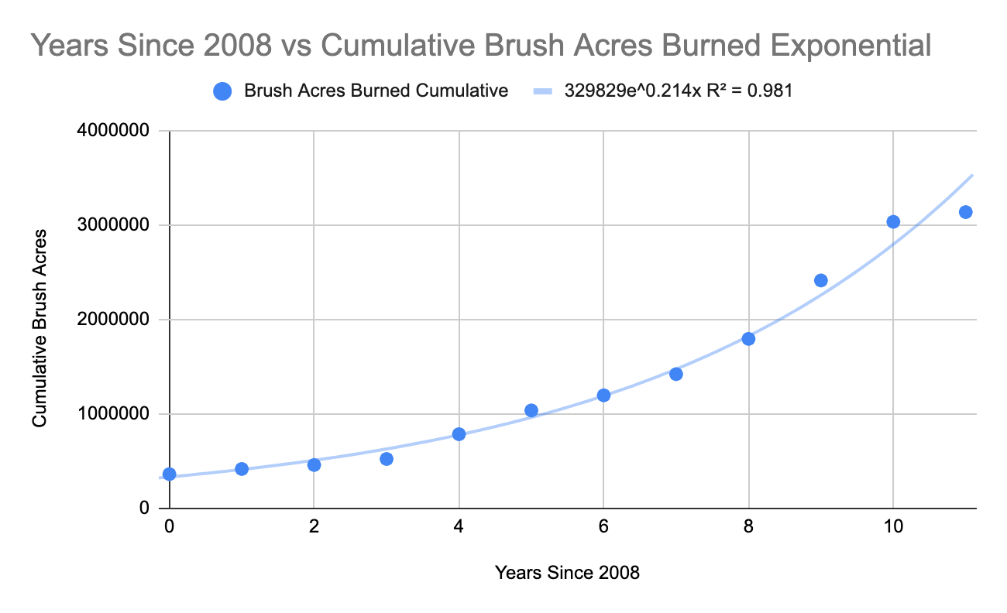

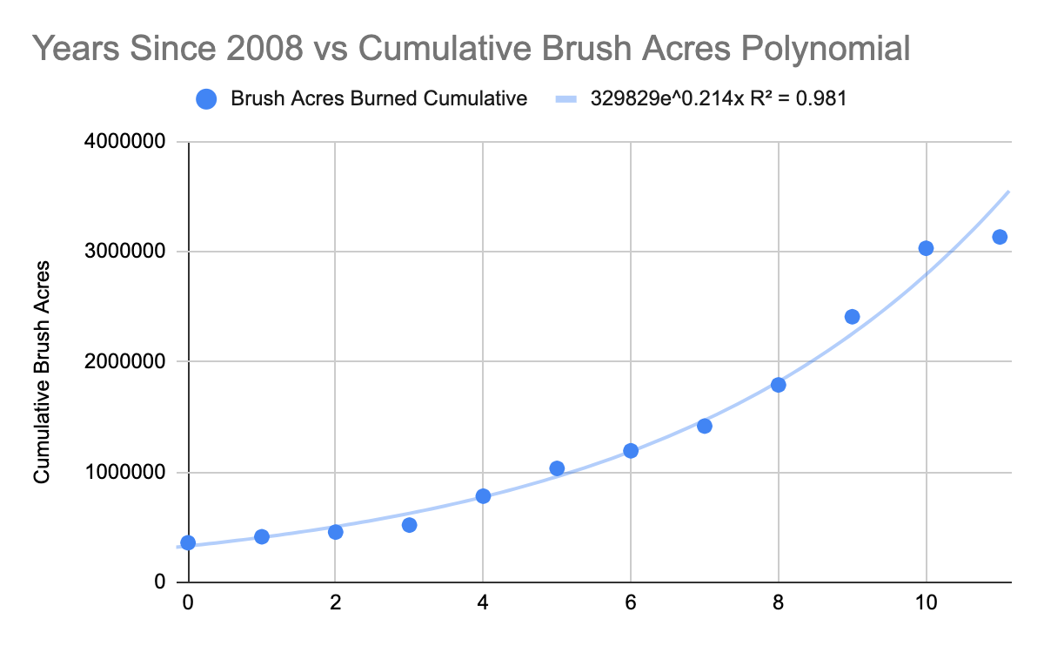

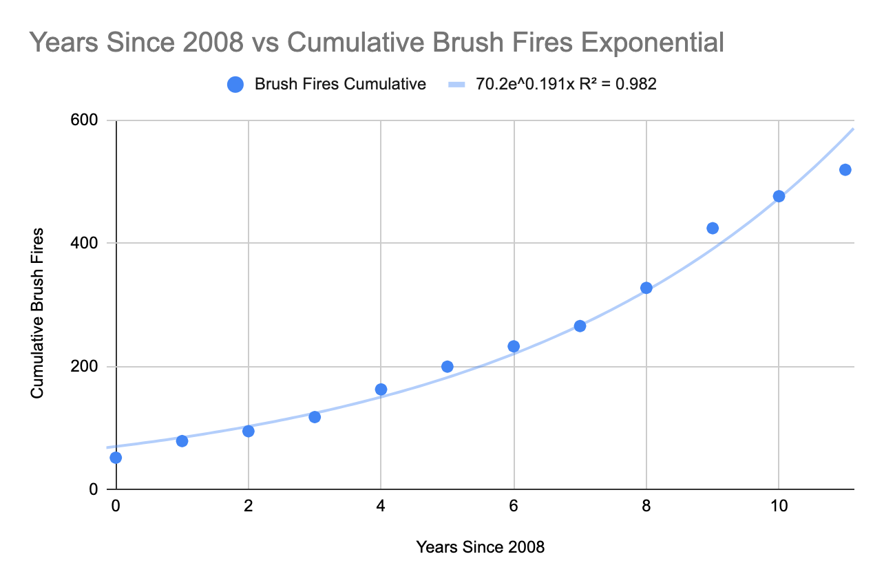

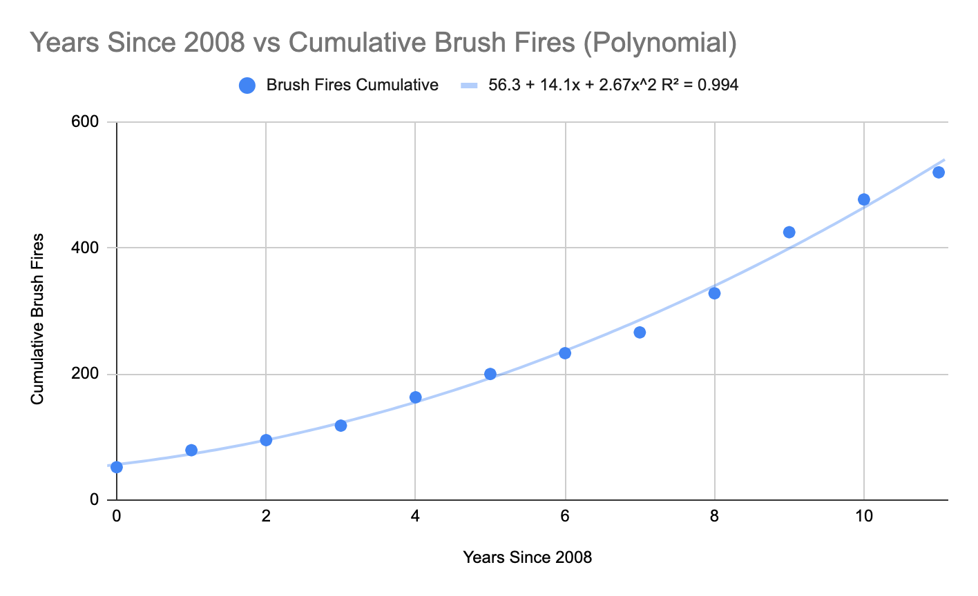

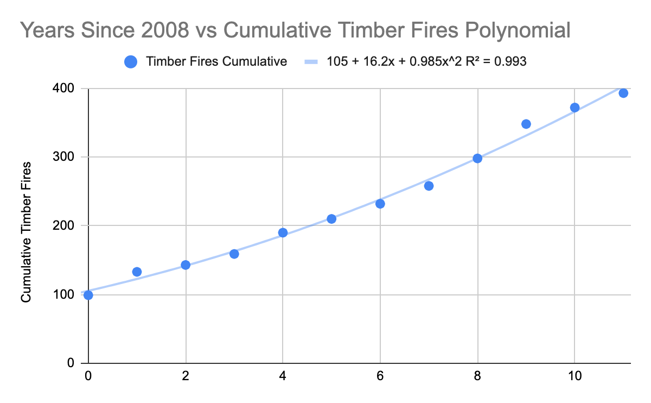 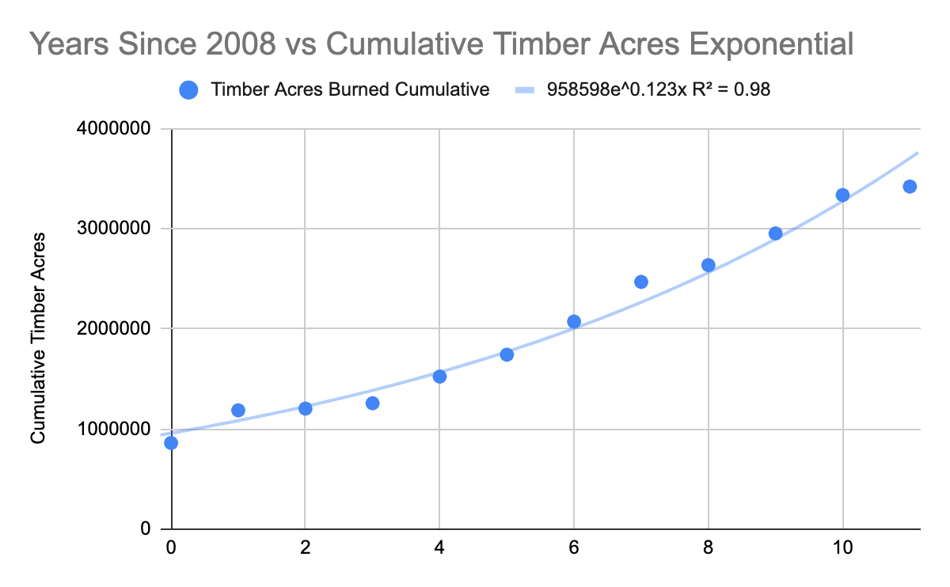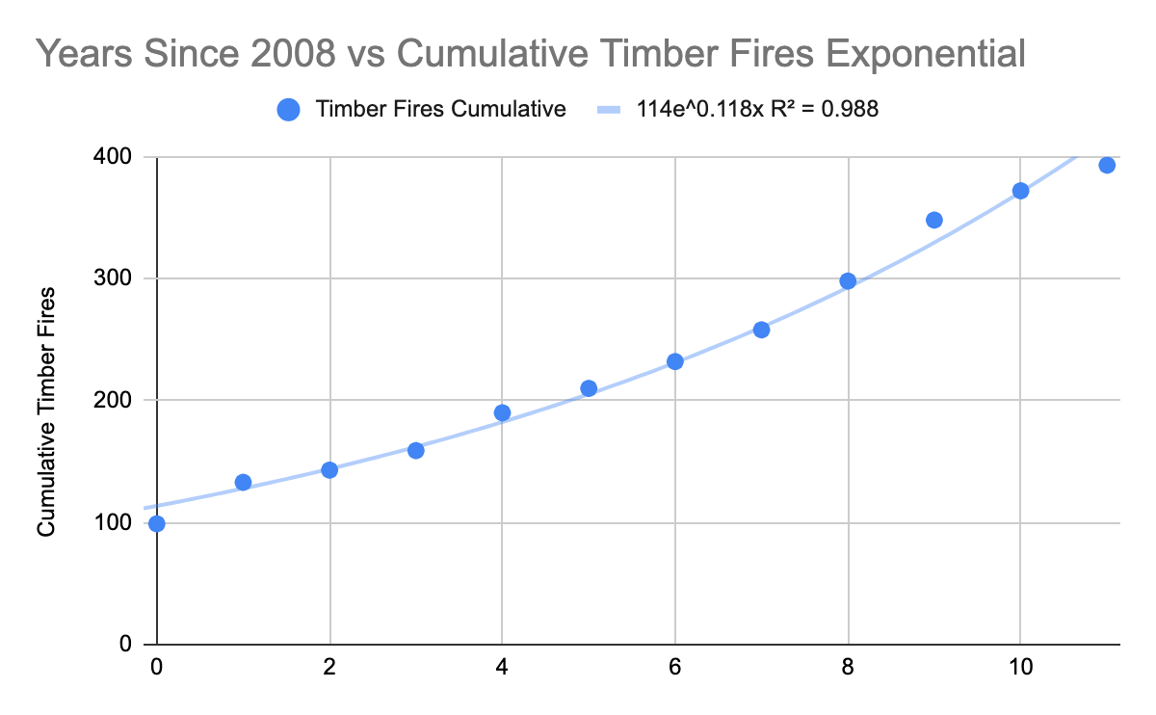

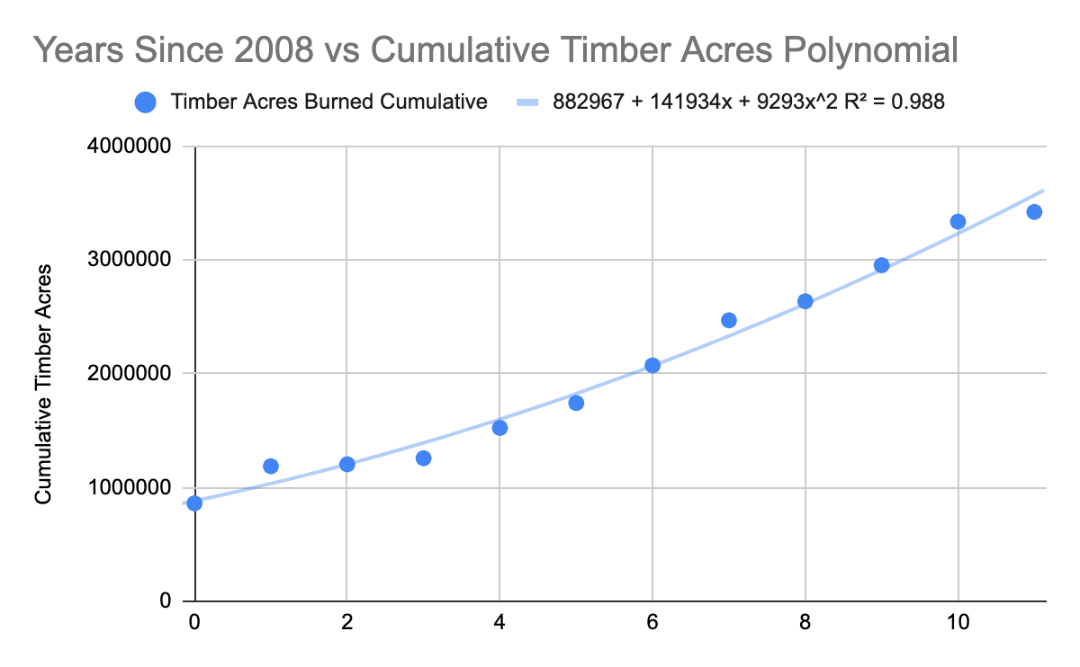

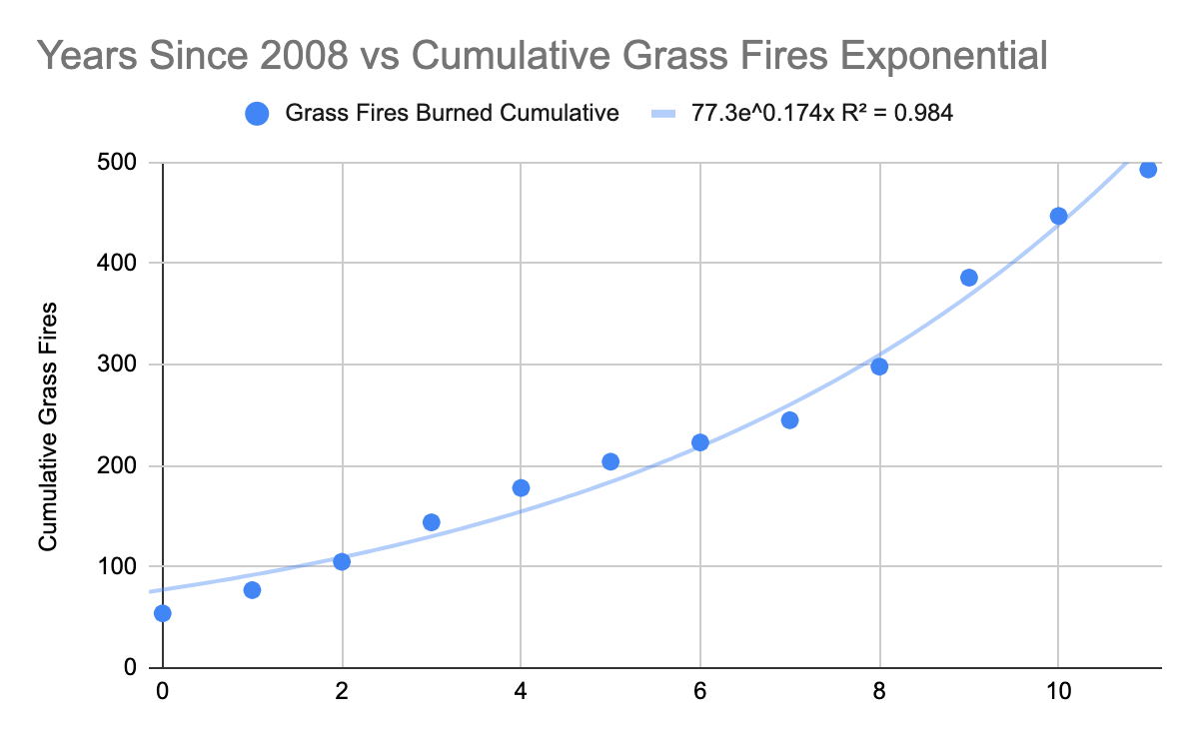

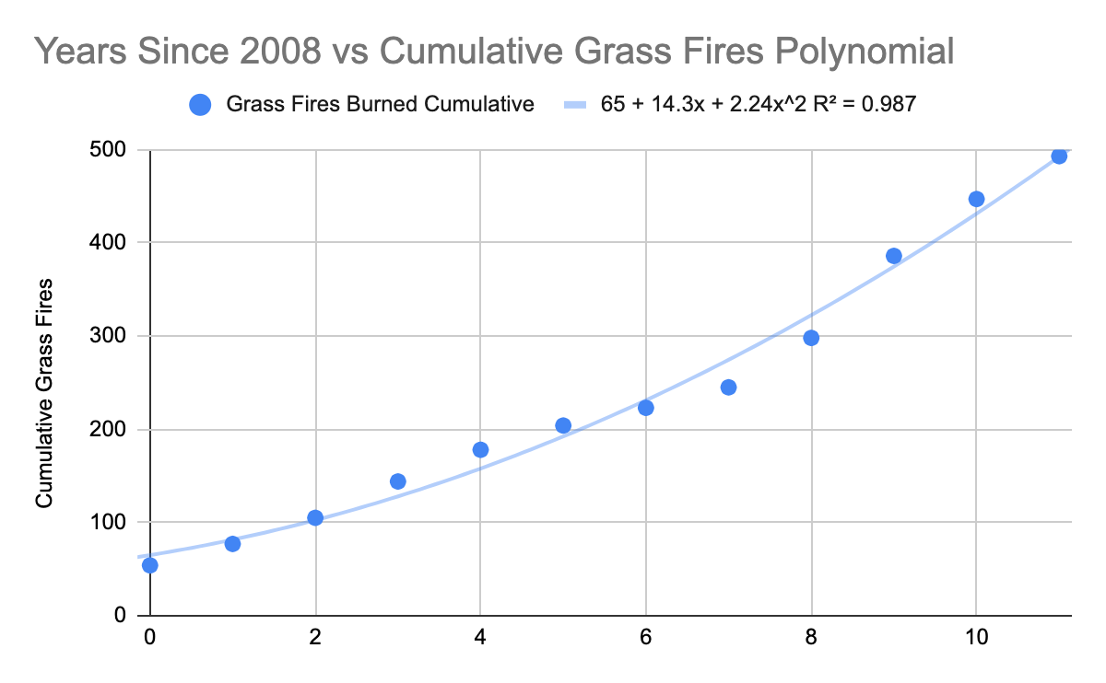

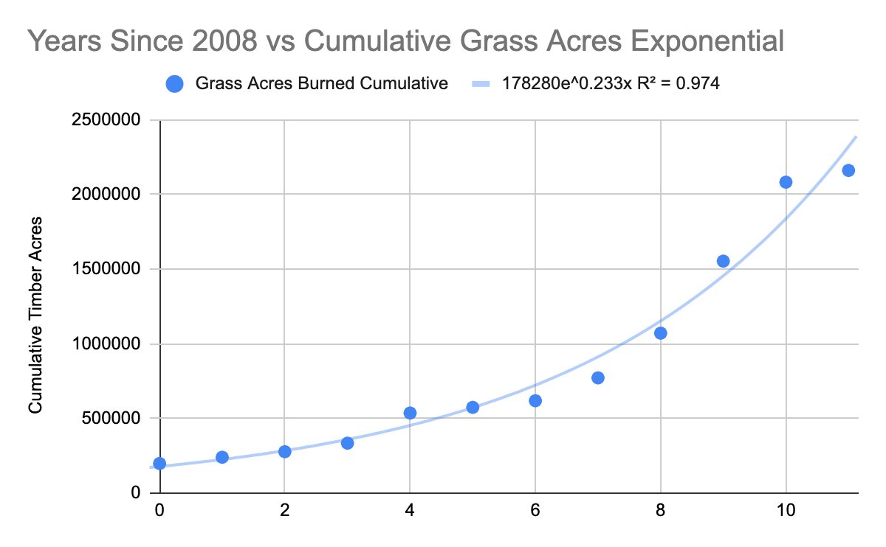

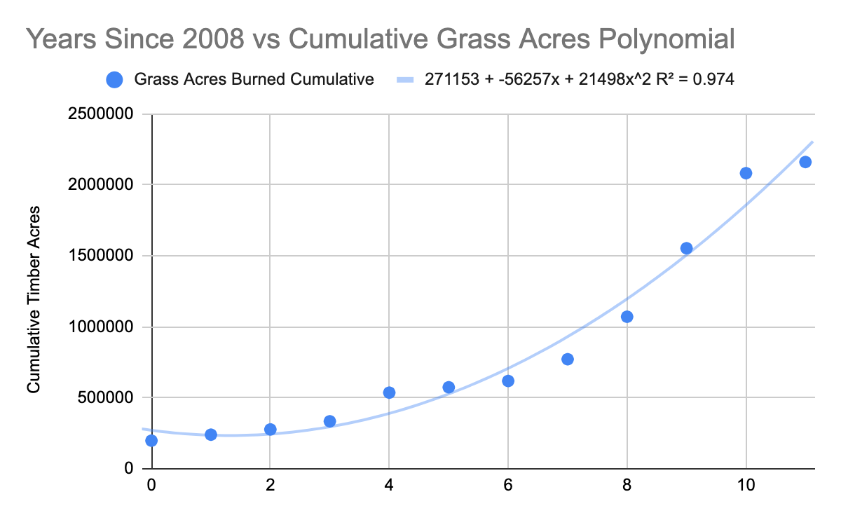

**4.d Model Prediction**

Below are our predictions from our models above. This graph illustrates the difference in the actual total acres burned from 2008 to 2019 and the predicted total acres burned until 2024. This graph shows that if mitigation strategies aren’t employed fires will

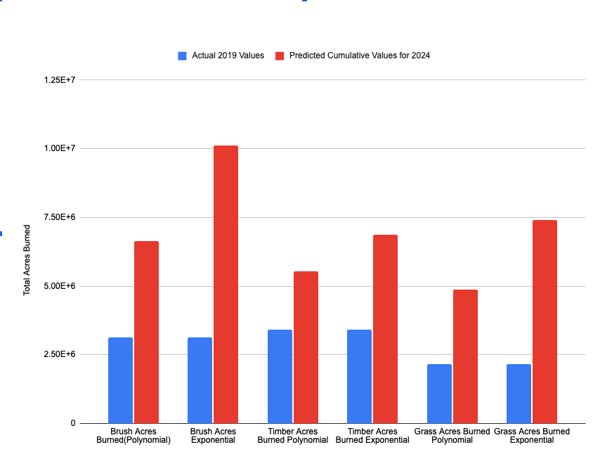

**5 Risk Analysis**

The main risk that we are addressing is the health risk from the smoke of the wildfires. There are other risks associated with wildfires such as property damage and loss of vegetation, but we believed that the most severe of these risks was the health risk. Specifically, the health risk is that increased carbon dioxide emissions from the smoke have negative effects on our lungs, and since the lungs are a vital organ in our body, it is essential that we keep them as healthy as possible. The smoke puts people of all ages at a higher risk for respiratory conditions such as asthma and chronic obstructive pulmonary diseases. Smoke particles stick to airways that connect to the lungs, and constrict the airflow which causes breathing problems like these to happen. Therefore, the health risk is the biggest risk, but it is not the only one. Based on our predictions above the health risk to people living in areas where wildfires are common and in most places around California will increase a lot more. The acres burned by wildfires looks to increase a lot for each vegetation type and in some cases double based on the model and this poses the much greater health risk compared to 2019 and other previous years.

Our analysis shows that the number of fires that burned timber, brush, and grass increased exponentially, and the acreage is also growing at an exponential rate. In fact, according to the equations of best fit, if no mitigation strategies are implemented, we could see around 5,000,000 acres of timber burned by approximately by 2025.

**6 Recommendations**

One recommendation that we have is to offer statewide insurance policies that compensate for loss of property. Apart from this, the addition of supplemental insurance policies to certain counties will be even more beneficial to the people there. For example, Mendocino County, Kern County, Tehama County, and San Diego County had some of the most acreage burnt, and if there are special, county-wide insurance policies that cover the cost of several thousands of acres of burning vegetation, many people would benefit from it. Therefore, it is in the state’s best interest to consider implementing specialized insurance policies for people living in these especially hard-hit counties, even though they are sparsely populated.

Our analysis showed that close to 40% of all the vegetation burned every year was timber, so one possible course of action could be to cut down a certain percentage of trees that exist in some of the most hard hit counties. At the same time, however, we do not want to deforest too much land, as cutting down too many trees depletes a natural source of fresh air. Therefore, after a certain number of trees are cut, tree saplings should be planted in order to compensate for the lost trees. In order to strike a balance between these two factors, we reasoned that partitioning an area into circles was the best way to go. We specifically chose a circle instead of a square or other polygon because of the simple fact that a circle of radius r (area being πr2) will cover more area than a square of side length r (area being only r2). Since we want to maximize the amount of area of trees that we keep, a circle rather than a square will benefit us more. If we partition a fire-prone area of land into circles of a certain radius and leave a good amount of space between each circle, we could then cut the trees that are not in any of the circles. This way, even if the timber in one circle were to catch on fire, it will not spread to another circle, unless there is wind. Since we cannot control the wind, if we control the fuel sources’ distance from each other, we can reduce the acreage of vegetation burnt. We believe that if this sort of controlled deforestation method is implemented every 3 to 5 years, we will reduce the severity of the adverse effects of these wildfires.

**7 References**

Effect on Human Health:

<https://www.lung.org/blog/how-wildfires-affect-health#:~:text=Wildfires%20threaten%20lives%20directly%2C%20and,COPD%20and%20other%20lung%20diseases.>

Effect on Human Health:

<https://www.who.int/health-topics/chronic-respiratory-diseases#tab=tab_1>

Wildfires 2008 Redbook:

<https://www.fire.ca.gov/media/10885/2008_wildfireactivitystatistics_complete_revised.pdf>

Wildfires 2009 Redbook:

<https://www.fire.ca.gov/media/10884/2009_redbook_complete_final.pdf>

Wildfires 2010 Redbook:

<https://www.fire.ca.gov/media/11189/2010-rb-final.pdf>

Wildfires 2011 Redbook:

<https://www.fire.ca.gov/media/10881/2011_redbook_final.pdf>

Wildfires 2012 Redbook:

<https://www.fire.ca.gov/media/10882/2012_redbook_complete.pdf>

Wildfires 2013 Redbook:

<https://www.fire.ca.gov/media/10883/2013_redbook_final.pdf>

Wildfires 2014 Redbook:

<https://www.fire.ca.gov/media/10062/2014_redbook_complete.pdf>

Wildfires 2015 Redbook:

<https://www.fire.ca.gov/media/10061/2015_redbook_final.pdf>

Wildfires 2016 Redbook:

<https://www.fire.ca.gov/media/10060/2016_redbook_final.pdf>

Wildfires 2017 Redbook:

<https://www.fire.ca.gov/media/10059/2017_redbook_final.pdf>

Wildfires 2018 Redbook:

<https://www.fire.ca.gov/media/11146/2018_redbook_final.pdf>

Wildfires 2019 Redbook:

<https://www.fire.ca.gov/media/iy1gpp2s/2019_redbook_final.pdf>

