VELLORE INSTITUTE OF TECHNOLOGY  Invention Disclosure Format (IDF)-B | Document No. | 02-IPR-R003
 | Issue No/Date | 2 / 01.02.2024
 | Amd. No/Date | 0 / 00.00.0000

1. Title of the invention
An IoT-Enabled Smart Campus Shuttle Management System Using Dual-Sensor Seat Occupancy Classification, Biometric Boarding Verification, and GPS-Based Automated Fare Computation with WiFi–GSM Fault-Tolerant Telemetry
2. Field / Area of invention
IoT-Based Intelligent Transportation Systems, Smart Campus Infrastructure, Sensor Fusion for Occupant Classification, Biometric Access Control and Fare Verification, Automated Distance-Based Billing, Demand-Responsive Transit Scheduling, Fault-Tolerant Wireless Telemetry
3. Prior Patents and Publications from literature
Related research works and patents, and their relevance to the proposed invention, are summarised below.
Publication / Patent Details | Description | Relevance to Invention
Campus Shuttle Tracker & Monitoring System, Int. J. Research in Applied Science & Engg. Technology (IJRASET), 2025 | • RFID + GPS based campus shuttle attendance and location tracking.  • Three-module architecture: server, bus unit, end-user app.  • Also logs fuel consumption and daily running data. | • Establishes the baseline campus-shuttle GPS + attendance pattern.  • The proposed invention extends this baseline with seat-level occupancy sensing and biometric-linked GPS billing, neither present here.
S. D. Murdan et al., “Low-cost bus seating information technology system,” IET Intelligent Transport Systems, 2020 | • Capacitive proximity + IR sensor pair per seat detects occupancy.  • Distinguishes a human occupant from an inanimate object.  • Transmits sensor state via Zigbee to a central database. | • Validates that dual-sensor fusion can separate humans from objects on a seat, the same principle behind the invention's pressure + temperature threshold logic.  • Has no link to biometric identity, GPS, or fare computation.
CN106127944A — Bus Fee Deduction System Based on Face Recognition Technology, Google Patents | • Face-information acquisition module matched against a stored user account.  • Automatically deducts a bus fare, replacing card/coin payment. | • Shares the face-recognition-to-fare-deduction concept.  • Uses a flat per-boarding fee, not a GPS distance-based fare, and has no seat-occupancy or object-rejection layer.
US9478071B2 — Anti Fare Evasion System, Google Patents | • Cameras track passenger faces changed between frames.  • Detects boarding without a valid fare token and updates passenger location in a database. | • Demonstrates camera-based passenger identification at fleet scale.  • Oriented toward evasion detection rather than paired entry/exit verification driving a distance-based fare.
US9,972,149 — Vision-Based Fare Collection, Justia Patents | • Cameras and/or RFID identify passengers at a distance.  • Enables hands-free fare collection linked to account balances. | • Relevant prior art for camera-based hands-free fare collection.  • The proposed invention differs by pairing identification with seat-level occupancy state and a WiFi/GSM fault-tolerant path suited to a closed campus network.
P. Vansteenwegen et al., “A survey on demand-responsive public bus systems,” Transportation Research Part C, 2022 | • Surveys scheduling/routing methods for demand-responsive transit (DRT).  • Covers dynamic route adaptation to real-time passenger requests. | • Confirms the value of demand-responsive dispatch.  • The invention's poll-driven fleet-size recommendation is a lightweight campus-scale instance of this research direction, extensible toward a full DRT solver.

4. Summary and background of the invention (Address the gap / Novelty)
Conventional campus shuttle systems typically combine GPS tracking with RFID-card or app-based attendance logging to monitor vehicle location and ridership. While effective for fleet visibility, these systems provide no seat-level information: they cannot report which of a vehicle's seats are physically occupied at a given moment, nor can they distinguish a seated student from an unattended bag left on a seat. Separately, seat-occupancy sensing has been explored using capacitive and infrared sensor pairs that reject non-human loads, but this line of work does not extend to passenger identity, fare computation, or vehicle-level GPS billing.
On the fare side, several inventions use face recognition to authenticate and bill a passenger at boarding, replacing physical tickets with biometric matching; however, these systems generally assume a flat or zone-based fare, omit any seat-level occupancy signal, and are architected for urban transit scale rather than a closed campus network with intermittent WiFi coverage. Demand-responsive transit research shows that request-driven dispatch improves fleet utilisation, but existing frameworks assume an external ride-request platform decoupled from the vehicle's own sensor and billing stack.
No prior system integrates all of the following within a single closed-campus vehicle unit: (i) a two-sensor (pressure and temperature) seat-occupancy classifier that rejects bags and other non-human loads using the normal human body-temperature band (36.1°C to 37.2°C); (ii) biometric entry and exit verification against the institution's own student database, paired directly with a haversine-distance GPS fare calculation; (iii) a WiFi-primary, GSM-fallback communication layer that keeps the vehicle reporting through campus WiFi dead zones; and (iv) a student demand-poll signal used to recommend fleet size and stop priority. The present invention addresses this gap by combining these four elements into one integrated pipeline, with trip-wise local data batching and two-tier (vehicle-local, then central college server) storage synchronisation, so that the vehicle unit remains a thin, low-bandwidth edge node while the college server retains the full historical record for billing, auditing, and fleet analytics.
5. Objective(s) of Invention
- Classify seat occupancy in real time using paired pressure and temperature thresholds, rejecting bags and other objects that a pressure-only sensor would misclassify as a passenger.
- Verify passenger identity at boarding and alighting via face-scan matching against the existing college student database, without deploying a duplicate biometric store on the vehicle.
- Compute a distance-based fare automatically from GPS-logged entry and exit coordinates, routed to the student's fee account or linked payment channel.
- Maintain continuous vehicle telemetry over campus WiFi with an automatic, low-latency fallback to a GSM channel during WiFi dropouts, and resynchronise once WiFi returns.
- Use student shuttle-need polling, combined with nearest-stop demand, to recommend fleet size and stop priority for the next dispatch cycle.
- Preserve a complete, queryable log of distance travelled, fuel consumption, passenger manifests, and payment status for each vehicle.
6. Working principle of the invention (in brief)
The vehicle unit is built around a WiFi- and GPS-capable microcontroller (ESP32 class, with a GSM/cellular module as fallback) instrumented with a per-seat force sensor and a co-located temperature sensor. On boarding, a camera-based face scan is matched against the institution's student database; a match logs the student's register number together with the vehicle's current GPS coordinate as the trip's entry point. While seated, the paired pressure and temperature readings are classified into EMPTY, BAG, or STUDENT states each sensor cycle, so that an object left on a seat does not register as ridership.
On alighting, a second face scan closes the trip: the haversine distance between the logged entry and current GPS coordinates is computed, and a fare is derived as the greater of a minimum fare and a fixed per-kilometre rate. Every event — seat-state changes, entry, exit, and periodic GPS updates — is published over MQTT while WiFi is available; if WiFi drops, the same payload is queued for transmission over the GSM fallback channel and resynchronised once WiFi returns. Independently of individual trips, students submit a post-class shuttle-need poll with a pickup stop; aggregated poll counts against the nearest stop feed a fleet-size and routing recommendation. All trip, billing, and vehicle-log data is intended to be batched per trip at the vehicle and synchronised once to a central college server, keeping the vehicle unit itself a lightweight edge node (Fig. 1).
7. Description of the invention in detail
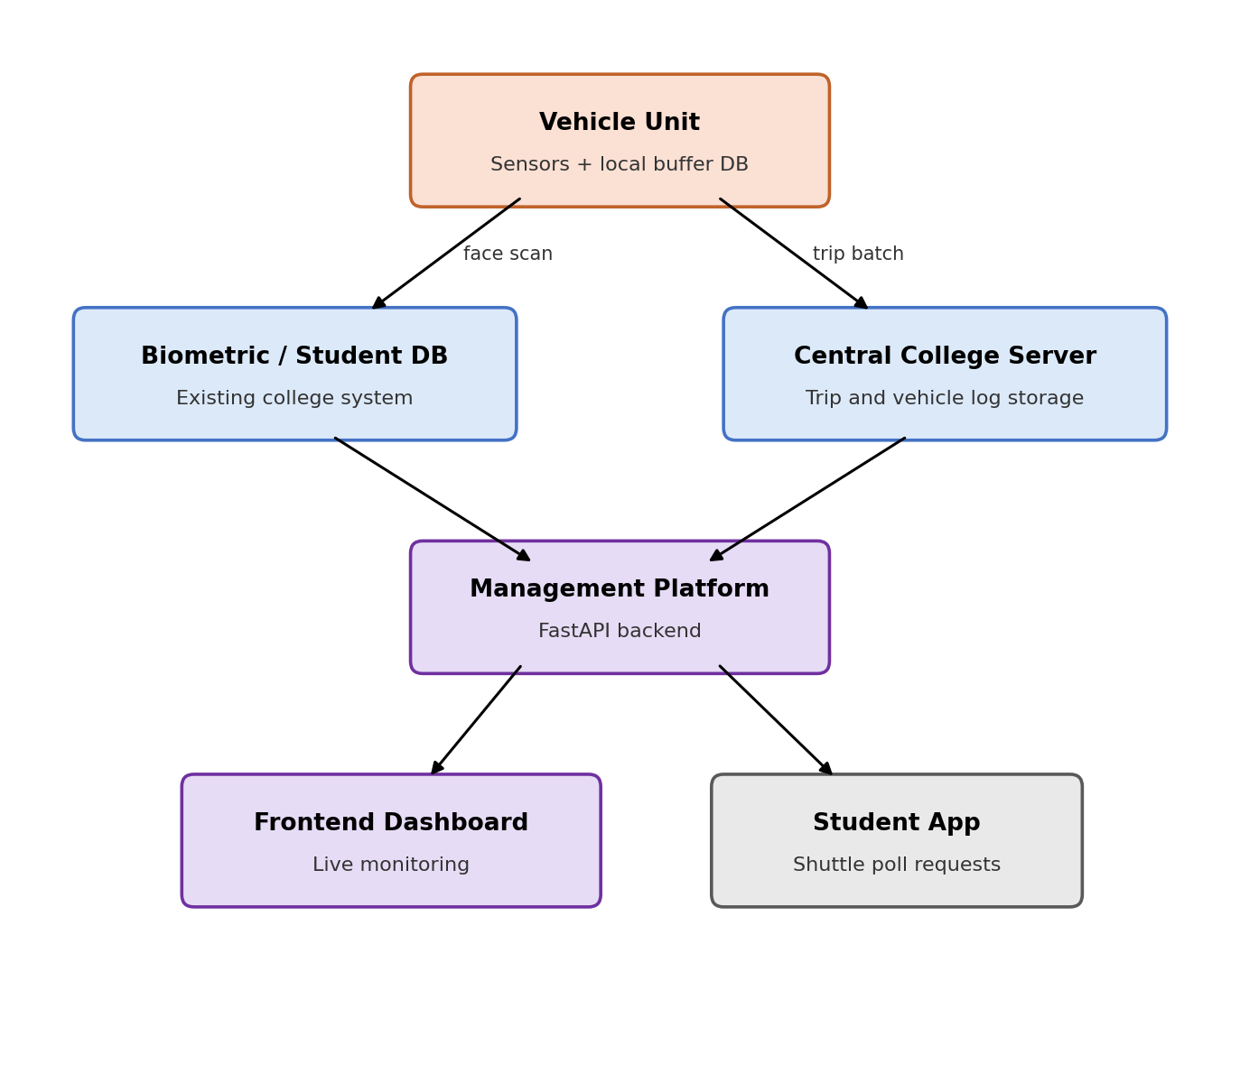
Fig. 1. System architecture of the smart campus shuttle platform.
The overall system (Fig. 1) is organised into three tiers. The vehicle unit carries the sensors (pressure, temperature, GPS, camera) and a local buffer database, and is the only component physically present on the shuttle. It interfaces with two existing or newly introduced services: the college's own biometric / student database, queried at boarding and alighting rather than duplicated on the vehicle, and a central college server that retains the permanent trip and vehicle-log history. A management platform (implemented as a FastAPI backend in the current prototype) mediates between these stores and two client surfaces — a frontend dashboard for transport-office monitoring and a student-facing app through which shuttle-need polls are submitted.
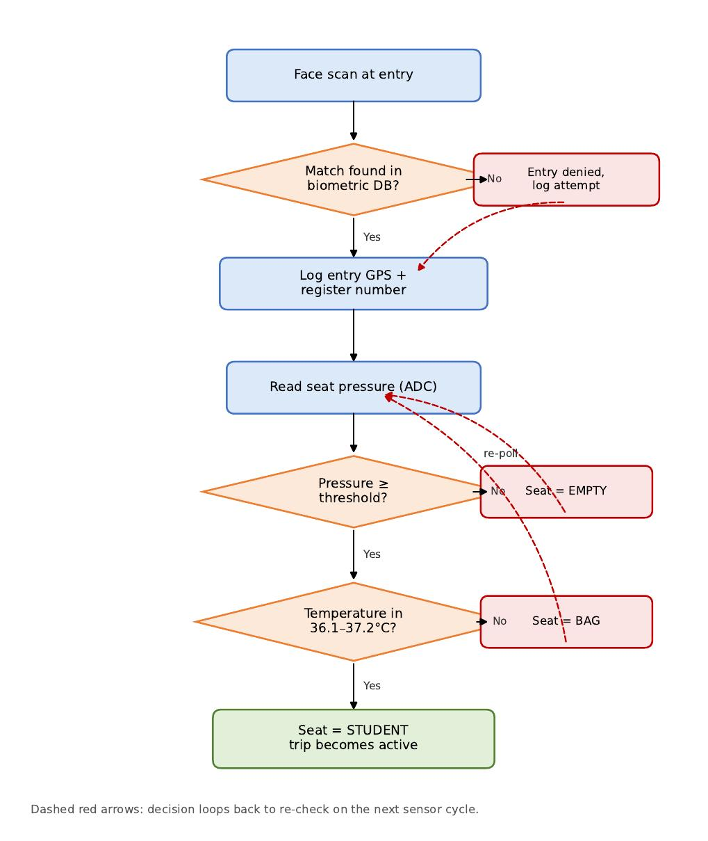
Fig. 2. Occupant verification and seat-occupancy classification decision logic.
Fig. 2 details the boarding-side logic. A face scan at entry is matched against the biometric database; on a mismatch the attempt is logged and denied, and the sensor loop re-checks on the next cycle. On a match, the entry GPS coordinate and register number are logged and the seat's pressure sensor is read. If pressure is below the empty-seat threshold, the seat is reported EMPTY and the sensor re-polls. If pressure indicates a load, the co-located temperature sensor is checked against the normal human body-temperature band (36.1°C–37.2°C); a reading outside this band is classified BAG, while a reading inside the band confirms STUDENT and marks the trip active. This paired-threshold approach is the invention's principal defence against the single-sensor failure mode noted in Section 4, where a heavy bag or a warm laptop can trick a pressure-only or temperature-only classifier.
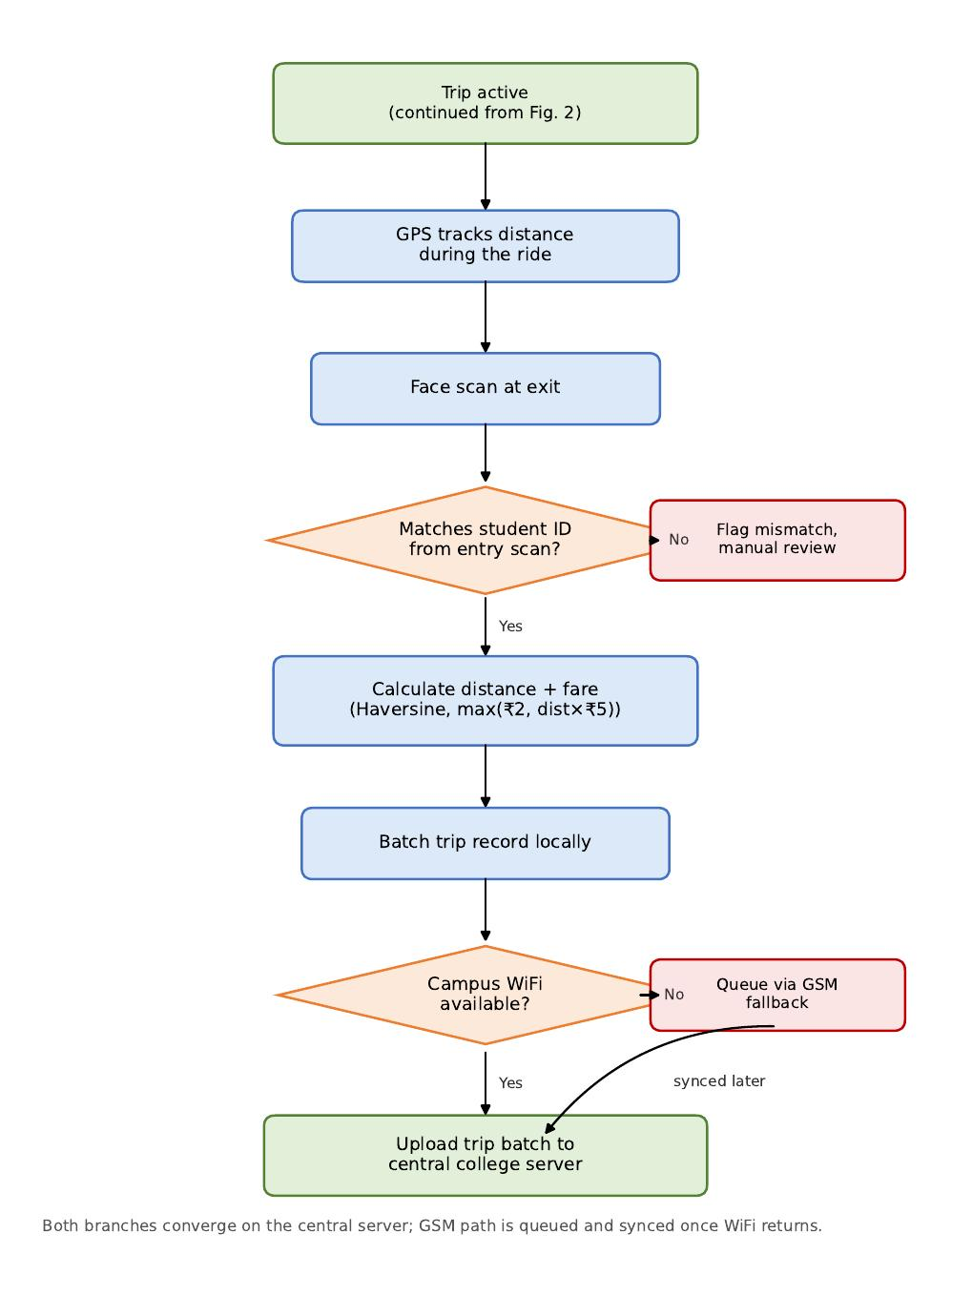
Fig. 3. Trip lifecycle: GPS tracking, exit verification, and billing synchronisation.
Fig. 3 continues the pipeline once a trip is active. GPS coordinates are logged at intervals while the student remains seated. A face scan at exit is matched against the register number captured at entry; a mismatch is flagged for manual review rather than silently closing the trip. On a match, the haversine distance between entry and exit coordinates yields a fare of max(minimum fare, distance × per-km rate). The completed trip record is batched locally and, if campus WiFi is available, uploaded to the central college server; if not, it is queued for transmission over the GSM fallback channel and synchronised once WiFi is restored. Both paths converge on the same central record, so a temporary network outage delays but never loses a trip's billing data.
The current software prototype validates this entire pipeline — sensor classification, biometric-linked billing, and network fallback — through an ESP32 simulation (Wokwi) integrated live with a FastAPI backend and a React dashboard, described further in Section 8. Two aspects of Fig. 1 are implemented as forward-looking design targets rather than validated hardware behaviour in the present prototype: first, the two-tier local-buffer-then-central-server storage split and trip-wise batching, which the prototype approximates today by streaming each event directly to the central server in real time; and second, the GSM fallback, which is exercised in the prototype through a network-availability toggle rather than a physical GSM/cellular modem. Both are scoped as near-term hardware-integration work rather than open research questions, since the corresponding protocols (MQTT batching, AT-command SMS/data fallback) are established techniques being fitted to this application.
The biometric interface (Section 5, objective 2) is deliberately scoped as a query against the institution's existing student database rather than a new face-image store on the vehicle: the vehicle unit transmits a match request keyed by register number and receives a verification result, so no additional copy of biometric data is created or retained outside the institution's own system. This narrows the invention's data-protection surface to the transport records it generates (GPS trace, seat state, fare) rather than to biometric templates.
The demand-poll module (Section 5, objective 5) currently recommends fleet size using a capacity-threshold rule: when aggregated poll demand at a stop exceeds one shuttle's seating capacity, an additional shuttle is recommended for that stop. This is presented as an extensible placeholder for the dynamic dial-a-ride / demand-responsive-transit optimisation methods surveyed in Section 3, and is the primary direction identified for the invention's continued algorithmic development.
8. Experimental validation results
The proposed pipeline was validated end-to-end using a live FastAPI + SQLite backend and a React dashboard polling that backend in real time, with vehicle-side sensor, GPS, and network behaviour represented through an ESP32 Wokwi simulation rather than a physically installed vehicle. Eight cases below exercise every functional block of Fig. 1.
Case 1 — Idle fleet state
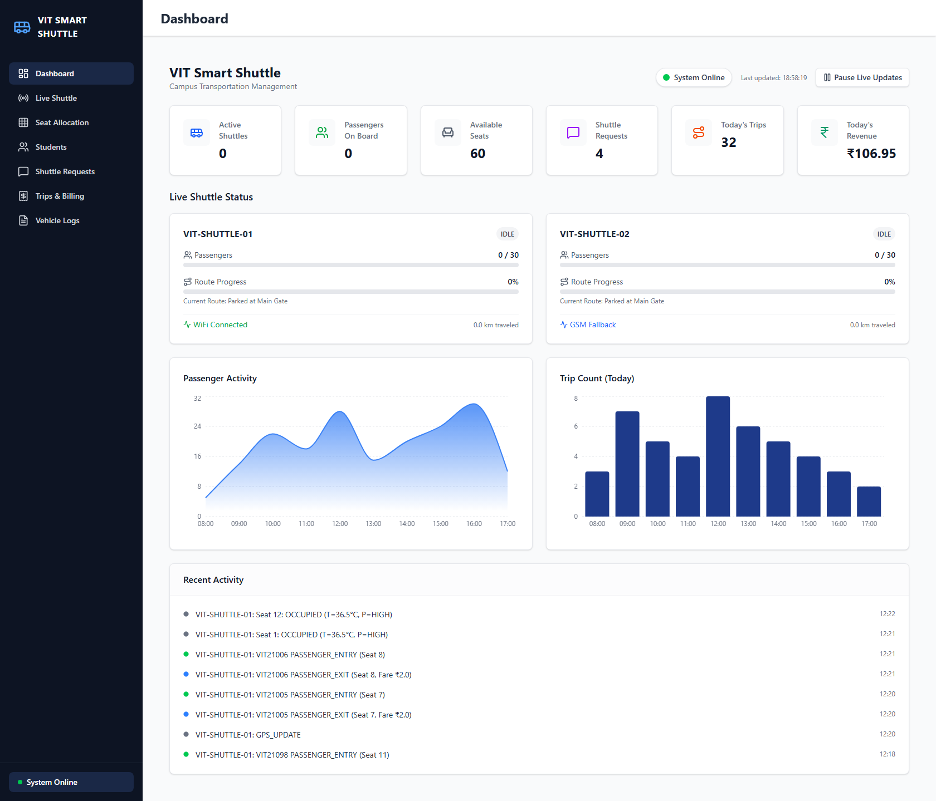
With no passengers boarded, the dashboard correctly reports 0 active passengers, 0/60 seats occupied across both shuttles, and both vehicles in an IDLE state at 0% route progress — confirming the fleet-level view correctly reflects a quiescent vehicle state rather than defaulting to stale or placeholder data.
Case 2 — Active multi-passenger state
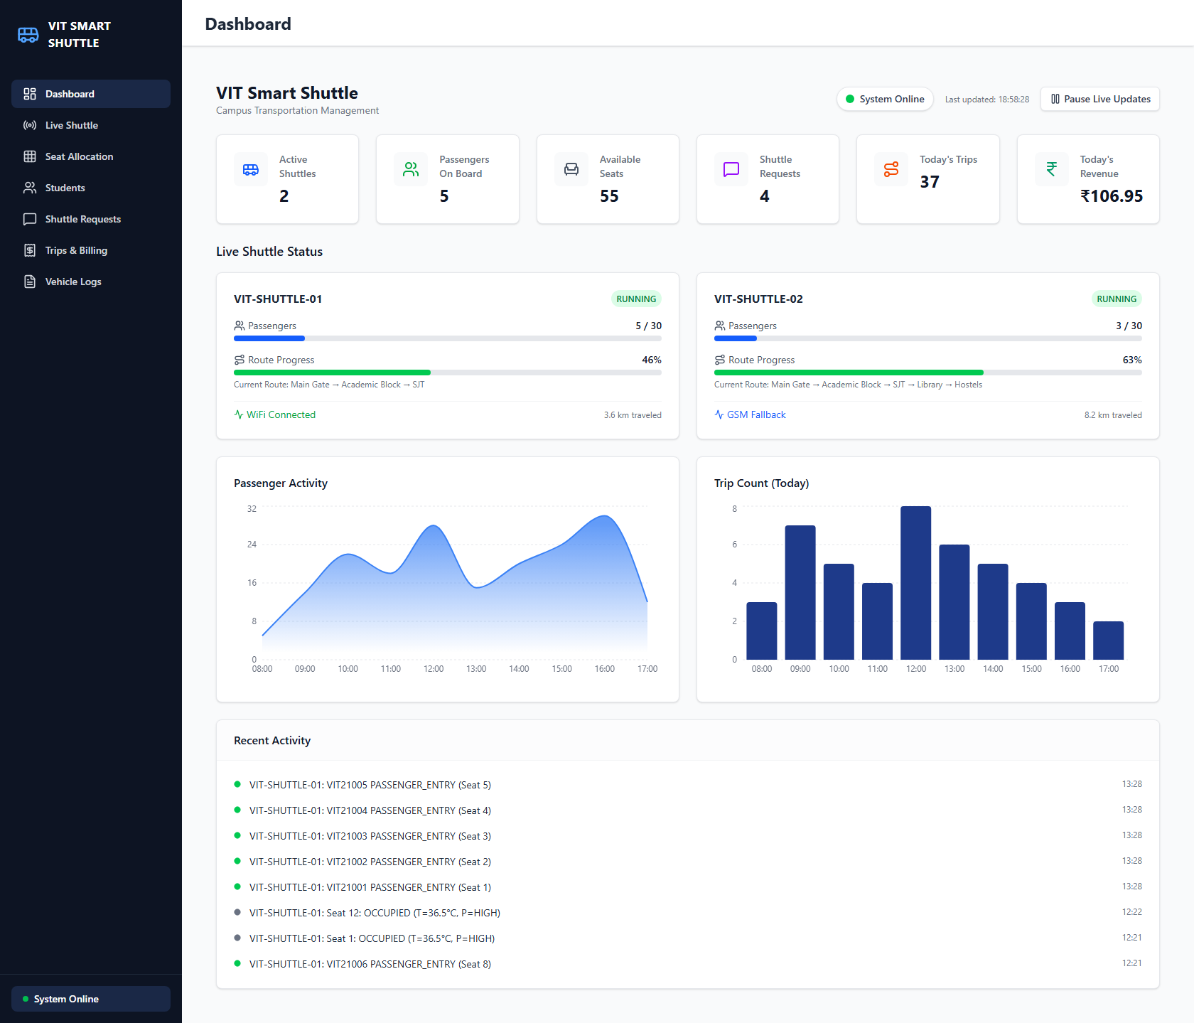
Once five students board VIT-SHUTTLE-01 and three board VIT-SHUTTLE-02, both vehicles move to RUNNING with live route-progress percentages (46% and 63%) and an updating passenger-activity chart, confirming that seat-level and GPS events are correctly aggregated into fleet-level statistics in real time.
Case 3 — Seat-occupancy classification across a full vehicle
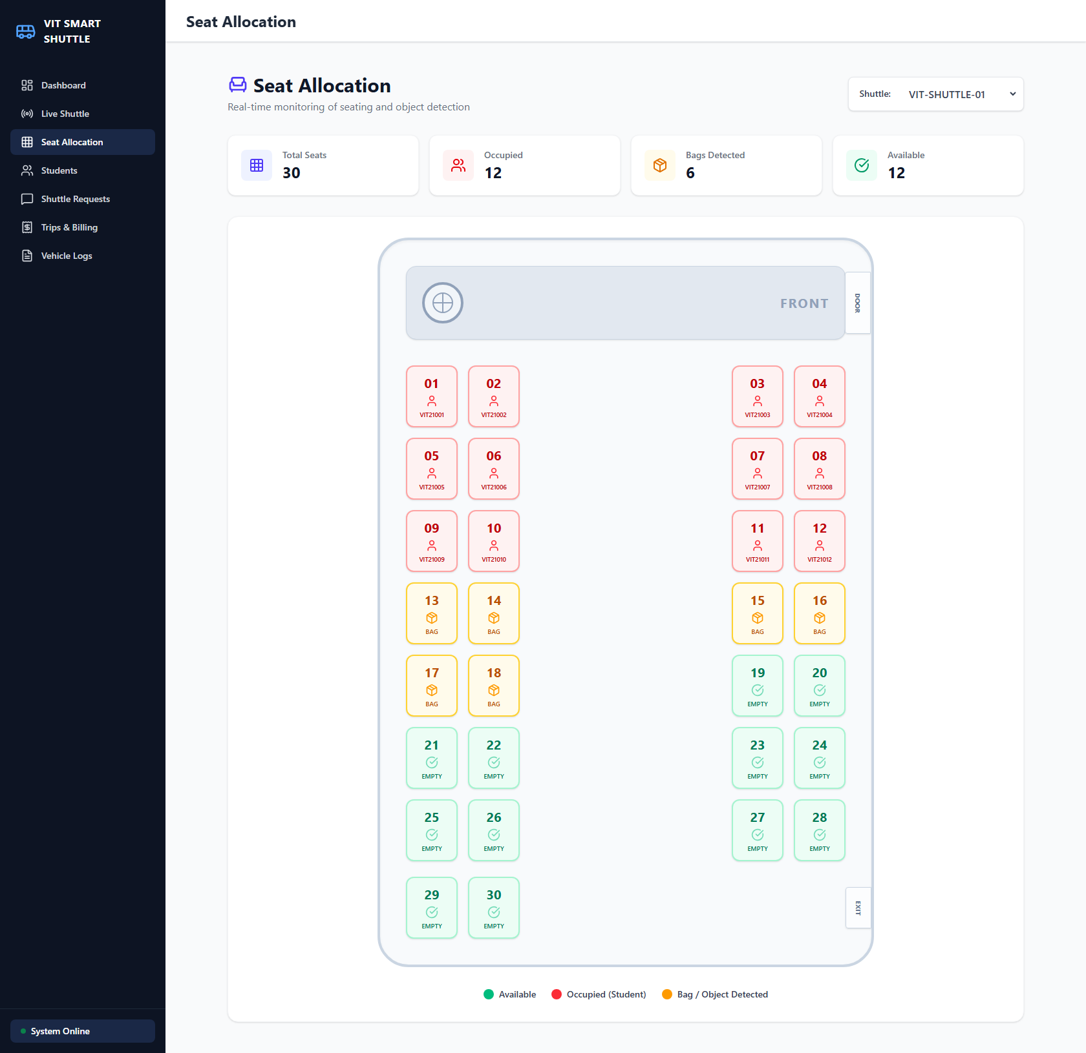
Direct inspection of the 30-seat grid for VIT-SHUTTLE-01 shows 12 seats correctly flagged OCCUPIED (with the matched register numbers shown), 6 flagged BAG, and 12 EMPTY, validating that the paired pressure/temperature threshold logic (Fig. 2) distinguishes all three states simultaneously across a full vehicle rather than a single test seat.
Case 4 — WiFi-to-GSM fault-tolerant switching
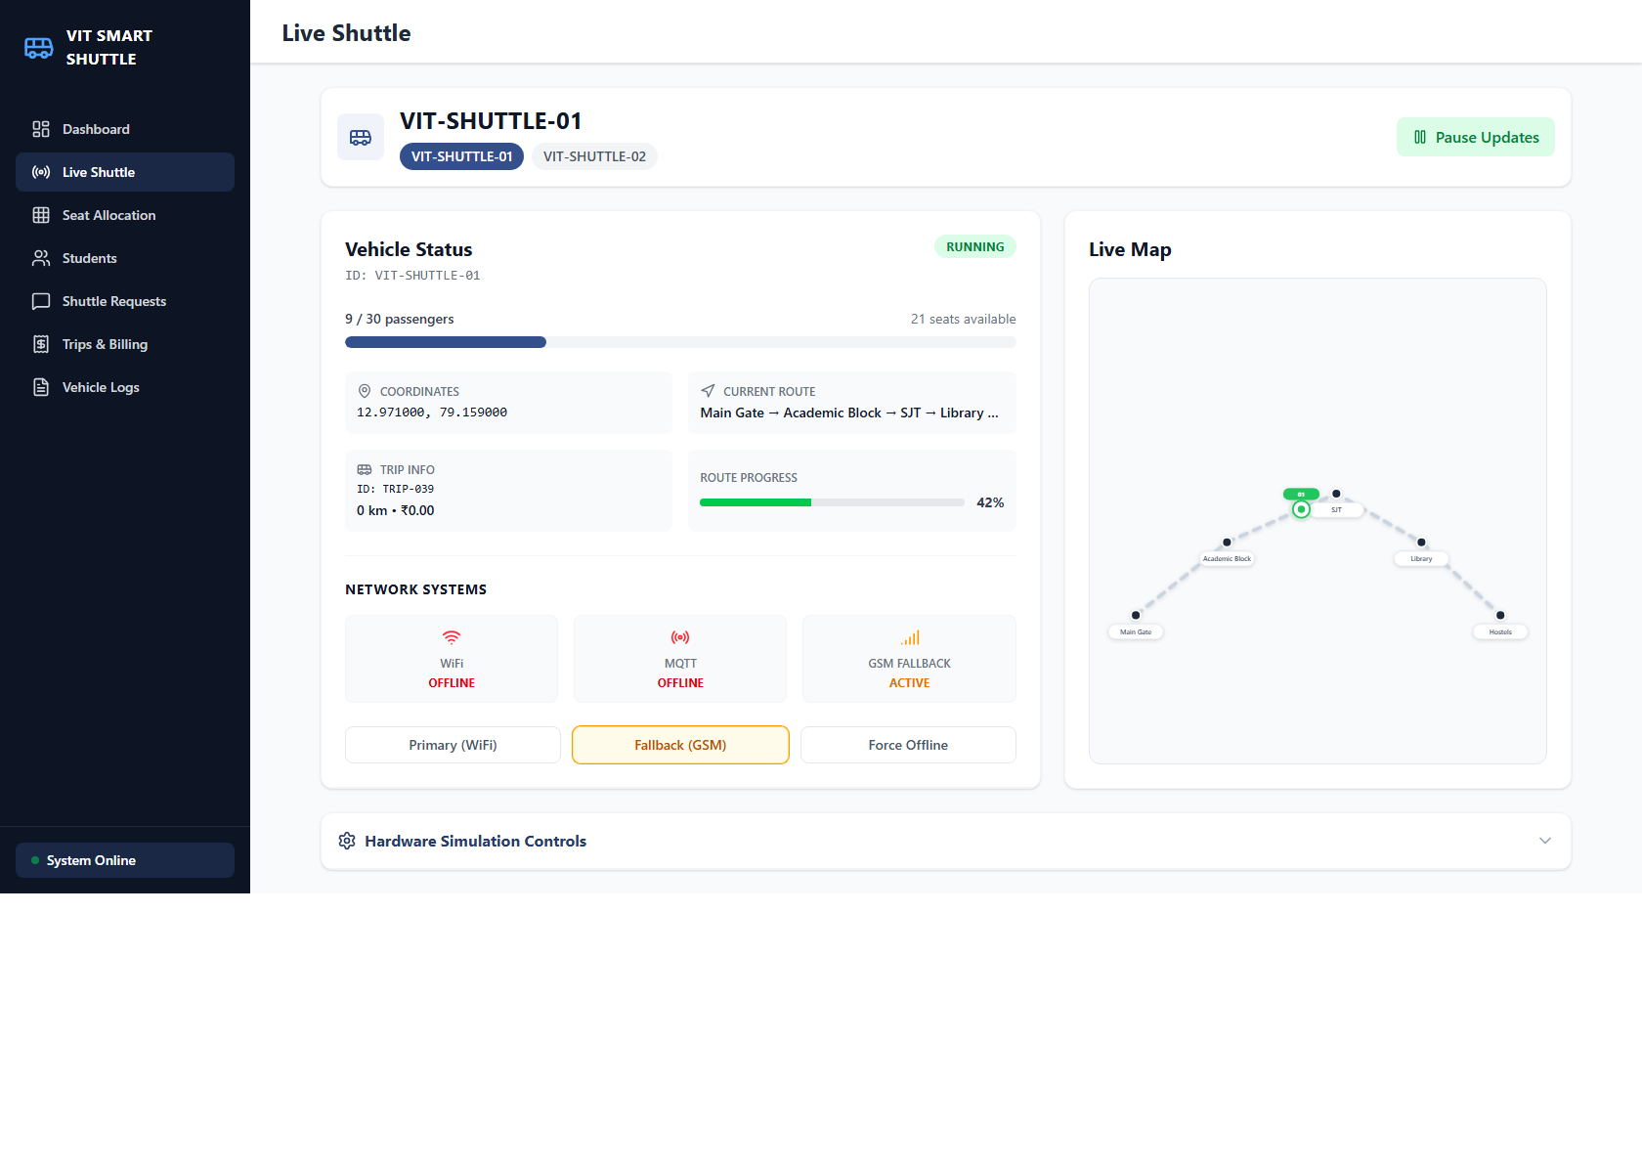
Toggling the WiFi-availability input while the vehicle unit is running switches the reported network mode to GSM Fallback ACTIVE within one sensor cycle, and reverts to WiFi Connected once availability is restored — confirming the fault-tolerant switch of Fig. 3 executes without operator intervention.
Case 5 — Distance-based fare computation at both fare boundaries
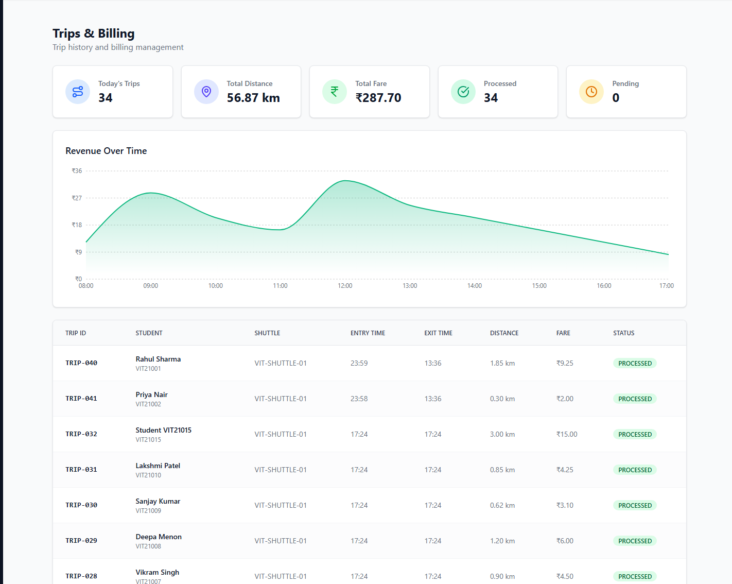
The trips table shows one trip closing at the minimum fare (₹2.00 for a 0.30 km ride) alongside a longer trip billed at ₹9.25 for 1.85 km in the same view, verifying the fare = max(minimum, distance × rate) rule against both boundary conditions of the formula.
Case 6 — Independent cross-validation of the classification logic
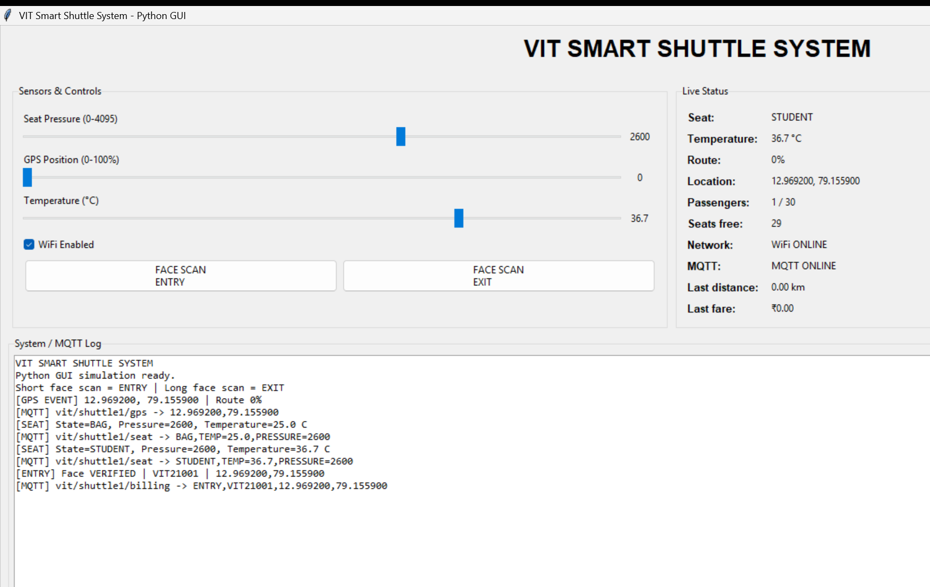
A Python/Tkinter re-implementation of the classification logic, used for rapid parameter testing independent of the Wokwi simulator, reproduces the same log sequence: a BAG classification at raw pressure 2600 / 25.0°C is followed by a STUDENT classification once temperature is raised to 36.7°C, and the entry event is logged against the matched register number — cross-validating the threshold logic in a second, independently coded implementation.
Case 7 — Persistent vehicle log including a live fallback event
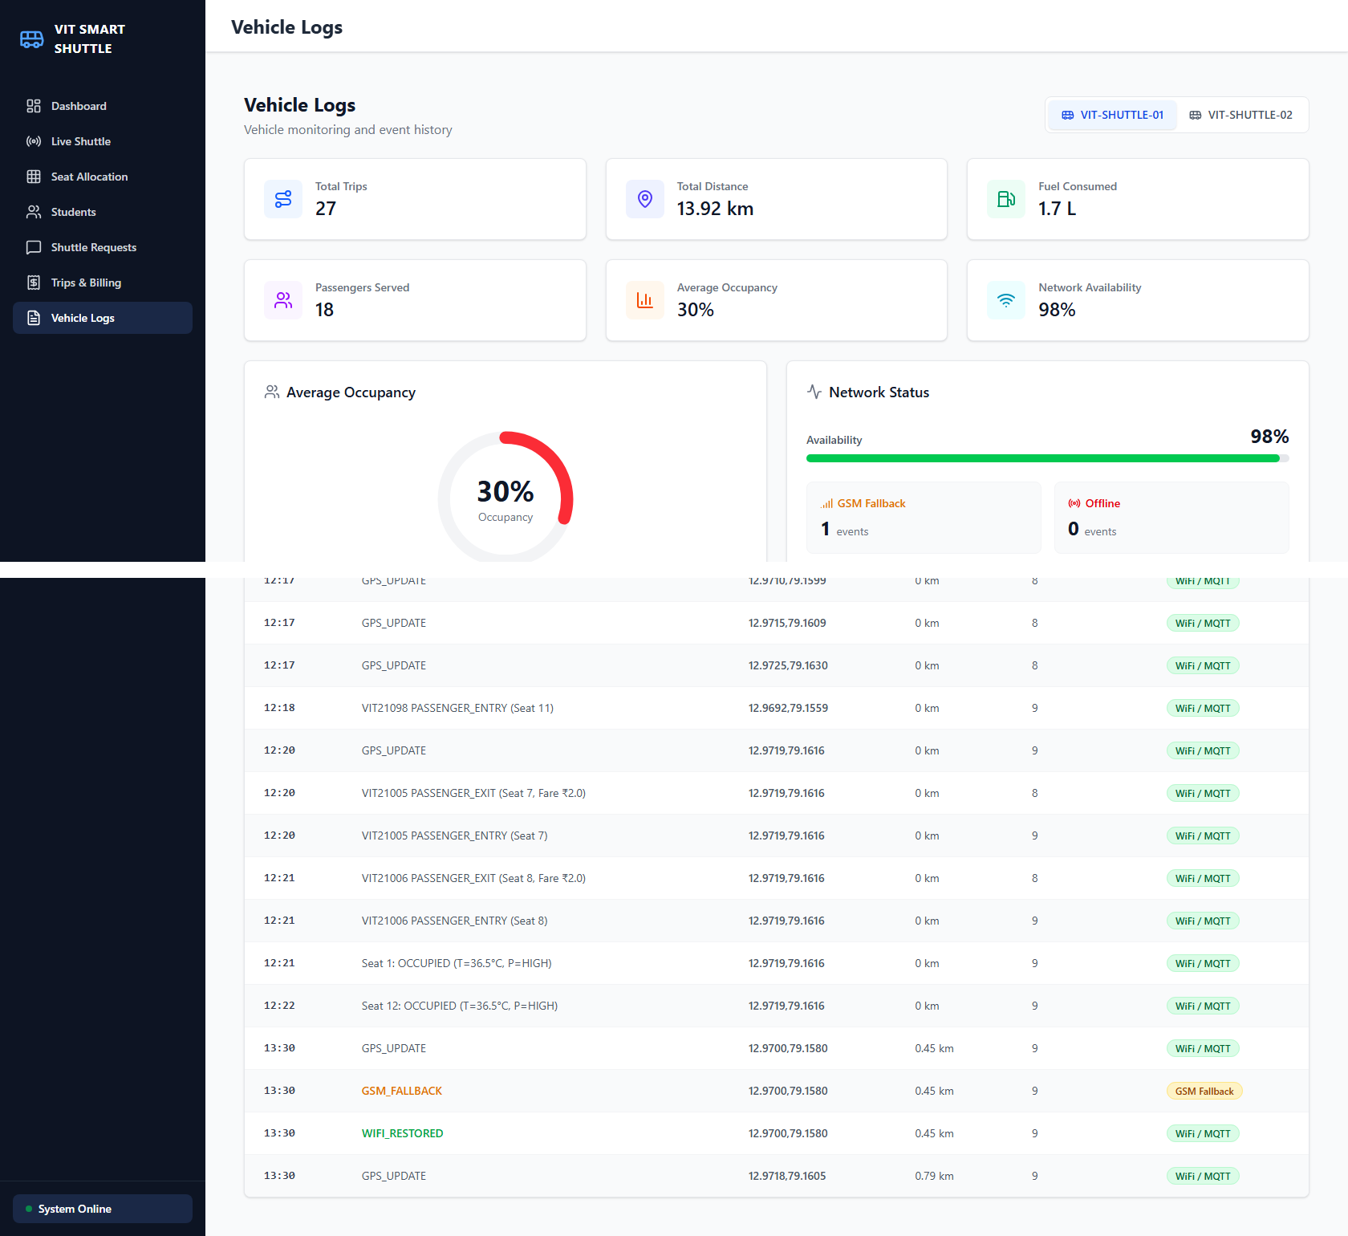
The vehicle log view aggregates 27 trips, 13.92 km travelled, and 1.7 L fuel consumed for VIT-SHUTTLE-01, and its event history captures a live GSM_FALLBACK event followed immediately by WIFI_RESTORED at the same GPS coordinate — demonstrating that the fallback transition itself, not just the resulting network state, is retained in the permanent vehicle log for later audit.
Case 8 — Poll-driven fleet-size recommendation
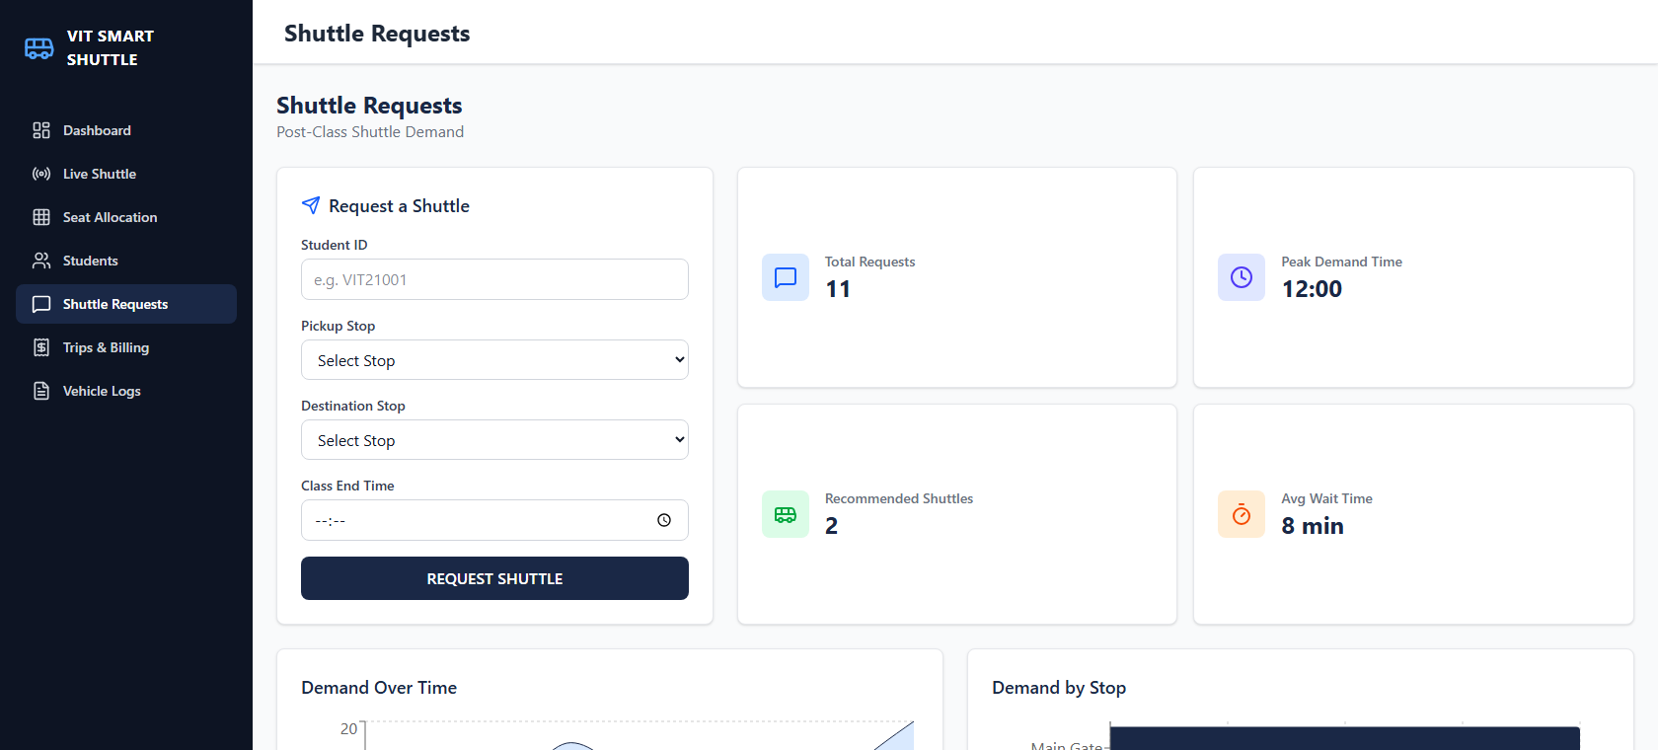
The shuttle-request module logged 11 post-class poll submissions across four campus stops (Main Gate, SJT, Hostels, Academic Block) and recommended deploying 2 shuttles with Main Gate flagged as the nearest high-demand stop — validating the poll-to-recommendation path of Section 7, noting that the underlying recommendation rule is presently the capacity-threshold heuristic described there rather than the optimisation-based dispatch proposed as future work.
Collectively, these eight validation cases exercise every functional block of Fig. 1: sensor-fusion occupancy classification (Cases 3, 6), biometric-linked GPS billing (Cases 2, 5), fault-tolerant telemetry (Cases 4, 7), fleet-level aggregation (Cases 1, 2, 7), and demand-driven dispatch (Case 8). Because these results were produced against a live backend and dashboard with vehicle-side behaviour represented in simulation rather than on an installed physical vehicle, Section 10 reflects the corresponding technology readiness level.
9. What aspect(s) of the invention need(s) protection?
- The dual-threshold (pressure + temperature) seat-occupancy classification method that rejects non-human loads using the normal human body-temperature band.
- The method of pairing biometric entry/exit verification directly with a GPS haversine-distance fare computation in a single closed-loop pipeline.
- The WiFi-primary / GSM-fallback fault-tolerant telemetry switching method for a campus vehicle, including automatic resynchronisation on WiFi restoration.
- The trip-wise local batching and two-tier (vehicle-local buffer + central college server) data synchronisation architecture.
- The student demand-poll to fleet-size / stop-priority recommendation method, and its extension path toward dynamic dispatch optimisation.
- The interface method for querying an institution's existing biometric/student database for boarding verification, without duplicating biometric storage on the vehicle.
10. What is Technology readiness level of your invention? (Tick the appropriate TRL)
Research | Development | Deployment
TRL 1 | TRL 2 | TRL 3 | TRL 4 | TRL 5 | TRL 6 | TRL 7 | TRL 8 | TRL 9
✔ | ✔ | ✔ | ✔
The end-to-end pipeline (sensor classification, biometric-linked billing, network fallback, and fleet dashboard) has been validated in an integrated software and simulated-hardware environment, corresponding to TRL 4. Validation on a physically installed shuttle vehicle (TRL 5 and above) has not yet been performed.
----------------------END OF THE DOCUMENT----------------------------

