VELLORE INSTITUTE OF TECHNOLOGY  Invention Disclosure Format (IDF)-B | Document No. | 02-IPR-R003
 | Issue No/Date | 2 / 01.02.2024
 | Amd. No/Date | 0 / 00.00.0000

1. Title of the invention
An IoT-Enabled Smart Campus Shuttle Management System Using Dual-Sensor Seat Occupancy Classification, Biometric Boarding Verification, and GPS-Based Automated Fare Computation with WiFi–GSM Fault-Tolerant Telemetry
2. Field / Area of invention
IoT-Based Intelligent Transportation Systems, Smart Campus Infrastructure, Sensor Fusion for Occupant Classification, Biometric Access Control and Fare Verification, Automated Distance-Based Billing, Demand-Responsive Transit Scheduling, Fault-Tolerant Wireless Telemetry
3. Prior Patents and Publications from literature
Related research works and patents, and their relevance to the proposed invention, are summarised below.
Publication / Patent Details | Description | Relevance to Invention
Campus Shuttle Tracker & Monitoring System, Int. J. Research in Applied Science & Engg. Technology (IJRASET), 2025 | • RFID + GPS based campus shuttle attendance and location tracking.  • Three-module architecture: server, bus unit, end-user app.  • Also logs fuel consumption and daily running data. | • Establishes the baseline campus-shuttle GPS + attendance pattern.  • The proposed invention extends this baseline with seat-level occupancy sensing and biometric-linked GPS billing, neither present here.
S. D. Murdan et al., “Low-cost bus seating information technology system,” IET Intelligent Transport Systems, 2020 | • Capacitive proximity + IR sensor pair per seat detects occupancy.  • Distinguishes a human occupant from an inanimate object.  • Transmits sensor state via Zigbee to a central database. | • Validates that dual-sensor fusion can separate humans from objects on a seat, the same principle behind the invention's pressure + temperature threshold logic.  • Has no link to biometric identity, GPS, or fare computation.
CN106127944A — Bus Fee Deduction System Based on Face Recognition Technology, Google Patents | • Face-information acquisition module matched against a stored user account.  • Automatically deducts a bus fare, replacing card/coin payment. | • Shares the face-recognition-to-fare-deduction concept.  • Uses a flat per-boarding fee, not a GPS distance-based fare, and has no seat-occupancy or object-rejection layer.
US9478071B2 — Anti Fare Evasion System, Google Patents | • Cameras track passenger faces changed between frames.  • Detects boarding without a valid fare token and updates passenger location in a database. | • Demonstrates camera-based passenger identification at fleet scale.  • Oriented toward evasion detection rather than paired entry/exit verification driving a distance-based fare.
US9,972,149 — Vision-Based Fare Collection, Justia Patents | • Cameras and/or RFID identify passengers at a distance.  • Enables hands-free fare collection linked to account balances. | • Relevant prior art for camera-based hands-free fare collection.  • The proposed invention differs by pairing identification with seat-level occupancy state and a WiFi/GSM fault-tolerant path suited to a closed campus network.
P. Vansteenwegen et al., “A survey on demand-responsive public bus systems,” Transportation Research Part C, 2022 | • Surveys scheduling/routing methods for demand-responsive transit (DRT).  • Covers dynamic route adaptation to real-time passenger requests. | • Confirms the value of demand-responsive dispatch.  • The invention's poll-driven fleet-size recommendation is a lightweight campus-scale instance of this research direction, extensible toward a full DRT solver.
“Face Anti-Spoofing Based on Adaptive Channel Enhancement and Intra-Class Constraint,” PMC, 2024 | • Deep-learning liveness detection distinguishing a genuine live face from a printed photo, video replay, or 3D mask presented to a camera. | • Represents the algorithmic route to preventing spurious face-scan events.  • The proposed invention instead enforces a physical/contextual gate (vehicle stationary and door open) as a low-compute complement that blocks accidental scans during motion or through a closed door — a scenario this line of work does not address.
S. Ganio et al., “Non-contact infrared assessment of human body temperature,” Temperature (Taylor & Francis), 2021 | • Reviews non-contact infrared temperature assessment practice, including standard fever-screening thresholds and the systematic skin-surface-to-core offset inherent to any contact/IR sensor. | • Provides the clinical/measurement basis for widening the invention's HUMAN classification band beyond normal resting temperature alone, so a febrile student is not misclassified as a non-human object.
“Driving the future with edge computing: a review of data offloading… for autonomous vehicles,” ScienceDirect, 2026 | • Reviews edge-computing data-offloading strategies for connected/autonomous vehicles, reporting 30–40% bandwidth reduction from local processing and batched cloud transmission. | • Supports the invention's trip-wise local batching and two-tier storage design as consistent with established edge-computing bandwidth-reduction practice, applied here to a campus shuttle's billing and telemetry data.

4. Summary and background of the invention (Address the gap / Novelty)
Conventional campus shuttle systems typically combine GPS tracking with RFID-card or app-based attendance logging to monitor vehicle location and ridership. While effective for fleet visibility, these systems provide no seat-level information: they cannot report which of a vehicle's seats are physically occupied at a given moment, nor can they distinguish a seated student from an unattended object (a bag, a piece of luggage, or any other item) left on a seat. Separately, seat-occupancy sensing has been explored using capacitive and infrared sensor pairs that reject non-human loads, but this line of work does not extend to passenger identity, fare computation, or vehicle-level GPS billing, and does not consider that a live human occupant's temperature can vary well outside its resting range — a point addressed further below.
On the fare side, several inventions use face recognition to authenticate and bill a passenger at boarding, replacing physical tickets with biometric matching; however, these systems generally assume a flat or zone-based fare, omit any seat-level occupancy signal, and are architected for urban transit scale rather than a closed campus network with intermittent WiFi coverage. None of them constrain *when* a scan is accepted: a moving vehicle or a closed door creates a realistic risk of an accidental or spurious scan attempt, which existing biometric-fare inventions do not address. Demand-responsive transit research shows that request-driven dispatch improves fleet utilisation, but existing frameworks assume an external ride-request platform decoupled from the vehicle's own sensor and billing stack.
A further gap concerns the temperature threshold itself. A classifier that treats only the normal resting body-temperature band (36.1°C–37.2°C) as “human” will misclassify a student running even a standard fever (≥38.0°C, and as high as 39.4°C–41.0°C) as a non-human object, silently dropping that student from occupancy and safety-relevant logging at precisely the time — a medical event on board — when accurate detection matters most. No prior seat-occupancy or biometric-fare system reviewed above accounts for this.
No prior system integrates all of the following within a single closed-campus vehicle unit: (i) a two-sensor (pressure and temperature) seat-occupancy classifier that rejects non-human objects while remaining tolerant of the full clinically plausible human temperature range, including fever and hyperpyrexia; (ii) biometric entry and exit verification against the institution's own student database, paired directly with a haversine-distance GPS fare calculation, and gated so that a scan is only accepted while the vehicle is stationary and the boarding door is open; (iii) a WiFi-primary, GSM-fallback communication layer that keeps the vehicle reporting through campus WiFi dead zones; and (iv) a student demand-poll signal used to recommend fleet size and stop priority. The present invention addresses this gap by combining these elements into one integrated pipeline, with trip-wise local data batching and two-tier (vehicle-local, then central college server) storage synchronisation, so that the vehicle unit remains a thin, low-bandwidth edge node while the college server retains the full historical record for billing, auditing, and fleet analytics.
5. Objective(s) of Invention
- Classify seat occupancy in real time using paired pressure and temperature thresholds, rejecting non-human objects (bags, luggage, or other items) that a pressure-only sensor would misclassify as a passenger, while remaining tolerant of the full clinically plausible human temperature range including fever and hyperpyrexia.
- Verify passenger identity at boarding and alighting via face-scan matching against the existing college student database, without deploying a duplicate biometric store on the vehicle.
- Gate every face-scan attempt so it is accepted only while the vehicle is stationary and the boarding door is open, preventing an accidental or unsafe scan while the shuttle is in motion or the door is shut.
- Compute a distance-based fare automatically from GPS-logged entry and exit coordinates, routed to the student's fee account or linked payment channel.
- Maintain continuous vehicle telemetry over campus WiFi with an automatic, low-latency fallback to a GSM channel during WiFi dropouts, and resynchronise once WiFi returns.
- Use student shuttle-need polling, combined with nearest-stop demand, to recommend fleet size and stop priority for the next dispatch cycle.
- Preserve a complete, queryable log of distance travelled, fuel consumption, passenger manifests, and payment status for each vehicle.
6. Working principle of the invention (in brief)
The vehicle unit is built around a WiFi- and GPS-capable microcontroller (ESP32 class, with a GSM/cellular module as fallback) instrumented with a per-seat force sensor and a co-located temperature sensor. Every face-scan attempt, at either boarding or alighting, is first passed through a gate that only allows it through while the vehicle is stationary and the boarding door is open; a scan attempted while the vehicle is moving or the door is shut is deferred rather than processed, which is the invention's primary defence against an accidental or spurious scan. On boarding, once the gate passes, a camera-based face scan is matched against the institution's student database; a match logs the student's register number together with the vehicle's current GPS coordinate as the trip's entry point. While seated, the paired pressure and temperature readings are classified into EMPTY, OBJECT (non-human), or STUDENT states each sensor cycle, using a temperature band wide enough to keep a febrile student classified as STUDENT rather than OBJECT (see Section 7).
On alighting, a second gated face scan closes the trip: the haversine distance between the logged entry and current GPS coordinates is computed, and a fare is derived as the greater of a minimum fare and a fixed per-kilometre rate. Every event — seat-state changes, entry, exit, and periodic GPS updates — is published over MQTT while WiFi is available; if WiFi drops, the same payload is queued for transmission over the GSM fallback channel and resynchronised once WiFi returns. Independently of individual trips, students submit a post-class shuttle-need poll with a pickup stop; aggregated poll counts against the nearest stop feed a fleet-size and routing recommendation. All trip, billing, and vehicle-log data is intended to be batched per trip at the vehicle and synchronised once to a central college server, keeping the vehicle unit itself a lightweight edge node (Fig. 1).
7. Description of the invention in detail
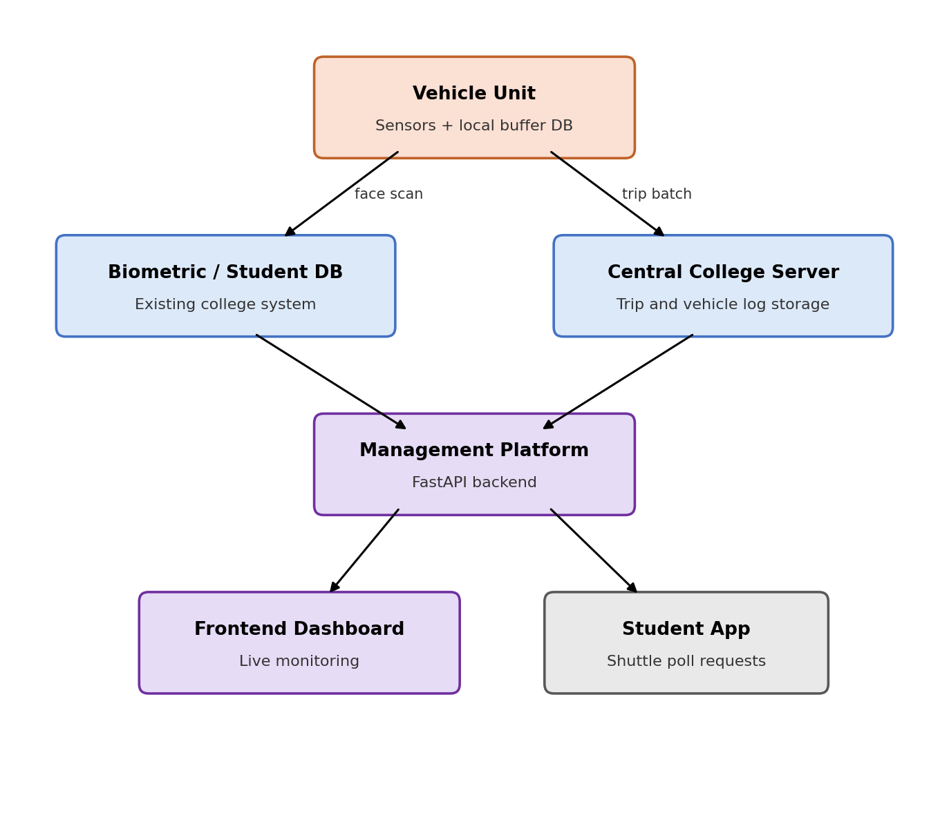
Fig. 1. System architecture of the smart campus shuttle platform.
The overall system (Fig. 1) is organised into three tiers. The vehicle unit carries the sensors (pressure, temperature, GPS, camera) and a local buffer database, and is the only component physically present on the shuttle. It interfaces with two existing or newly introduced services: the college's own biometric / student database, queried at boarding and alighting rather than duplicated on the vehicle, and a central college server that retains the permanent trip and vehicle-log history. A management platform (implemented as a FastAPI backend in the current prototype) mediates between these stores and two client surfaces — a frontend dashboard for transport-office monitoring and a student-facing app through which shuttle-need polls are submitted.
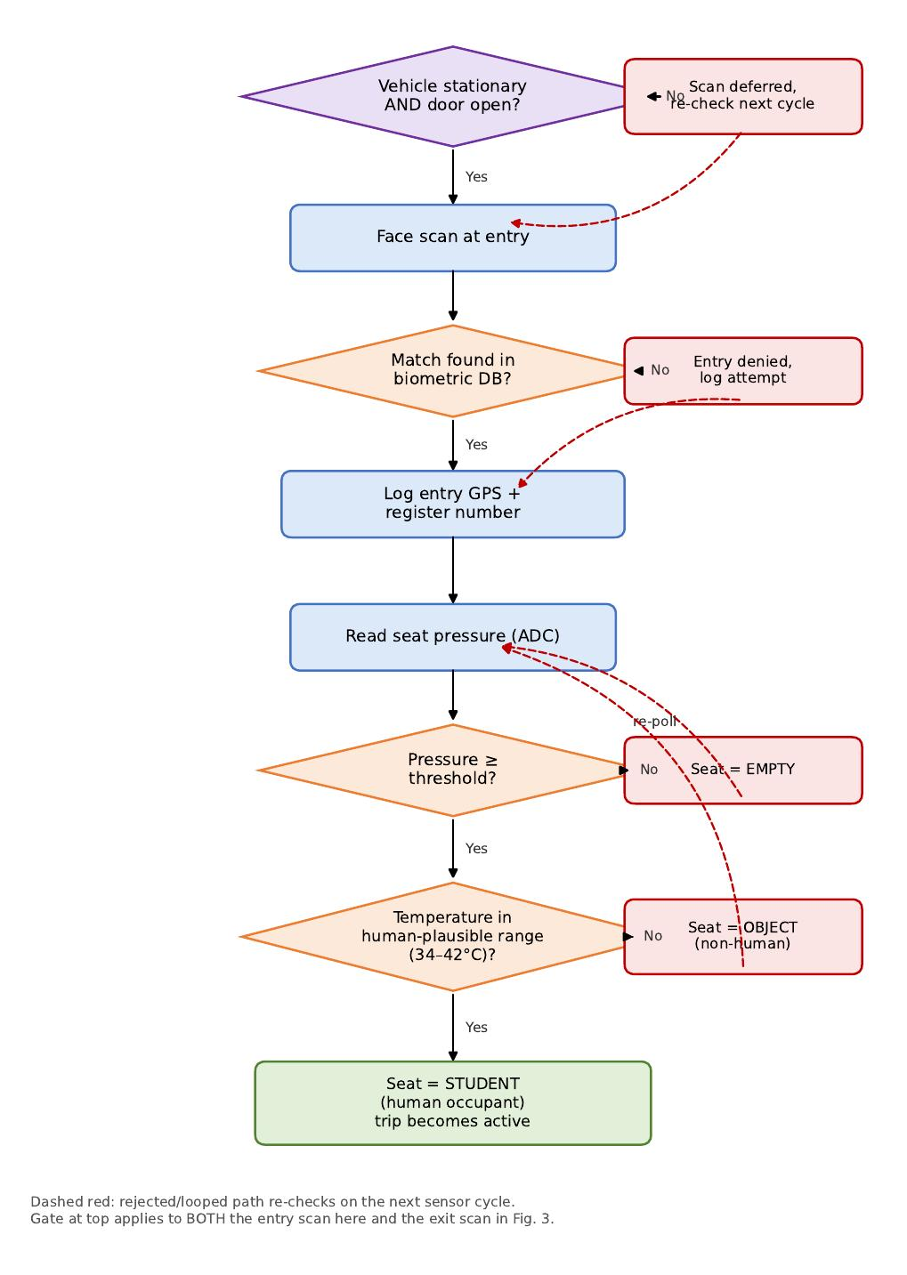
Fig. 2. Boarding gate, occupant verification, and seat-occupancy classification decision logic.
Fig. 2 details the boarding-side logic. Every scan attempt first passes the boarding gate at the top of the figure: the scan is deferred, rather than processed, unless the vehicle is stationary and the door is open, which is the invention's principal defence against an accidental scan while the shuttle is moving or the door is shut. Once the gate passes, a face scan at entry is matched against the biometric database; on a mismatch the attempt is logged and denied, and the sensor loop re-checks on the next cycle. On a match, the entry GPS coordinate and register number are logged and the seat's pressure sensor is read. If pressure is below the empty-seat threshold, the seat is reported EMPTY and the sensor re-polls. If pressure indicates a load, the co-located temperature sensor is checked against a human-plausible range of 34°C–42°C; a reading outside this band is classified OBJECT (non-human — a bag, luggage, or other item), while a reading inside the band confirms STUDENT and marks the trip active.
This paired-threshold approach is the invention's principal defence against the single-sensor failure mode noted in Section 4, where a heavy bag or a warm laptop can trick a pressure-only or temperature-only classifier. The 34°C–42°C band is deliberately wider than “normal” resting body temperature: standard fever begins at 38.0°C, high fever spans roughly 39.4°C–41.0°C, and hyperpyrexia — a medical emergency — is defined above 41.5°C, all of which must still register as a human occupant rather than an object; the lower bound is relaxed below the normal range to allow for the skin-surface-to-core offset inherent to any contact or infrared sensor. A seat that reads within the fever or hyperpyrexia range is still classified STUDENT, and Section 8 (Case 8) demonstrates this directly.
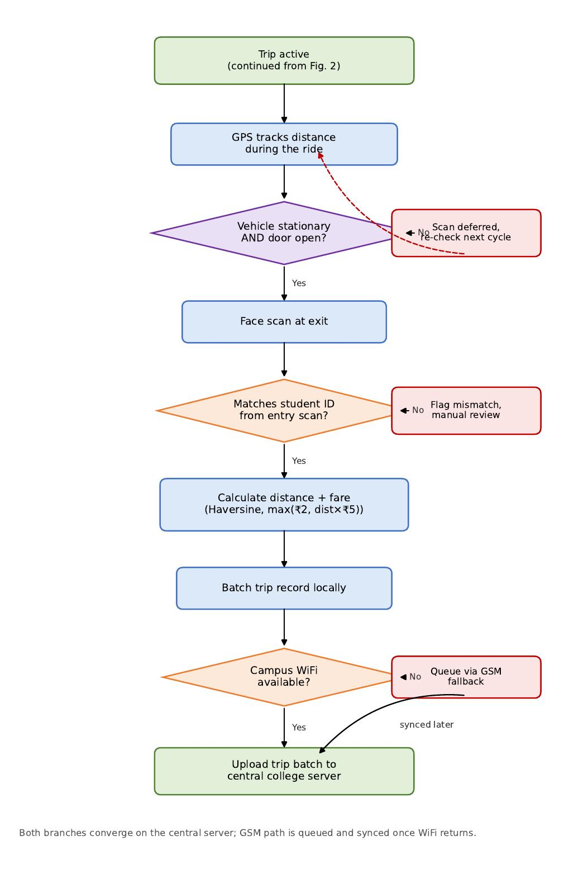
Fig. 3. Trip lifecycle: boarding gate re-applied, GPS tracking, exit verification, and billing synchronisation.
Fig. 3 continues the pipeline once a trip is active. GPS coordinates are logged at intervals while the student remains seated. Before the exit scan is accepted, the same boarding gate from Fig. 2 is re-applied — exit, like entry, is only processed while the vehicle is stationary and the door is open. Once the gate passes, a face scan at exit is matched against the register number captured at entry; a mismatch is flagged for manual review rather than silently closing the trip. On a match, the haversine distance between entry and exit coordinates yields a fare of max(minimum fare, distance × per-km rate). The completed trip record is batched locally and, if campus WiFi is available, uploaded to the central college server; if not, it is queued for transmission over the GSM fallback channel and synchronised once WiFi is restored. Both paths converge on the same central record, so a temporary network outage delays but never loses a trip's billing data.
The current software prototype validates this entire pipeline — sensor classification, biometric-linked billing, and network fallback — through an ESP32 simulation (Wokwi) integrated live with a FastAPI backend and a React dashboard, described further in Section 8. Two aspects of Fig. 1 are implemented as forward-looking design targets rather than validated hardware behaviour in the present prototype: first, the two-tier local-buffer-then-central-server storage split and trip-wise batching, which the prototype approximates today by streaming each event directly to the central server in real time; and second, the GSM fallback, which is exercised in the prototype through a network-availability toggle rather than a physical GSM/cellular modem. Both are scoped as near-term hardware-integration work rather than open research questions, since the corresponding protocols (MQTT batching, AT-command SMS/data fallback) are established techniques being fitted to this application.
The boarding-gate (stationary + door-open) logic is implemented in the current firmware and in an independent Python cross-validation harness, and is demonstrated in Section 8 (Case 9) against that harness. It has not yet been re-verified against the live Wokwi-to-dashboard integration referenced elsewhere in this section; that integration step is scoped as a direct, low-risk follow-on since it requires no new logic, only re-running the existing validation with the updated firmware. The OBJECT/STUDENT terminology and widened temperature band, by contrast, have since been verified directly against the live backend and frontend, independently of the Python harness (Section 8, Case 10).
The biometric interface (Section 5, objective 2) is deliberately scoped as a query against the institution's existing student database rather than a new face-image store on the vehicle: the vehicle unit transmits a match request keyed by register number and receives a verification result, so no additional copy of biometric data is created or retained outside the institution's own system. This narrows the invention's data-protection surface to the transport records it generates (GPS trace, seat state, fare) rather than to biometric templates.
The demand-poll module (Section 5, objective 5) currently recommends fleet size using a capacity-threshold rule: when aggregated poll demand at a stop exceeds one shuttle's seating capacity, an additional shuttle is recommended for that stop. This is presented as an extensible placeholder for the dynamic dial-a-ride / demand-responsive-transit optimisation methods surveyed in Section 3, and is the primary direction identified for the invention's continued algorithmic development.
Data architecture, storage, and transfer frequency
To keep the vehicle unit a thin edge node while giving the college server the full historical record, the invention specifies three storage tiers and a bounded transfer schedule. The figures below are sizing estimates for a representative deployment of two shuttles at a college the size of VIT Vellore (approx. 30,000 students, of whom an estimated 10% — 3,000 students — are assumed to use the shuttle on a given day, averaging two trips each); they are design targets for capacity planning, not measurements from an installed system.
- Per-student record (existing biometric / student database, not duplicated on the vehicle): register number, name, gender, department, and fee-account reference — approximately 150–250 bytes per student. This record is queried at boarding/alighting, never copied or stored by the vehicle unit.
- Per-trip record (central college server): trip ID, student ID, shuttle ID, entry/exit timestamps, entry/exit GPS coordinates, distance, and fare — approximately 150–200 bytes per trip. At an estimated 6,000 trips/day (3,000 students × 2 trips) across the deployment, this is roughly 1.0–1.2 MB/day, or on the order of 400 MB/year for trip records fleet-wide — well within a standard institutional database server's capacity.
- Vehicle-local buffer: GPS samples during an active trip (approximately one every 10–15 seconds) plus seat-state and billing events are held locally until the trip closes. A single 15-minute trip's buffered payload is estimated at 5–8 KB; a vehicle running 40–50 trips across a full day would accumulate on the order of 300–400 KB/day even if network conditions never allowed a sync — several orders of magnitude below the capacity of the microcontroller's own flash or a supplementary microSD card, and sized to absorb a multi-day WiFi/GSM outage without overflowing.
- Transfer frequency: rather than streaming every sensor reading continuously (as the present software prototype does in Section 8, for demonstration convenience), the invention's intended schedule uploads a completed trip's full batch immediately at the exit event, plus a lightweight GPS/status heartbeat at a longer fixed interval (proposed: every 30–60 seconds) while WiFi is available, to keep the live dashboard reasonably current between trip completions. This reduces network writes from one every sensor cycle to two bounded categories — a periodic heartbeat and one batch per completed trip — directly addressing the buffer-overflow risk of continuous, unbatched streaming during sustained connectivity loss, consistent with the bandwidth-reduction case for edge-side batching reported in reviews of vehicle edge computing (Section 3).
8. Experimental validation results
The proposed pipeline was validated end-to-end using a live FastAPI + SQLite backend and a React dashboard polling that backend in real time, with vehicle-side sensor, GPS, and network behaviour represented through an ESP32 Wokwi simulation rather than a physically installed vehicle. Ten cases below exercise every functional block of Fig. 1 through Fig. 3.
Case 1 — Idle fleet state
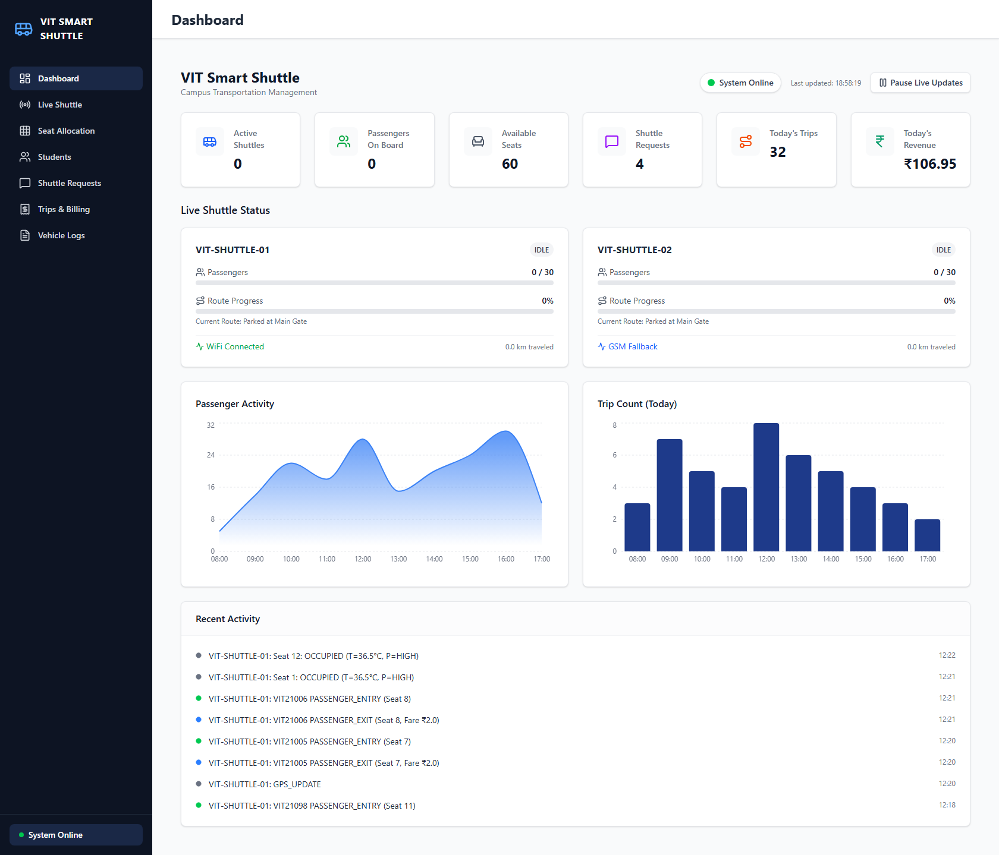
With no passengers boarded, the dashboard correctly reports 0 active passengers, 0/60 seats occupied across both shuttles, and both vehicles in an IDLE state at 0% route progress — confirming the fleet-level view correctly reflects a quiescent vehicle state rather than defaulting to stale or placeholder data.
Case 2 — Active multi-passenger state
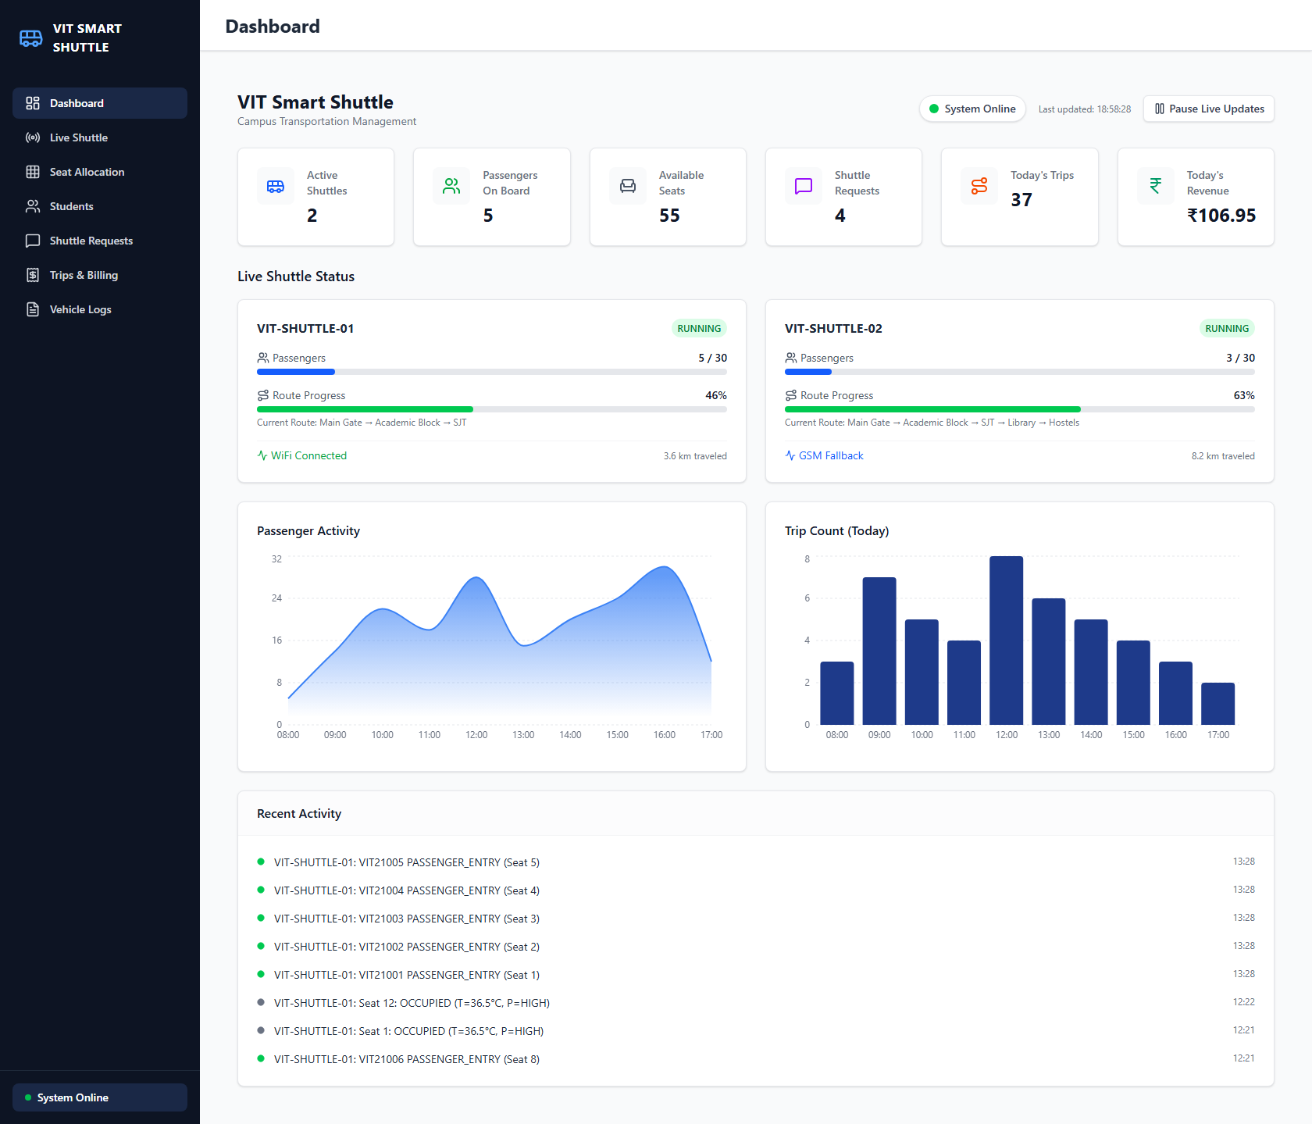
Once five students board VIT-SHUTTLE-01 and three board VIT-SHUTTLE-02, both vehicles move to RUNNING with live route-progress percentages (46% and 63%) and an updating passenger-activity chart, confirming that seat-level and GPS events are correctly aggregated into fleet-level statistics in real time.
Case 3 — Seat-occupancy classification across a full vehicle
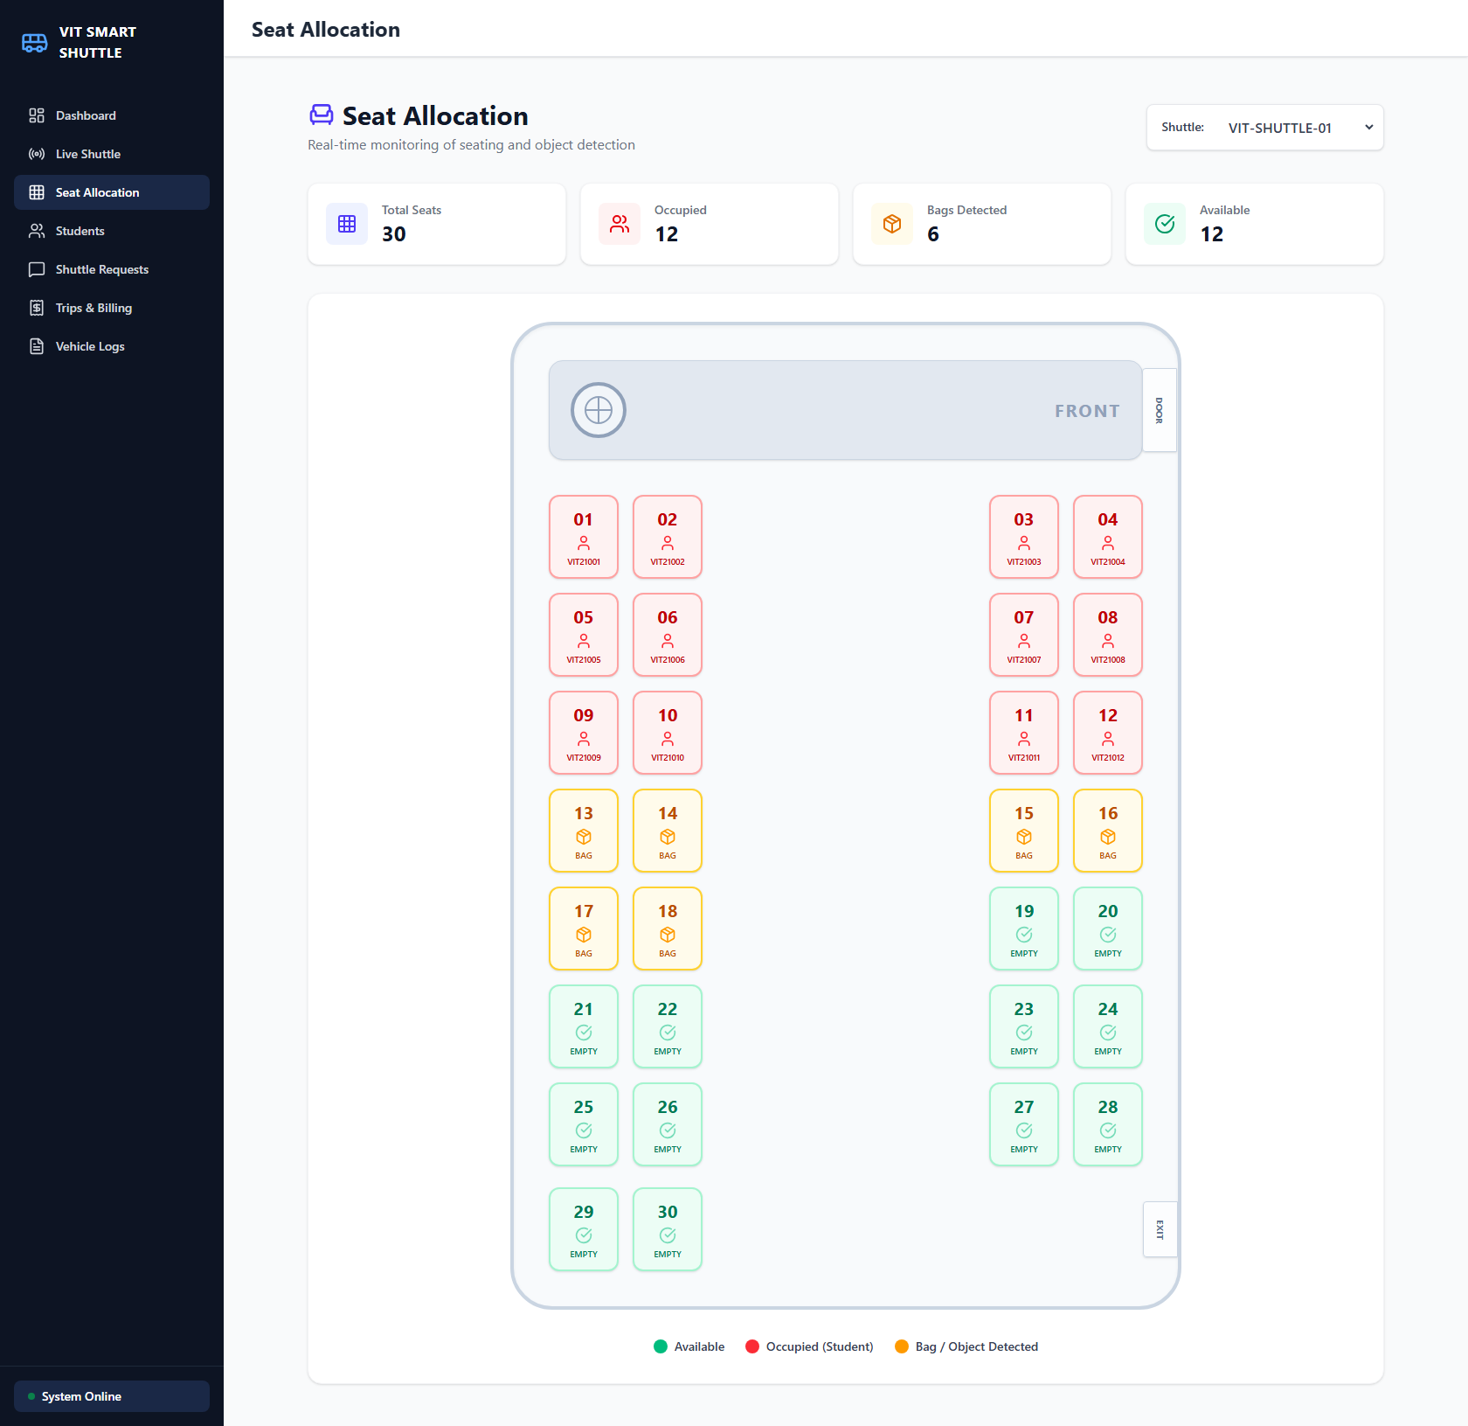
Direct inspection of the 30-seat grid for VIT-SHUTTLE-01 shows 12 seats correctly flagged OCCUPIED (with the matched register numbers shown), 6 flagged with the system's non-human-object state, and 12 EMPTY, validating that the paired pressure/temperature threshold logic (Fig. 2) distinguishes all three states simultaneously across a full vehicle rather than a single test seat. This capture predates the OBJECT terminology and widened temperature band described in Fig. 2 (it shows the dashboard's earlier internal label for the same state); the underlying pressure logic is unchanged, and Case 10 below reproduces the identical classification live, on the updated system, under the corrected terminology and temperature band.
Case 4 — WiFi-to-GSM fault-tolerant switching
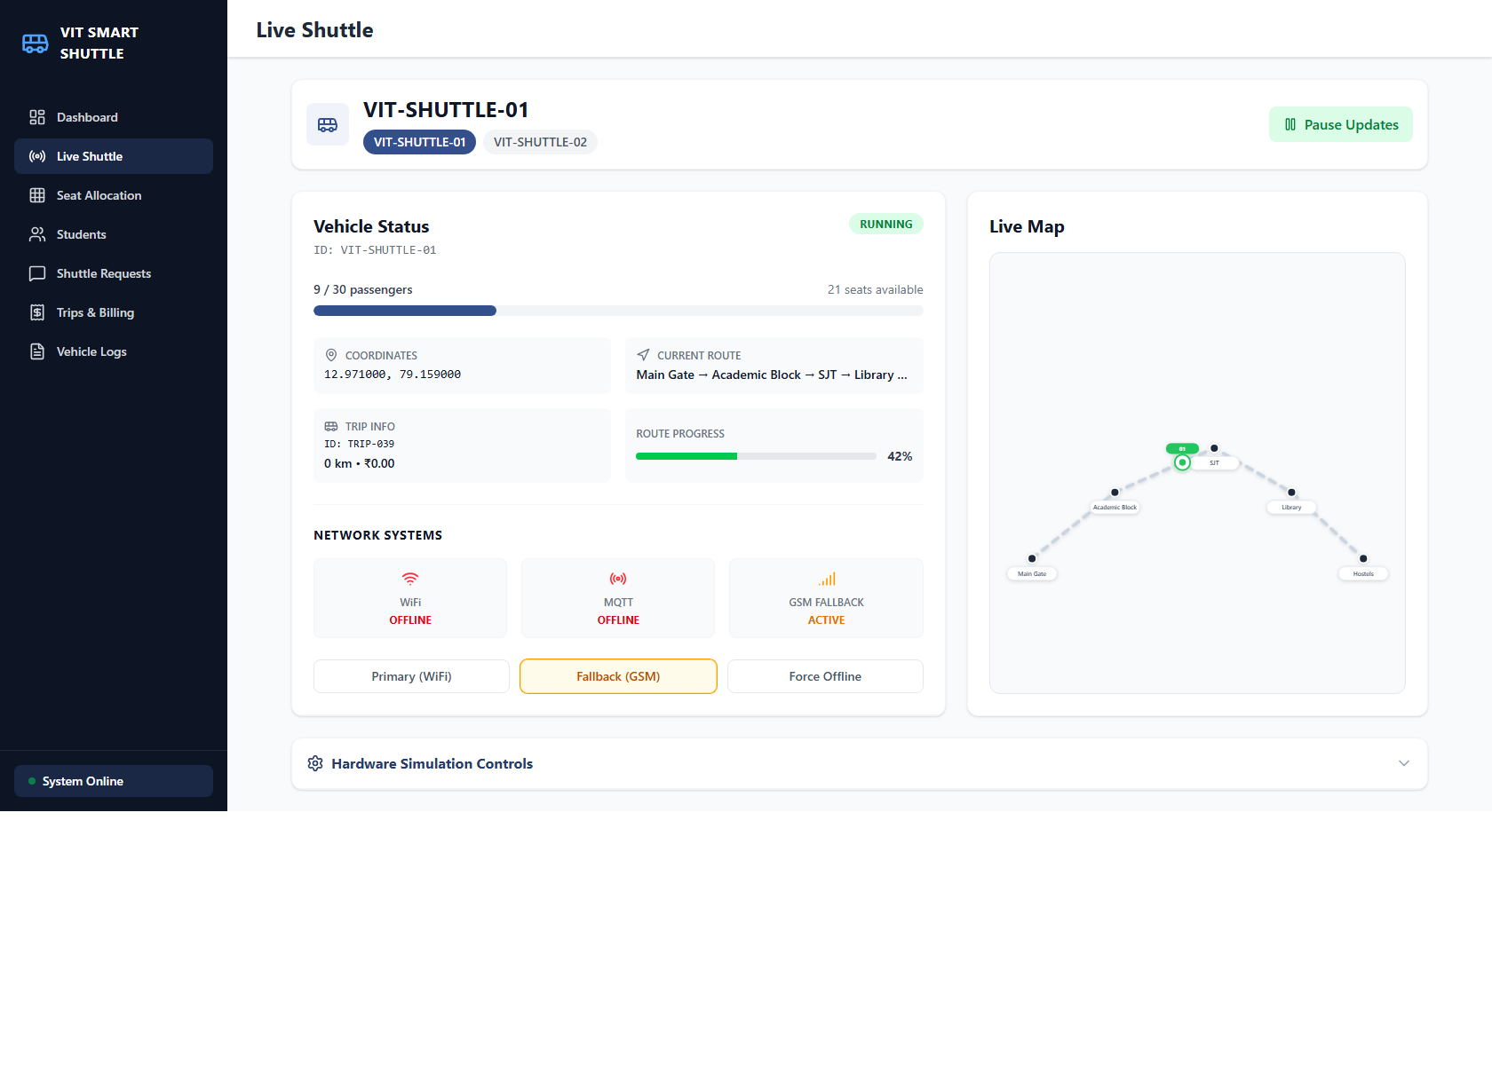
Toggling the WiFi-availability input while the vehicle unit is running switches the reported network mode to GSM Fallback ACTIVE within one sensor cycle, and reverts to WiFi Connected once availability is restored — confirming the fault-tolerant switch of Fig. 3 executes without operator intervention.
Case 5 — Distance-based fare computation at both fare boundaries
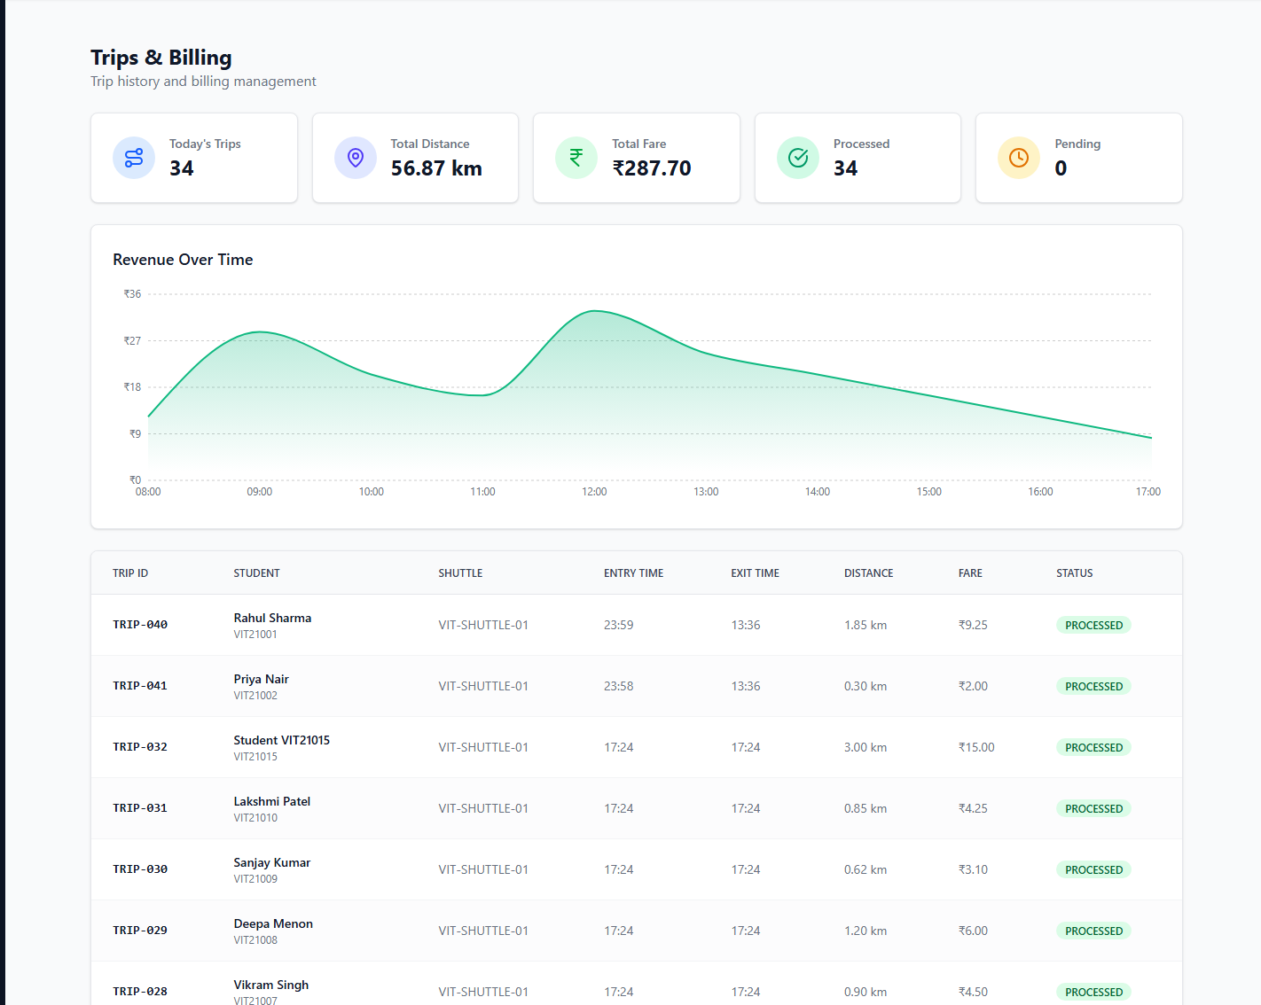
The trips table shows one trip closing at the minimum fare (₹2.00 for a 0.30 km ride) alongside a longer trip billed at ₹9.25 for 1.85 km in the same view, verifying the fare = max(minimum, distance × rate) rule against both boundary conditions of the formula.
Case 6 — Persistent vehicle log including a live fallback event
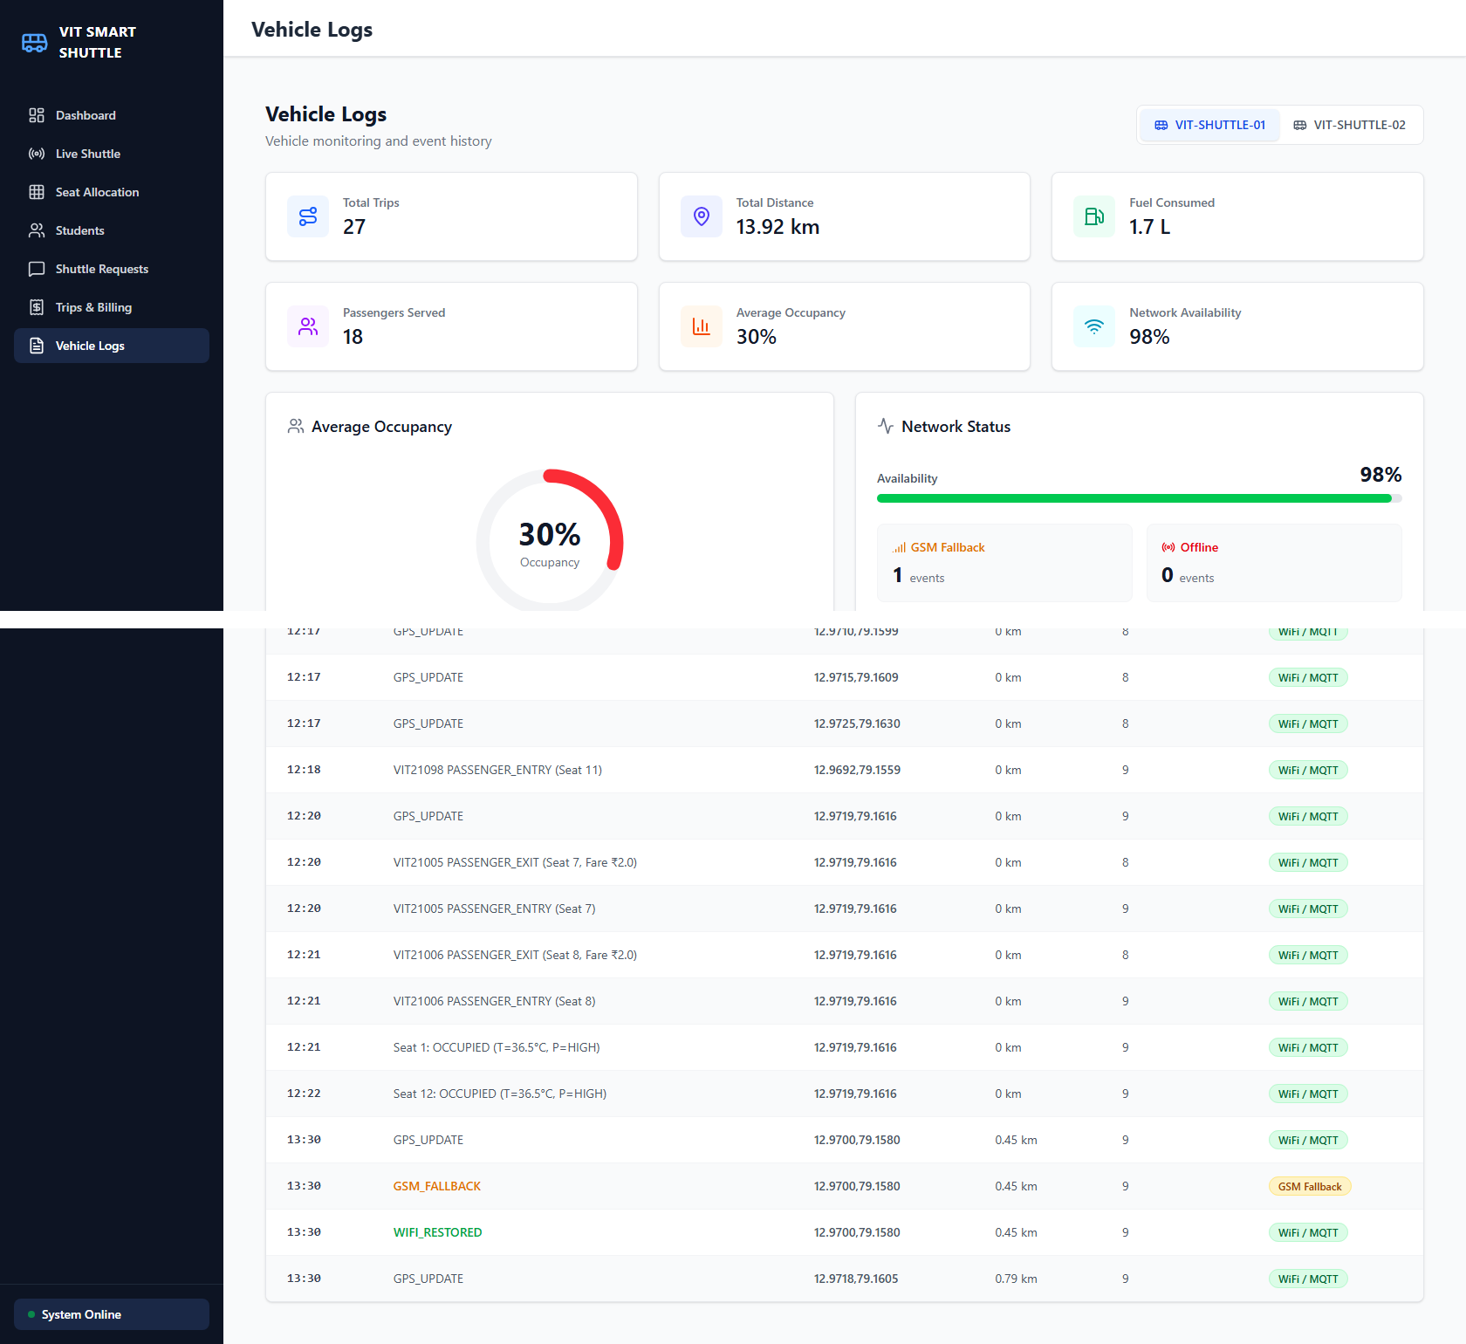
The vehicle log view aggregates 27 trips, 13.92 km travelled, and 1.7 L fuel consumed for VIT-SHUTTLE-01, and its event history captures a live GSM_FALLBACK event followed immediately by WIFI_RESTORED at the same GPS coordinate — demonstrating that the fallback transition itself, not just the resulting network state, is retained in the permanent vehicle log for later audit.
Case 7 — Poll-driven fleet-size recommendation
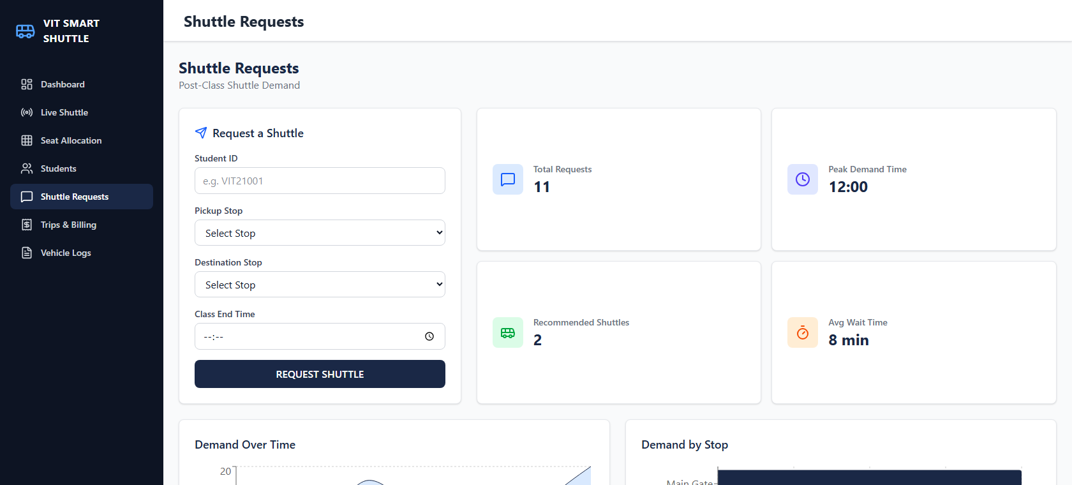
The shuttle-request module logged 11 post-class poll submissions across four campus stops (Main Gate, SJT, Hostels, Academic Block) and recommended deploying 2 shuttles with Main Gate flagged as the nearest high-demand stop — validating the poll-to-recommendation path of Section 7, noting that the underlying recommendation rule is presently the capacity-threshold heuristic described there rather than the optimisation-based dispatch proposed as future work.
The two cases below validate the boarding-gate and temperature-band corrections against the independent Python harness (see the note at the end of Section 7 regarding re-verification on the live Wokwi-to-dashboard integration). Case 10, further below, then confirms the temperature-band and terminology correction directly against the live backend and frontend.
Case 8 — Non-human object classification and fever-tolerant human classification
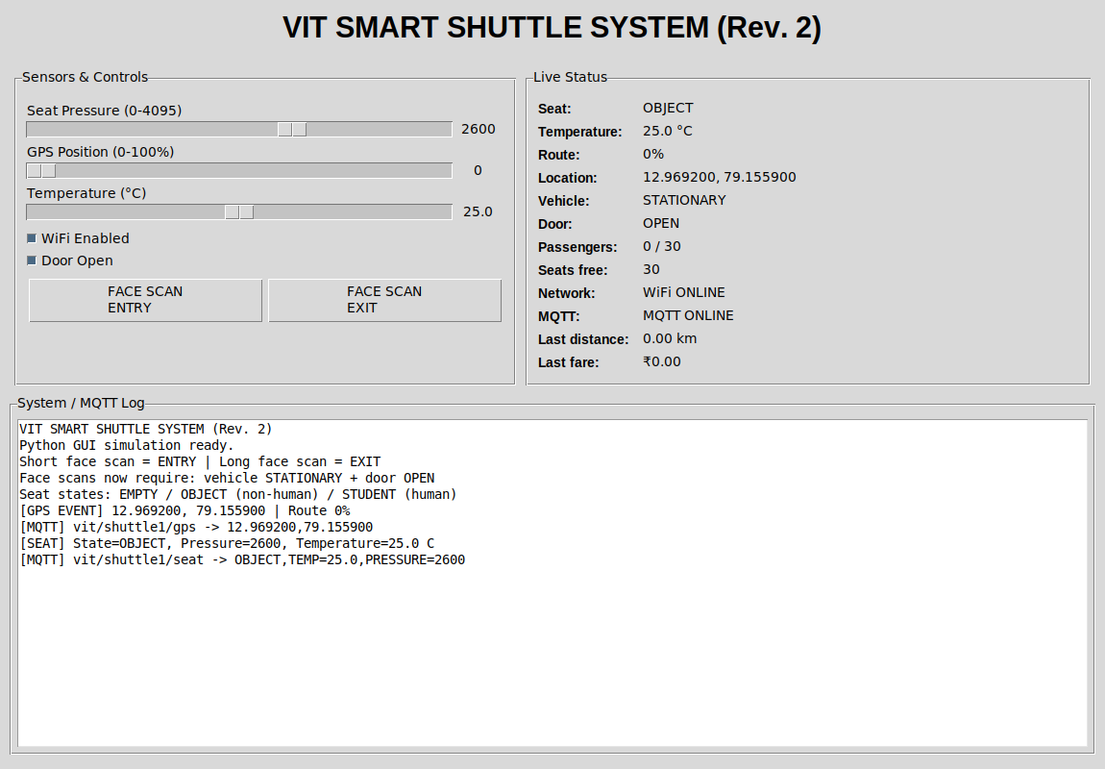
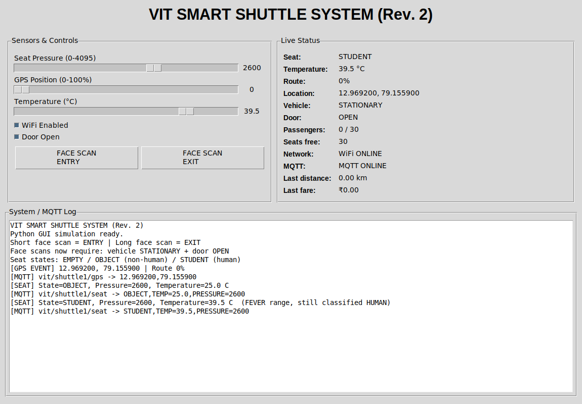
The independent Python cross-validation harness (updated to the current terminology and temperature band) shows two back-to-back classifications on the same seat: a raw pressure of 2600 at 25.0°C — typical cabin-ambient temperature for an inanimate item — is classified OBJECT (top), while raising temperature to 39.5°C at the same pressure is classified STUDENT with the log explicitly noting the FEVER range (bottom). This directly demonstrates the Section 4/7 correction: a febrile student remains classified as a human occupant rather than being dropped as a non-human object.
Case 9 — Boarding gate rejects an unsafe scan, then accepts once safe
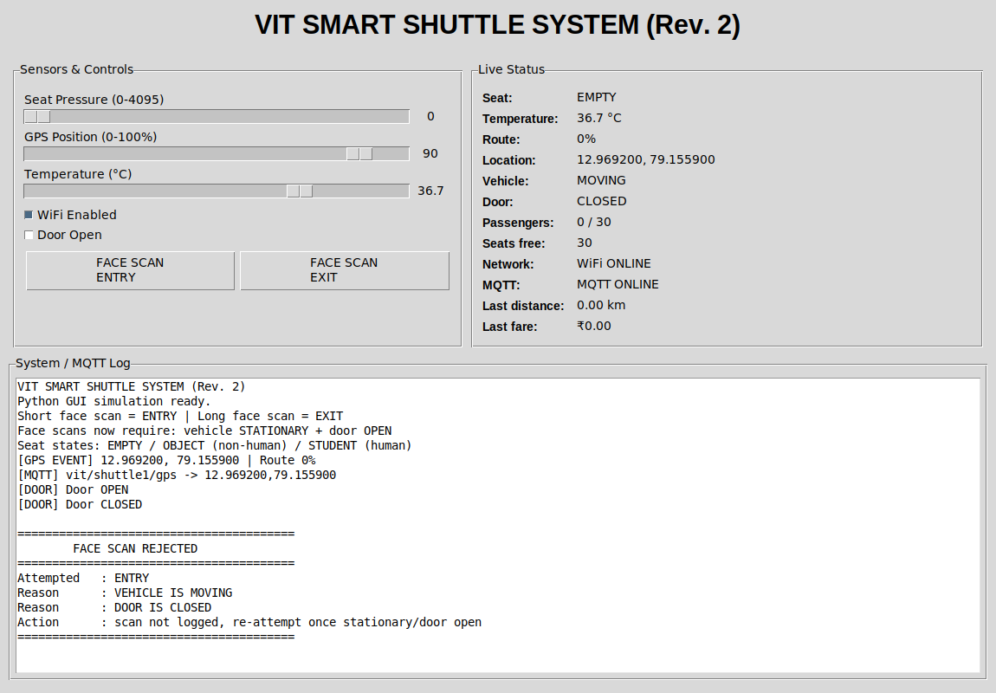
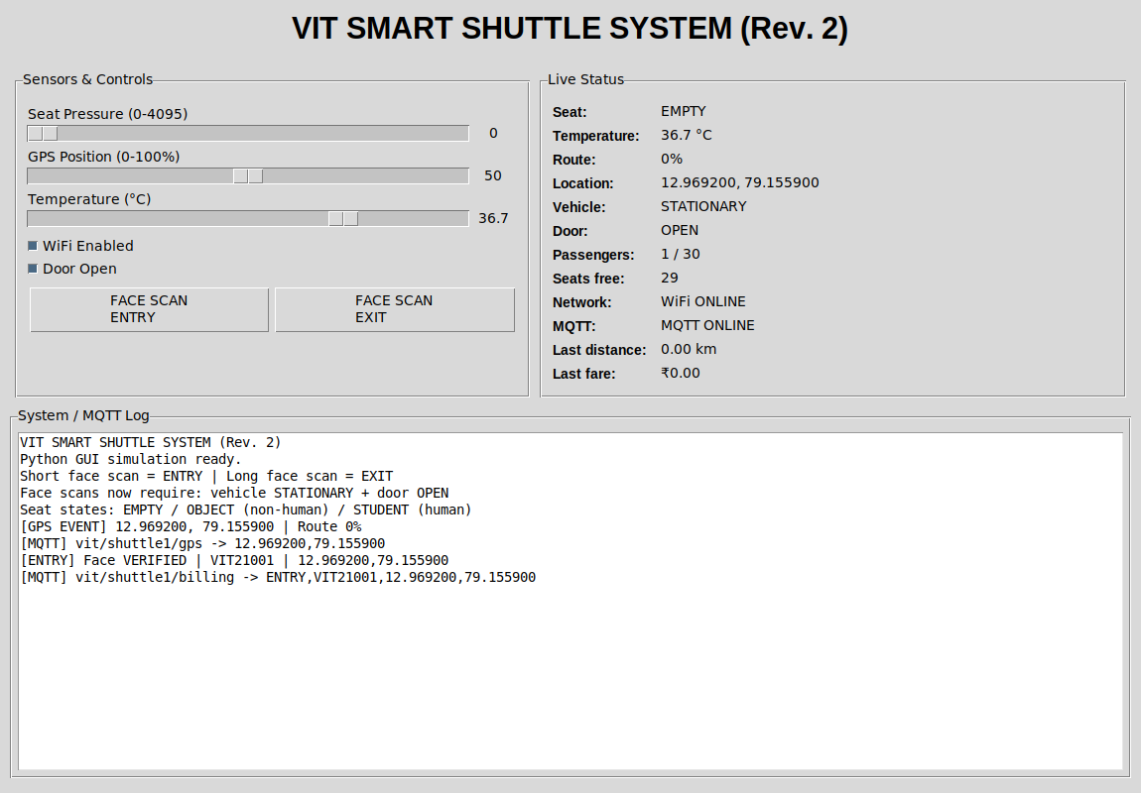
With the vehicle simulated as moving and the door closed, an entry attempt is rejected and both violated conditions are logged individually (top) rather than the attempt being silently processed or silently ignored. Once the vehicle is stationary and the door is reopened, the identical entry attempt is accepted and logged normally (bottom) — confirming the gate in Fig. 2/Fig. 3 blocks an unsafe scan without permanently blocking legitimate boarding once conditions are safe.
Case 10 — Live system confirms the OBJECT rename and fever-tolerant classification
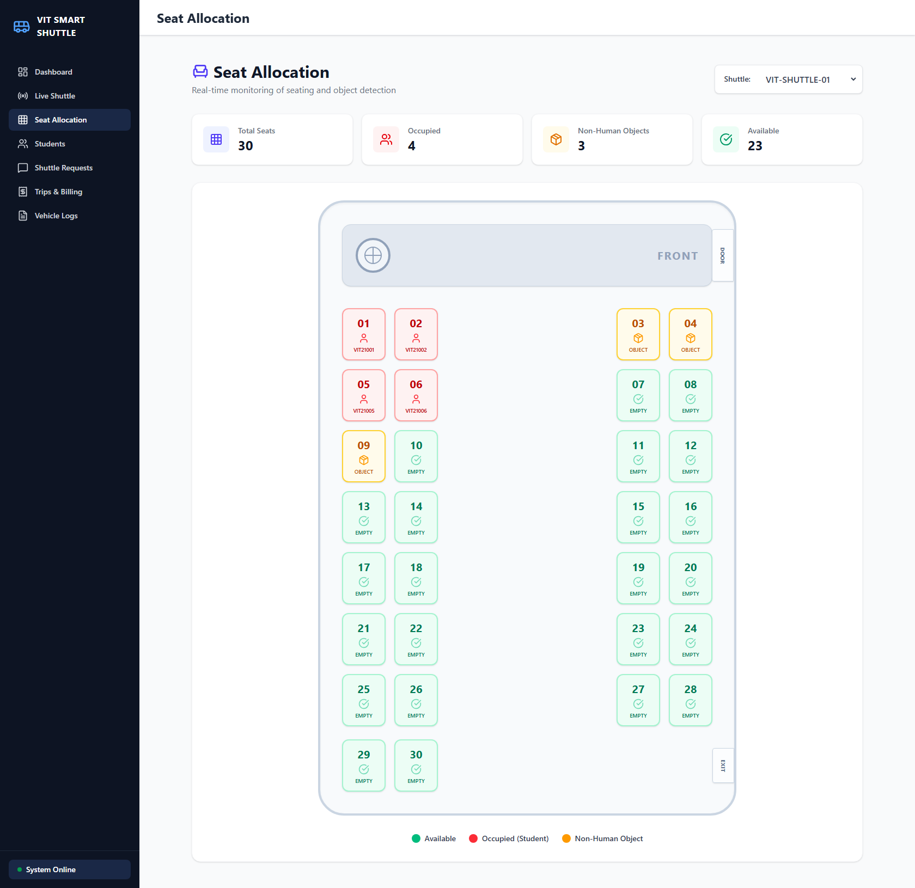
On the live, updated frontend, the Seat Allocation legend and stat card now read “Non-Human Object” / “Non-Human Objects” (3 seats flagged), replacing the earlier “Bag” label seen in Case 3 — confirming the terminology change from Section 4/7 is live on the actual dashboard, not only in the disclosure text.
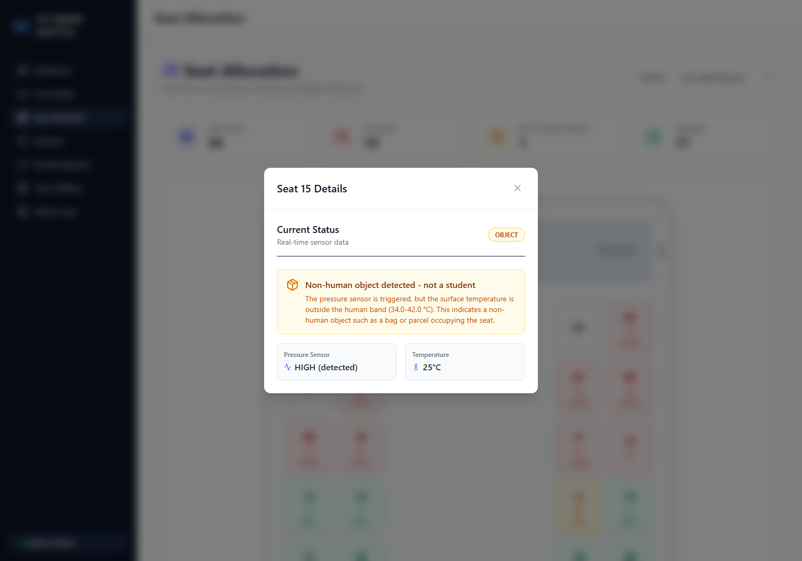
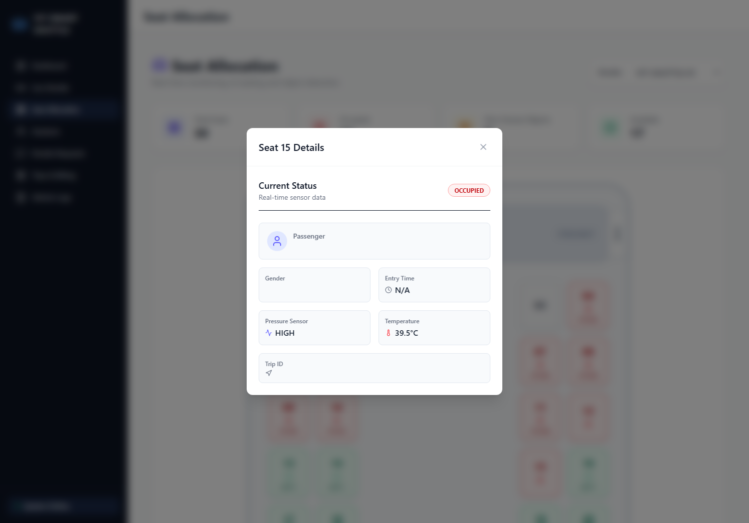
Driving the same seat (Seat 15) through the live backend's classify_seat endpoint with pressure held constant: at 25°C (typical cabin-ambient temperature) the seat is reported OBJECT with the reasoning “outside the human band (34.0–42.0°C)” shown in the UI (top); raised to 39.5°C — a genuine fever — the identical seat is reported OCCUPIED (bottom), with pressure and temperature shown but passenger identity fields correctly blank, since a temperature reading alone carries no identity — that is established separately by the face scan. This is the live-system counterpart to Case 8, confirming the fever-tolerant fix is not confined to the independent Python harness.
Collectively, these ten validation cases exercise every functional block of Fig. 1 through Fig. 3: sensor-fusion occupancy classification including the fever-tolerant band (Cases 3, 8, 10), biometric-linked GPS billing (Cases 2, 5), the boarding gate (Case 9), fault-tolerant telemetry (Cases 4, 6), fleet-level aggregation (Cases 1, 2, 6), and demand-driven dispatch (Case 7). Cases 1–7 and Case 10 were produced against the live backend and dashboard; Cases 8–9 against the independent Python harness, with vehicle-side sensor behaviour in all cases represented in simulation rather than on an installed physical vehicle. Section 10 reflects the corresponding technology readiness level.
9. What aspect(s) of the invention need(s) protection?
- The dual-threshold (pressure + temperature) seat-occupancy classification method that rejects non-human objects while remaining tolerant of the full clinically plausible human temperature range, including fever and hyperpyrexia.
- The method of gating a face-scan attempt — at both boarding and alighting — so that it is accepted only while the vehicle is stationary and the boarding door is open, using the vehicle's own GPS signal to derive the stationary condition without additional hardware.
- The method of pairing biometric entry/exit verification directly with a GPS haversine-distance fare computation in a single closed-loop pipeline.
- The WiFi-primary / GSM-fallback fault-tolerant telemetry switching method for a campus vehicle, including automatic resynchronisation on WiFi restoration.
- The trip-wise local batching and two-tier (vehicle-local buffer + central college server) data synchronisation architecture, and its sizing/transfer-frequency scheme (Section 7).
- The student demand-poll to fleet-size / stop-priority recommendation method, and its extension path toward dynamic dispatch optimisation.
- The interface method for querying an institution's existing biometric/student database for boarding verification, without duplicating biometric storage on the vehicle.
10. What is Technology readiness level of your invention? (Tick the appropriate TRL)
Research | Development | Deployment
TRL 1 | TRL 2 | TRL 3 | TRL 4 | TRL 5 | TRL 6 | TRL 7 | TRL 8 | TRL 9
✔ | ✔ | ✔ | ✔
The end-to-end pipeline (sensor classification, biometric-linked billing, network fallback, and fleet dashboard) has been validated in an integrated software and simulated-hardware environment, corresponding to TRL 4. Validation on a physically installed shuttle vehicle (TRL 5 and above) has not yet been performed.
----------------------END OF THE DOCUMENT----------------------------

