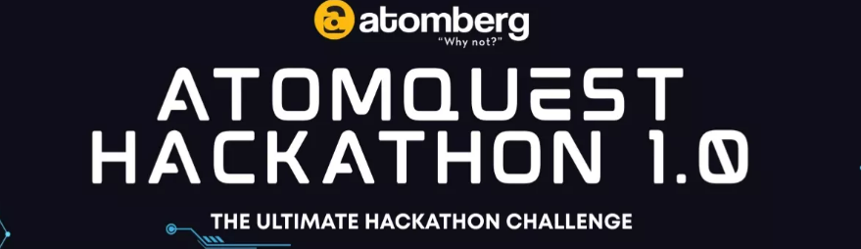
AtomQuest Hackathon 2026 - Round 2 Finale Submission
ClariVue - Real-time, self-hosted video support platform

Candidate Name | Gurjas Singh Gandhi
College | P.E.S's Modern College of Engineering, Pune
Course & Graduation Year | MCA, 2026
Live Application | https://clari-vue.vercel.app/
Source Code (GitHub) | https://github.com/Gurjas2112/ClariVue
Submission Date | June 13th, 2026

1. Project Overview
ClariVue is a real-time, self-hosted video support platform for customer support teams. A support agent creates a call session and invites a customer via a shareable link; both join from the browser - no install - onto live audio/video routed through our own media server (a self-hosted LiveKit SFU, never a third-party hosted video API). They chat in-call, share files, and the agent can record; every session (presence, chat, files, recording) is persisted and reviewable afterward.
Roles are enforced server-side: agents create / end / record sessions, while customers can only join via a valid invite. The system is live at https://clari-vue.vercel.app/.

2. Login Credentials (for judging)
Role | Email | Password
Agent | agent@clarivue.demo | clarivue123
Admin | admin@clarivue.demo | clarivue123

Ready-made invite link: /join/demo-call - a pre-seeded active session owned by the demo agent (open it in a second browser to join as the customer).
New agents can also sign up at /signup: a confirmation email is sent via Gmail SMTP - click the link to activate, then sign in. The demo accounts above are pre-confirmed.

3. System Architecture
Self-hosted, real-time video support platform. This document covers the system design, the data model, the security model, and a requirement-by-requirement traceability matrix.

1. System overview
ClariVue separates two planes:
- App plane — the Next.js application: UI (React + @livekit/components-react) *and* the app
backend as App-Router route handlers. It mints LiveKit tokens, enforces roles, and persists everything to Supabase. Stateless and serverless-friendly.
- Media plane — a self-hosted LiveKit SFU (+ Egress + Redis). All audio/video flows through
it; clients never connect peer-to-peer and we never use a third-party hosted video API. This is the hard constraint of the brief, and the reason media lives in its own plane: WebRTC needs UDP/TCP traffic that has no business touching the app server.
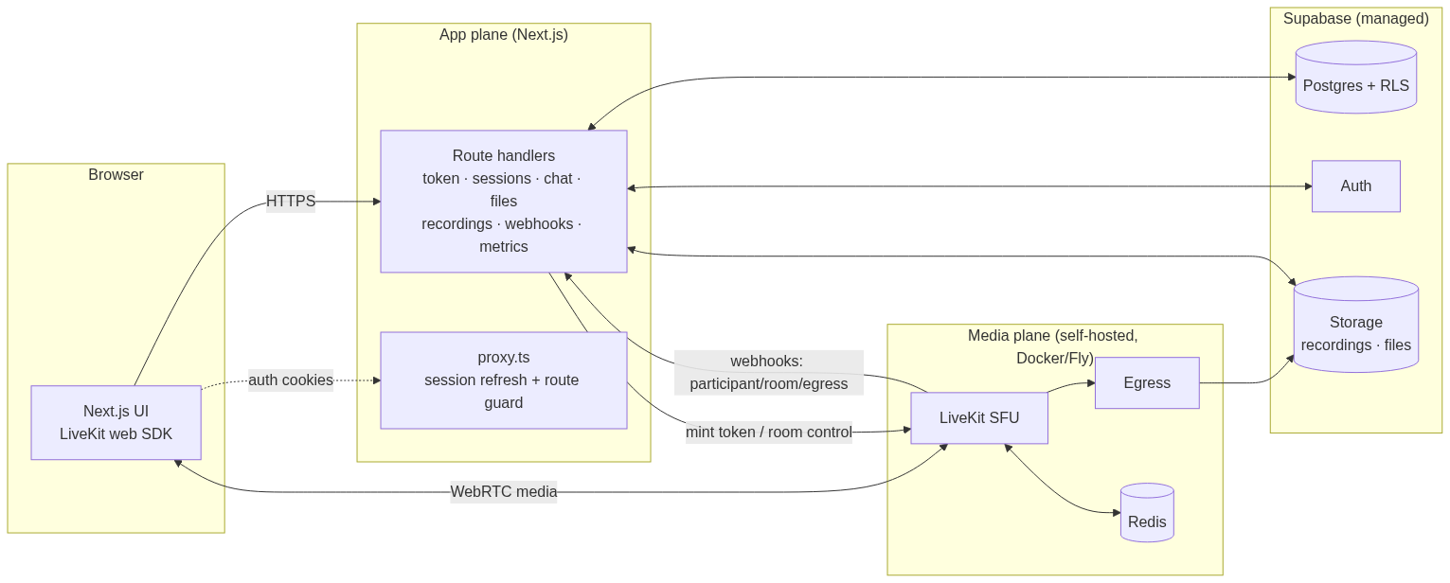
Diagram 1 – High Level System Architecture Diagram

Why this split (and why not Railway)
A WebRTC SFU needs a wide UDP port range + a stable IP. Railway/Render/Heroku only route HTTP/TCP, so the media plane runs on infrastructure that exposes raw UDP/TCP (locally: Docker; for a stable public deployment: a VM with a dedicated IP). The app backend needs no UDP, so it lives as Next.js route handlers co-located with the UI — no separate API service to operate. Locally everything is localhost; on Docker Desktop, clients use LiveKit's ICE/TCP fallback (port 7881) because the container's UDP candidates aren't reachable across the Docker VM boundary.

Deployment (live)
The live app runs at https://clari-vue.vercel.app: the Next.js app is on Vercel, the database/ auth/storage on Supabase cloud, and the self-hosted LiveKit + Egress + Redis run in local Docker, exposed to the cloud through a cloudflared tunnel (so media still flows through *our own* SFU — never a third-party hosted video API). NEXT_PUBLIC_LIVEKIT_URL (wss → the tunnel) is the browser signal URL; LIVEKIT_URL (https → the tunnel) is the server SDK URL; LiveKit posts webhooks back to the public Vercel URL.
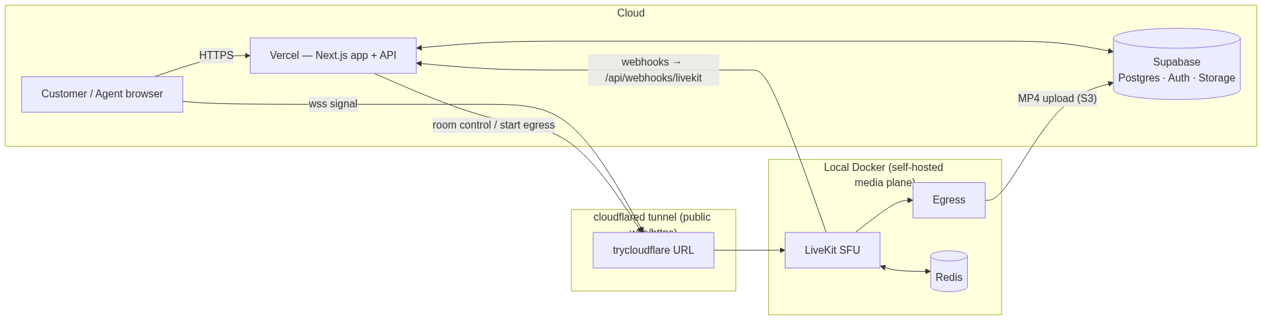
Diagram 2 – Deployment Diagram

2. Key flows

Create + join a session
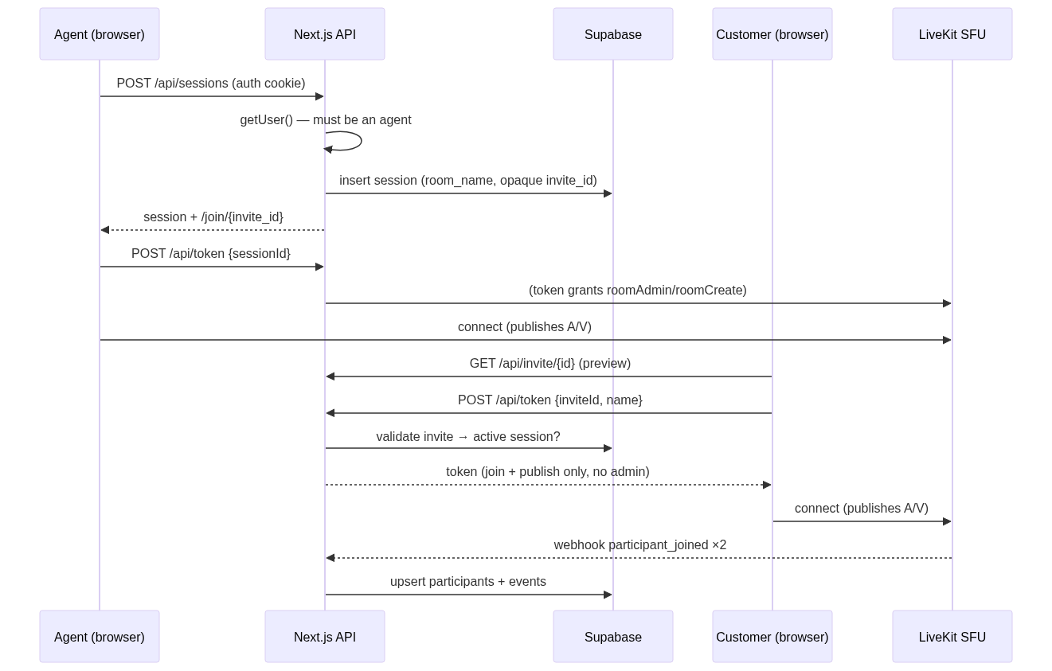
Diagram 3 – System Sequence Diagram

Token minting — the single enforcement point (R13–R15)
All role logic lives in POST /api/token:
- Agent path: requires a Supabase-verified user who owns the session (or admin) → grants
roomAdmin + roomCreate.
- Customer path: requires a valid, active invite that maps to the room → grants roomJoin
- publish/subscribe only. No admin grants. Identity is namespaced (customer-…) so it can never
impersonate an agent.
Privileged routes (/api/sessions POST, /end, /recordings/*, /admin/*) independently verify getUser() and ownership. Client-side guards (proxy.ts, redirects) are UX only.

Recording lifecycle (R16)
recordings/start → EgressClient.startRoomCompositeEgress → row in_progress. recordings/stop → stopEgress → processing. The signed LiveKit egress_ended webhook → ready. The UI pill reflects each transition; download is a short-lived signed Storage URL.

3. Data model (Supabase Postgres)
profiles · sessions · session_participants · session_events · chat_messages · shared_files · recordings (see supabase/migrations/0001_init.sql).
- sessions carry a unique room_name and an opaque invite_id.
- session_participants track presence with joined_at / left_at / disconnected_at /
reconnect_count (the reconnect grace window).
- session_events is an append-only log (joins, leaves, room/egress lifecycle) → queryable history.

Security model
- RLS is on for every table. Authenticated agents can read only their own sessions and children
(agent_id = auth.uid()); admins read all (is_admin()).
- Customers are anonymous — they never use a Supabase client key for privileged data. Every
customer read/write (join, chat, file upload) goes through a server route that validates the invite and then uses the service key (which bypasses RLS). This keeps the browser locked by default while letting validated customers participate.
- Auth/token routes are dynamic = 'force-dynamic' + Cache-Control: no-store (never cache a
Set-Cookie or a per-user token). The service key is server-only, never NEXT_PUBLIC_.
- LiveKit webhooks are verified with WebhookReceiver (unsigned requests rejected). Invite ids are
unguessable random tokens. File uploads are mime/size-checked, stored per-session, served via signed URLs.

4. Caching
A cache-aside layer over Upstash Redis (HTTP) sits in front of hot reads (invite validation, admin live snapshot, recording status, metrics, chat hydrate). It is optional — when the UPSTASH_* env vars are absent the helper transparently falls through to the source, so local dev is zero-config. All invalidation funnels through the LiveKit webhook handler (the single place room state changes), so the cache can't silently drift. Authenticated/token responses are never cached.

5. Requirements traceability

# | Requirement | Type | Where | Status
R1 | Agent creates session, invite link/token | MH | POST /api/sessions, /join/[inviteId] | ✅ verified
R2 | Both join from browser, no install | MH | Next.js + LiveKit web SDK | ✅ verified
R3 | Track who's in a session at any time | MH | session_participants + webhooks | ✅ verified
R4 | Either party ends; connections closed | MH | /api/sessions/[id]/end → deleteRoom | ✅
R5 | Session history persisted & queryable | MH | sessions, session_events, record view | ✅ verified
R6 | Real-time A/V both directions | MH | LiveKit SFU | ✅ verified (2-browser test)
R7 | Media routes through server, no P2P | MH | self-hosted LiveKit SFU | ✅ verified
R8 | Stable under normal network | MH | ICE/TCP fallback on :7881 | ✅
R9 | Mute audio / disable video anytime | MH | control bar | ✅
R10 | In-call text chat, real-time | MH | LiveKit data channel | ✅ verified
R11 | Chat persisted | MH | chat_messages via /api/chat | ✅ verified
R12 | Chat retrievable after call | MH | GET /api/chat, session record | ✅ verified
R13 | Role: Agent (create/end/record) | MH | token grants + route checks | ✅ verified
R14 | Role: Customer (join by invite only) | MH | invite validation, no admin grants | ✅ verified
R15 | Access enforced server-side | MH | getUser() in privileged routes | ✅ verified
R16 | Recording: start/stop, status, download | B | Egress + recordings + signed URL | ✅ built (needs S3 keys to capture)
R17 | File sharing in chat | B | Storage + shared_files + signed URLs | ✅ verified
R18 | Reconnect grace, silent re-entry | B | disconnected_at + grace in webhook | ✅ built
R19 | Admin dashboard: live, history, force-end | B | /admin + RoomServiceClient | ✅ verified
R20 | Observability metrics | B | /api/metrics (Prometheus) | ✅ verified

6. Technology choices
Layer | Choice | Why
Frontend + App API | Next.js 16 (App Router, TS) | One codebase for UI + backend route handlers
Media SFU | self-hosted LiveKit | OSS, server-routed media, token-based roles, webhooks, egress, metrics
Recording | LiveKit Egress → Supabase Storage | OSS room-composite MP4
Auth | Supabase Auth | agents only; instant signups for the demo
Database | Supabase Postgres + RLS | sessions, presence, chat, files, recordings
Storage | Supabase Storage | private buckets, signed URLs
Cache | Upstash Redis (optional) | serverless-safe hot-read cache
Local dev | Docker Compose | LiveKit + Egress + Redis identical to prod
Metrics | Prometheus (prom-client + LiveKit native) | standard scrape format

5. Setup, Run & Operate (Workflow)
This document is the single operator-facing guide: what the system is, how it maps to the problem statement, how it's architected, and exactly how to install, run, test, and deploy it.

1. The problem & the solution
Support teams resolve simple issues over voice, but go blind the moment a problem needs to be *seen* — a field engineer at a device, an agent walking a customer through a UI. ClariVue adds a real-time video layer that the support team owns and operates entirely: an agent creates a session, invites a customer by link, both join from the browser onto audio/video routed through our own media server, they chat and share files, the agent can record, and every session is persisted and reviewable.

2. Problem-statement requirement coverage
Area | Requirement | How ClariVue does it
Session management | Agent creates session + invite link | POST /api/sessions → row with unique room_name + opaque invite_id; share /join/{invite_id}
 | Both join from browser, no install | Next.js + LiveKit web SDK
 | Track who's in a session | session_participants updated by signed LiveKit webhooks
 | Either party ends; connections closed | POST /api/sessions/[id]/end → RoomServiceClient.deleteRoom
 | History persisted & queryable | sessions + session_events (append-only log) + session record view
Audio & video | Both see/hear in real time | LiveKit SFU
 | Media routes through server (no P2P) | self-hosted LiveKit SFU — server-routed by design
 | Stable under normal network | ICE/TCP fallback on :7881
 | Mute audio / disable video anytime | in-call control bar
In-call chat | Real-time text | LiveKit data channel
 | Persisted | chat_messages via /api/chat
 | Retrievable after call | GET /api/chat + session record
Roles & access | Agent: create/end/record | Supabase auth + token grants roomAdmin/roomCreate
 | Customer: join by invite only | invite validated server-side; join + publish only, no admin
 | Access enforced server-side | getUser() checked in every privileged route
Bonus | Recording (start/stop/status/download) | LiveKit Egress → Supabase Storage; status pill + signed URL
 | File sharing in chat | server-mediated upload → Storage → in-chat card + record
 | Reconnect grace | disconnected_at + 30s window + suppressed re-join in webhook
 | Admin dashboard | /admin live sessions + participants + force-end + history
 | Observability | /api/metrics Prometheus exposition

3. Data Flow Diagram
ClariVue separates an app plane (stateless, serverless-friendly) from a media plane (self-hosted, needs raw UDP/TCP). The app never proxies media; LiveKit never holds business state.
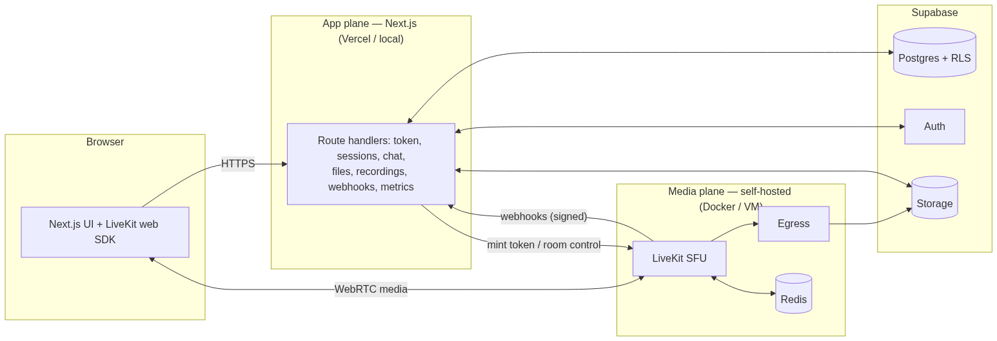
Diagram 4 - Data Flow Diagram
Why the split (and why not Railway): a WebRTC SFU needs a wide UDP range + a stable IP, which HTTP-only PaaS (Railway/Render) can't provide. So the media plane runs on infrastructure that exposes UDP (locally: Docker; in production: a VM/Fly with a dedicated IP). The app backend needs no UDP and lives as Next.js route handlers co-located with the UI.
Roles are enforced at one choke point — POST /api/token:
- *Agent* (Supabase-verified owner/admin) → grants roomAdmin + roomCreate.
- *Customer* (valid active invite) → roomJoin + publish/subscribe only; identity namespaced
customer-… so it can't impersonate an agent.
Security: RLS on every table; anonymous customers reach data only through invite-validated server routes using the service key; auth/token routes are no-store; webhooks verified with WebhookReceiver; uploads mime/size-checked + signed URLs; service key server-only.

4. Tech stack
Layer | Technology
Frontend + app API | Next.js 16 (App Router, TypeScript), React 19
UI | Tailwind CSS v4, @livekit/components-react, lucide-react
Media SFU | self-hosted LiveKit (+ Egress for recording)
Realtime/reconnect cache | Redis
Auth | Supabase Auth (agents)
Database | Supabase Postgres (RLS)
Object storage | Supabase Storage (recordings + files)
App cache (optional) | Upstash Redis (HTTP)
Metrics | Prometheus (prom-client + LiveKit native)
Local dev | Docker Compose (LiveKit + Egress + Redis)
Tests | Playwright (two-browser fake-media e2e)

5. Prerequisites
- Node.js 20.9+ (developed on Node 26)
- Docker Desktop (for the local media plane)
- A Supabase project (free tier) — provides Postgres, Auth, Storage
- npm (pnpm optional; this repo uses npm)

6. Install
git clone https://github.com/Gurjas2112/ClariVue.git
cd ClariVue
# root tooling (db scripts, e2e tests)
npm install
# web app
cd apps/web && npm install && cd ../..

7. Run locally (three steps)

7.1 Media plane (Docker)
cd infra
docker compose up -d # redis + LiveKit SFU
# recording (optional): add Supabase S3 keys, then:
# SUPABASE_S3_ACCESS_KEY=... SUPABASE_S3_SECRET_KEY=... docker compose --profile recording up -d
cd ..

7.2 Database (apply schema + buckets)
# session-pooler URL from Supabase → Project Settings → Database → Connection string
DB_URL="postgresql://postgres.<ref>:<password>@<region>.pooler.supabase.com:5432/postgres" \
npm run db:apply

(Or paste supabase/migrations/0001_init.sql then supabase/seed.sql into the Supabase SQL editor.)

7.3 App
cp apps/web/.env.example apps/web/.env.local # fill Supabase keys; LiveKit defaults are local
cd apps/web
npm run dev # http://localhost:3000 (dev: compiles routes on demand)
# — or, for a snappy demo (recommended) —
npm run build && npm start # precompiled, instant routes

On Windows/OneDrive the dev server compiles each route on first hit (slow I/O). The production
server (build && start) avoids this — it's what the demo and tests were validated against.

8. Verify (automated)
Two-browser fake-media end-to-end checks (no manual clicking needed), run against a server on :3000:
node scripts/media-gate-test.mjs # SFU media both ways + real-time chat + file sharing
node scripts/admin-test.mjs # admin access control + dashboard render

9. Demo script
- Log in as the agent → Start support session → copy the invite link.
- Open the link in a second browser/incognito → enter a name → Join the call. Both see & hear.
- Toggle mute / camera; share your screen.
- Exchange a chat message; share an image/PDF (appears as a card both sides).
- *(Recording enabled)* agent hits Record → pill goes live → Stop → Processing → Ready → download.
- Open /admin (as admin) → see the live session → Force end.
- Agent ends the call → open the session record → chat transcript, shared file, participants, events.
Demo credentials: agent agent@clarivue.demo / clarivue123 · admin admin@clarivue.demo / clarivue123 · ready invite /join/demo-call.

10. Deployment
Live app: https://clari-vue.vercel.app — Next.js app on Vercel, database/auth/storage on Supabase cloud, and the self-hosted LiveKit + Egress + Redis in local Docker exposed to the cloud through a cloudflared tunnel (media stays on our own SFU — no third-party hosted video).
Deploy steps
# 1. expose the local SFU publicly (keep running)
cloudflared tunnel --url http://localhost:7880 # → https://<name>.trycloudflare.com
# 2. set Vercel env (production): Supabase keys + S3 keys, plus:
# LIVEKIT_URL = https://<name>.trycloudflare.com NEXT_PUBLIC_LIVEKIT_URL = wss://<name>.trycloudflare.com
# 3. deploy apps/web (set the project Root Directory to apps/web)
cd apps/web && vercel --prod

⚠️ Tunnel recovery (do this if live video/recording stops). trycloudflare quick tunnels are ephemeral and drop. NEXT_PUBLIC_LIVEKIT_URL is inlined at build time, so the new URL needs a redeploy:
# 1. restart tunnel → new https URL
cloudflared tunnel --url http://localhost:7880
# 2. update BOTH urls on Vercel (production)
cd apps/web
vercel env rm LIVEKIT_URL production --yes; echo "https://<new>.trycloudflare.com" | vercel env add LIVEKIT_URL production
vercel env rm NEXT_PUBLIC_LIVEKIT_URL production --yes; echo "wss://<new>.trycloudflare.com" | vercel env add NEXT_PUBLIC_LIVEKIT_URL production
# 3. redeploy
vercel --prod

Keep docker compose -f infra/docker-compose.yml --profile recording up -d running (LiveKit + Egress
- Redis) the whole time — recording needs the local Egress container. For a hands-off demo, use a
named Cloudflare tunnel (stable URL on your domain) or a public-IP VM for LiveKit.

11. Known limitations
- Single-node LiveKit (no horizontal SFU scaling) — fine for the demo and many small concurrent calls.
- On Docker Desktop, media uses ICE/TCP fallback (:7881); slightly higher latency, rock-solid for localhost.
- Recording requires the egress profile + Supabase S3 keys (one dashboard step).
- Reconnect grace window fixed at 30s.
- Live video on a cloud-hosted app requires a publicly reachable self-hosted LiveKit (see §10).

