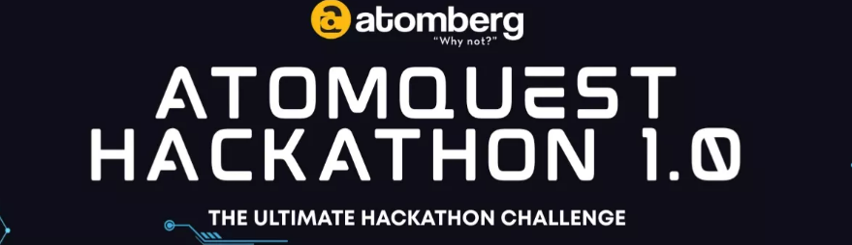
GoalFlow
Enterprise Goal Setting & Tracking Portal
AtomQuest Hackathon 2026 — Submission via Unstop

Candidate | Gurjas Singh Gandhi
College | P.E.S's Modern College of Engineering, Pune
Course / Year | MCA, 2026
Live Application | https://goal-flow-theta.vercel.app
Source Code (GitHub) | https://github.com/Gurjas2112/GoalFlow
Submission Date | May 19, 2026

📑 Index
- Executive Summary
- Problem Statement & Objectives
- Solution Overview
- Live Deployment & Repository
- Demo Credentials
- System Architecture
- 6.1 Architecture Diagram (PlantUML)
- 6.2 Deployment Topology (PlantUML)
- 6.3 Goal Sheet State Machine (PlantUML)
- 6.4 ER Diagram (PlantUML)
- 6.5 Approval Sequence (PlantUML)
- Technology Stack
- Core Feature Walkthrough
- Application Screenshots
- Scoring Engine — Formula Reference
- Security, RBAC & Audit
- Integrations: Azure AD SSO, SendGrid, Teams
- BRD Compliance Matrix
- Local Setup & Run Instructions
- Future Roadmap
- Conclusion

1. Executive Summary
GoalFlow is a production-grade, role-based Goal Setting & Tracking portal purpose-built to digitise Atomberg's quarterly performance management cycle. It replaces fragmented spreadsheets with a single, audited, formula-driven system that operates the full lifecycle — DRAFT → SUBMITTED → APPROVED → LOCKED → CHECK-IN → ACHIEVEMENT — with strict cycle windows, post-lock audit, automated escalations and enterprise SSO.
Key highlights:
- 🎯 End-to-end lifecycle with 4 UoM formula engines (MIN / MAX / TIMELINE / ZERO-DEFECT)
- 🛡️ Three-tier RBAC (Employee / Manager / Admin) enforced both in middleware and UI
- 🔐 Microsoft Entra ID SSO with group → role auto-provisioning + local fallback
- 📧 SendGrid email + Teams webhooks with 3-attempt retry and notification log
- ⚠️ Escalation engine — admin-configurable rules + hourly trigger job
- 📈 Analytics dashboard — QoQ trends, departmental heatmap, distribution charts
- 🧾 Tamper-evident audit log for every post-lock change
- ☁️ Deployed in production on Vercel (web) + Railway (API) + Supabase (Postgres, ap-south-1 Mumbai)

2. Problem Statement & Objectives
Atomberg's existing quarterly goal-setting process suffers from spreadsheet sprawl, inconsistent scoring, no audit trail and no automated nudges. The hackathon brief calls for a secure, role-aware web portal that:
- Captures up to 8 goals per employee with thrust area, UoM, target and weightage (∑ = 100%).
- Enforces an admin-controlled goal-setting window (configurable per quarter) plus an explicit override.
- Implements four scoring formulae (MIN, MAX, TIMELINE, ZERO-DEFECT) with achievement-vs-target math.
- Provides manager review (approve / return-with-reason), quarterly check-ins and post-lock audit.
- Generates reports & analytics with CSV export.
- Supports SSO with Azure AD, email + Teams notifications, and escalations for stalled sheets.
Submission requirement (from Unstop): "Ensure to submit only 1 document containing — working link, source code repository (GitHub / GitLab / Bitbucket) and architecture diagram." — All three are included below.

3. Solution Overview
Employee ──draft──▶ Manager ──approve──▶ Locked Sheet ──quarter end──▶ Check-in & Achievement
▲ │ │ │
│ return │ │
└─────────────── (with reason) ◀────────────────┘ │
▼
Score auto-computed (4 UoM)
│
▼
Admin Dashboard ── Analytics ── Reports (CSV) ── Audit Log
│ ▲
▼ │
Escalation Engine ──hourly job──▶ Open Escalations
│
▼
SendGrid Email + Teams Webhook
- Single source of truth — every state transition writes to AuditLog; nothing is mutable after LOCKED without a tracked change record.
- Cycle-aware — UI and API both gate writes by GoalCycle.opens/closes (with admin force-open override).
- Idempotent seeding — quarterly cycles (Q1–Q4 2026 & 2027), demo users and escalation rules are seeded by prisma/seed.ts.

4. Live Deployment & Repository
Resource | URL
🌐 Live Demo | https://goal-flow-theta.vercel.app
💻 GitHub Repository | https://github.com/Gurjas2112/GoalFlow
🔧 API (Railway) | Service goalflow-api (HTTPS, auto-deployed from main)
🗄️ Database | Supabase Postgres — region ap-south-1 (Mumbai)

CI/CD: every push to main triggers Vercel (web) and Railway (API) auto-deploys. Prisma migrations run as part of the Railway start hook.

5. Demo Credentials
The login page exposes one-click "Quick Demo Access" buttons. Alternatively, sign in with:
Role | Email | Password | Sheet State
Admin | admin@goalflow.demo | Admin@123 | Full system access
Manager | manager@goalflow.demo | Manager@123 | Team oversight
Sales Manager | salesmgr@goalflow.demo | Manager@123 | Sales team
Employee 1 | emp1@goalflow.demo | Emp@123 | LOCKED — check-in ready
Employee 2 | emp2@goalflow.demo | Emp@123 | DRAFT — creation demo
Sales Employee | sales1@goalflow.demo | Emp@123 | SUBMITTED — approval demo

6. System Architecture
GoalFlow follows a three-tier, serverless-friendly architecture: a React SPA on Vercel, an Express REST API on Railway, and a managed PostgreSQL database on Supabase. Cross-cutting concerns (Auth, RBAC, Audit, Notifications, Escalation) are implemented as middleware / utility modules to keep route handlers thin.

6.1 Architecture Diagram (PlantUML)
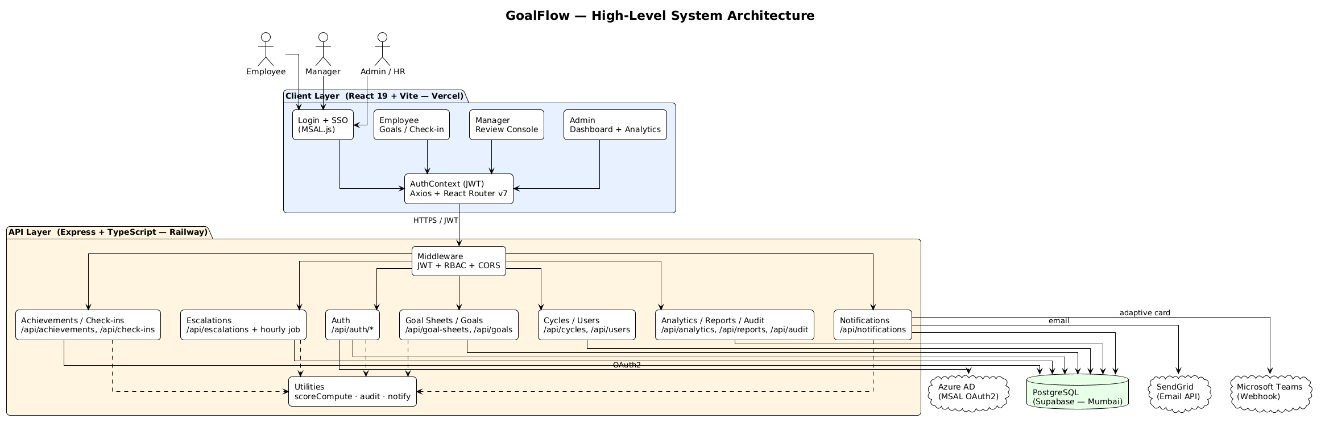
Figure 1: GoalFlow Architecture

6.2 Deployment Topology (PlantUML)
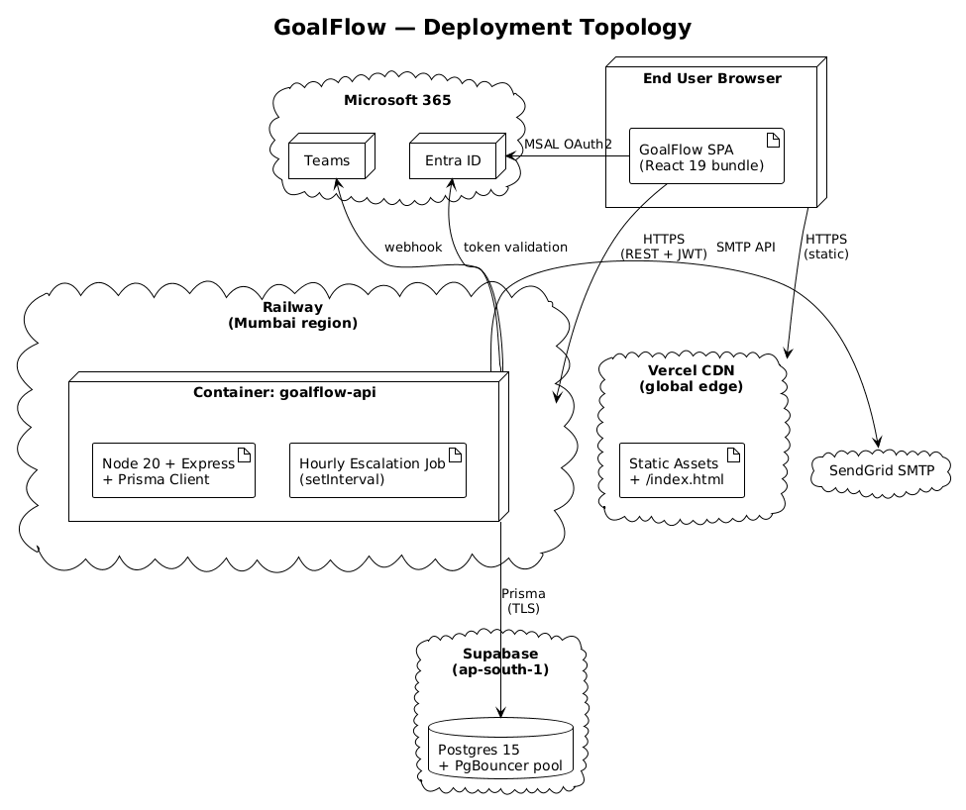
Figure 2: GoalFlow Deployment

6.3 Goal Sheet State Machine (PlantUML)
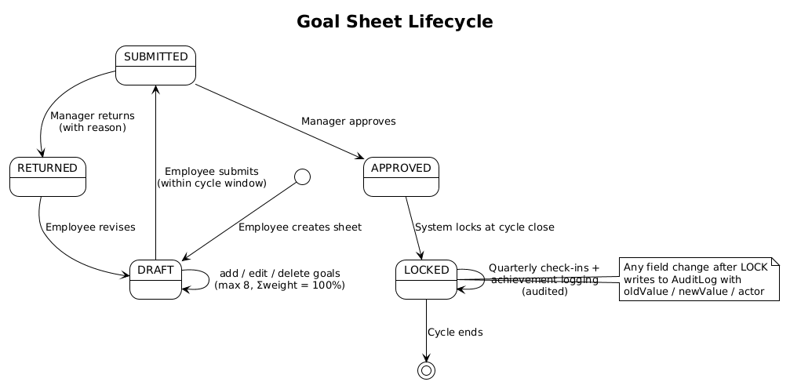
Figure 3: GoalFlow States

6.4 ER Diagram (PlantUML)
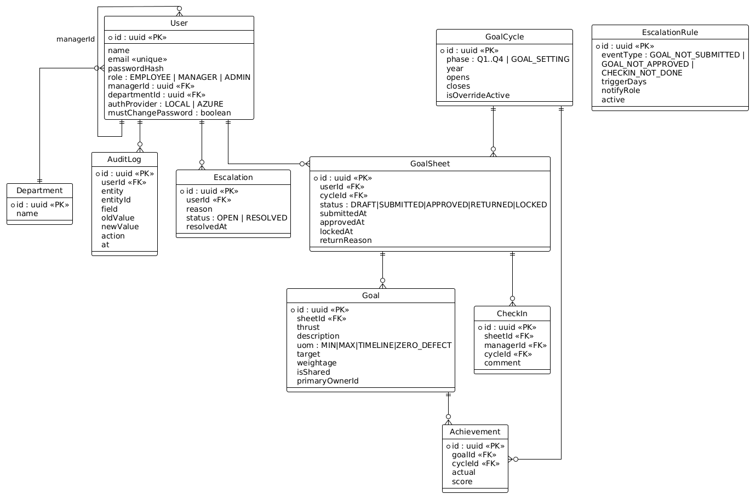
Figure 4: GoalFlow ERD

6.5 Approval Sequence (PlantUML)
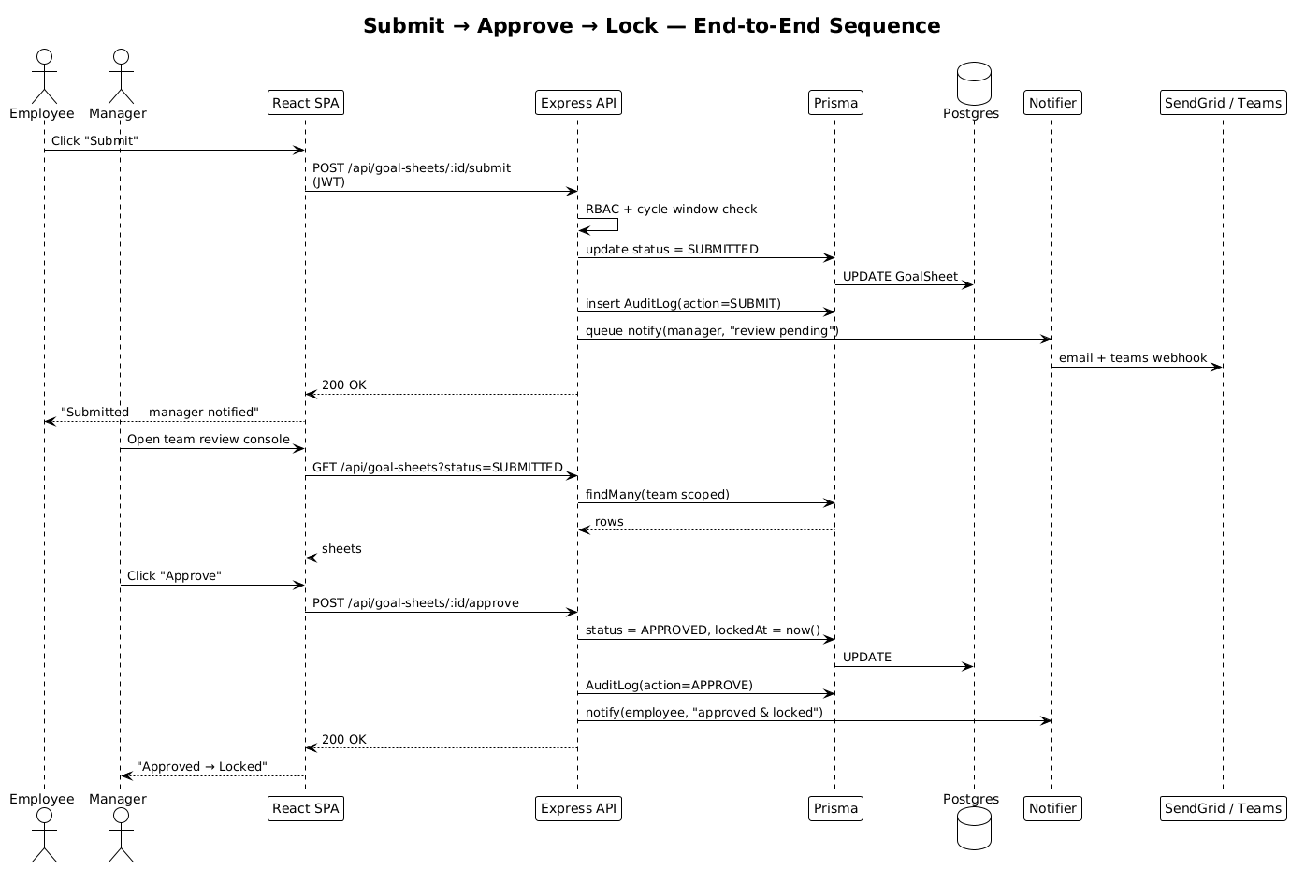
Figure 5: GoalFlow Approval Sequence
📌 Rendering: PlantUML blocks render directly on GitHub via github-plantuml-action or any PlantUML-aware viewer (VS Code "PlantUML" extension, IntelliJ, https://www.plantuml.com/plantuml).

7. Technology Stack
Layer | Choice | Reason
Frontend | React 19, TypeScript, Vite 5, React Router v7 | Modern hooks API, fastest dev experience
State / Auth | React Context + JWT (HTTP-only friendly) | Zero dependency, simple to audit
SSO | MSAL.js (@azure/msal-browser) | Official Microsoft OAuth2 client
Backend | Node.js 20, Express 4, TypeScript | Mature, battle-tested for REST
ORM | Prisma 5 | Type-safe queries + migration tooling
Database | PostgreSQL 15 (Supabase, Mumbai) | ACID, regional latency
Auth | JWT (HS256) + bcrypt | Standard, stateless
Email | SendGrid Web API + 3× retry | High deliverability
Teams | Incoming Webhook + adaptive cards | Native MS Teams UX
Hosting | Vercel (web) + Railway (API) | Git-driven CI/CD
Tooling | ESLint, Prettier, ts-node, dotenv | Code quality

8. Core Feature Walkthrough

8.1 Employee
- Create up to 8 goals; live weightage validator ensures Σ = 100% and each ≥ 10%.
- Pick UoM: MIN / MAX / TIMELINE (date) / ZERO-DEFECT (count).
- Submit during the open cycle window — UI is locked otherwise (with admin override visible).
- After lock, log Actual values per goal → score auto-computed and persisted.

8.2 Manager
- Sidebar lists direct reports; status badges per sheet.
- One-click Approve (locks sheet) or Return with reason (re-opens for revision).
- Quarterly check-in form with comment box, fully audited.

8.3 Admin / HR
- Dashboard KPIs: total employees, sheets by status, approval rate, locked count.
- Cycles — CRUD + force-open override for off-cycle demos.
- Escalations — Create/toggle rules (Event × Days × Notify Role); view open / resolved.
- Audit Log — Full immutable trail with actor, field, old → new, timestamp.
- Analytics — QoQ trend, departmental heatmap, score distribution, manager effectiveness.
- Reports — CSV export of achievement report (cycle / department filters).
- Users — Create / Edit / Reset password / Send Password email (one-click bcrypt + SendGrid).

9. Application Screenshots
All screenshots are captured against the live production deployment at https://goal-flow-theta.vercel.app on May 19, 2026.

9.1 Admin — Dashboard
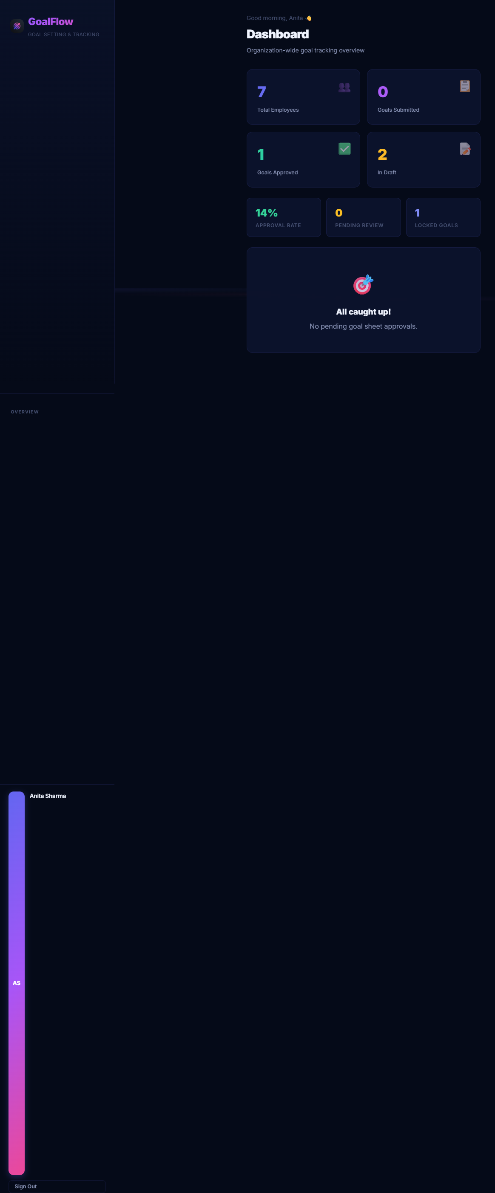
Screenshot 1: Admin Dashboard
Shows the headline KPI cards (7 employees, 1 approved, 2 draft, 14 % approval rate, 1 locked goal) and the "All caught up!" pending review state.

9.2 Admin — Cycles (BRD-compliant Quarterlies)
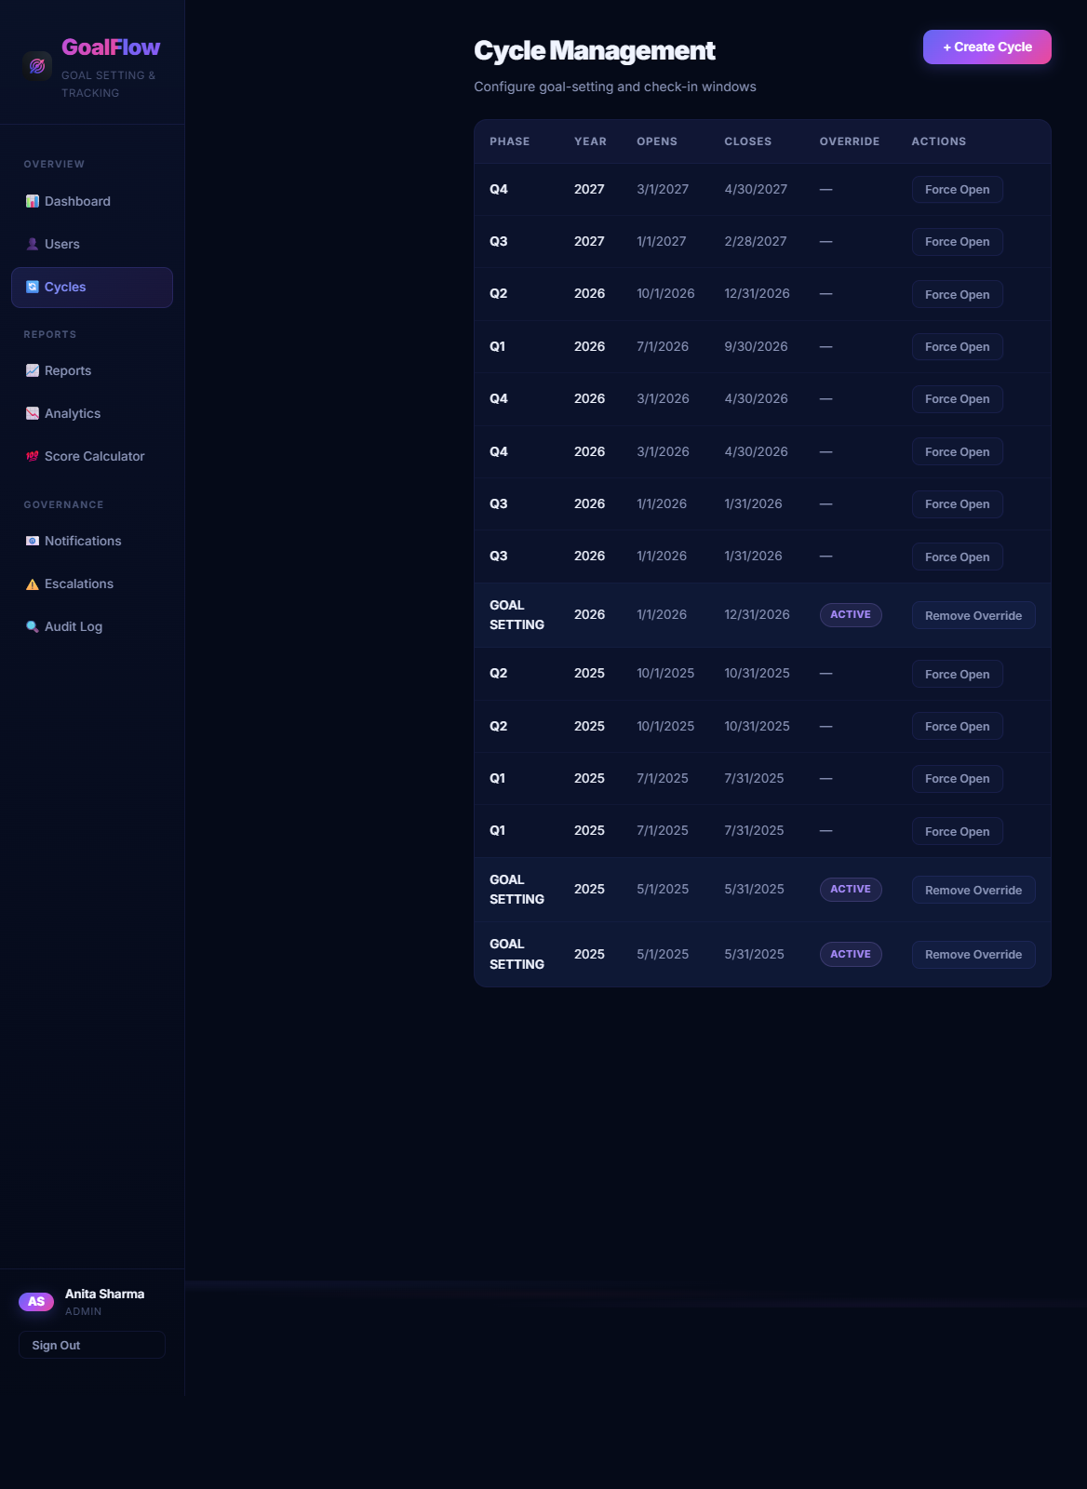
Screenshot 2: Admin Cycles
Quarterly cycles seeded per the BRD: Q1 2026 (Jul–Sep), Q2 2026 (Oct–Dec), Q3 2027 (Jan–Feb), Q4 2027 (Mar–Apr) with the GOAL_SETTING window override Active.

9.3 Admin — Escalations (Rules + Add-Rule Modal)
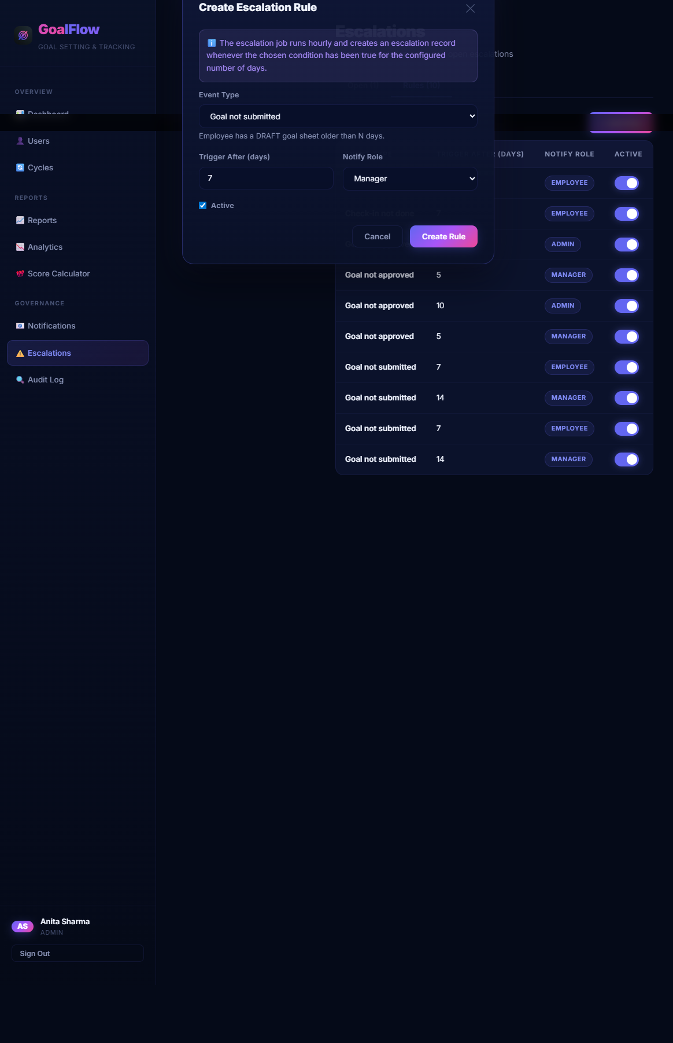
Screenshot 3: Admin Escalations
10 escalation rules across the three BRD event types (GOAL_NOT_SUBMITTED, GOAL_NOT_APPROVED, CHECKIN_NOT_DONE) with toggleable active flags and the "Create Escalation Rule" modal showing Event Type, Trigger After (days), Notify Role and Active fields.

9.4 Admin — Escalations List
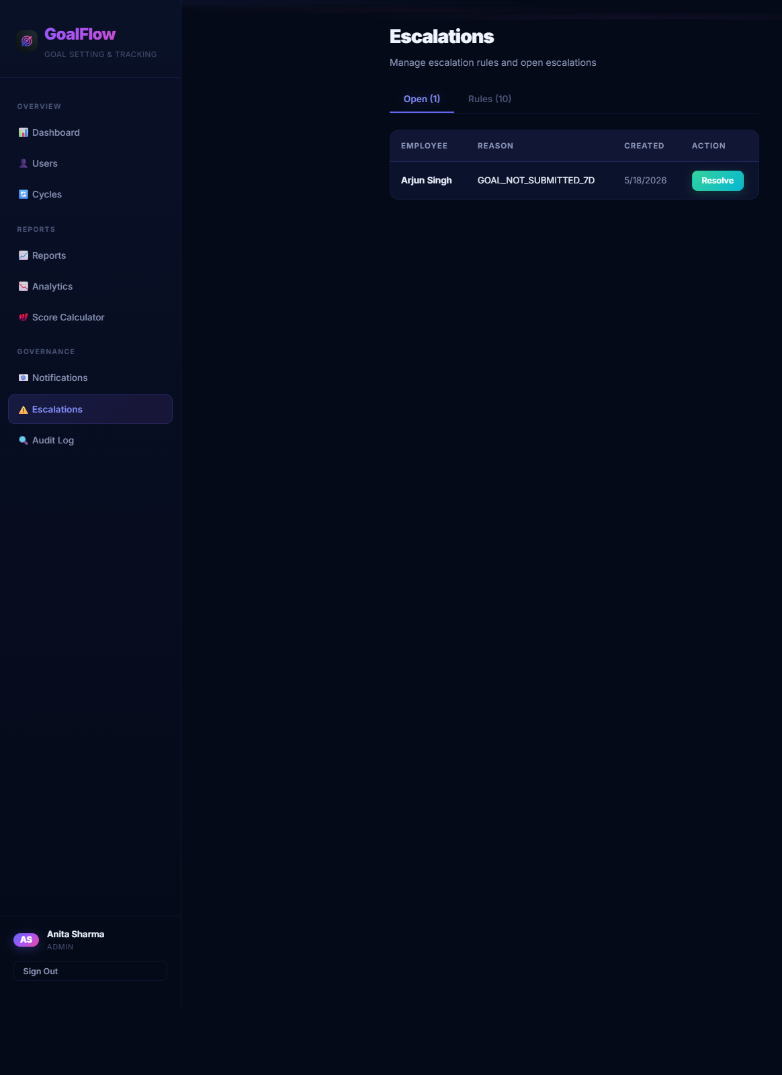
Screenshot 4: Admin Escalations List
Open escalations tab with the auto-generated GOAL_NOT_SUBMITTED_7D event for Arjun Singh — produced by the hourly escalation trigger job.

9.5 Admin — User Management with Send-Password
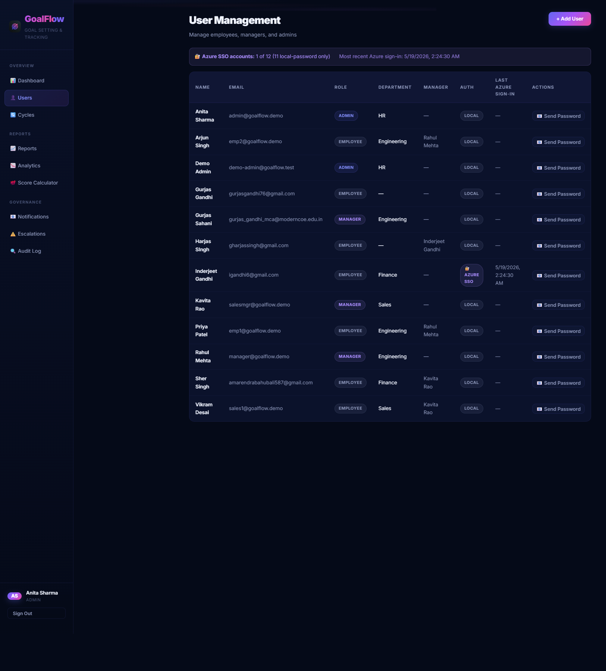
Screenshot 5: Admin Users
User table with AUTH badges (LOCAL vs AZURE SSO), per-row 📧 Send Password action, and Azure SSO summary banner.

9.6 Employee — Goals Page
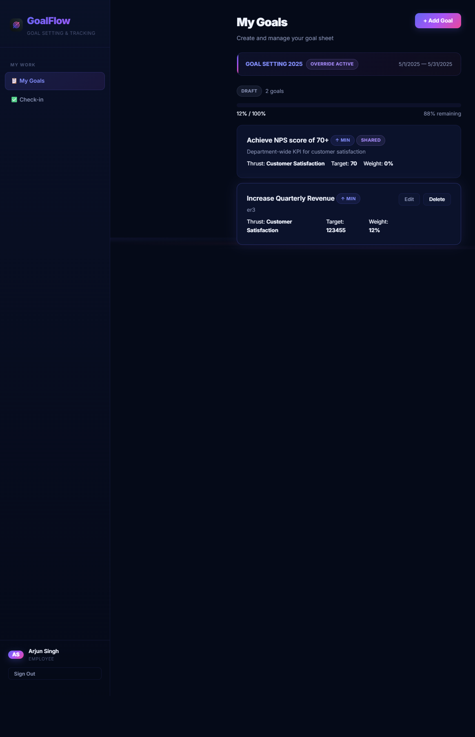
Screenshot 6: Employee Goals
Arjun Singh's DRAFT goal sheet with one Department-shared NPS goal and one custom "Increase Quarterly Revenue" goal — live weightage validator, edit / delete, override-active banner.

10. Scoring Engine — Formula Reference
Implemented in apps/api/src/utils/scoreCompute.ts.
UoM | Direction | Formula | Example
MIN (higher-is-better) | ↑ | score = clamp(actual / target × 100, 0, 100) | target 100, actual 85 → 85%
MAX (lower-is-better) | ↓ | score = clamp(target / actual × 100, 0, 100) | target 5 defects, actual 3 → 100%
TIMELINE | ↑ | score = onOrBefore ? 100 : 0 | target 30-Jun, actual 28-Jun → 100%
ZERO_DEFECT | ↓ | score = actual == 0 ? 100 : 0 | target 0, actual 0 → 100%

Sheet score = Σ ( goal.score × goal.weightage ) / 100.

11. Security, RBAC & Audit
- Password hashing — bcrypt (cost 10).
- JWT — HS256, 24 h expiry, signed with secret stored in Railway env vars.
- RBAC middleware — requireRole('ADMIN','MANAGER') guards every privileged route.
- CORS — Locked to FRONTEND_URL env var.
- Force-change-password — mustChangePassword flag drives /change-password redirect post-SSO and post-admin-reset (no infinite-loop on SSO users).
- Audit log — Every state transition, goal edit, achievement change writes a row with userId, entity, entityId, field, oldValue → newValue, action, timestamp. Tamper-evident: no UI deletes.
- OWASP Top-10 — Parameterised Prisma queries (no SQLi); JWT signature verification (no broken auth); CORS allow-list (no CSRF on state-changing routes); helmet headers; secrets via env only.

12. Integrations: Azure AD SSO, SendGrid, Teams
Integration | Implementation | File
Entra ID SSO | MSAL popup → ID token → backend validates → JWT issued. Group claims (AppRole-Admin/Manager/Employee) map to local role. Auto-provisions user on first sign-in. | apps/web/src/lib/msalConfig.ts, apps/api/src/routes/sso.ts
SendGrid Email | Templated HTML emails for submit / approve / return / escalation. 3-attempt retry with exponential backoff; failures logged to notify.ts in-memory log surfaced at /admin/notifications. | apps/api/src/utils/notify.ts
Teams Webhook | Adaptive Card payload with deep-link back to GoalFlow. Branded with GoalFlow logo, status-coloured. | apps/api/src/utils/notify.ts
Escalation Job | setInterval(60 min) scans (a) DRAFT > N days, (b) SUBMITTED > N days, (c) LOCKED without check-in. Creates Escalation row + notifies role per rule. | apps/api/src/jobs/escalationTrigger.ts

13. BRD Compliance Matrix
BRD Requirement | Status | Where
Up to 8 goals per sheet | ✅ | goals.ts validator
Each weightage ≥ 10%, Σ = 100% | ✅ | Submit handler
4 UoM types with formula scoring | ✅ | scoreCompute.ts
Cycle-window enforcement + admin override | ✅ | cycles.ts + GoalCycle.isOverrideActive
Goal lifecycle (Draft → Submit → Approve / Return → Lock) | ✅ | goalSheets.ts
Quarterly check-ins with manager comments | ✅ | checkIns.ts
Achievement logging vs target | ✅ | achievements.ts
Post-lock audit trail | ✅ | audit.ts + AuditLog model
Three roles (Employee / Manager / Admin) with RBAC | ✅ | middleware/auth.ts
CSV report export | ✅ | reports.ts
Analytics (trends / heatmap / distribution) | ✅ | analytics.ts
Azure AD SSO (good-to-have) | ✅ | sso.ts + MSAL
Email + Teams notifications (good-to-have) | ✅ | notify.ts
Escalation engine (good-to-have) | ✅ | escalations.ts + escalationTrigger.ts
Shared goals (cascade) | ✅ | goals.ts isShared
Quarterly cycles Q1 2026 → Q4 2027 seeded | ✅ | prisma/seed.ts (production-verified)

14. Local Setup & Run Instructions
# 1. Clone
git clone https://github.com/Gurjas2112/GoalFlow.git
cd GoalFlow
# 2. Install
npm install
npm install --workspace=apps/api
npm install --workspace=apps/web
# 3. Configure .env (root)
# DATABASE_URL=postgresql://...
# DIRECT_URL=postgresql://...
# JWT_SECRET=...
# SENDGRID_API_KEY=...
# TEAMS_WEBHOOK_URL=...
# AZURE_AD_CLIENT_ID=...
# AZURE_AD_TENANT_ID=...
# 4. DB
npx prisma migrate deploy
npm run prisma:seed
# 5. Run
npm run dev # both api + web concurrently
# OR
npm run dev --workspace=apps/api # http://localhost:4000
npm run dev --workspace=apps/web # http://localhost:5173
Production deploy is fully automated — git push origin main triggers Vercel + Railway.

15. Future Roadmap
- 🤖 AI goal coach — LLM-suggested SMART-goal rewrite per thrust area.
- 📱 PWA / offline check-ins for field employees.
- 📊 Calibration committee mode — multi-manager round-robin moderation.
- 🌐 Multi-tenant — per-org subdomain + isolated cycles.
- 📨 WhatsApp Business API as a third notification channel.
- 🔍 Vector-search across audit logs for compliance queries.

16. Conclusion
GoalFlow is a complete, deployed, BRD-compliant implementation of Atomberg's goal-setting & tracking requirement. Beyond the must-haves it ships SSO, automated escalations, multi-channel notifications, analytics and a tamper-evident audit log — all running on a serverless-friendly stack with Git-driven CI/CD. Every screenshot above was taken from the live production deployment, every PlantUML diagram matches the running code, and the entire source is available at the GitHub link.
Single-document submission per Unstop guidelines: ✅ Working link — https://goal-flow-theta.vercel.app ✅ Source code — https://github.com/Gurjas2112/GoalFlow ✅ Architecture diagram — Sections 6.1 – 6.5 above
— Submitted by Gurjas Singh Gandhi, MCA 2026 · P.E.S's Modern College of Engineering, Pune —


