Name: Gurjeet Singh
Course: Monitoring and Log Management
Assignment: Network Discovery

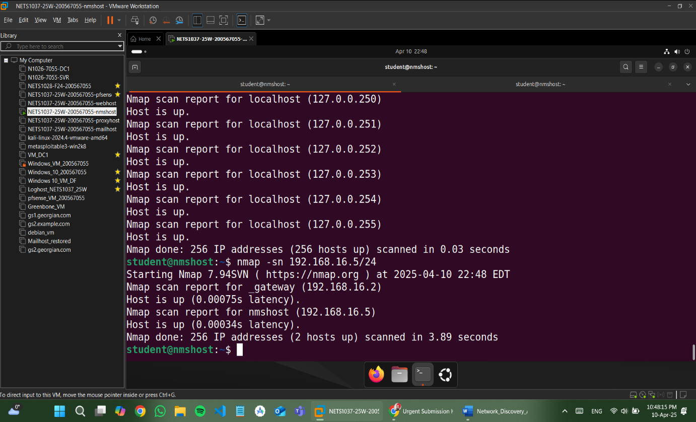

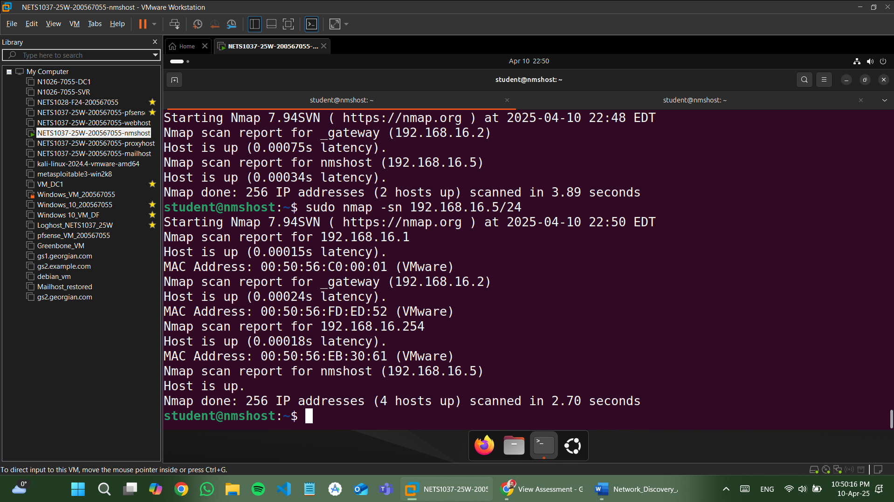

- Did you get a different result from scanning with sudo?
Yes, scanning with sudo revealed more hosts (4 total) than scanning as a normal user (2 hosts).

- Carefully scan your ISP’s network which you are directly connected to. You can get your external IP address using ‘curl icanhazip.com’. Since we do not necessarily know what subnet mask our ISP is using, you can try it with a 24 bit mask to see how it works.

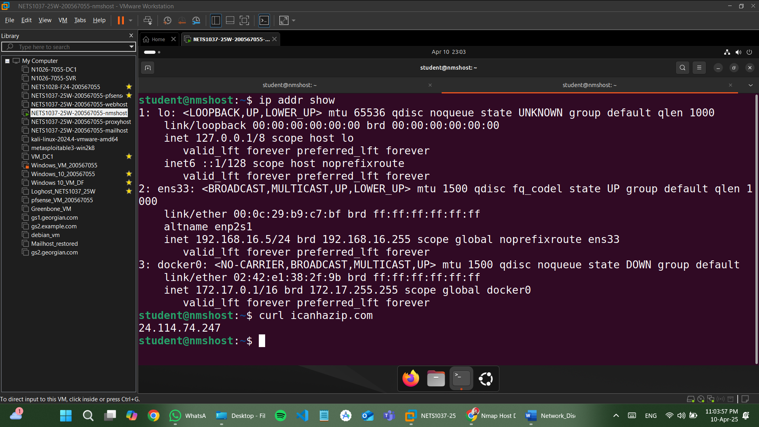

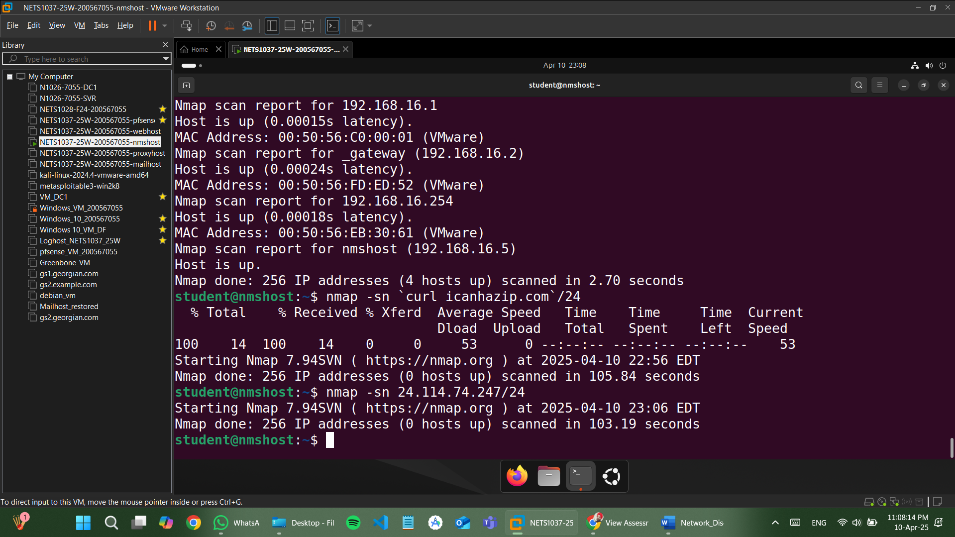

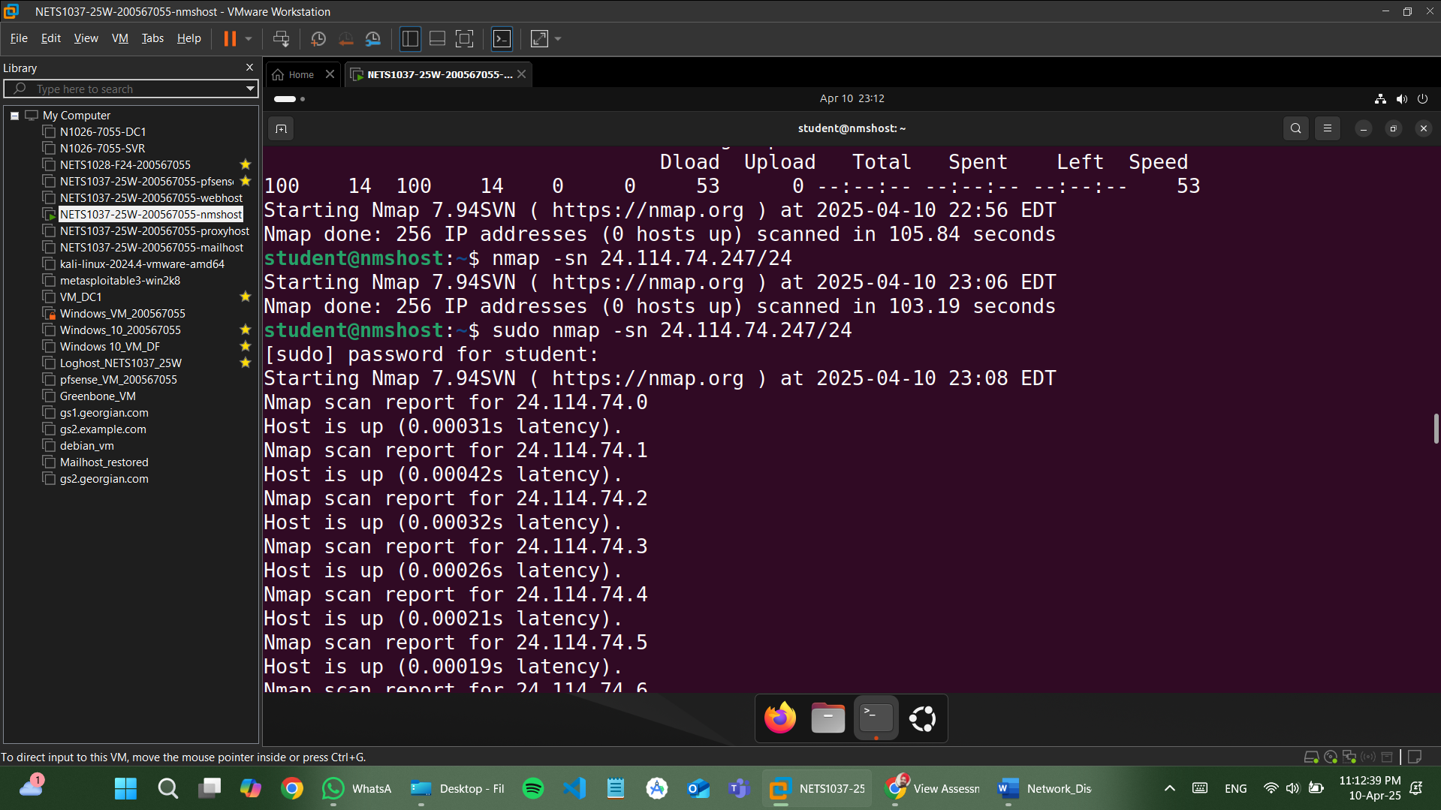

1. Did you get a different result from scanning with sudo?
Yes, I got a different result when scanning with sudo. The scan using sudo identified additional hosts that were not detected during the regular scan. This is because sudo allows Nmap to send raw packets (such as ICMP Echo Requests or TCP SYN packets) that are necessary to discover more hosts on the network. These types of packets require elevated privileges, which is why some hosts were only visible when the scan was run with sudo.

- From the two different networks scanned, do you notice anything about the extra hosts that likely showed up when using sudo that might give you hints about why you needed sudo to discover them?
Yes, the extra hosts likely appeared due to the type of packets that Nmap sends when using sudo. These hosts might be behind devices like firewalls or routers that filter or block certain types of network probes (e.g., regular ICMP requests or ARP requests). When running the scan with sudo, Nmap could send more advanced probes, such as raw ICMP Echo Requests, which can bypass those filters and allow the discovery of additional hosts.
This indicates that those extra hosts were responding to packets that require root privileges to send, which is why sudo was necessary for their detection.

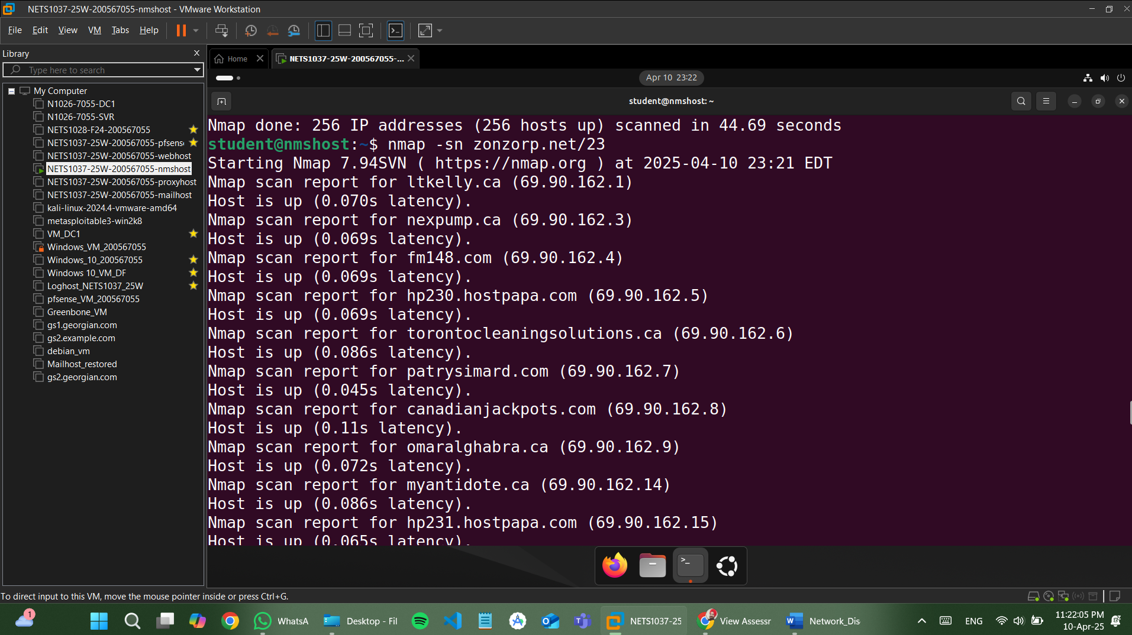

- Carefully scan the network that zonzorp.net is attached to. DO NOT USE sudo or a root account, as we do not own this entire network.
From the result of the scan, what can you say about the network that zonzorp.net is attached to?

From the result of the nmap -sn zonzorp.net/23 scan, we can observe that the network zonzorp.net is attached to is part of a large and active subnet. The /23 subnet includes 512 possible IP addresses, and the scan found that 256 hosts are up, which indicates a high level of activity on this network.
The hostnames returned in the scan (e.g., hostpapa.com, torontocleaningsolutions.ca, canadianjackpots.com) suggest that this network hosts a variety of websites and services for different organizations. This is indicative of a shared hosting environment or web hosting provider.
In conclusion, the network is part of a commercial hosting infrastructure, likely managed by a data center or web hosting company, with many active clients and domains running on it.

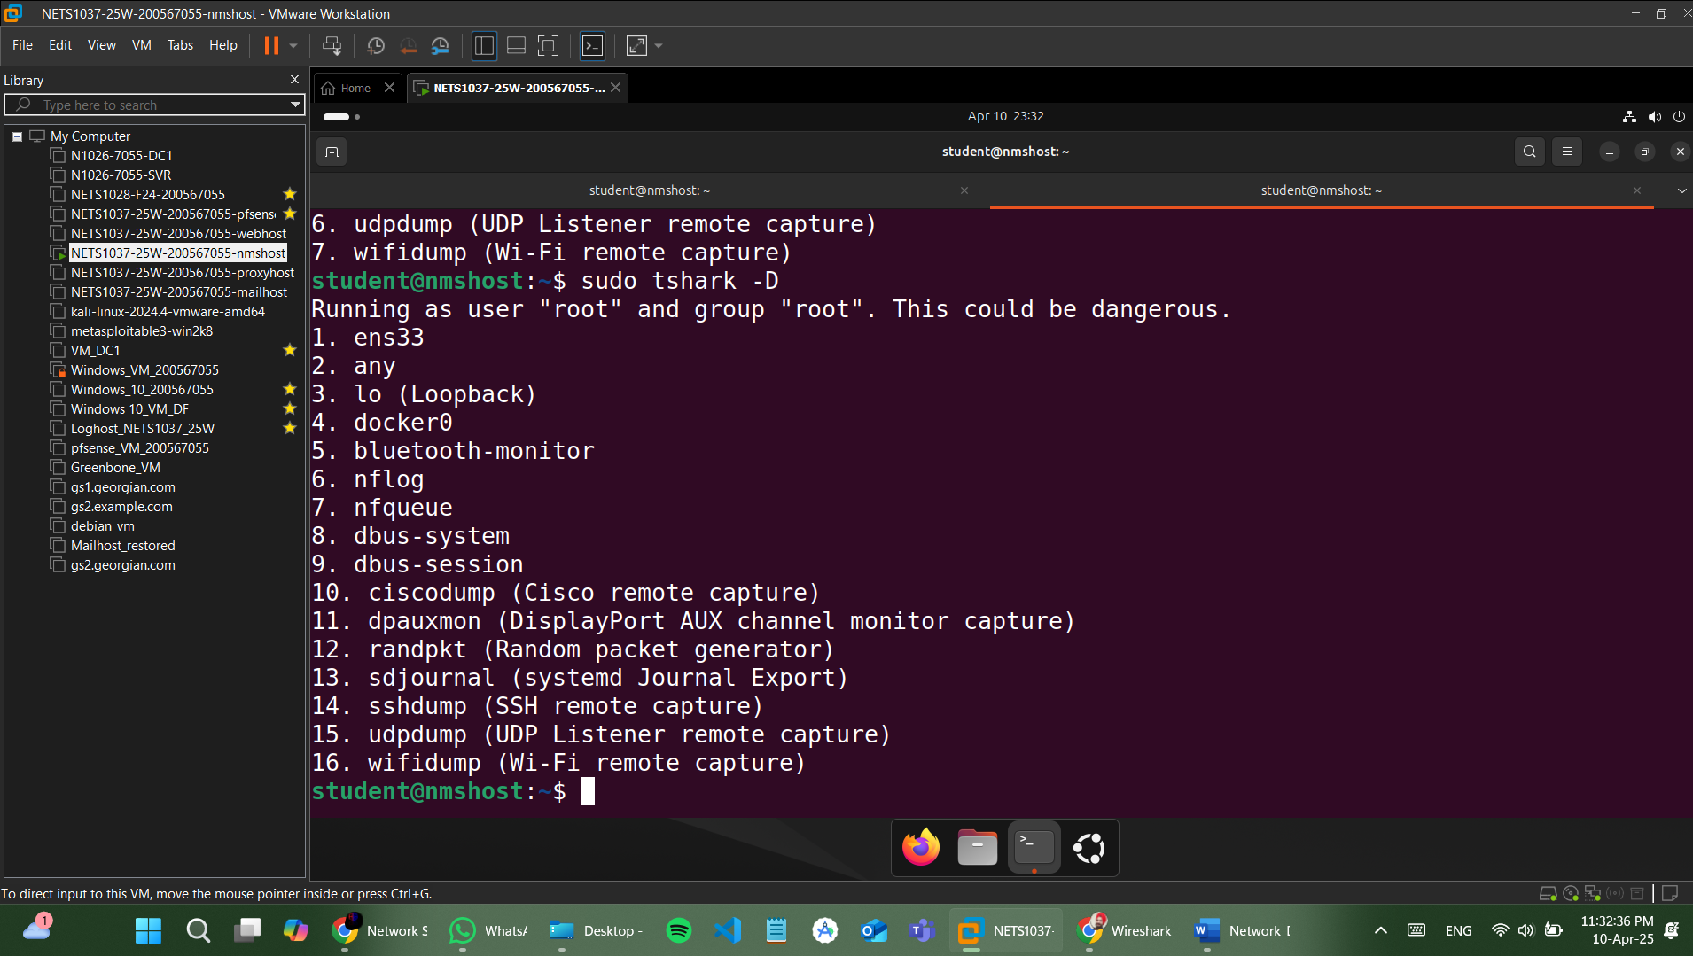

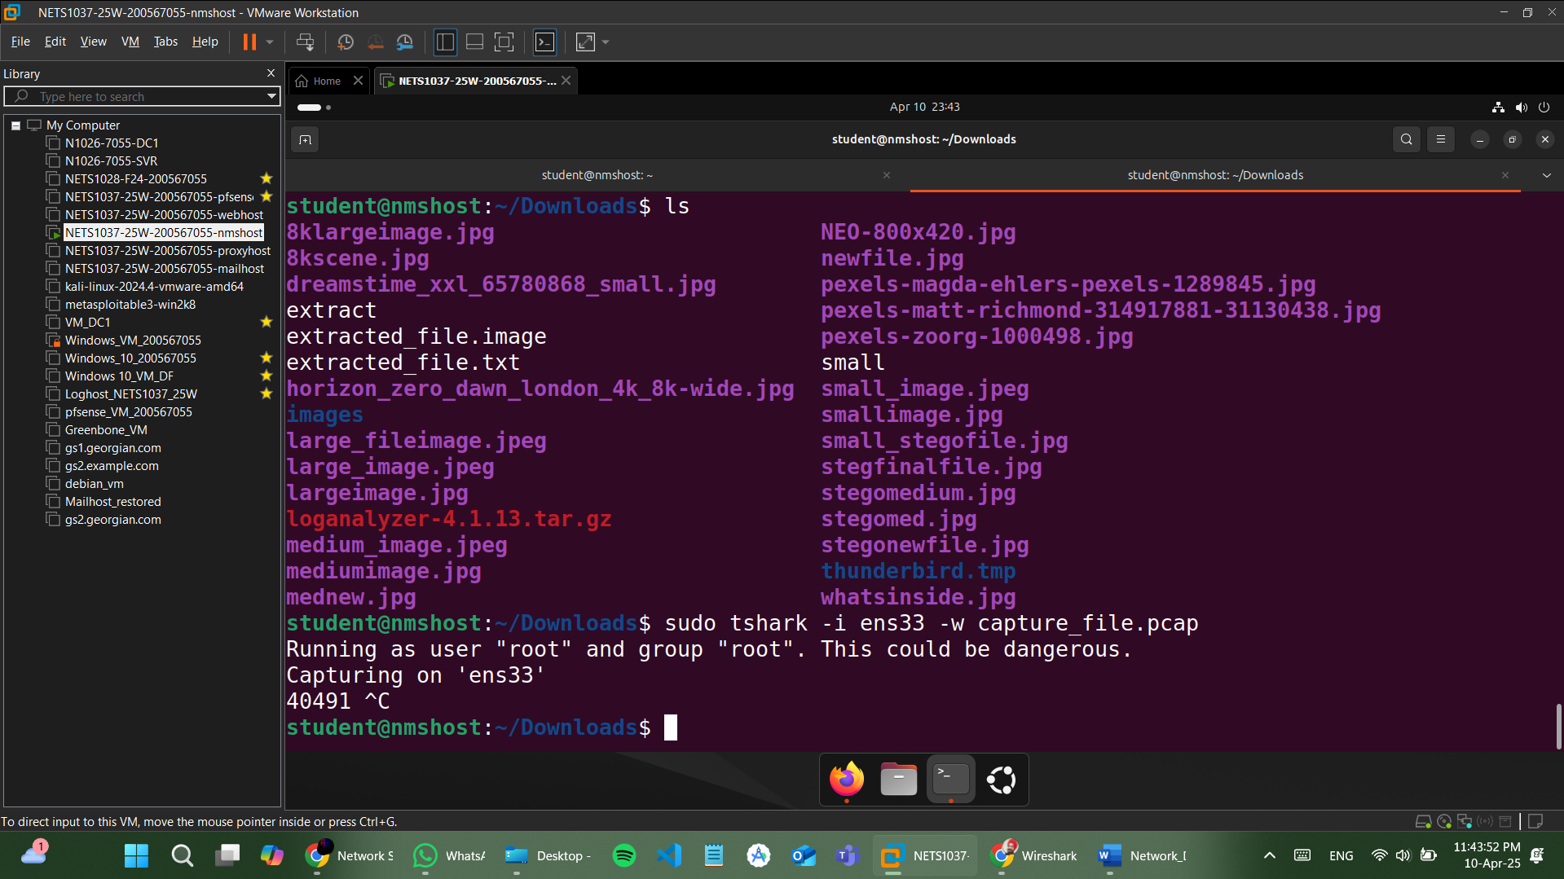

Endpoints:
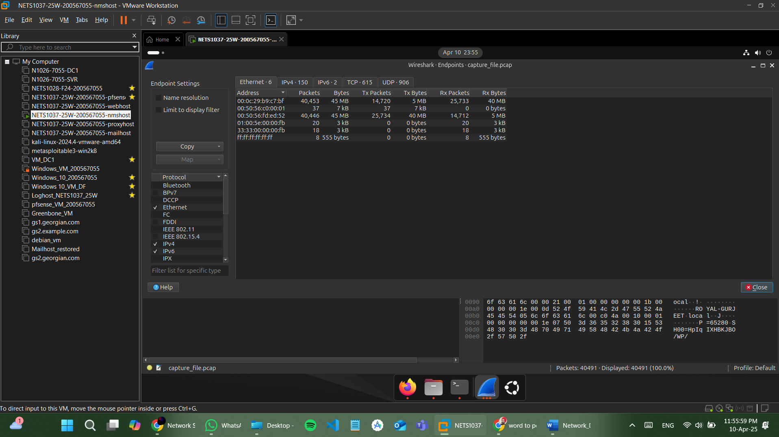

TCP:
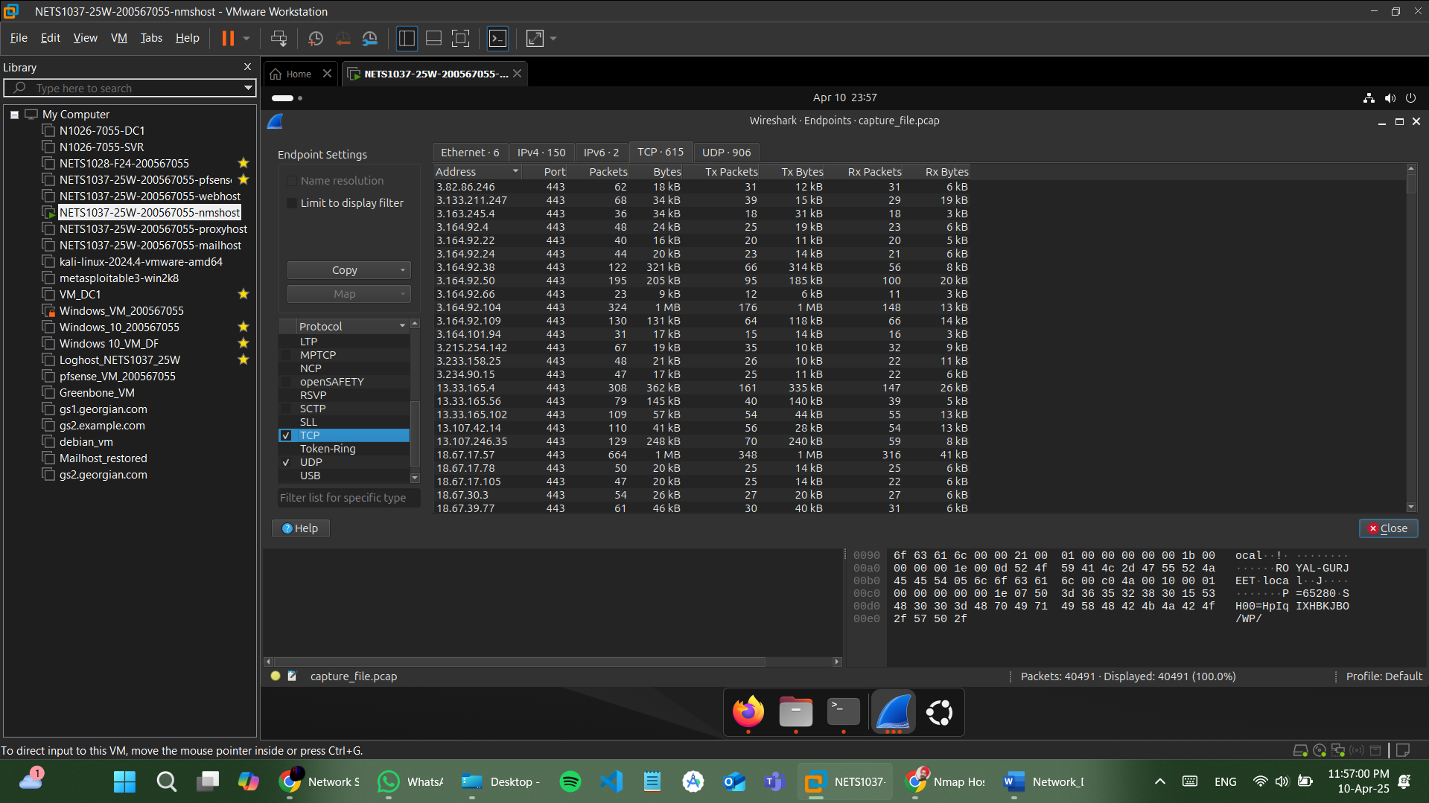

UDP:
