**ARTIFICIAL INTELLIGENCE PROJECT Course Code: UCS411**

Computer Science and Engineering Department



Thapar Institute of Engineering and Technology, Patiala,

Punjab

Submitted by:

* Gurjot Singh(102103173)
* Alok Shree Koirala (102103157)
* Mayank Chopra(102103158)

Group: 2CO6

Submitted to:

Dr. Sachin Kansal

**Project title:**

Face Expression Detection.

**Need Analysis:**

There are several potential reasons why there may be a need for face emotion recognition, including:

1. Mental health: Face emotion recognition can help in identifying early signs of mental health issues such as depression, anxiety, and PTSD.
2. Marketing: Companies may use face emotion recognition to gauge customer reactions to products, ads, or services.
3. Security: Face emotion recognition can be used in security systems to detect suspicious behavior or identify potential threats.
4. Education: Teachers may use face emotion recognition to better understand their students' emotional states, which can help them tailor their teaching methods and provide support when needed.
5. Autism: Face emotion recognition can assist in detecting symptoms of autism and other disorders that affect social communication.
6. Human-computer interaction: Face emotion recognition can be used to improve human-computer interaction, such as in gaming, virtual reality, and robotics.

**Link To Google Colaboratory:**

[https://colab.research.google.com/drive/14SUg9ur9Tamgyygdv0OCmxb6mV1w-Ywl?authuser=1#scrollTo=126d5e28](https://colab.research.google.com/drive/14SUg9ur9Tamgyygdv0OCmxb6mV1w-Ywl?authuser=1%23scrollTo=126d5e28)

**Link To Google Drive(data set):**

<https://drive.google.com/drive/folders/11ezNGHlehT4v65k3wMKk0tAckZ92QsDf?usp=share_link>

**Codes:**

For detecting the emotion:

















For drawing a rectangle around the face:



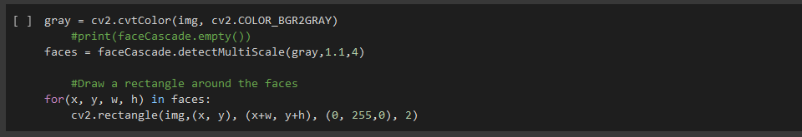



**Modules Imported:**



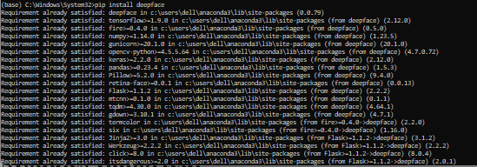

**OUTPUT:**

* Happy Face

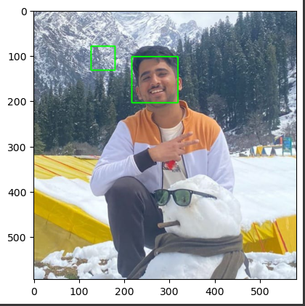 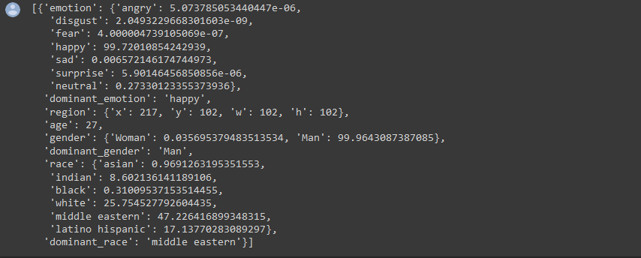

* Neutral Face

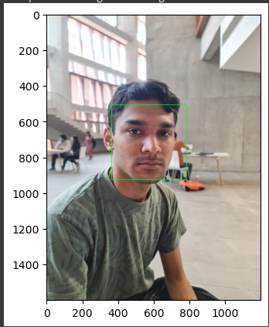

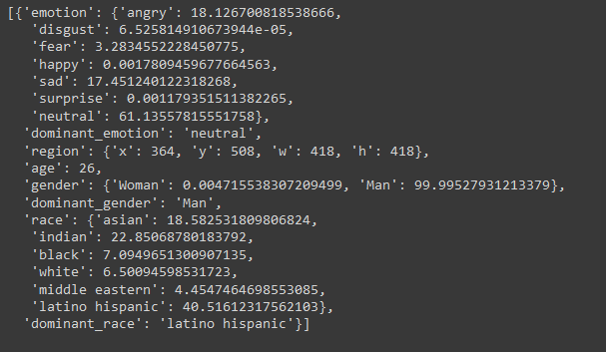

* Surprise Face

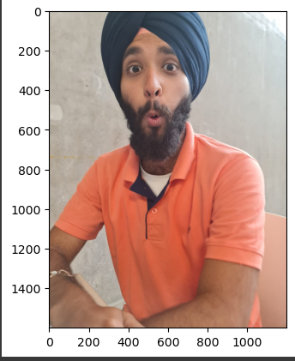

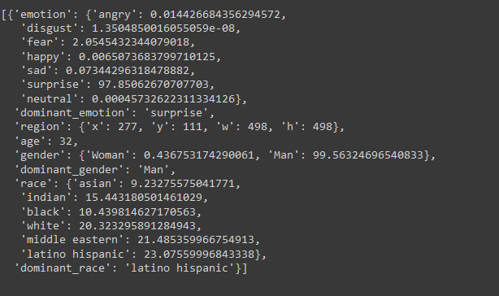

* Fear Face

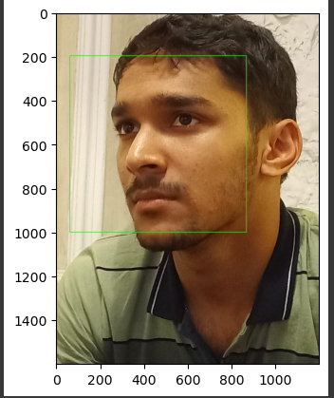

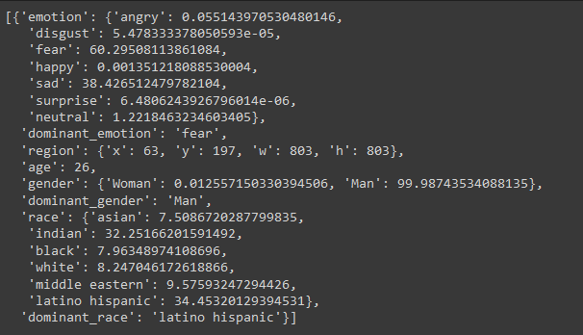

* Sad Face

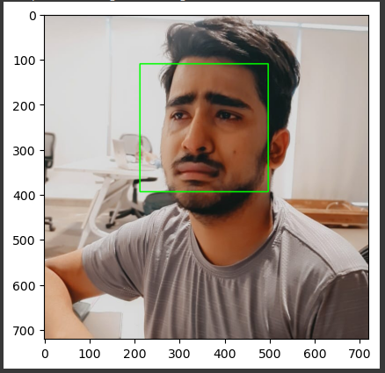

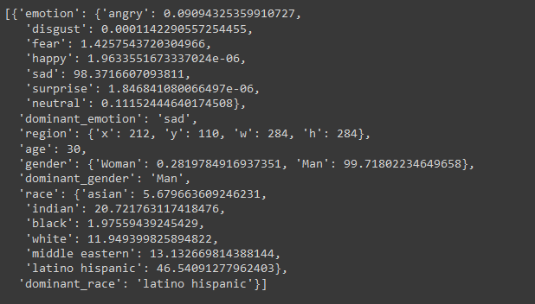

**Summary:**

As the results show:

1. We created an A.I model that can successfully detect human faces.
2. After detecting Faces from image, Deepface analysed our image and returned the results.
3. The result determined the person emotion in the given image.

Thank You