**Patterns**

1. #include <iostream>

using namespace std;

int main(){

int a;

cout<<"Enter number : ";

cin>>a;

for(int i=1;i<=a;i++){

for(int j=1;j<=i;j++){

cout<<"*";

}

cout<<endl;

}

}

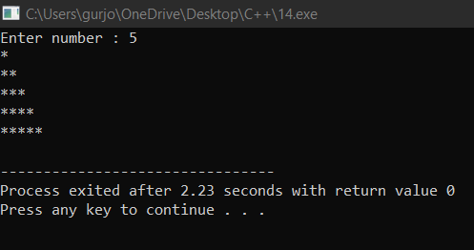

2) #include <iostream>

using namespace std;

int main(){

int a;

cout<<"Enter number : ";

cin>>a;

for(int i=1;i<=a;i++){

for(int k=1;k<=a-i;k++)

{

cout<<" ";

}

for(int j=1;j<=i;j++){

cout<<"*";

}

cout<<endl;

}

}

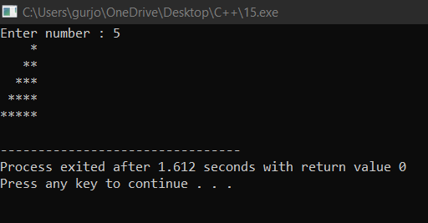

3) #include <iostream>

using namespace std;

int main(){

int a;

cout<<"Enter number : ";

cin>>a;

for(int i=1;i<=a;i++){

for(int k=1;k<=a-i;k++)

{

cout<<" ";

}

for(int j=1;j<=2*i-1;j++){

cout<<"*";

}

cout<<endl;

}

}

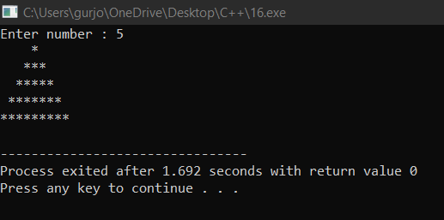

4) #include <iostream>

using namespace std;

int main(){

int a;

cout<<"Enter number : ";

cin>>a;

for(int i=1;i<=a;i++){

for(int j=1;j<=a;j++){

cout<<"*";

}

cout<<endl;

}

}

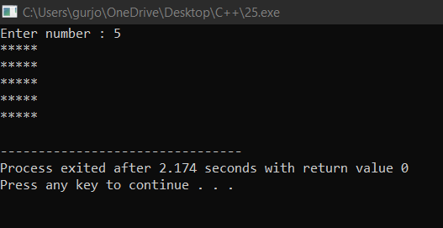

5) #include <iostream>

using namespace std;

int main(){

cout<<"Enter Number : ";

int a;

cin>>a;

for(int i=1;i<=a;i++){

for(int k=1;k<=a-i+1;k++){

cout<<" ";

}

for(int j=1;j<=a;j++){

cout<<"*";

}

cout<<endl;

}

}

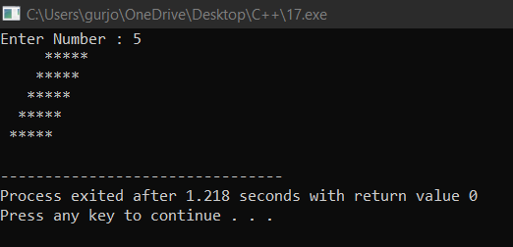

6) #include<iostream>

using namespace std;

int main()

{

int n;

cout<<"Enter n"<<endl;

cin>>n;

int i,j;

for(i=1; i<=n; i++)

{

for(j=1; j<=(2*n); j++)

{

if(i>(n-j+1))

cout<<" ";

else

cout<<"*";

if((i+n)>j)

cout<<" ";

else

cout<<"*";

}

cout<<endl;

}

for(i=1; i<=n; i++)

{

for(j=1; j<=(2 * n); j++)

{

if(i<j)

cout<<" ";

else

cout<<"*";

if(i<=((2*n)-j))

cout<<" ";

else

cout<<"*";

}

cout<<endl;

}

}

