1. Log in to your AWS Educate account
2. Select your Class and a new page would appear (similar to below)

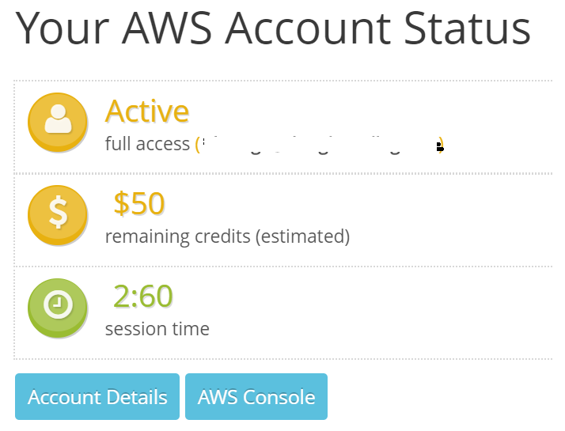

1. Click “AWS Console”
2. Search and Select Cloud9

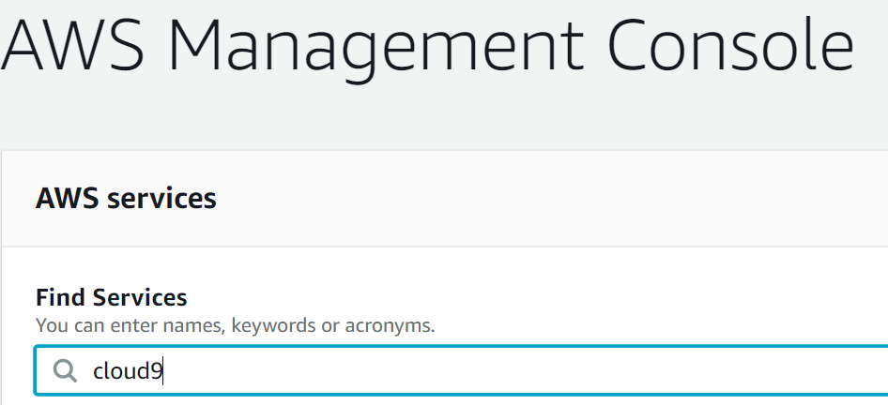

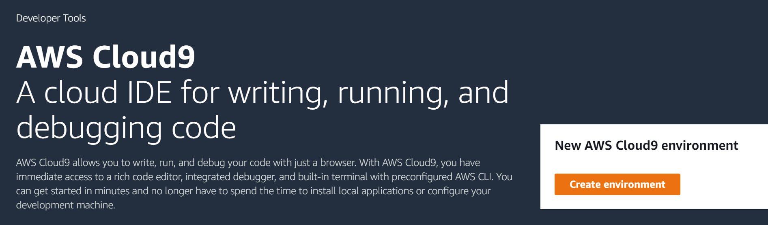

1. Click “Create environment” and follow the instructions

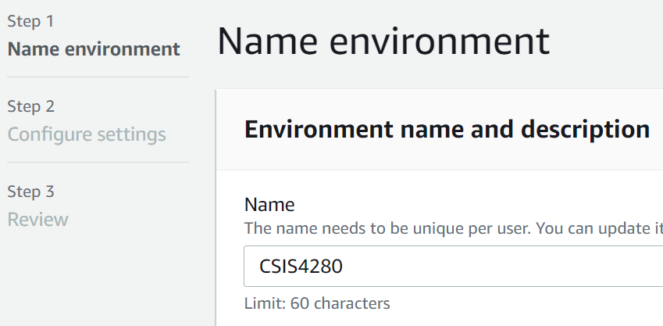

**There’s a default setting. Let’s just use that. Then click Next Step**

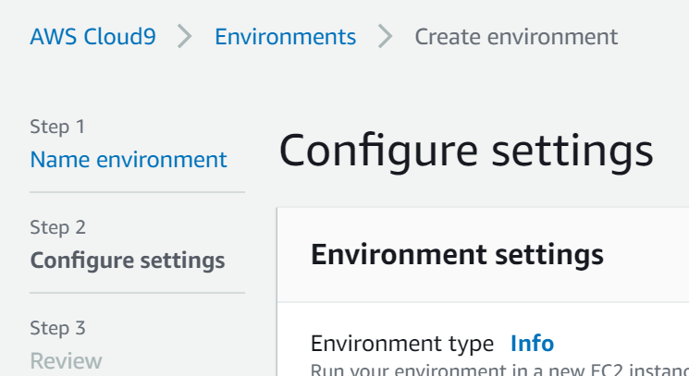

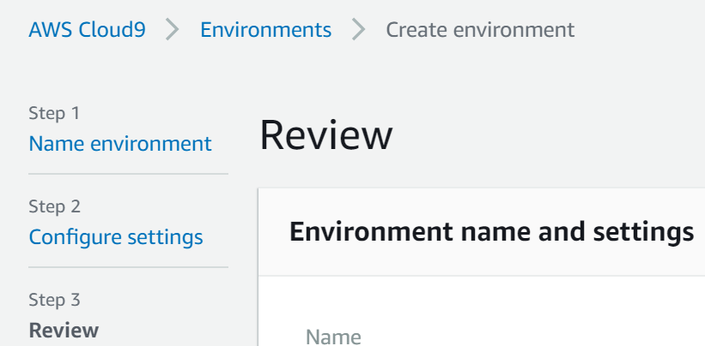

Click “Create environment” (at the end of the page)

1. Installation complete (if you see something similar)

