Site: <https://www.mongodb.com/cloud/atlas>

**Part 1 – Creating a free account**

Step 1



Step 2

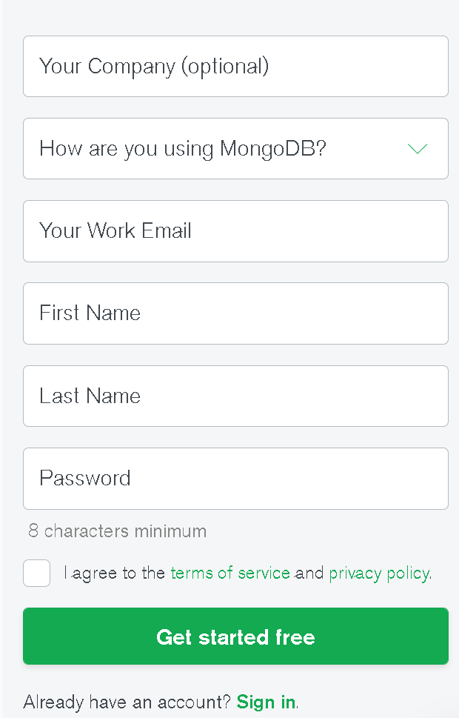

Step 3 – Choose the free Cluster

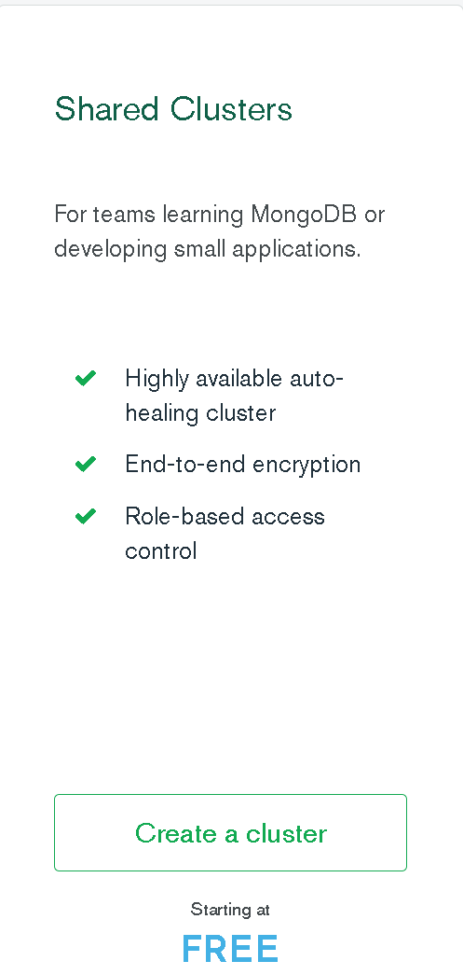

Step 4 – Select the defaults then select “Create Cluster”

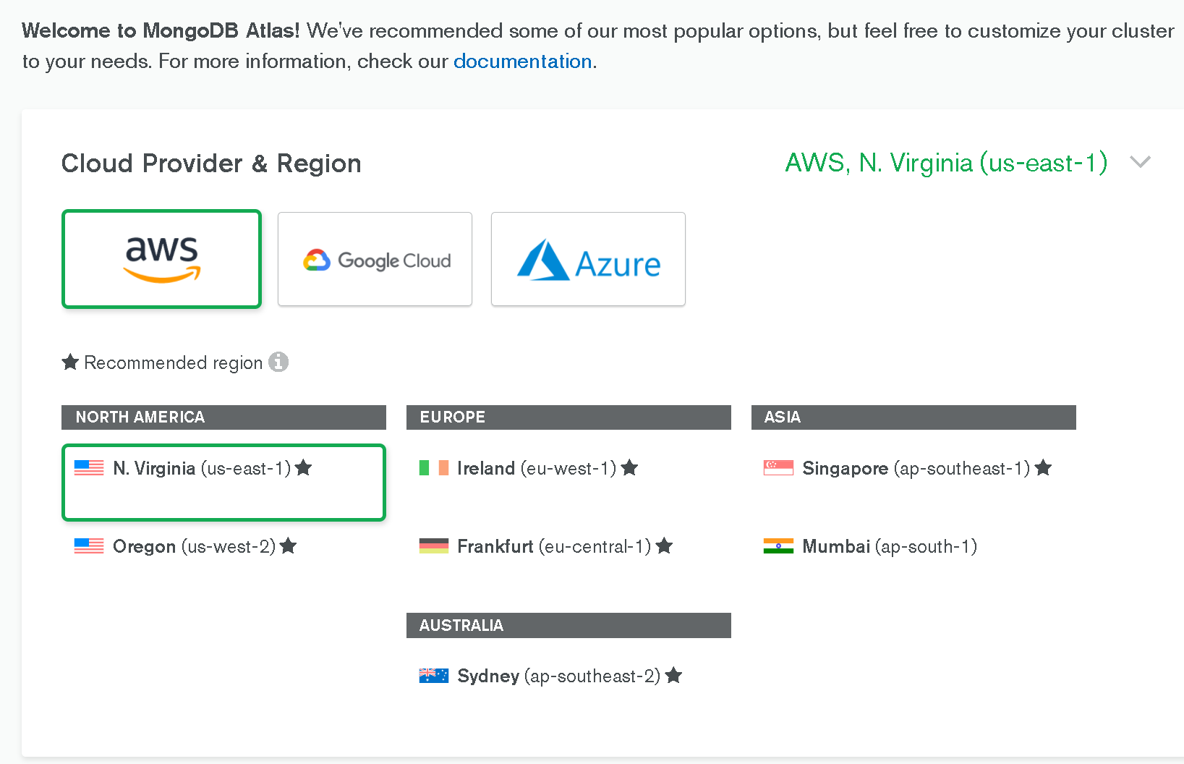

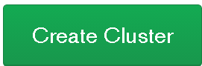

Then wait

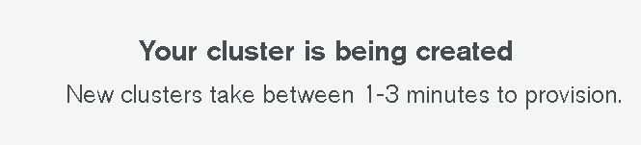

**Part 2 – Network Access**

Step 1 – Select Network Access (found on the left panel)

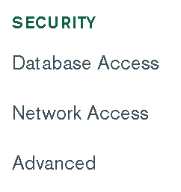

Step 2 – Add IP Address

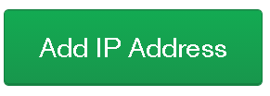

Step 3 – Select ALLOW ACCESS FROM ANYWHERE



Step 4 – Confirm

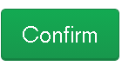

**Part 3 – Create user**

Step 1 – Select Clusters

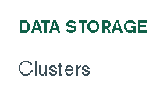

Step 2 – Connect



Step 3 – Provide username and password then “Create Database User”

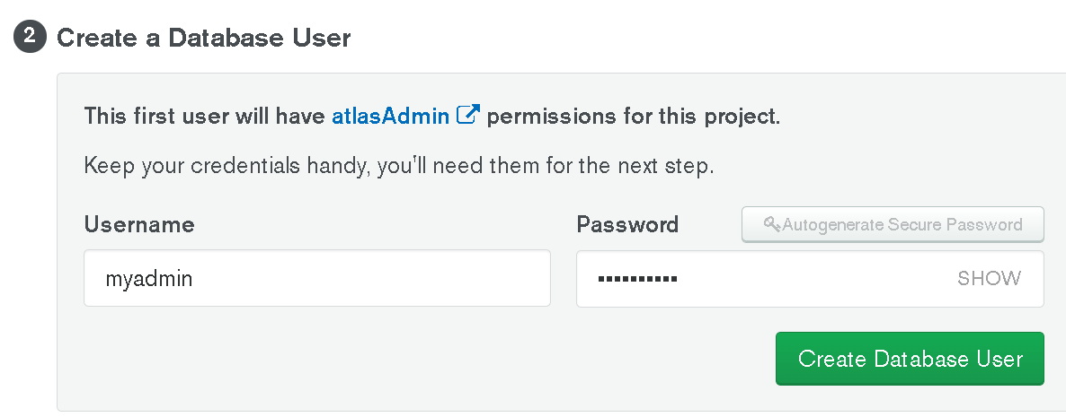

**Part 4 – Create a collection**

Step 1 – Select Collections



Step 2 – Select “Load a Sample Dataset”

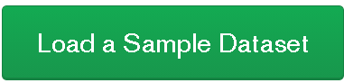

**Part 5 – Find your connection**

**Step 1 –** Select Clusters

Step 2 – Select Connect

Step 3 – Connect your Application

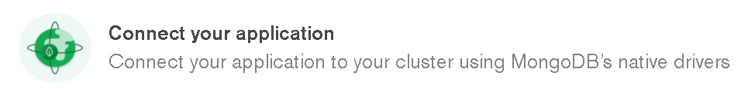

Step 4 – get the Connection code (don’t forget to change the password and database)

