Steps

1. Log in to your AWS Educate -> Cloud9
2. On the upper right corner, look for the “V” icon and select “Manage EC2 Instance”

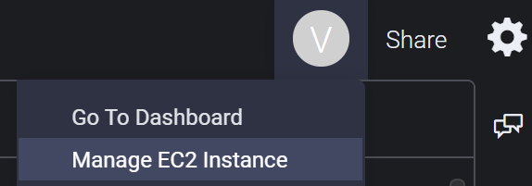

1. Under “Instances”, you will find the public DNS and IP (these changes every time you restart)

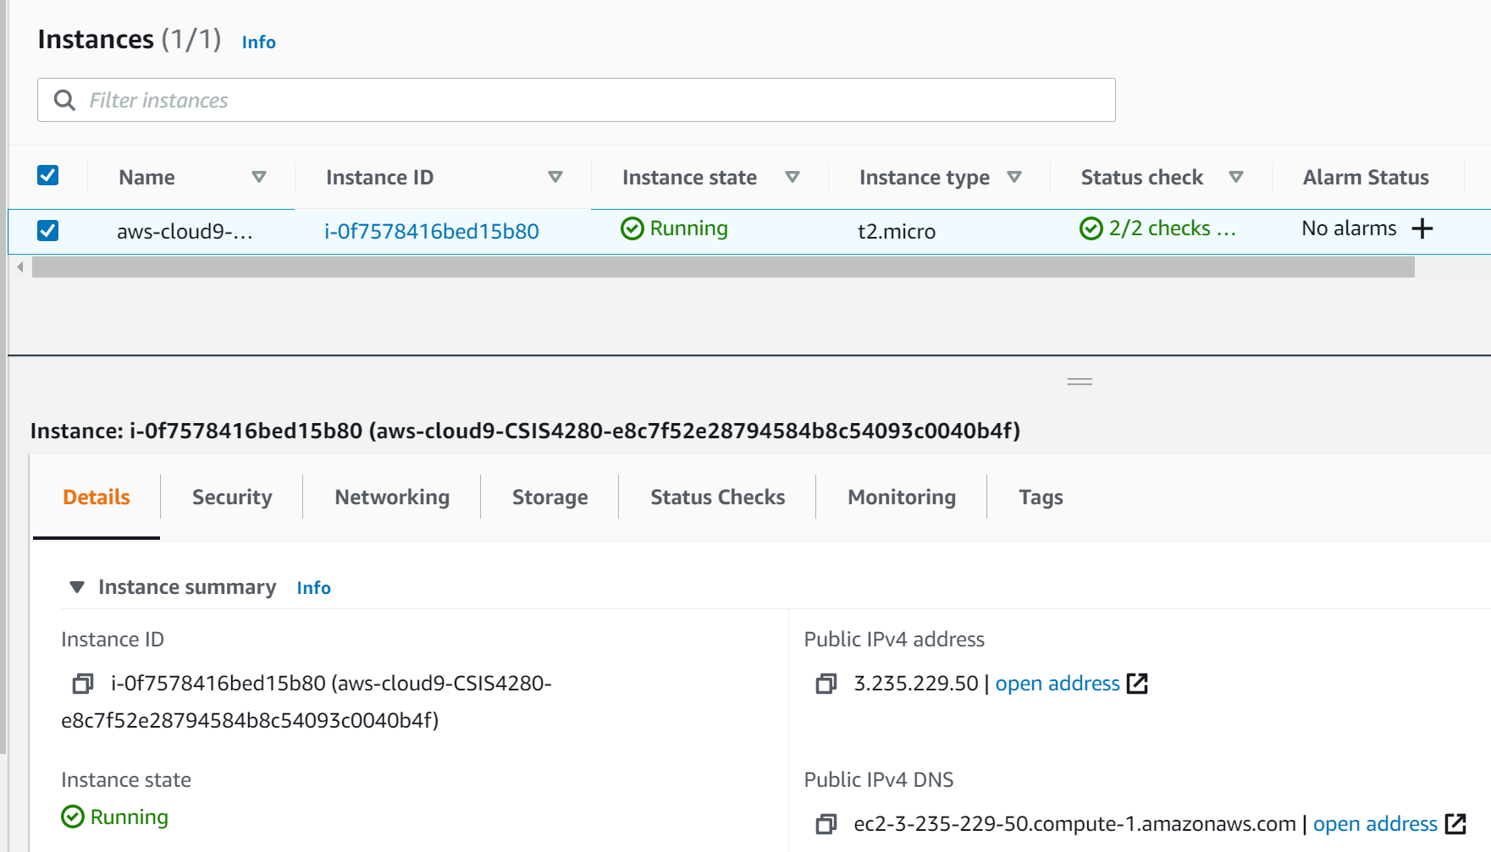

In this example, the public IP is 3.235.229.50 (we would be using this later)

1. On the left panel, look for Security Groups then select it

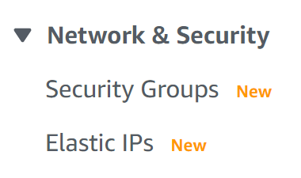

1. Select the security group assigned to your Cloud9 then click Actions -> Edit inbound rules

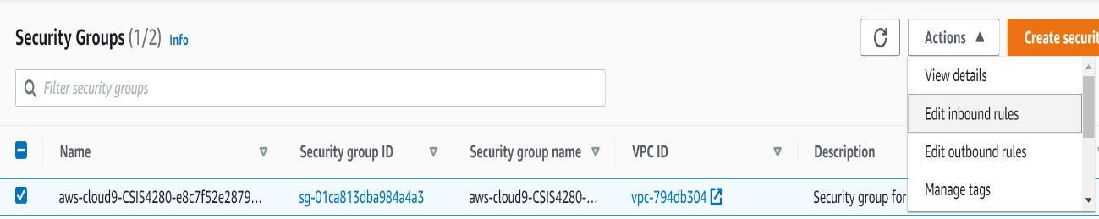

1. Select Add Rule

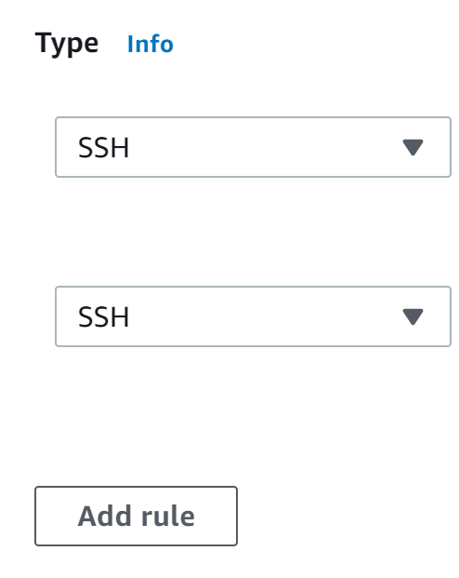

1. Custom TCP would appear. Enter the port you would like to use. In my example, I’m using 8040. So, I typed 8040 on the empty text box then select “Anywhere”

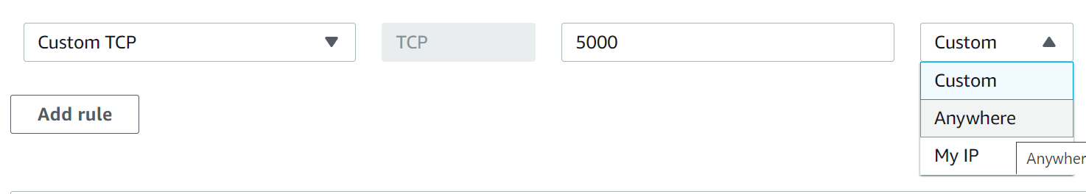

Result

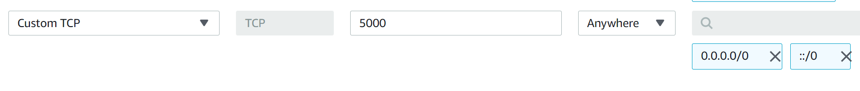

1. Click Save Rules (lower right of the page)



To access your server side script/Flask, you need

1. Browser
2. Public DNS or IP
3. Port

Example using Public IP and port

