## **Start with a Mock**

I am working with the Spotify app.

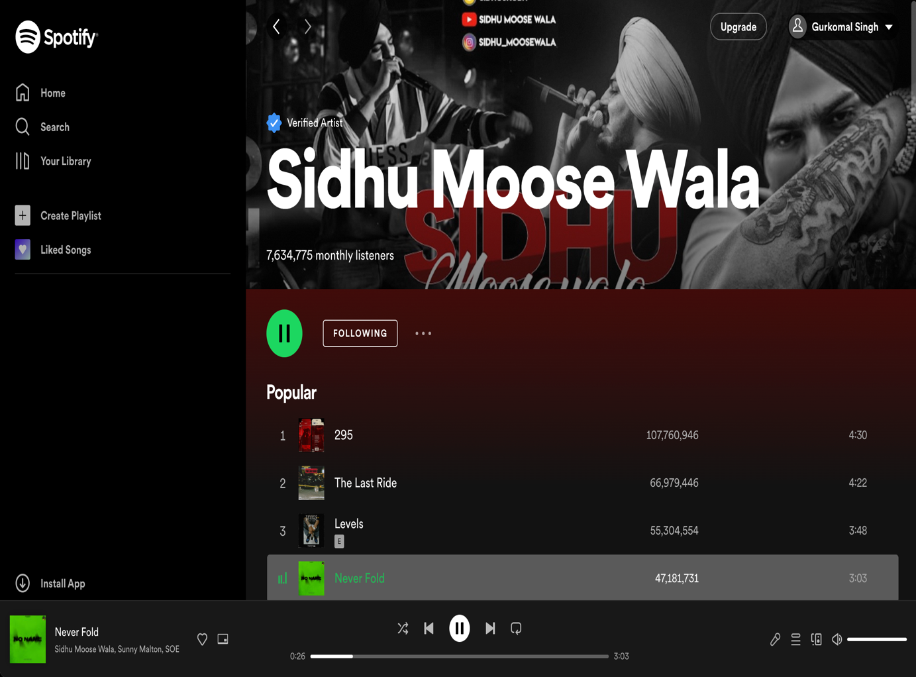

# **DMIT2008: Thinking in React – Spotify**

Functionality on this page:

1. Go to “Home” page
2. Go to “Your Library” page
3. Go to “Search” page
4. Go to “Create Playlist” page
5. Go to “Liked Songs” page
6. Save to library
7. Picture in picture play
8. Shuffle songs
9. Play previous song
10. Play/Pause song
11. Play next song
12. Repeat songs
13. Song progress bar
14. Lyrics
15. Queue song
16. Connect to external device
17. Volume/Mute
18. Play/Pause song
19. Follow the artist
20. More options (share, hide song, view artist)
21. Select song to play
22. User Sign-in
23. Go to Artist’s Social Media Platforms

**Json API:**

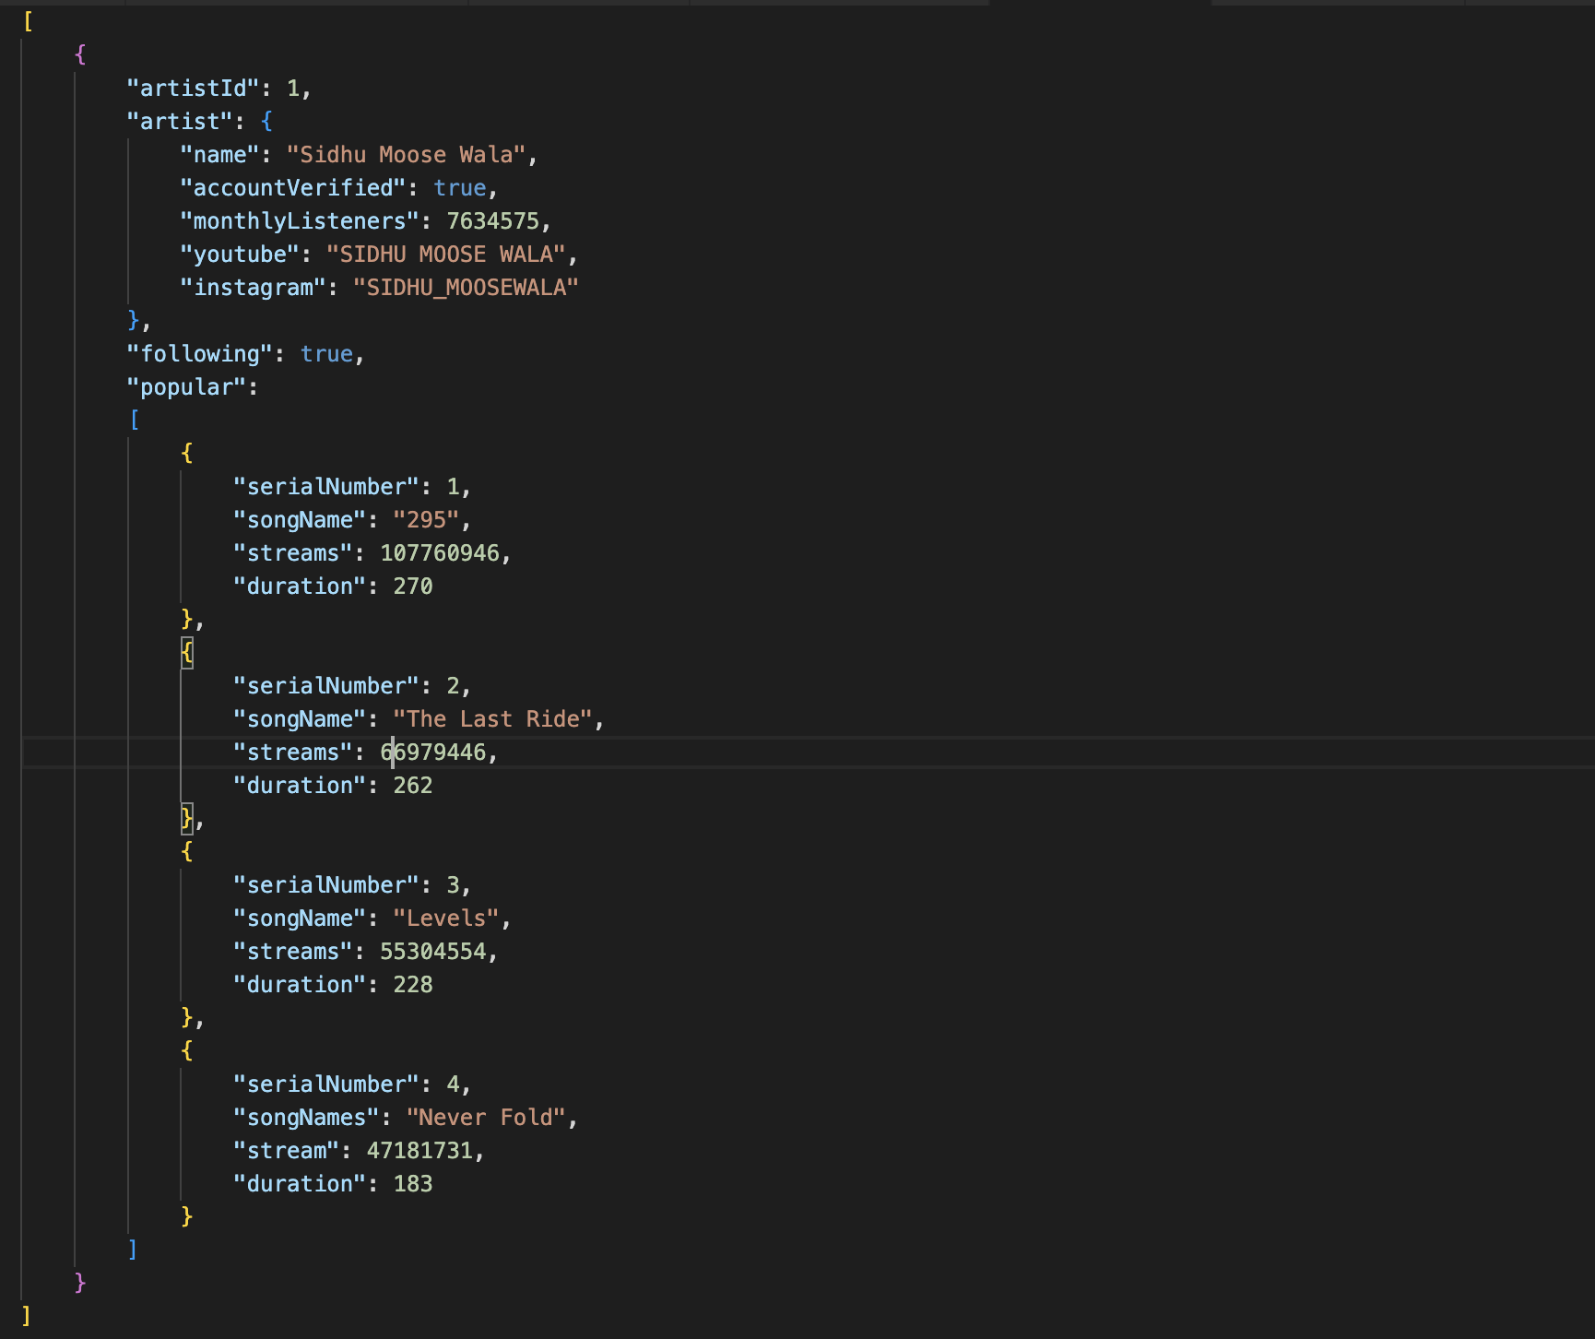

## **Break the UI into a Component Hierarchy**

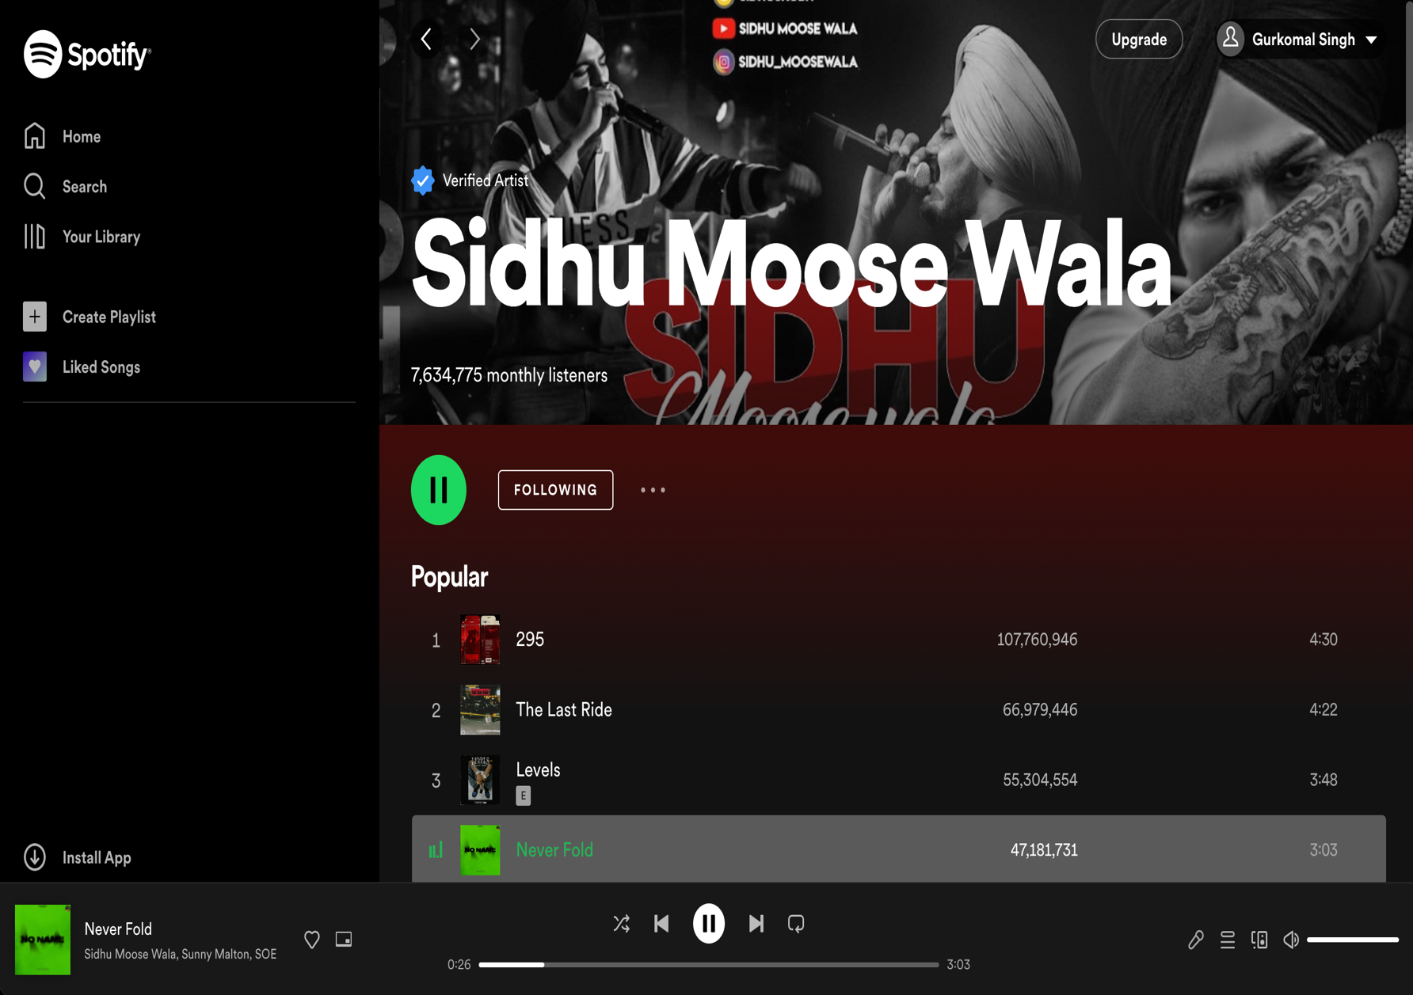

23

22

21

20

19

18

17

16

15

14

13

8

12

11

10

9

8

7

6

5

4

3

2

1

Below is the breakdown of the Components of the image above in a nested hierarchy.

* Navigation [Green Box] - no props
* Home Button (Sportify Logo) - no props
* Icon Button (1-5) - props: icon
* Main Box [Right side of the page] - no props
* SocialMediaPlatforms (23) - props: url_youtube, url_Instagram
* ArtistPage [Blue Box]: uses json api
* ArtistInfo (ArtistName, MonthlyListeners, AccountVerified): It uses json api
* ArtistPage [Purple Box]:
* Play/PausePlaylistButton (18) - no props
* FollowButton (19) – props: isFollowing
* MoreOptions (20) – no props
* ArtistSongsInfo [Orange Box (21)]: - use json api
* SerialNumber, SongName, Streams, Duration: this uses the json api
* PlayingSongActions [Green Box]
* SongName, AartistName: using json api
* AddToPlaylist (6) - props: SongID
* PictureInPictureMode (7) – no props
* SongAction (shuffle, PreviousSong, Play/Pause, NextSong, RepeatSong, ProgressBar) – no props
* OtherActions (Lyrics, QueueSong, ConnectDevice, Volume/Mute) - props : SongID

## **Minimal Representation of State**

* "following" is a stateful value that can be either true or false and belongs in the "FollowButton. If you click the button, this will toggle. If true, “Following” and if false, “Follow” will appear in component.
* “CurrentPage” is also a stateful value which shows the current open page. It is little bold and brighter than other page titles.
* “SaveToLibrary” is a stateful value. It will add the current playing song to the user library. It will toggle on clicking. If it is filled with red color, song is added to library and is it is not colored then the song is not added in the library. It is in the “PlayingSongActions” component.
* “Play/Pause” is a stateful value. It will play/pause the selected song. It will toggle on clicking. The icon in the button will change on clicking, which represents if it is playing or pause. It is linked to “Play/PausePlaylistButton” in the component.
* “Shuffle” is a stateful value. It will shuffle all the songs in the playlist on the selected artist page. It will toggle on clicking. It is in the “PlayingSongActions” component.
* “Repeat” is a stateful value. It will repeat the current playing song. It will toggle on clicking. It is in the “PlayingSongActions” component.
* “Mute” is a stateful value. It will mute the current playing songs. It will toggle on clicking. It is in the “PlayingSongActions” component. It will change icon when it is pressed.
* “Lyrics” is a stateful value. It will show the lyrics underneath the song progress bar. It will add a section with lyrics on clicking. It is in the “PlayingSongActions” component.