Computer Organisation and Architecture

Unit 1:
Introduction

Unit 2:
CPU Design and Peripheral Devices

Unit 3:
Pipelining

Unit 4:
Memory Organisation

______________________________________________________________________

Unit 1:
Introduction to computer organisation and architecture

What is computer architecture:
- The description of all the functions of the units of digital computer.

What is computer organisation:
-

Basically:
Architecture is WHAT a computer does (high level)
Organisation is HOW a computer does (low level)

Von-Neumann/Princeton:
- Program and data memory same
- Single bus
- Instruction fetch and data transfer can’t be simultaneous

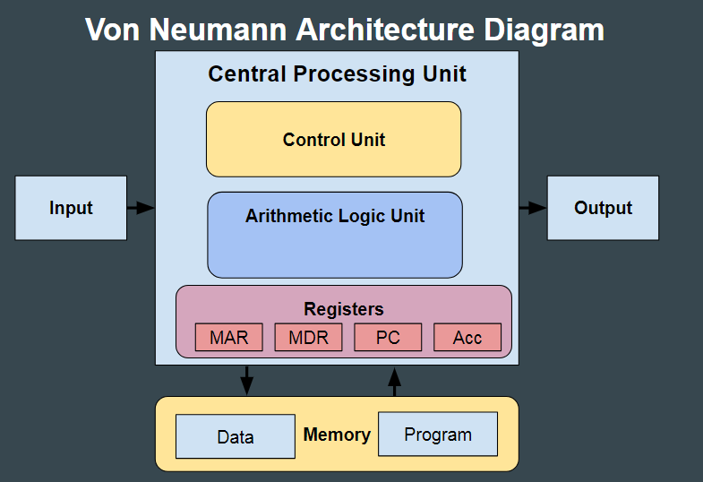

Harvard:
- Separate program and data memory
- Separate buses for program and data memory
- Instruction fetch and data transfer can be same time
- Modified Harvard: separate coche memory but same main memory.

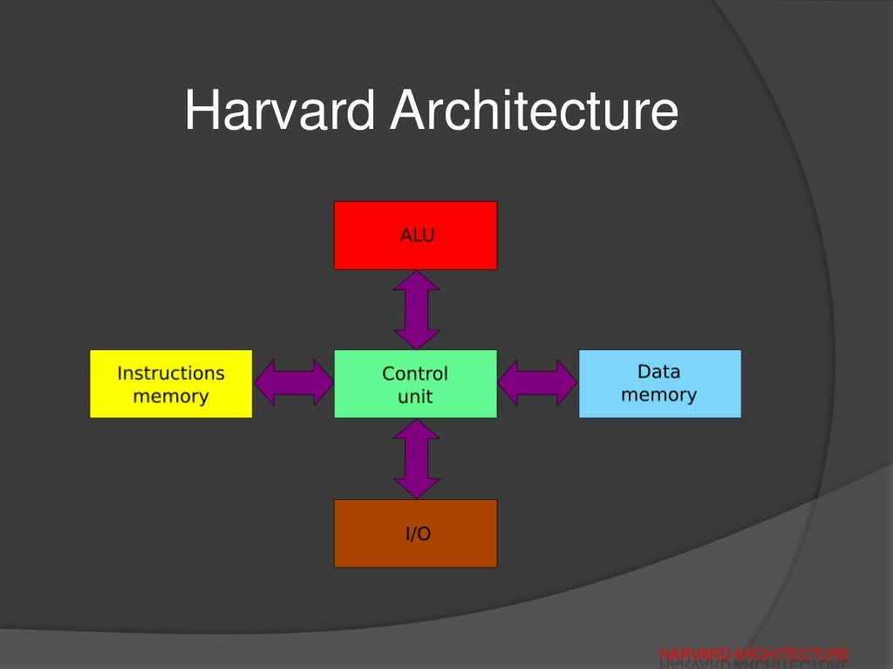
Outline:

CPU (central processing unit)

carries out all the instructions given by a program.

Has the following elements:
- Register set (intermedieate data)
- ALU (arithmetic and logical unit) (micro-operations)
- Control unit (supervises the processes)

Main memory:

RAM(Rendom access memory):
- DRAM (dynamic RAM) (slow & cheap) {main mem}
- SRAM (static RAM) (fast & expensive) {cache}

ROM(Read only memory) (non-volatile)
- PROM (Programmable ROM) (one time)
- EPROM (Erasable PROM) (erasable by UV light)
- EEPROM (Electronically EPROM) (electronically erasable)

Secondary memory:
- HDD (slow, large capacity)
- SSD (fast, expensive)
- Optical drive (CD, DVD, Blu-ray)
- Magnetic tapes

