* Docker images in your repository in DockerHub

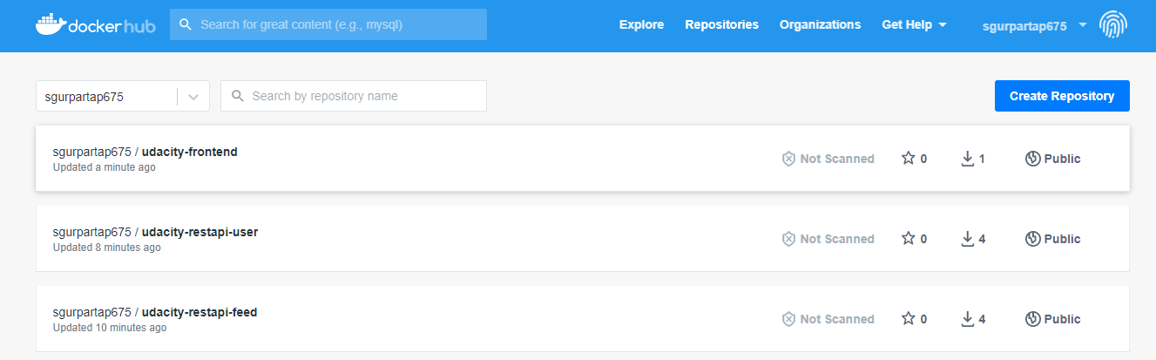

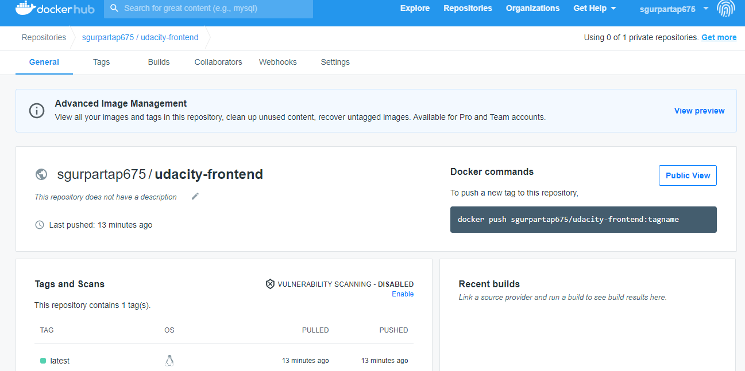

* TravisCI build pipeline showing successful build jobs

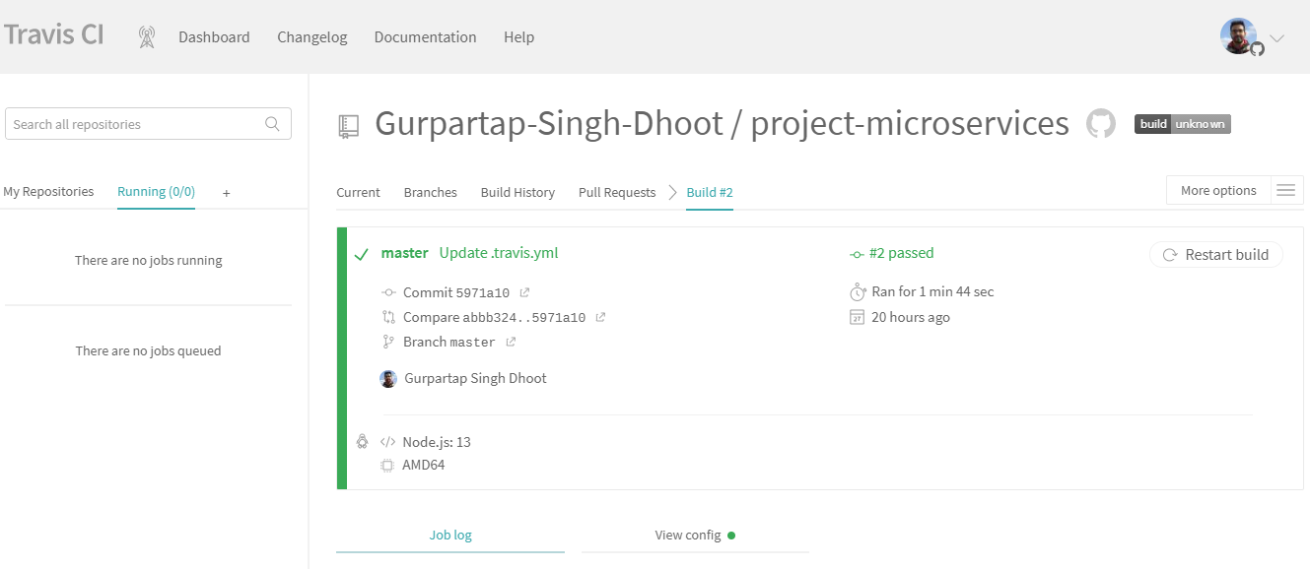

* Kubernetes kubectl get pods output

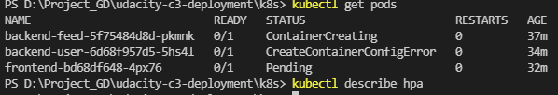

* Kubernetes kubectl describe services output

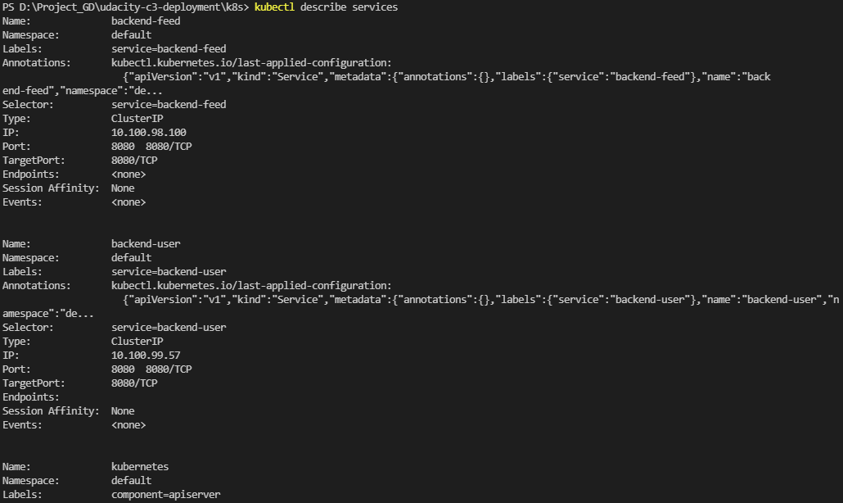

* Kubernetes kubectl describe hpa output



* Kubernetes kubectl logs <your pod name> output

