

[Web develoapment report](https://www.studocu.com/in/document/dr-babasaheb-ambedkar-technological-university/computer-engineering/web-develoapment-report/42493619?utm_campaign=shared-document&utm_source=studocu-document&utm_medium=social_sharing&utm_content=web-develoapment-report)

[Computer Engineering (Dr. Babasaheb Ambedkar Technological University)](https://www.studocu.com/in/course/dr-babasaheb-ambedkar-technological-university/computer-engineering/4793659?utm_campaign=shared-document&utm_source=studocu-document&utm_medium=social_sharing&utm_content=web-develoapment-report)



Scan to open on Studocu

Studocu is not sponsored or endorsed by any college or university

**An Industrial Training Report on**

**HTML, CSS, JAVASCRIPT for Web Developers**

Submitted in partial fulfillment of the requirements for the degree of

**B.Tech. in Information Technology** by

**Rohit Dinkar Gaikwad Roll No:2030331246036** under the guidance of **Prof. S.S. Barphe**



**Department of Information Technology**

**Dr. Babasaheb Ambedkar Technological University, Lonere-402103, Dist. Raigad, (MS) INDIA.**

**December 10, 2022**

**Certificate**

An Industrial Training report, HTML, CSS, JAVASCRIPT for web developers submitted by Rohit Dinkar Gaikwad (2030331246036), is approved for the partial fulfillment of the requirements for the degree of B.Tech.in Information Techonolgy of Dr. Babasaheb Ambedkar Technological University, Lonere - 402 103, Raigad (MS).

**Examiner(s)**

1. —————————————————————— Sign.: ——————–
2. —————————————————————— Sign.: ——————–

|  |  |
| --- | --- |
| **Guide** | **Head of Department, IT** |
| **Ms. Sapna Barphe** | **Dr. Sanjay S. Sutar** |

Place: Dr. Babasaheb Ambedkar Technological University, Lonere - 402 103.

Date:December 10 2022

CERTIFICATE



**Acknowledgments**

My first and foremost words of recognition go to my highly esteemed Guide for her constructive academic advice and guidance, constant encouragement and valuable suggestions, and all other supports and kindness on me. Her supervision and guidance proved to be the most valuable to overcome all the hurdles in the completion of this report.

I am also thankful to Head of Department, Dr. Sanjay R. Sutar, for his guidance and valuable suggestions.I would also like to thank my departmental staff, library staff for their timely help.

Finally, I would like to thank all whose direct and indirect support helped me in completing this report in time.

**Rohit Dinkar Gaikwad (2030331246036)**

**Abstract**

This course intends to provide basic knowledge and skills required for planning, designing and developing effective web pages with a focus on the practical application of the technologies used in the web development. It covers basic terminologies, tools, HTML, Cascading Style Sheet (CSS) and the basics of javascript. It also describes how to host a website on a selected web server. It is part of the five courses related to Web Application Development.

**Contents**

**1 Introduction** **1**

1.1 What is Web Hosting? 2

1.2 What is Website? 6

1.2.1 How to access Websites? 6

1.2.2 Types of Website: 6

1.3 Domain Names 7

**2 Tools of Web Development** **9**

**3 HTML** **10**

3.1 What is HTML used for ? 10

3.2 HTML Basic Format Page Structure 10

3.3 Designing Web Page 11

**4 CSS** **16**

4.1 What is CSS ? 16

4.2 Why we learn CSS? 16

4.3 How CSS is different from HTML? 19

4.4 Why is CSS used in HTML? 20

**5 JavaScript** **22**

5.1 What is JavaScript 22

5.2 Why JavaScript is used? 24

5.3 How JavaScript is different from HTML? 25

5.4 Why to learn JavaScript ? 26

**6 Conclusion** **27**

**Bibliography** **28**

**List of Figures**

3.1 HTML Page Structure . . . . . . . . . . . . . . . . . . . . . . . . . . . . 11

3.2 HTML . . . . . . . . . . . . . . . . . . . . . . . . . . . . . . . . . . . . . 14

4.1 CSS . . . . . . . . . . . . . . . . . . . . . . . . . . . . . . . . . . . . . . 17

5.1 Javascript . . . . . . . . . . . . . . . . . . . . . . . . . . . . . . . . . . . 24

**Chapter 1**

# Introduction

Web development, also known as website development, refers to the tasks associated with creating, building, and maintaining websites and web applications that run online on a browser. It may, however, also include web design, web programming, and database management.

Web development is closely related to the job of designing the features and functionality of apps (web design). The term development is usually reserved for the actual construction of these things (that is to say, the programming of sites).

The basic tools involved in web development are programming languages called HTML (Hypertext Markup Language), CSS (Cascading Style Sheets), and JavaScript. There are, however, a number of other programs used to “manage” or facilitate the construction of sites that would otherwise have to be done “from scratch” by writing code. A number of content management systems (CMS) fall into this category, including WordPress, Joomla!, Drupal, TYPO3, and Adobe Experience Manager, among others.

The word Web Development is made up of two words, that is:

**Web:** It refers to websites, web pages or anything that works over the internet.

**Development:** It refers to building the application from scratch.

## 1.1 What is Web Hosting?

A web hosting service is a type of Internet hosting service that hosts websites for clients, i.e. it offers the facilities required for them to create and maintain a site and makes it accessible on the World Wide Web. Companies providing web hosting services are sometimes called web hosts.

Web Hosting is a service that allows hosting/post-web-server applications( website or web page ) on a computer system through which web-browser clients can have easy access to electronic content on the Internet.

Web Server or Web Host is a computer system that provide web hosting. When Internet user’s want to view your website, all they need to do is type your website address or domain into their browser. The user’s computer will then connect to your server and your web pages will be delivered to them through the browser. Basically, the web hosts allow the customers to place documents, such as HTML pages, graphics, and other multimedia files, etc. onto a special type of computer called a web server. It provides a constant and high-speed connection to the backbone of the Internet.

Typically, web hosting requires the following:

* + one or more servers to act as the host(s) for the sites; servers may be physical or virtual
  + colocation for the server(s), providing physical space, electricity, and Internet connectivity;
  + Domain Name System configuration to define name(s) for the sites and point them to the hosting server(s);

a web server running on the host;

* for each site hosted on the server:
* space on the server(s) to hold the files making up the site
* site-specific configuration
* often, a database;
* software and credentials allowing the client to access these, enabling them to create, configure, and modify the site;
* email connectivity allowing the host and site to send email to the client.

Types of Web Hosting

Different types of Web hosting services are listed below:

* Free Hosting
* Virtual or Shared Hosting
* Dedicated Hosting
* Co-location Hosting

**Free Hosting:**

This is a free non-paid web hosting service. This type of hosting is available with many prominent sites that offer to host some web pages for no cost, like Hostinger.

**Advantages:**

* Free of cost
* Use websites to place advertisements. banners and other forms of advertising media

**Disadvantages:**

Customer support is missing

* Low bandwidth and lesser data transfer
* No control over your website

**Shared/Virtual Hosting:**

It’s a web hosting service where many websites reside on one web server connected to the internet. This type of hosting is provided under one’s own domain name, www.yourname.com. With a hosting plan with the wed b hosting company, one can present oneself as a fully independent identity to his/her web audience, like Lindo.

**Advantages:**

* Easy and affordable
* Secured by hosting provider
* 24/7 Technical support

**Disadvantages:**

* Shared resources can slow down the whole server
* Less flexible than dedicated hosting

**Dedicated Hosting:**

Hosted on a dedicated server, this type of hosting is best suited for large websites with high traffic. In this, the company wishing to go online rents an entire web server from a hosting company. This is suitable for companies hosting larger websites, maintaining others’ sites or managing a big online mall, etc like Google Cloud.

**Advantages:**

Ideal for large business

* Strong database support
* Unlimited software support
* Powerful e-mail solutions
* Complete root access to your servers

**Disadvantages:**

* Its very expensive
* Requires superior skill sets

**Co-located Hosting:**

This hosting lets you place your own web server on the premises of a service provider. It is similar to that of dedicated hosting except for the fact that the server is now provided by the user-company itself and its physical needs are met by the hosting company like AWS.

**Advantages:**

* Greater Bandwidth High Up-Time
* Unlimited Software Options
* High Security

**Disadvantages:**

* Difficult to configure and debug
* Its expensive

Require high skills

It’s simple to find a reliable web hosting platform on which to host your website or launch a company.

## 1.2 What is Website?

Website is the collection of web pages, different multimedia content such as text, images, and videos which can be accessed by the URL which you can see in the address bar of the browser.For example: https://www.geeksforgeeks.org

### 1.2.1 How to access Websites?

When we type a certain URL in a browser search bar, the browser requests the page from the Web server and the Web server returns the required web page and its content to the browser. Now, it differs how the server returns the information required in the case of static and dynamic websites.

### 1.2.2 Types of Website:

* **Static Website**
* **Dynamic Website**

**Static Website:** In Static Websites, Web pages are returned by the server which are prebuilt source code files built using simple languages such as HTML, CSS, or JavaScript. There is no processing of content on the server (according to the user) in Static Websites. Web pages are returned by the server with no change therefore, static Websites are fast. There is no interaction with databases. Also, they are less costly as the host does not

need to support server-side processing with different languages.

Static does not mean that it will not respond to user actions, These Websites are called static because these cannot be manipulated on the server or interact with databases (which is the case in Dynamic Websites).

**Dynamic Website:** In Dynamic Websites, Web pages are returned by the server which are processed during runtime means they are not prebuilt web pages but they are built during runtime according to the user’s demand with the help of server-side scripting languages such as PHP, Node.js, ASP.NET and many more supported by the server. So, they are slower than static websites but updates and interaction with databases are possible.

Dynamic Websites are used over Static Websites as updates can be done very easily as compared to static websites (Where altering in every page is required) but in Dynamic Websites, it is possible to do a common change once and it will reflect in all the web pages.

## 1.3 Domain Names

Every website on the Internet has its IP (Internet Protocol) address and this IP address points to the particular website through which we can reach that website but this IP address is hard to remember the IP address for the websites which we want to reach because the IP address will look something like that– 236.56.23.156

That’s why remembering all these numbers is a little bit challenging and hence exploring the website, to solve all these challenges the system called DNS (Domain Name System) came into existence which converts the IP address into Domain name and vice versa. which makes it easy to remember the name that is pointing to the particular IP address of any website these names are called the Domain name.

For example “www.geeksforgeeks.org” is the domain name which it pointing to the particular IP address. When we type the domain name to our browser URL bar then the DNS converts this domain name to the IP address and we become able to explore that particular website.

Some of the popular extensions used in Domain names are:

**.com:** It is the short form of the “commercial” word and this was the first TLD and most popular for the business and commercial websites.

**.net:** It is the short form of the “network” word and this TLD is for the technologyrelated website but now it is commonly used for many websites.

**.edu:** It is the short form of the “education” word and this TLD is used for Educational websites.

**.org:** It is the short form of the “organization” word and this TLD is for the organizational websites.

**.gov:** It is the short form of the “government” word and this TLD is used for the government websites.

**.mil:** It is the short form of the “military” word and this TLD is strictly used for the U.S military and government agencies.

**Chapter 2**

# Tools of Web Development

A Front-End Web Development Tool is actually the software that allows the front-end developers to build the website layout and UI more efficiently and without any hassle. With the help of such tools – the work of front-end web developers, especially the repetitive or monotonous tasks, gets reduced that subsequently fastens the web development process.

There are numerous front-end web development tools out there for various specific requirements such as HTML, CSS, and JavaScript tools, Code-Editing tools, Deployment Tools, Prototyping Wireframing tools, Security tools, and many more. Though you’re required to consider various factors before opting out for a particular tool such as your requirements (quite obvious it is!!), offered functionalities, ease of use, platform compatibility, prices, etc. The 3 basic and most important tools for web development are

1. **HTML :** To define the content of web pages
2. **CSS :** To specify the layout of web pages
3. **JavaScript :** To program the behavior of web pages

**Chapter 3**

# HTML

HTML is known as HyperText Markup Language. It is a combination of both Hypertext and Markup language. Here hypertext means the link between the web pages and markup is used to define the text document within tag which defines the structure of web pages. It acts as a skeleton of a web page and without HTML it would be very difficult or impossible to build a webpage. It is used by all the browsers and used to manipulate text, images, and other content, in order to display it in the required format. In this article, we will learn how to create an HTML webpage.

## 3.1 What is HTML used for ?

HTML is used to create the structure of web pages that are displayed on the World Wide Web (www). It contains Tags and Attributes that are used to design the web pages.

Also, we can link multiple pages using Hyperlinks.

## 3.2 HTML Basic Format Page Structure

The basic structure of an HTML page is laid out below. It contains the essential buildingblock elements (i.e. doctype declaration, HTML, head, title, and body elements) upon which all web pages are created.

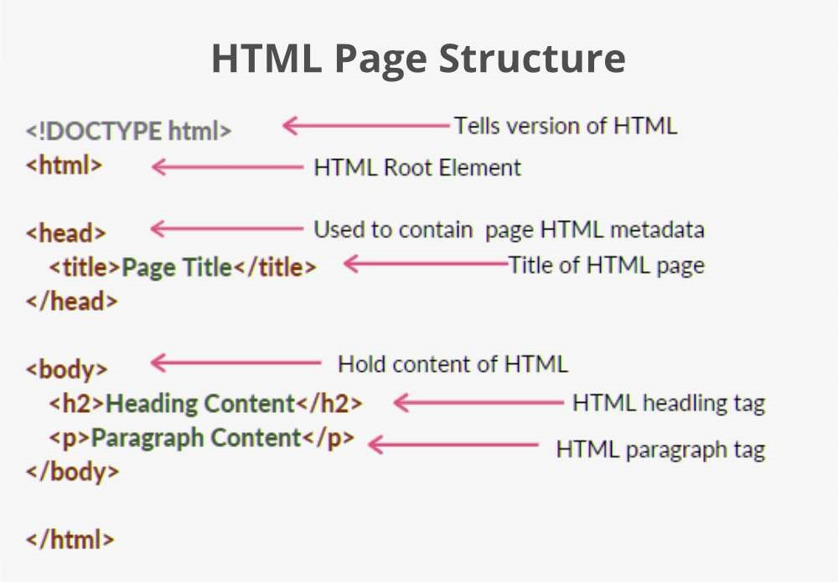

Figure 3.1: HTML Page Structure

## 3.3 Designing Web Page

To design a webpage in HTML we need to learn about tags and attributes available in HTML. In HTML, tags are some instructions that are enclosed in angle braces. With the help of these tages, we can design a more attractive HTML page. Some of the important tags to be used are as follows:

**DOCTYPE! html** – A doctype or document type declaration is an instruction that tells the web browser about the markup language in which the current page is written. It is not an element or tag. The doctype declaration is not case-sensitive.

**html tag** – This tag is used to define the root element of HTML document. This tag tells the browser that it is an HTML document. It is the second outer container element that contains all other elements within it.

**head tag** – This tag is used to define the head portion of the HTML document that contains information related to the document. Elements within the head tag are not visible on the front-end of a webpage.

**body tag** – The body tag is used to enclose all the visible content of a webpage. In other words, the body content is what the browser will show on the front end.

**Title tag:** It is used to define the title of an HTML document. Syntax: ¡title¿ Statements... ¡/title¿

**Paragraph tag:** It is used to define paragraph content in an HTML document.

Syntax: ¡p¿ Statements... ¡/p¿

**Header tag (¡h1¿ ... ¡/h1¿ to ¡h5¿ ... ¡/h5¿):**

These tags are called header tags and they are used to give heading to your webpage of different sizes.¡h1¿...¡/h1¿ being the Largest Heading to ¡h5¿ ...¡/h5¿ being the Smallest Heading.

**Bold Tag (¡strong¿...¡/strong¿ or¡b¿...¡/b¿):** These tags are used to make text look bold.

**Italic Tag (¡i¿ ...¡/i¿ or ¡em¿... ¡/em¿):**

These tags are used to make text look italics. The only difference between ¡i¿ and ¡em ¿ is that ¡em¿semantically emphasis on important text or word whereas ¡i¿ tag is used to make is just used to make text italics.

**Underline tag:** It is used to set the content underline.

**Comment tag:** It is used to set the comment in an HTML document. It is not visible on the browser.

Syntax: ¡!– Statements... –¿

**Line break tag:** It is used to break the line. Syntax: ¡br¿

**Image Tag:** If we need to add an image to our website we need to use the following

Syntax: ¡img src=”gfg.PNG” alt=”GeeksforGeeks Image”¿ img: Tells browser that we want to add an image. src: Tells source of image for eg image from desktop or a website. alt: This attribute is used to describe an image. If the image is not able to download in a web browser due to some reason then alt is shown.

**Anchor Tag:** This tag is mainly used to connect one web page to another.

Syntax: ¡a href=”https://www.geeksforgeeks.org/c-plus-plus/?ref=shm”¿ Click Here to Learn C++¡/a¿

**Radio button tag:** It is used to select only one option from the given options.

Syntax: ¡input type=”radio” name=”option”¿ option*value*

**Checkbox button tag:***Itisusedtoselectanoptionfromthegivenoptions. Syntax* :*< inputtype* = ”*checkbox*”*name* = ”*check*”*value* = ”” *>*

**Submit input tag:***Itisusedtotakeinputfromtheuser.*

*Syntax* :*< inputtype* = ”*Submit*”*value* = ”*Submit*” *>*

*Example*1 : *ThisisthebasicexampleofHTMLthatdisplaytheheadingandparagraphcontent.*

HTML

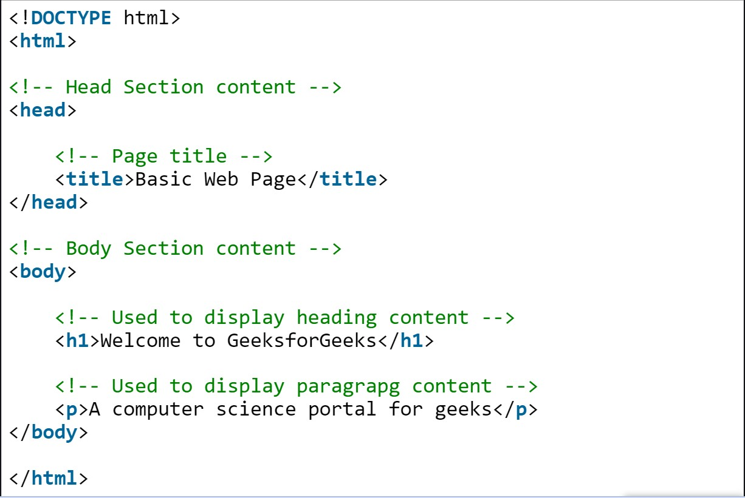

Figure 3.2: HTML

Output:

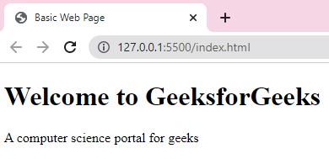

**Chapter 4**

# CSS

## 4.1 What is CSS ?

CSS (Cascading Style Sheets)is used to apply styles to web pages. Cascading Style Sheets are fondly referred to as CSS. It is used to make web pages presentable. The reason for using this is to simplify the process of making web pages presentable. It allows you to apply styles on web pages. More importantly, it enables you to do this independently of the HTML that makes up each web page.

## 4.2 Why we learn CSS?

Styling is an essential property for any website. It increases the standards and overall look of the website that makes it easier for the user to interact with it. A website can be made without CSS, as styling is MUST since no user would want to interact with a dull and shabby website. So for knowing Web Development, learning CSS is mandatory.

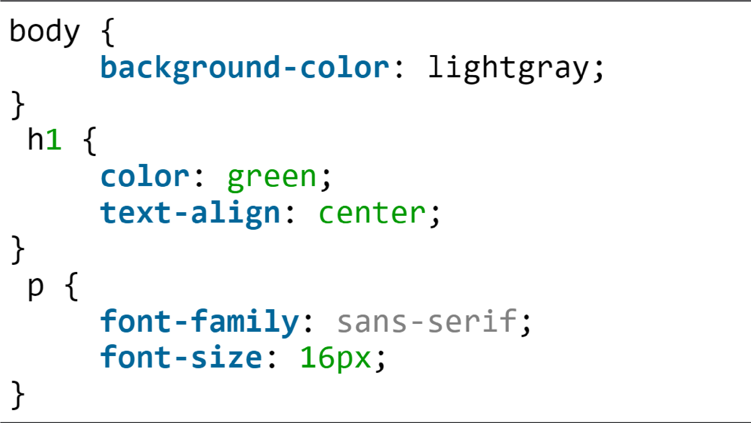Basic Format: It is the basic structure of CSS style of an webpage.

Figure 4.1: CSS

There are three types of CSS which are given below:

**Inline:** Inline CSS contains the CSS property in the body section attached with the element known as inline CSS.

**Internal or Embedded:** The CSS ruleset should be within the HTML file in the head section i.e the CSS is embedded within the HTML file.

**External:** External CSS contains a separate CSS file that contains only style property with the help of tag attributes.

Let’s see a small example of HTML webpage with CSS styles. Here, we use styles to set the alignment and text color of a webpage.

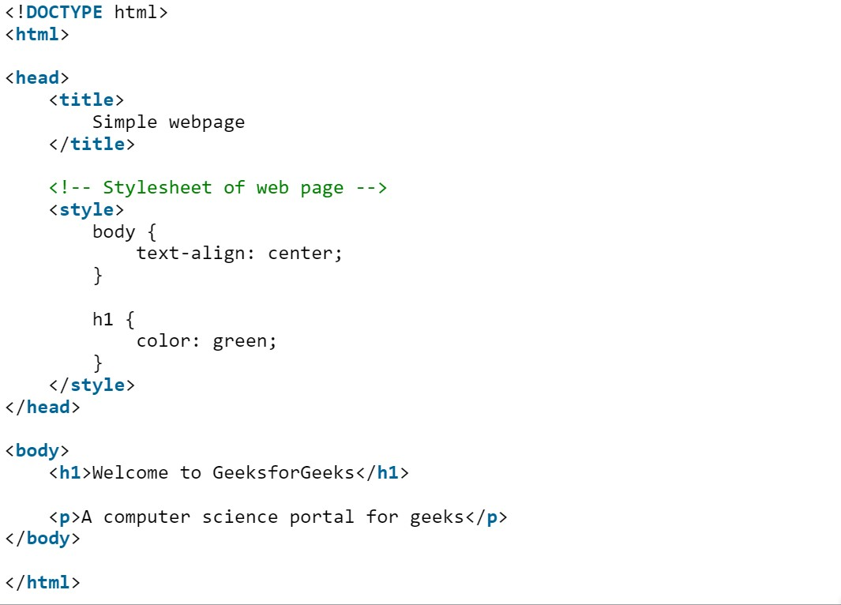

Output :

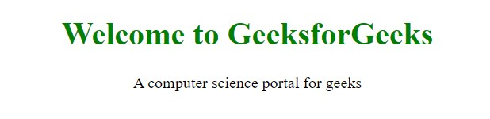

## 4.3 How CSS is different from HTML?

HTML is used to define a structure of a web page whereas CSS is used to style the web pages by using different styling features.

* HTML consists of tags inside which text is enclosed and CSS consists of selectors and declaration blocks.
* CSS can be internal or external depending upon the requirement.
* We cannot use HTML inside a CSS sheet but we can use CSS inside an HTML document.
* CSS has comparatively higher backup and support than HTML.

## 4.4 Why is CSS used in HTML?

**Solves a big problem:** Font, color, background style, element alignments, border, and size tags had to be duplicated on each web page before CSS. This was a lengthy procedure.

**Saves a lot of time:** Because CSS style definitions are stored in external CSS files, updating only one file can modify the entire website.

**Provide more attributes:** CSS gives more specific features for defining the look and feel of a website than simple HTML.

**Pages load faster:** CSS doesn’t require you to write HTML tag attributes all of the time. A tag’s rule can be written once and applied to all instances of the tag. As a result, CSS uses less code, resulting in speedier download times.

**Easier Website maintenance:** CSS makes website maintenance much easier. If we need to make a global change to the file, we can simply alter the style, which will update all of the elements on the web page.

**Multiple device compatibility:** We can use CSS with older language versions because it is compatible with them. CSS makes it possible to optimize material for several devices. Base for web development: HTML and CSS is the basic skill that every web developer should know. It is the basic skill that is required for building a website.

**Makes your website look attractive:** A website that’s dull and plain will not attract the user, so adding some style would surely make your website presentable to the user.

**Makes the design come live:** A web developer is responsible for making the design given to him as a live product. It is used for styling to develop the design of the website. Increases user experience of the website: A website with a simple yet beautiful UI would help the users to go through the website easily. It is used to make the user interface better.

**More career opportunities:** Since CSS is a basic requirement while learning Web Development, therefor there are abundant career opportunities for it. As a freelancer, you can land up to many projects.

**Chapter 5**

# JavaScript

## 5.1 What is JavaScript

JavaScript (JS) is the world’s most popular lightweight, interpreted compiled programming language. It is also known as a scripting language for web pages. It can be used for Client-side as well as Server-side developments.

JavaScript can be added to your HTML file in two ways:

**Internal JavaScript:** We can add JS code directly to our HTML file by writing the code inside the ¡script¿ tag. The ¡script¿ tag can either be placed inside the ¡head¿ or the ¡body¿ tag according to the requirement.

**Advantages of using Internal JS:**

* Browser does not have to make an extra HTTP request for JavaScript code.
* It does not allow caching.

**Disadvantages of Internal JS:**

* The readability of code becomes poor.
* Maintenance of code becomes hard when there is a lot of code.

**External JavaScript File:** We can create a file with .js extension and paste the JS code inside it. After creating the file, add this file in ¡script src=”file*name.js*” *> taginside < head > tagoftheHTMLfile.*

**Advantages of using External JS**

*HTMLandJavaScriptfilesbecomemorereadableandeasytomaintain.*

* Page loads speed up due to Cached JavaScript files.

**Disadvantages of External JS:**

* Coders can easily download your code using the url of the script(.js) file.
* An extra HTTP request is made by the browser to get this JavaScript code.

Syntax: It is the basic syntax to write code.

¡script¿

// JS Code

¡/script¿

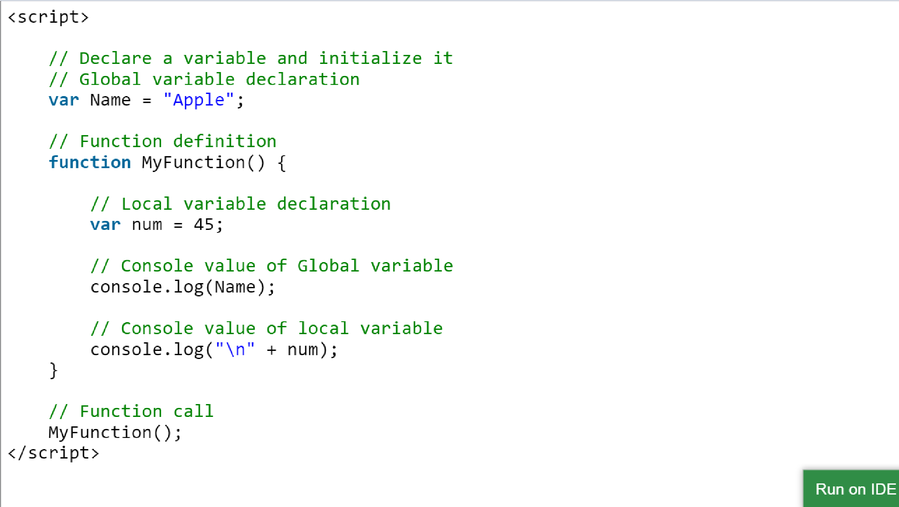This example describes a simple function and prints the values.

Figure 5.1: Javascript

Output: Console output

**Apple**

**45**

## 5.2 Why JavaScript is used?

JavaScript is the most popular programming language for both client-side and serverside to make interactive web pages. It is mainly used to develop websites and web-based applications.

**Creating Interactive Websites:** JavaScript is used to make the web pages dynamic and interactive. It means using JavaScript, we can change the web page content and styles dynamically.

**Building Applications:** JavaScript is used to make web and mobile applications. To build the web and mobile apps, we can use most popular JavaScript frameworks like – ReactJS, React Native, Node.js etc.

**Web Servers:** We can make robust server applications using JavaScript. To be precise we use JavaScript frameworks like Node.js and Express.js to build these servers.

**Game Development:** JavaSCript can be used to design Browser games. In JavaScript, lots of game engines available that provide frameworks for building games.

## 5.3 How JavaScript is different from HTML?

JavaScript is an advanced programming language that makes web pages more interactive and dynamic whereas HTML is a standard markup language that provides the primary structure of a website.

JavaScript simply adds dynamic content to websites to make them look good and HTML work on the look of the website without the interactive effects and all.

JavaScript manipulates the content to create dynamic web pages whereas HTML pages are static which means the content cannot be changed.

JavaScript is not cross-browser compatible whereas HTML is cross-browser compatible. JavaScript can be embedded inside HTML but HTML can not be embedded inside

JavaScript.

## 5.4 Why to learn JavaScript ?

JavaScript is the most popular and hence the most loved language around the globe. Apart from this, there are abundant reasons to learn it. Below are a listing of few important points:

**No need of compilers:** Since JavaScript is an interpreted language, therefore it does not need any compiler for compilations.

**Used both Client and Server-side:** Earlier JavaScript was used to build client-side applications only, but with the evolution of its frameworks namely Node.js and Express.js, it is now widely used for building server-side applications too.

**Helps to build a complete solution:** As we saw, JavaScript is widely used in both client and server-side applications, therefore it helps us to build an end-to-end solution to a given problem.

**Used everywhere:** JavaScript is so loved because it can be used anywhere. It can be used to develop websites, games or mobile apps, etc.

**Huge community support:** JavaScript has a huge community of users and mentors who love this language and take it’s legacy forward.

**Chapter 6**

# Conclusion

In today’s Web development, a good page design is essential. A bad design will lead to the loss of visitors and that can lead to a loss of business. In general, a good page layout has to satisfy the basic elements of a good page design. This includes color contrast, text organization, font selection, style of a page, page size, graphics used, and consistency. In order to create a well-designed page for a specific audience. The developer needs to organized and analyze the users’ statistics and the background of the users. Although it can be hard to come up with a design that is well suited to all of the users, there will be a design that is appropriate for most of the audience. The better the page design, the more hits a page will get. That implies an increase in accessibility and a possible increase in business. A general purposed Web site should use non-frame pages and graphics navigation bar with rollover effects. In addition to the graphic navigation bar with rollover effects, each page should also have a text-only navigation bar for easy control. The developer should also create a Cascading Style Sheet to control the font and font-size and use the style sheet throughout the site to obtain a consistent look and feel.

## Bibliography

1. https://www.geeksforgeeks.org/
2. https://www.w3schools.com/