**Hello, this is Gurpreet Singh presenting you my solution.**

**This is my Login page**

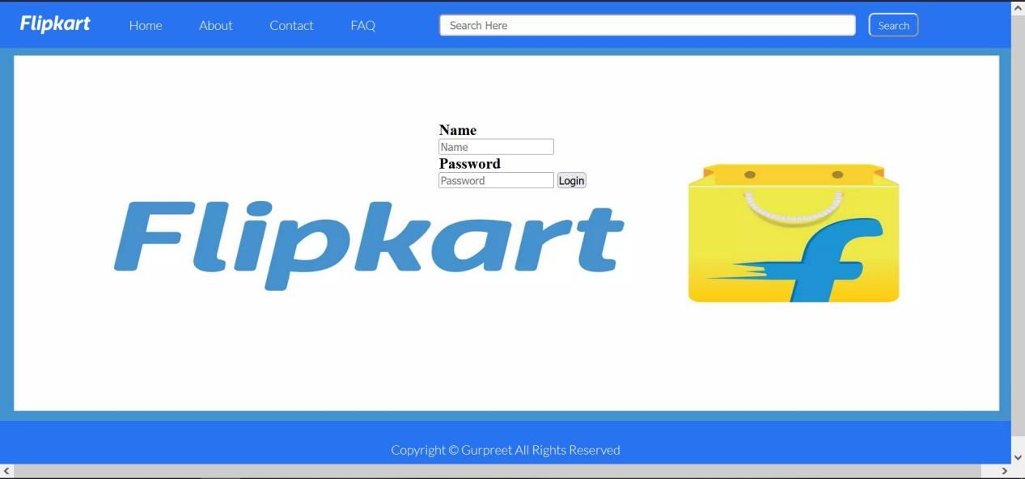

**After you put your name and password then you can login and land on homepage**



You can now access all the pages on the website.

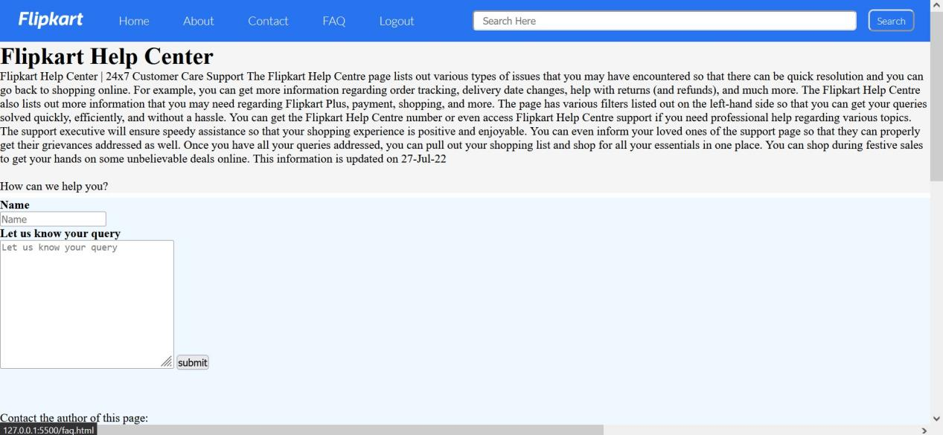

FAQ Part  
