**INDEX**

**Chapter – 1**

Introduction

* 1. Purpose
  2. Scope
  3. Technologies to be Used
  4. Overview

**Chapter – 2**

Overall Description

2.1) the Goal of Proposed System

2.2) Requirements of Project

**Chapter – 3**

Feasibility Study

3.1) Technical Feasibility

3.2) Operational Feasibility

3.3) Economic Feasibility

**Chapter – 4**

Project Time Dividing in 20 Days

**Chapter – 5**

Flow Diagram

**Chapter – 6**

Coding

**Chapter – 7**

Output Screens

1. **Introduction**
   1. **Purpose**

• The Software is for the automation of Hospital Management.

• It maintains two levels of users:-

1. Administrator Level
2. Manager Level

• The Software includes:-

1. Home Page.
2. Login Page.
3. Department
4. Designation
5. Doctor
6. Nurse
7. Opd Registration
8. Patient Admission
9. Day Care
   1. **Scope**

It can be used in any Hospital, Clinic, Dispensary or for maintaining patient details and their test results.

* 1. **Technologies to be used**

This project will be a desktop application to be developed in Asp.net MVC having SQL Server as backend.

• Database Design (SQL Server)

• Asp.net MVC (Design)

• Coding (Asp.net MVC)

• Testing (Asp.net MVC)

* 1. **Overview**

1. Project is related to Hospital Management System.
2. The project maintains two levels of users:-

• Administrator Level-Doctor

• Manager Level-Data Entry Operator

1. Main facilities available in this project are:-
   * Maintaining records of patients.
   * Maintaining patient’s details.
   * Maintaining patient’s entry records.
   * Maintaining patient’s prescription

* Maintaining Day Care

1. **Overall Description**
   1. **Goals of proposed system:**

**1. Planned approach towards working: -** The working in the organization will be well planned and organized. The data will be stored properly in data stores, which will help in retrieval of information as well as its storage.

**2. Accuracy: -** The level of accuracy in the proposed system will be higher. All operation would be done correctly and it ensures that whatever information is coming from the center is accurate.

**3. Reliability: -** The reliability of the proposed system will be high due to the above stated reasons. The reason for the increased reliability of the system is that now there would be proper storage of information.

**4. No Redundancy: -** In the proposed system utmost care would be that no information is repeated anywhere, in storage or otherwise. This would assure economic use of storage space and consistency in the data stored.

**5. Immediate retrieval of information: -** The main objective of proposed system is to provide for a quick and efficient retrieval of information. Any type of information would be available whenever the user requires.

**6. Immediate storage of information: -** In manual system there are many problems to store the largest amount of information.

**7. Easy to Operate: -** The system should be easy to operate and should be such that it can be developed within a short period of time and fit in the limited budget of the user.

**2.2) Project Requirements**

**Hardware/Software Requirements**

**System Specifications Minimum Hardware Requirements:-**

* I3 Processor
* 4 GB Ram
* Hard disk 500 GB
* Microsoft Compatible 101 or more Key Board Software Requirements: -

**Operating System** :

* Windows 7 , 10
* Programming language: .NET
* Web-Technology: ASP.NET 4.5
* Front-End: ASP.NET MVC
* Back-End: SQL SERVER
* Web Server: IIS

1. **Feasibility Study**

Feasibility study is conducted once the problem is clearly understood. Feasibility study is a high level capsule version of the entire system analysis and design process. The objective is to determine quickly at a minimum expense how to solve a problem. The purpose of feasibility is not to solve the problem but to determine if the problem is worth solving. The system has been tested for feasibility in the following points.

3.1. Technical Feasibility

3.2. Economical Feasibility

3.3. Operational Feasibility.

1. **Technical Feasibility:** The project entitles "Hospital Management System” is technically feasibility because of the below mentioned feature. The project was developed in Asp.net MVC which is depending upon Model View Controller. It provides the high level of reliability, availability and compatibility. All these make Asp.net MVC an appropriate language for this project. Thus the existing software Asp.net MVC is a powerful language.
2. **Economical Feasibility:** The computerized system will help in automate the selection leading the profits and details of the organization. With this software, the machine and manpower utilization are expected to go up by 80-90% approximately. The costs incurred of not creating the system are set to be great, because precious time can be wanted by manually.
3. **Operational Feasibility:** In this project, the management will know the details of each project where he may be presented and the data will be maintained as decentralized and if any inquires for that particular contract can be known as per their requirements and necessaries.
4. **Project Time Divination (20 Days)**

|  |  |
| --- | --- |
| 6th Feb to 9th Feb | Feasibility Study |
| 10th Febto 12th Feb | **Requirement Gathering** |
| 13th Feb to 15th Feb | **Designing** |
| 16th Feb to 23rd Feb | **Coding** |
| 24th Feb to 26th Feb | **Testing and Implementation** |

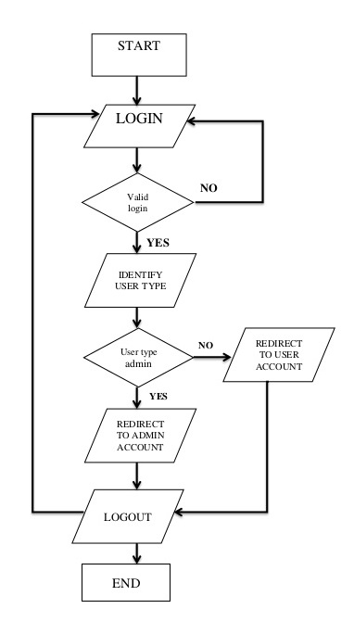**5 Flow Diagram**

**6 Coding**

* + 1. **Department Controller : -**

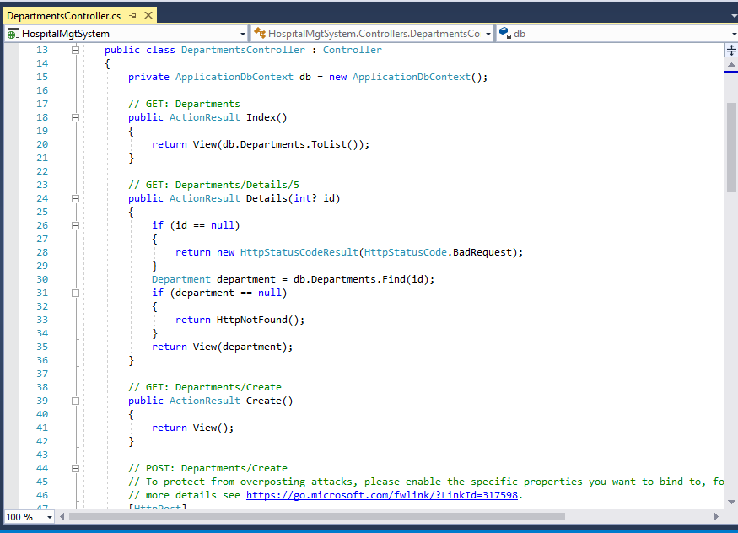

* + 1. **Designation Controller: -**

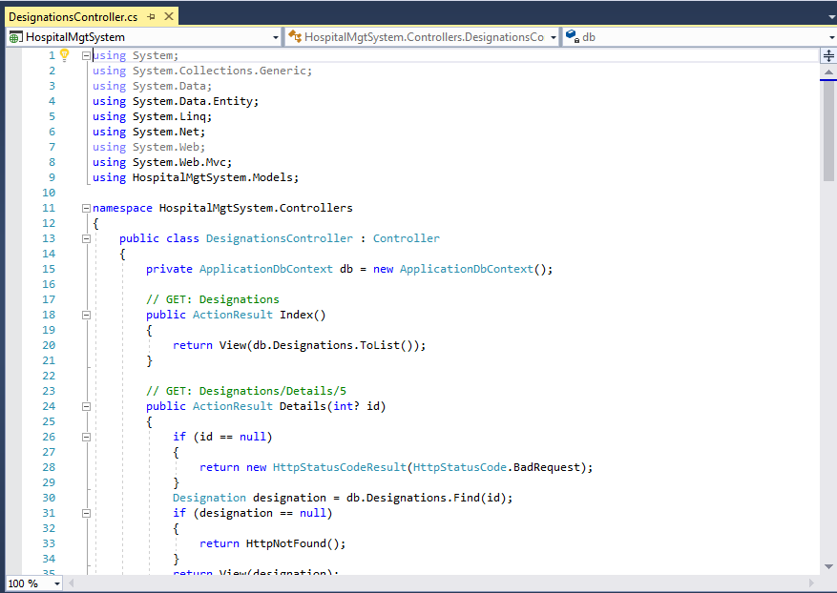

**c. Doctor Controller:-**

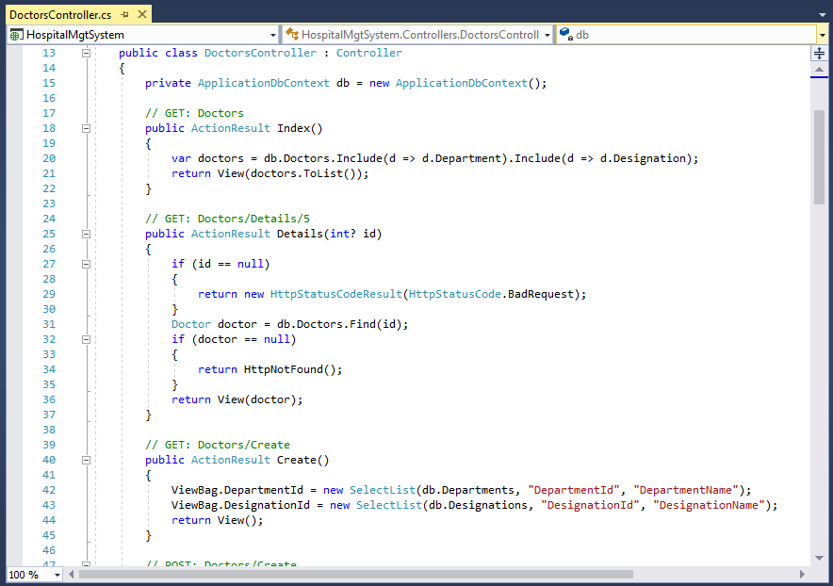

**d. Nurse Controller:-**

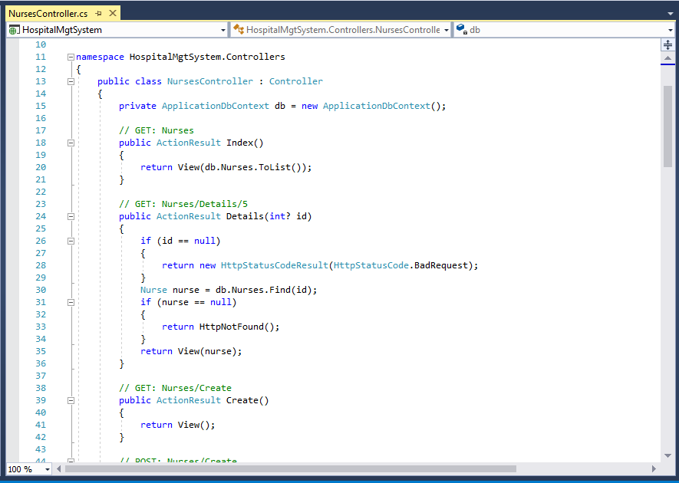

e. **Patient Controller:-**

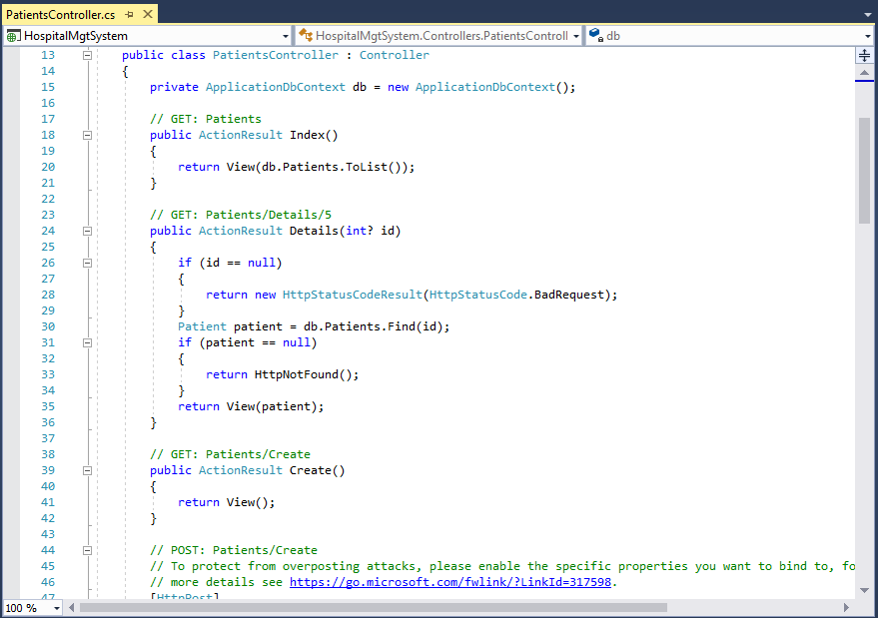

f. **Patient Admission Controller:-**

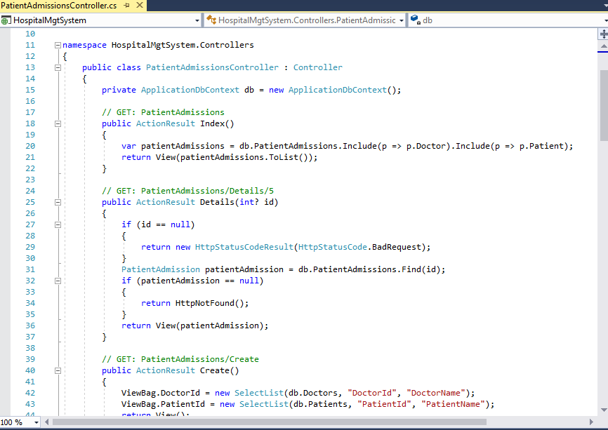

**g. Opd Registration Controller:-**

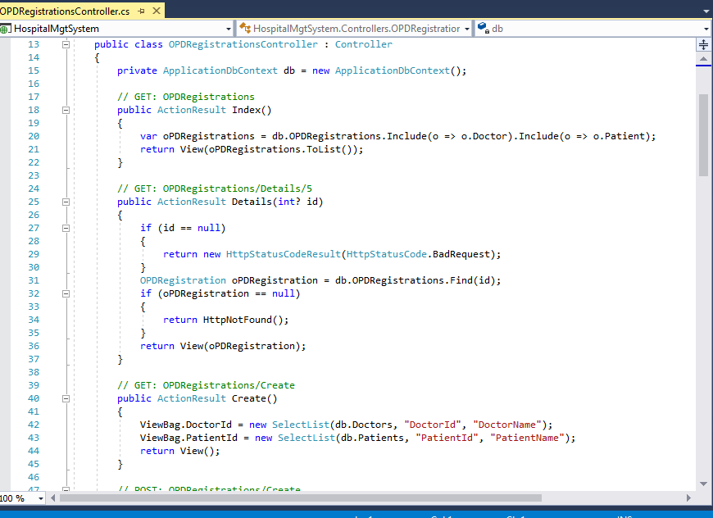

**h. Roles Controller:-**

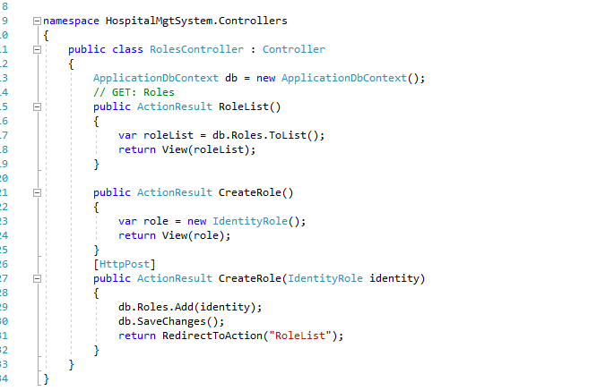

**8. Output Screens**

**1. Home Page: -** This is home page which is first page of our website.

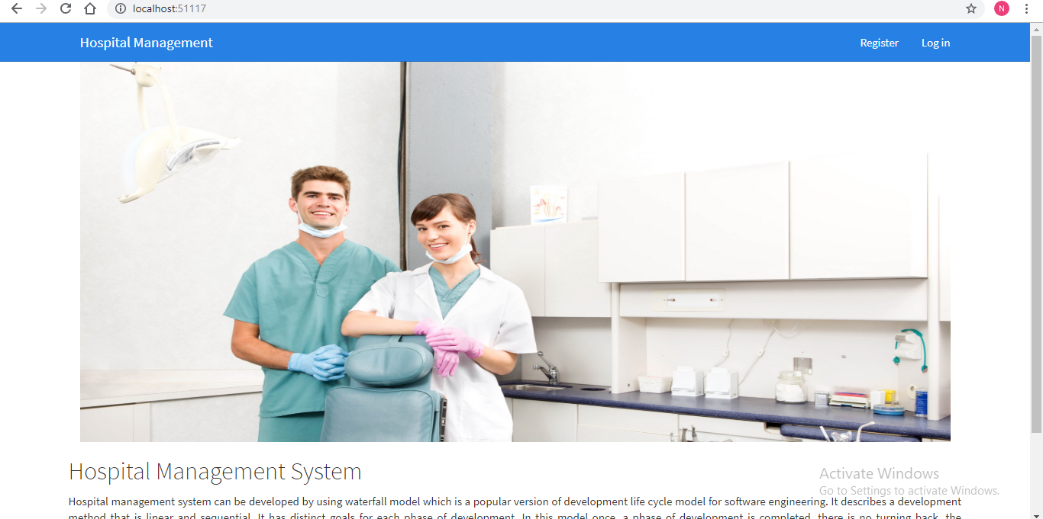

**2. Login Page: -** This is Login page of our website. In this page I can login as a Admin and As a Manager.

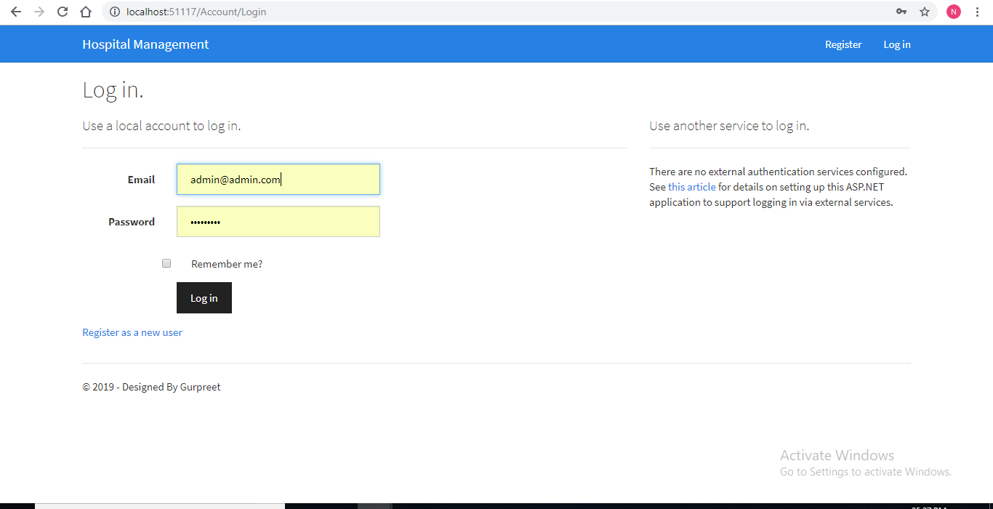

**3. Admin Login**: When admin logins then he can access the all modules of website. Which are shown in the picture.

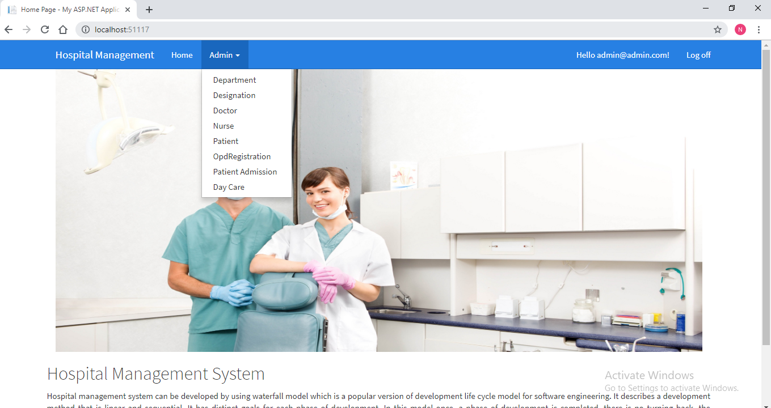

**4. Departments: -**  Here I can show the departments in my website. And clicking on the create new link I can create the departments. Edit and delete faci;ities are also available here.

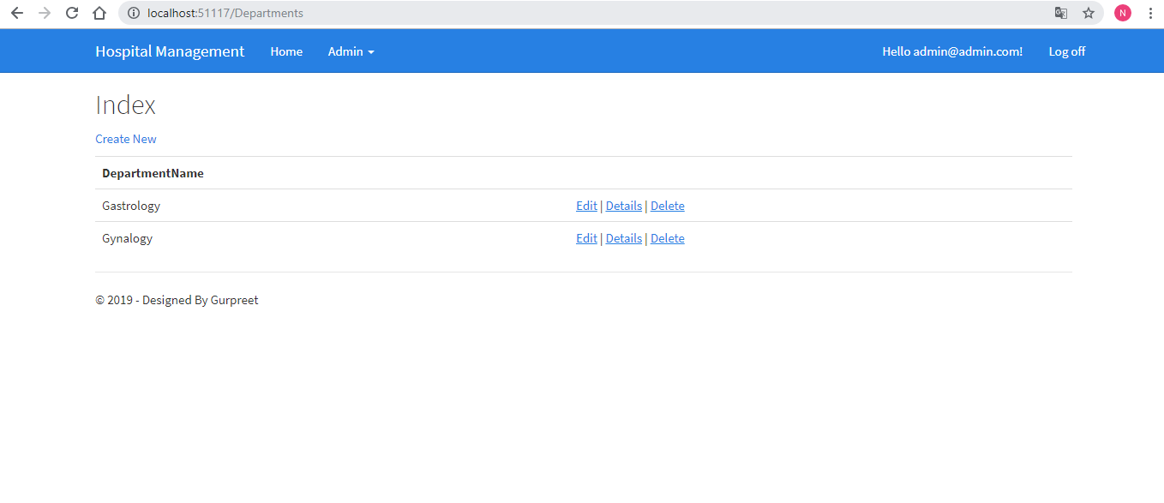

**5. Manager Logins:-** this is manager login view. In this manager can access that modules which are shown in the picture as below.

