1. Creating and Renaming Files/Directories

Create a directory named test_dir using mkdir.

Inside test_dir, create an empty file called example.txt.

Rename example.txt to renamed_example.txt using mv

Ans.

* To create directory -mkdir test_dir
* To create empty file –
  + cd test_dir
  + touch example.txt
* to rename in same folder use - mv example.txt renamed_example.txt

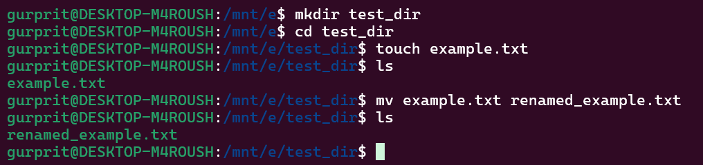

2. Viewing File Contents

Use cat to display the contents of /etc/passwd.

Display only the first 5 lines of /etc/passwd using head.

Display only the last 5 lines of /etc/passwd using tail.

Ans.

* To display contents in /etc/passwd – cat /etc/passwd
* Display only the first 5 lines of /etc/passwd using head - head -n 5 /etc/passwd

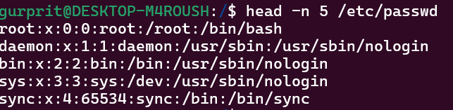

* Display only the last 5 lines of /etc/passwd using tail- tail-n 5 /etc/passwd

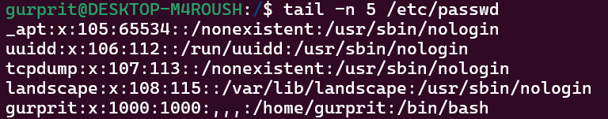

3. Searching for Patterns

Use grep to find all lines containing the word "root" in /etc/passwd.

Ans

* finding all lines containing the word “root” - cat /etc/passwd |grep root -n 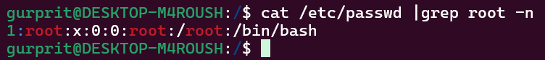

4. Zipping and Unzipping

Compress the test_dir directory into a file named test_dir.zip using zip.

Unzip test_dir.zip into a new directory named unzipped_dir.

Ans.

* Compress the test_dir directory into zip –
  + Need to have zip first - sudo apt install zip
  + Then use - zip test_dir.zip ./test_dir

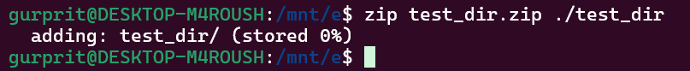

* Unziping it –
  + Remove if any directory present with same name- rm -rf test_dir
  + Then use unzip test_dir.zip

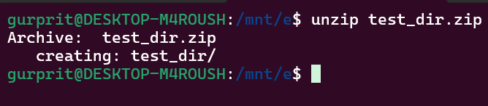

5. Downloading Files

Use wget to download a file from a URL (e.g., <https://example.com/sample.txt>).

Ans.

* Have used -https://gist.githubusercontent.com/Talha-Altair/b8a27d2b45add1dd7658fd34fa1968db/raw/bc45208c96df65e8e659c04e7d1f1bb54ec5b7e2/linux_commands.txt
* Command – wget <https://gist.githubusercontent.com/Talha-Altair/b8a27d2b45add1dd7658fd34fa1968db/raw/bc45208c96df65e8e659c04e7d1f1bb54ec5b7e2/linux_commands.txt>

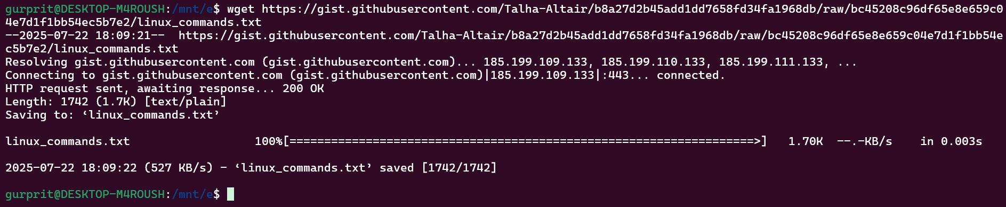

6. Changing Permissions

Create a file named secure.txt and change its permissions to read-only for everyone using chmod.

Ans.

* Create a file secure.txt using - touch secure.txt
* Check what are the current permissions using – ls -l
* For fully read only permissions use - chmod 444 secure.txt(it will be read only for all)

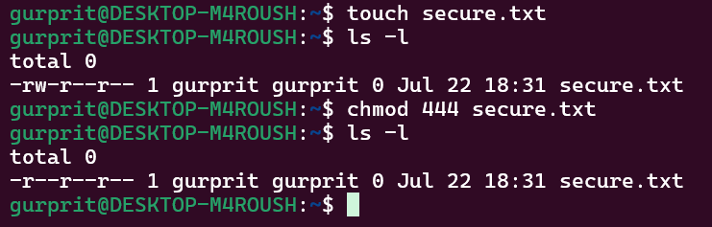

7. Working with Environment Variables

Use export to set a new environment variable called MY_VAR with the value "Hello, Linux!".

Ans.

* Use command - export MY_VAR="Hello, Linux!"
* Then use echo $MY_VAR

