**Machine Learning**

**Name: Gurpuneet Singh**

**Class: CSE3**

**Enrollment No.:01776802717**

**EXPERIMENT-5**

**Problem Statement**

Use any machine learning method to classify the email dataset

**Program Snippet**

**Reading CSV**

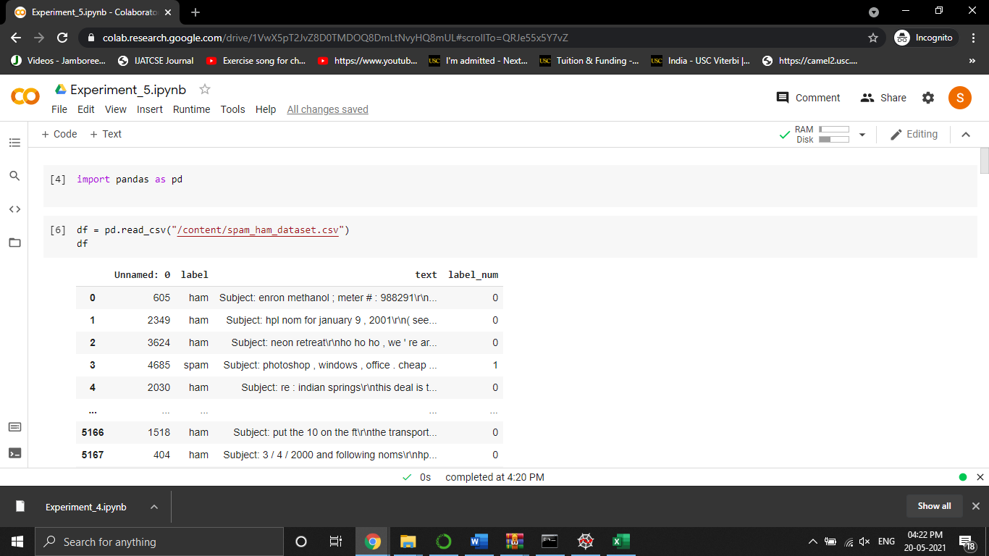

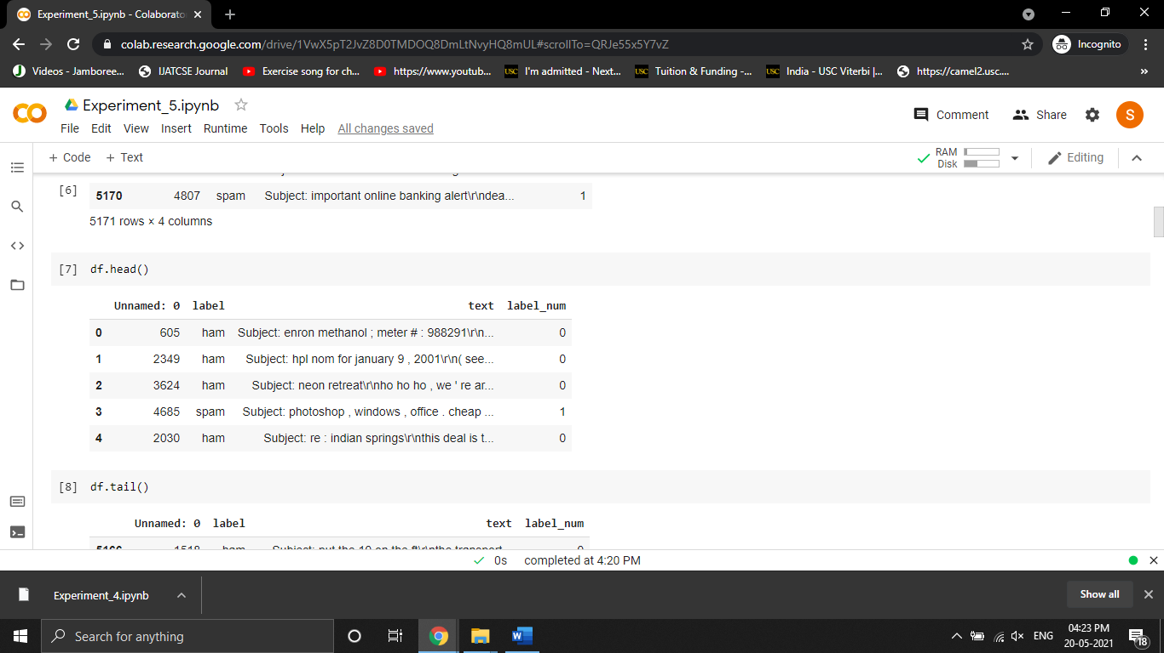

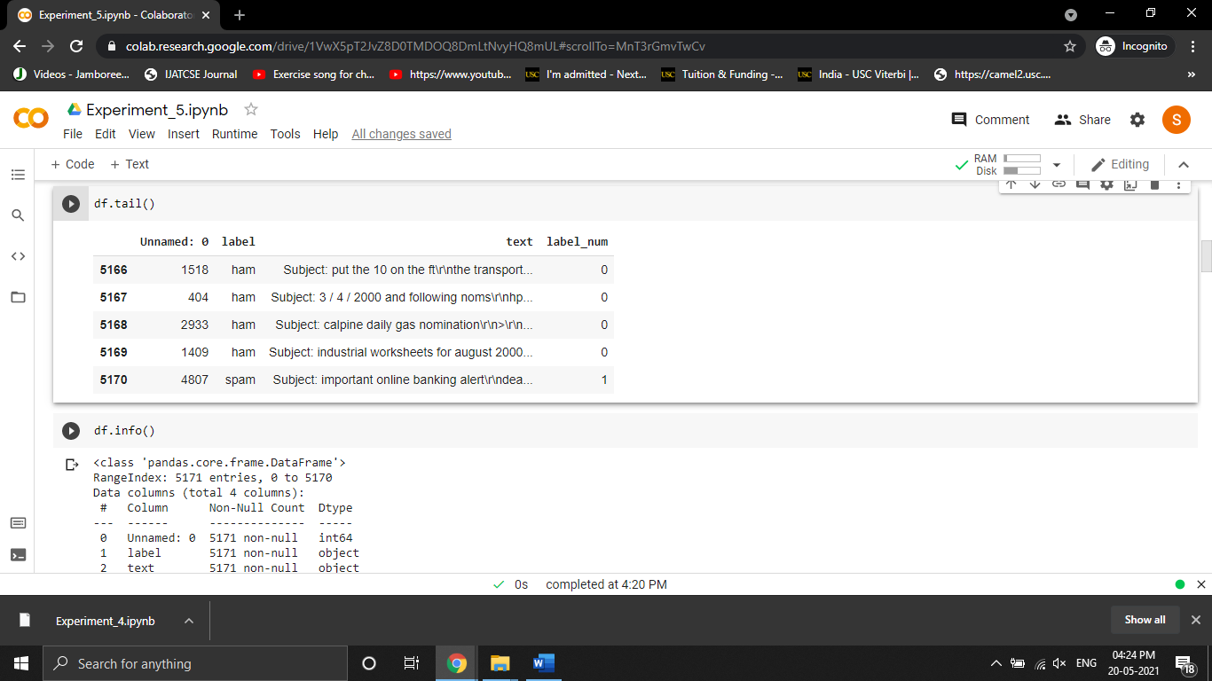

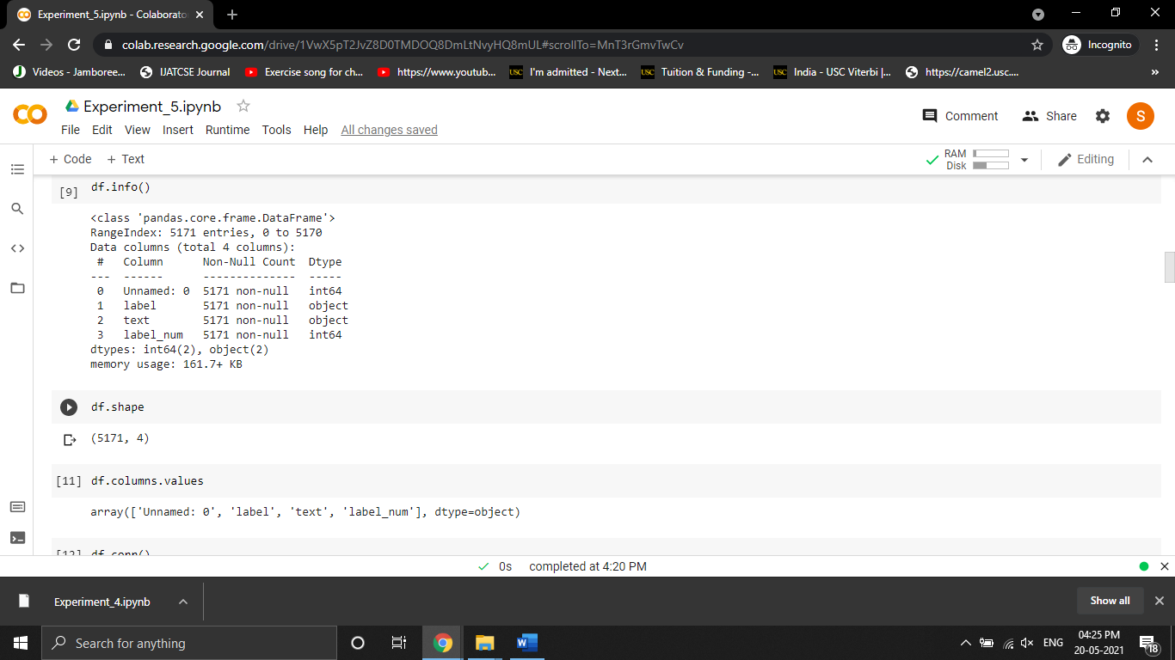

**Estimating the Relation**

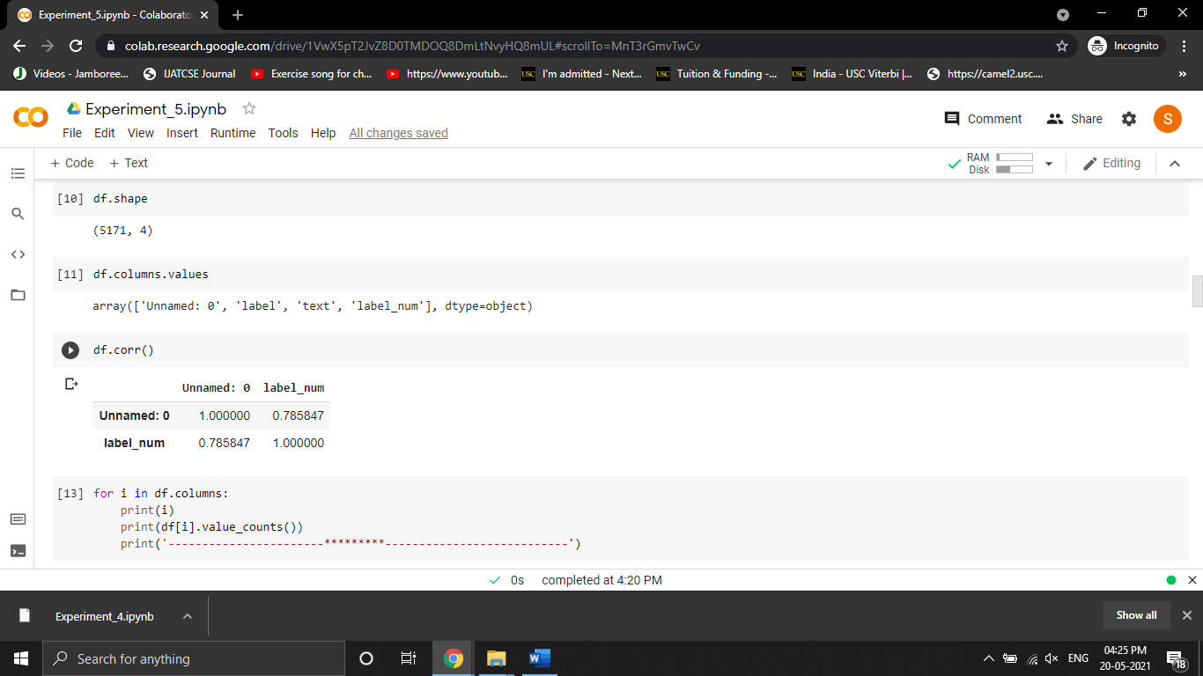

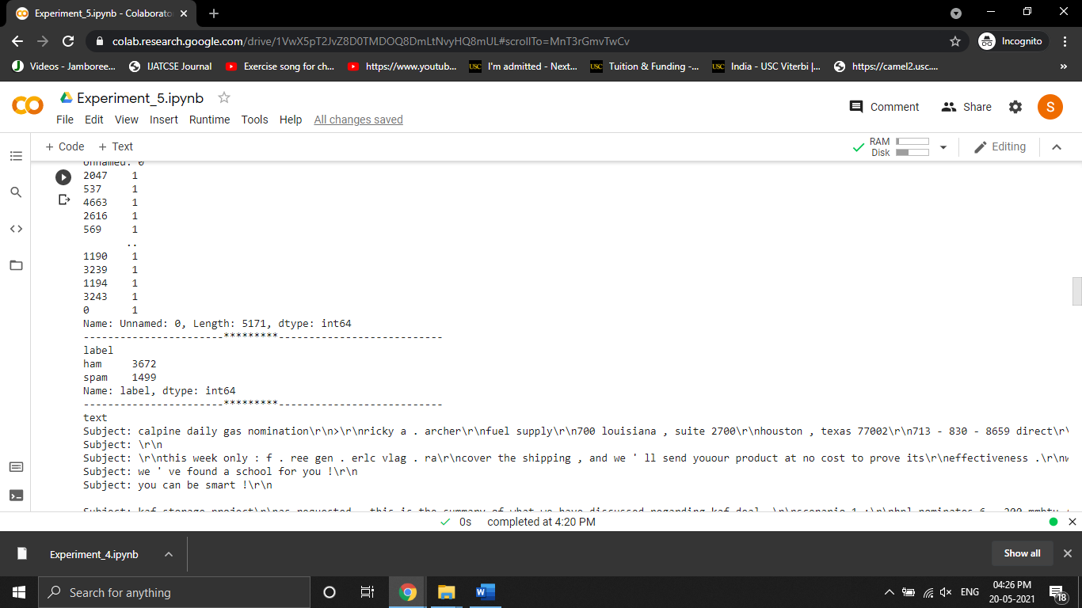

**Visualization**

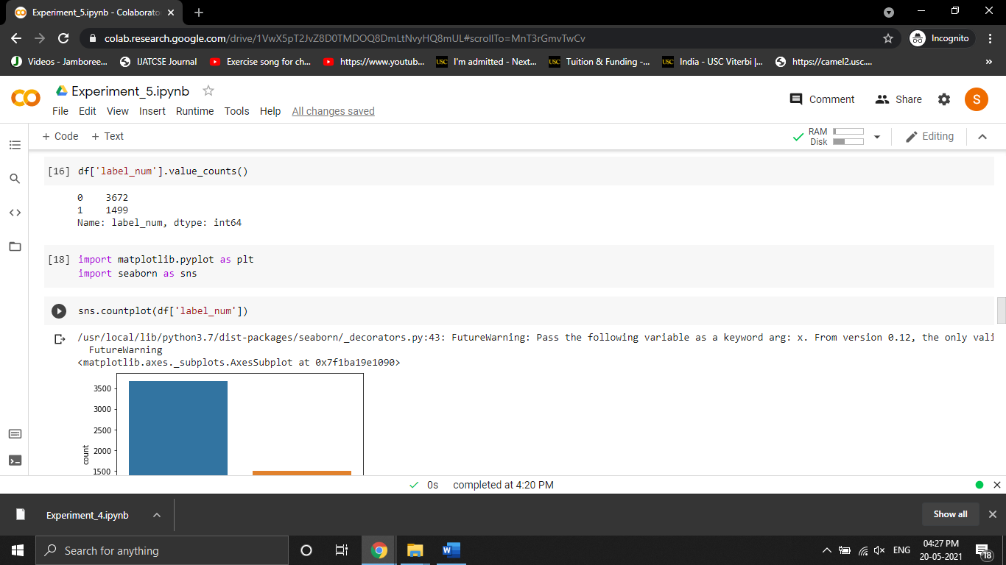

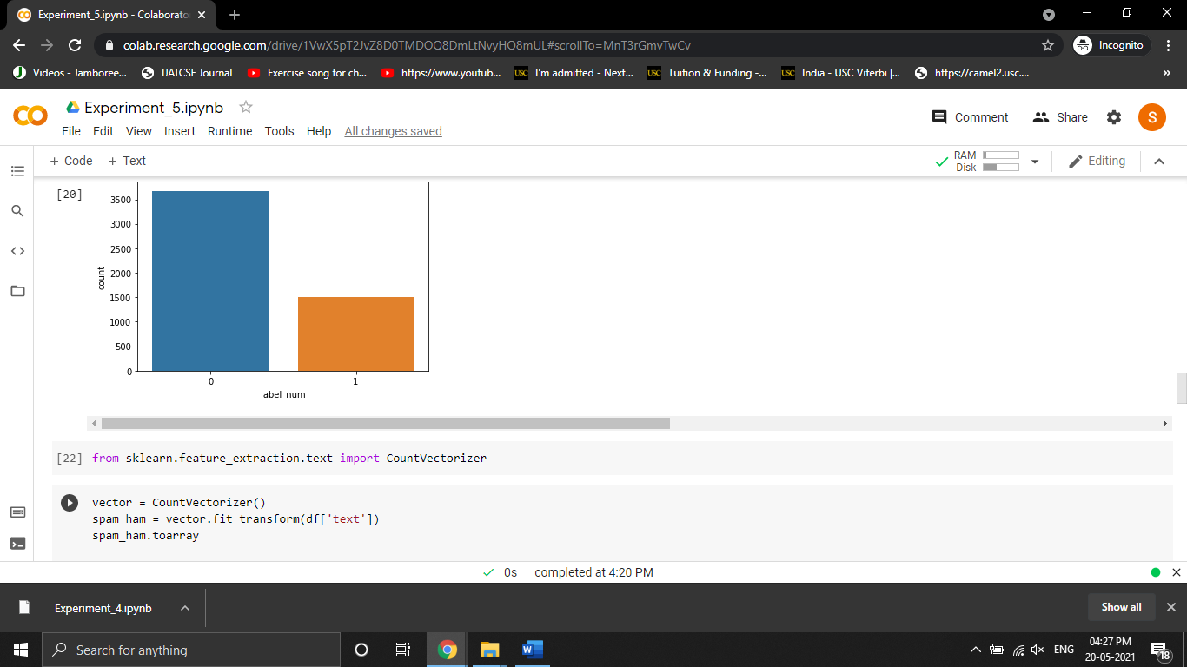

**Training and Testing the Dataset**

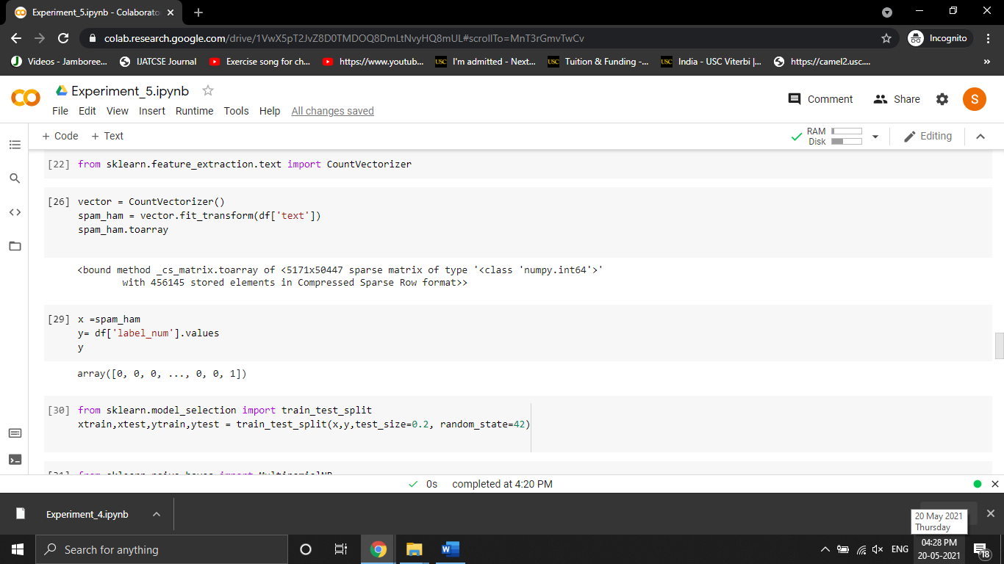

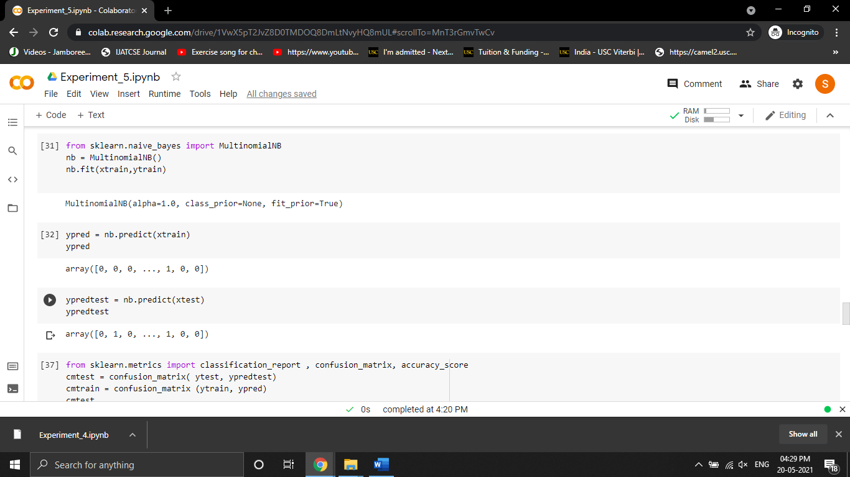

**Classification Report and Confusion Matrix**

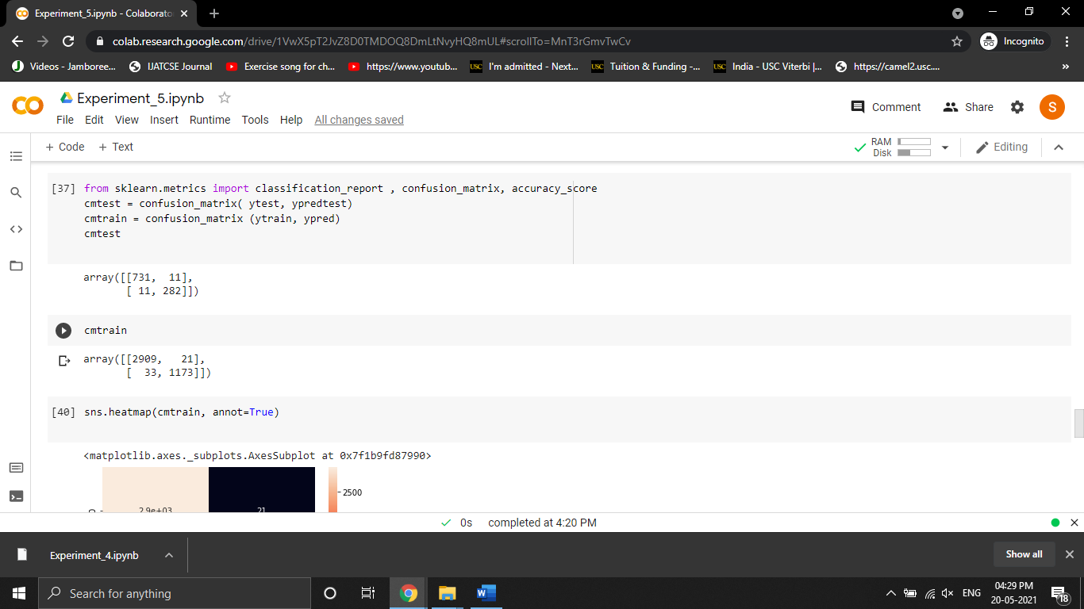

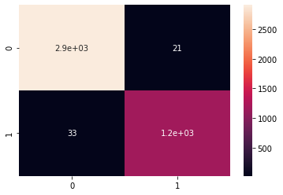

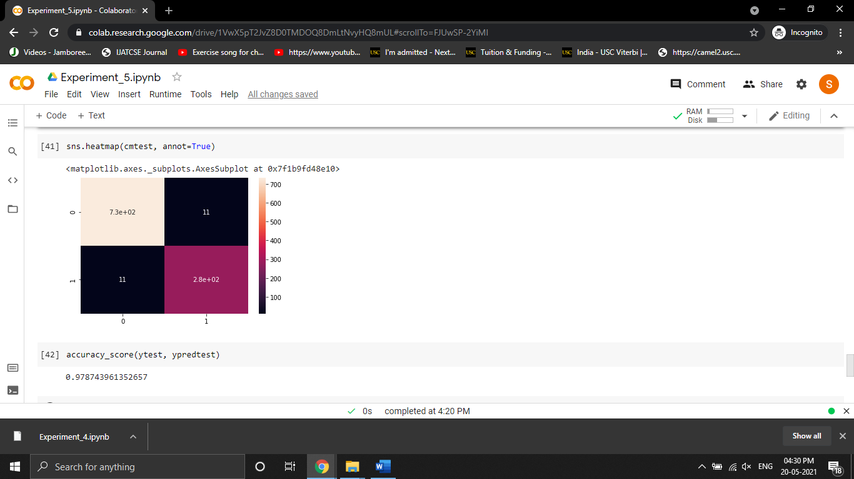

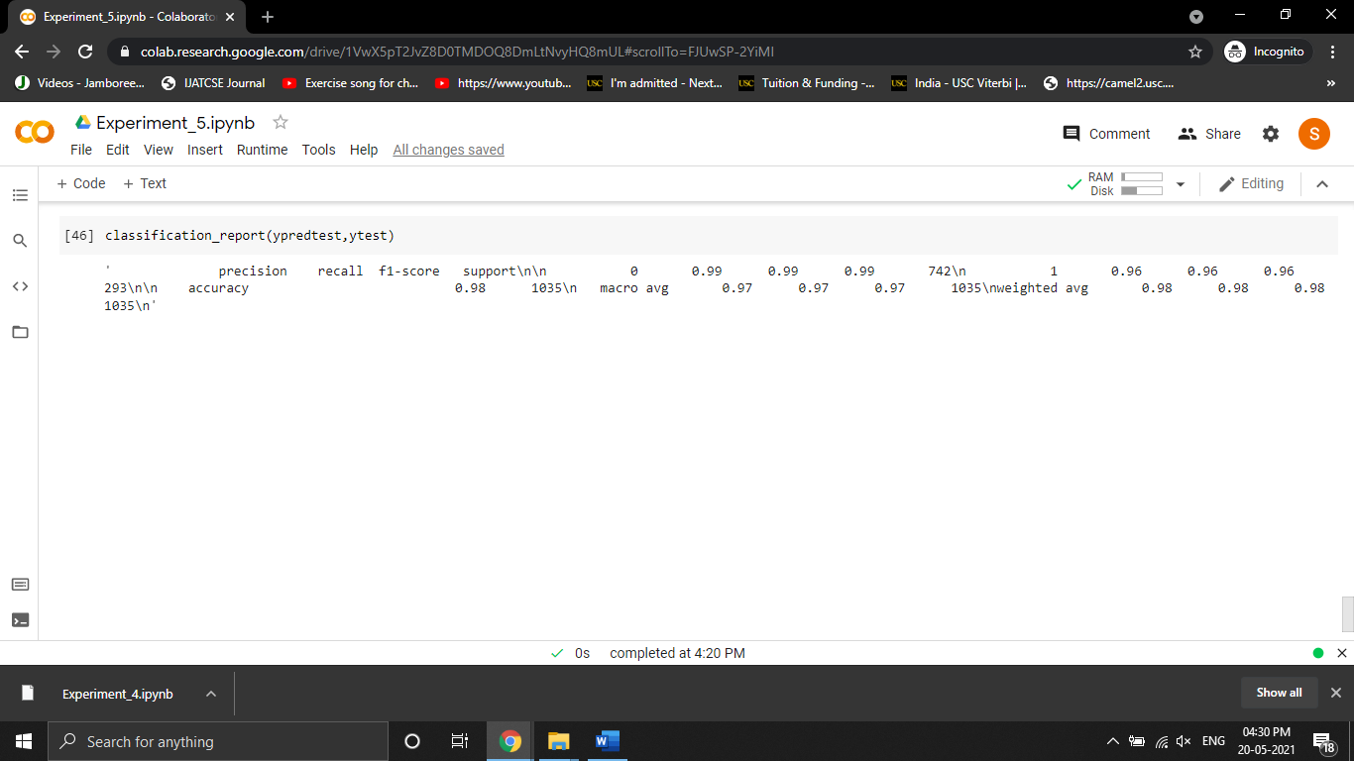

**Github Link**

<https://github.com/GurpuneetSingh/ML_FILE_EXPERIMENTS/blob/main/Experiment_5.ipynb>