Connect to a running mongo instance, use a database named mongo_practice. Document all your queries in a javascript file to use as a reference.

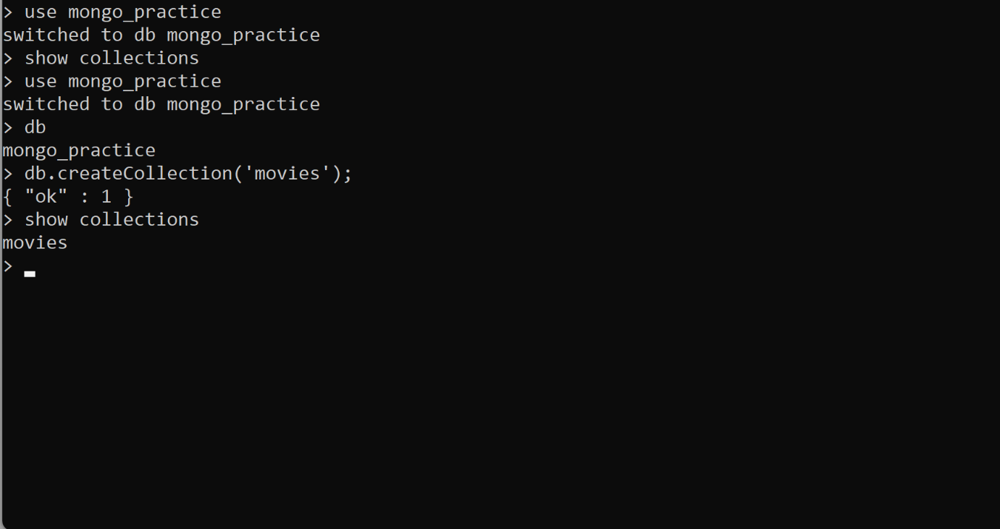

Insert the following documents into a movies collection.