What Is BizTalk Server?

* It is a middleware product from Microsoft that helps to connect various systems together.
* It allows you apply business rules to vendor data.
* In example, why we post letters in post office? because it is impossible for all of us to go and deliver letters to each address so, we post it in post office, and they take care of delivering it. Imagine Microsoft BizTalk Server as a post man delivering letters.

Integration through Adapters:

* BizTalk communicates with a variety of platforms and applications. How does that happen?

Microsoft has created a set of default adapters to communicate.

|  |  |
| --- | --- |
| **Adapter** | **Description** |
| FILE | Transfer files into and out of Microsoft Biztalk Server. Uses file receive adapter to read message from files and submit to server .After reads the files ,it create Biztalk msg obj so Biztalk server can process the message |
| HTTP | Exchange of information b/w Biztalk server and an application by means of HTTP protocol. Application can send msg to server by sending HTTP POST ,HTTP GET requests to a specified url. |
| SMTP | Exchange information b/w Biztalk server and an application by means of SMTP protocol. Server can send message to other application by creating an e-mail msg and delivering to a specified e-mail address |
| SFTP | send and receive messages from a secure FTP server using the SSH file transfer protocol |
| SQL | To communicate with SQL server database by developing BizTalk app using WCF |
| SB-Messaging | used to receive and send from service bus entities like Queues,topics,relays.Has methods to authenticate namely 1.Access Control Service(ACS) 2.Shared Access Signature(SAS). Support max size of msg is 1mb and doesn’t support AMQP protocol which can handle larger messages |
| Azure Blob Storage | can send and receive msg b/w Biztalk server and Azure Blob storage(Microsoft’s object storage solution for the cloud ,optimized for storing massive amount of unstructured data |
| SOAP | Microsoft Biztalk Server Web Services use the SOAP adapter when receiving and sending Web Service Requests |
| WCF-Custom | it is an in process adapter to allow configuring receive locations and send ports with any binding behavior settings for Window Communication Foundation(WCF) |

Building a BizTalk Server application:

* Schema
  + Document Schema (XML Schema)
  + Property Schema
  + Flat file Schema
  + Flat file Schema Wizard
* Map
* Pipeline
  + Receive Pipeline
  + Send Pipeline
  + Pipeline Components
* Orchestration

**Schema:**

* Schema defines structure of an XML (incoming message)
* First, we need to establish the structure to our data.
* Once after creating schema, you can revisit them later anytime and can do edit as you need.

**Inbound:**

<employeedetails>  
 <FirstName>Sai</FirstName>  
 <LastName>Kumar</LastName>  
 <Id>12345</Id>  
 <OfficeAddress>SIPCOT IT Park</OfficeAddress>  
 <OfficeLocation>Chennai</OfficeLocation>  
</employeedetails>

**Outbound:**

<employee>  
 <Name>Sai Kumar</Name>  
 <Id>12345</Id>  
 <Location> SIPCOT IT Park, Chennai</Location>  
</employee>

**Maps:**

* The transformation from Inbound message to Outbound message happens using Map.
* Once after creating Maps, you can revisit them later anytime and can do edit as per the requirement.
* Where the Maps called?  
  when these maps are invoked in orchestration, then the transformation will take place.

**Pipeline:**

* In receive pipeline, any format of message will be converted into XML format.
* In receive pipeline, any encrypted message will be decrypted and will feed to BizTalk.
* In send pipeline, XML format of message will be further converted into any format.
* In send pipeline, message can be encrypted and sent to the destination.
* In both sides, we are converting from ANSI to UTF8 and UTF8 to ANSI.

**Orchestration:**

* Within orchestrations we can make decision making scenarios or business processes.

**Receive Port:**

* Incoming Message will be received in **Receive Ports** through one of the **Receive Locations** associated with that Port.

**Receive Location:**

* In receive location, we will configure the **Adapter Type**, **URI, Receive Pipeline and Receive Handler**

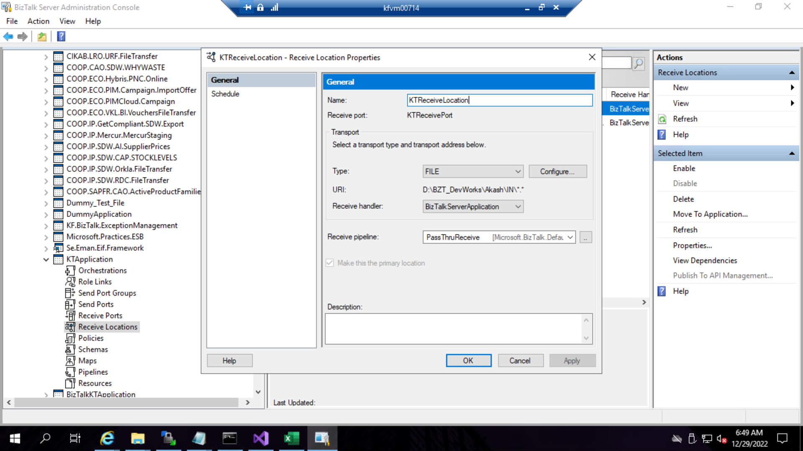

**Send Port:**

* Using Send Ports, message will be further processed from BizTalk to the destination system.
* In Send Port, we will configure the **Adapter Type**, **URI, Send Pipeline and Send Handler**

Q: Is Schema, Map, Orchestrations are necessary to create BizTalk application?  
Ans: No, without using we can transmit message from Source to Destination by applying Filters in the Send Port. Refer below screenshot and see what property, operator, value we have given.

In case if we are using Orchestrations, we must configure **Receive Port** and **Send Port** in Orchestration**.** So, Orchestration will get message from Receive Port, it will go through the business logic and further transmits to the message to destination using **Send Port**. Refer below screenshot for configuring Orchestration.

