**Restaurant Recommendation System**

Firstly we have downloaded the zomato restaurant dataset from Kaggle.

You can download the dataset with the following link

<https://www.kaggle.com/himanshupoddar/zomato-bangalore-restaurants>

As this dataset set is hugh and it has a lot of messy data, we performed preprocess of data and removed few records, replaced null values with appropriate values and we also add few columns like discount, capacity, acceptable payment mode, catering etc to the existing data.

Then we loaded the resultant data into the table using pyspark and spark sql as shown below

from pyspark.sql import *

s=SparkSession.builder.getOrCreate()

rest=s.read.csv("C:/Users/USER/Desktop/Revature/cleanedData_final.csv",inferSchema=True,header=True)

The schema of the table is as shown below

rest.printSchema()

root

|-- url: string (nullable = true)

|-- address: string (nullable = true)

|-- name: string (nullable = true)

|-- online_order: string (nullable = true)

|-- book_table: string (nullable = true)

|-- rate: double (nullable = true)

|-- votes: integer (nullable = true)

|-- phone: string (nullable = true)

|-- location: string (nullable = true)

|-- rest_type: string (nullable = true)

|-- cuisines: string (nullable = true)

|-- approx_cost_for_two_people: integer (nullable = true)

|-- reviews_list: string (nullable = true)

|-- menu_item: string (nullable = true)

|-- listed_in_type: string (nullable = true)

|-- listed_in_city: string (nullable = true)

|-- payMode: string (nullable = true)

|-- Discount: integer (nullable = true)

|-- Capacity: integer (nullable = true)

|-- Catering: string (nullable = true)

Creating table from dataframe

rest.registerTempTable('restaurant2')

Now we processed the data in the table to extract few usecases from the user’s perspective

**Usecases :**

**1. Restaurant names in Banashankari with online order and table booking availability**

**2. Top rated restaurant with their type of service.**

**3. The costly restaurant (cost for 2 greater than 800) with restaurant type and location located in Bannerghatta Road**

**4. Restaurants in Bannerghatta Road with cost for two people between 500 to 800 with its type, rating and location**

**5. Top Voted Restaurant details**

**6. Restaurants in Banashankari having votes greater than 500 and having the menu list with restaurant type**

**7. Top 5 Restaurant details based on votes and rating in both cities.**

**8. Top five restaurants based on rating and votes which has continental in their cuisines list**

**9. Top 5 restaurants based on rating and votes, having the rest_type as Casual Dining**

**10. Top 5 costly restaurants with restaurant name location,cuisines,rate,votes,approx_cost_2 and listed_in_type based on approx_cost_2,rate and votes.**

**11. List of restaurants which are rated more than 3.5 in reviews list**

**12. Restaurant name,loaction,rating and discount having discount>30 order by discount and rating in descending order**

**13. Restaurant having catering facility in Banashankari area**

**14. Café Restaurant accepting credit card and Paytm mode of payment**

**15. Dessert type restaurant having capacity greater than 100 order by capacity, rating and votes**

**16.Restaurant details which have catering facility and accepting cash with high discounts with menu**

**17. find menu list of restaurant where online orders are accepted, book table facility should be there and PhonePe is available.**

**18. Looking for good discount and restaurant type should be Drinks and Night Life.**

**19. Restaurant type should be dine out and dosa should be there in the menu item**

**20. Veg food in banashankari, budget is 800 max, please provide url, address, name, mobile Number of the restaurant and one more thing I only have Paytm to pay the bills.**

**Restaurant names in Banashankari with online order and table booking availability**

s.sql('select distinct name from restaurant2 where online_order="Yes" and book_table="Yes" and listed_in_city="Banashankari"').show()

+-------------------+

| name|

+-------------------+

| Patio 805|

| Sri Udupi Food Hub|

| The Coffee Shack|

| Subz|

| Vinny's|

| Grazers|

| Goa 0 Km|

| Cafe Shuffle|

| The Grillo|

| My Tea House|

|Sea Spice by 7 Star|

+-------------------+

**Top rated restaurant with their type of service.**

s.sql('select name,rest_type,rate from restaurant2 where rate>="4.0/5" group by name,rest_type,rate order by rate').show()

+--------------------+------------------+----+

| name| rest_type|rate|

+--------------------+------------------+----+

| Curry Leaves| Casual Dining| 4.1|

|Zhang's - Chinese...| Casual Dining| 4.1|

| The Airos| Cafe| 4.1|

|Eurasia Pasta and...|Casual Dining/ Bar| 4.1|

| Chai Kraft| Beverage Shop| 4.1|

| Chutney Chang| Casual Dining| 4.1|

| Andhra Ruchulu|Casual Dining/ Bar| 4.1|

|Bengaluru Coffee ...| Quick Bites| 4.1|

| SLV Refreshment| Quick Bites| 4.1|

| Sri Udupi Food Hub| Casual Dining| 4.1|

| Punjabi Times| Casual Dining| 4.1|

| 24th Main| Casual Dining| 4.1|

| Spice Elephant| Casual Dining| 4.1|

|Udupi Sri Krishna...| Quick Bites| 4.1|

| Kabab Magic| Quick Bites| 4.1|

|Biggies Burger 'n...| Quick Bites/ Cafe| 4.1|

| Cafe Aira| Cafe| 4.1|

| Mystique Palate| Quick Bites| 4.1|

| Gorbandh| Quick Bites| 4.1|

|Dev Sagar - Food ...| Quick Bites| 4.1|

+--------------------+------------------+----+

**The costly restaurant (cost for 2 greater than 800) with restaurant type and location located in Bannerghatta Road**

s.sql('select name,rest_type,location from restaurant2 where approx_cost_2>=800 and listed_in_city="Bannerghatta Road"').show()

+--------------------+------------------+-----------------+

| name| rest_type| location|

+--------------------+------------------+-----------------+

| Cafe Coffee Day| Cafe|Bannerghatta Road|

| Smoor| Dessert Parlor|Bannerghatta Road|

| Shee-Sha Cafe|Cafe/Casual Dining|Bannerghatta Road|

| Mudpipe Cafe| Cafe| JP Nagar|

| Sai Abhiruchi| Casual Dining| BTM|

|Capsicum Family R...| Casual Dining| BTM|

| Kundana| Casual Dining|Bannerghatta Road|

| Daniyal's| Quick Bites| BTM|

| Nellore Ruchulu| Casual Dining|Bannerghatta Road|

| Cafe Coffee Day| Cafe|Bannerghatta Road|

| Smoke Oil Salt| Quick Bites| BTM|

|Street Foods by P...| Food Court|Bannerghatta Road|

|Melting Pot at Wo...| Quick Bites| JP Nagar|

| The Kitchen| Casual Dining| JP Nagar|

| Nandhana Palace| Casual Dining/Bar|Bannerghatta Road|

| Aramane Restaurant| Casual Dining|Bannerghatta Road|

| Calvin's| Takeaway/Delivery| Bommanahalli|

| Mudpipe Cafe| Cafe| JP Nagar|

| Smoor| Dessert Parlor|Bannerghatta Road|

+--------------------+------------------+-----------------+

**Restaurants in Bannerghatta Road with cost for two people between 500 to 800 with its type, rating and location**

s.sql('select name,listed_in_type,rate,location from restaurant2 where (approx_cost_2 between 500 and 800) and listed_in_city="Bannerghatta Road"').show()

+--------------------+--------------+-----+-----------------+

| name|listed_in_type| rate| location|

+--------------------+--------------+-----+-----------------+

| Ovenstory Pizza| Delivery|4.0/5|Bannerghatta Road|

| Slate Cafe| Delivery|4.1/5| JP Nagar|

| Nellore Ruchulu| Delivery|3.7/5|Bannerghatta Road|

| Bangaliana| Delivery|2.9/5|Bannerghatta Road|

| Gud Dhani| Delivery|4.0/5| BTM|

| McDonald's| Delivery|4.0/5|Bannerghatta Road|

| Pancuzzi| Delivery|4.2/5| JP Nagar|

| The Egg Factory| Delivery|4.0/5| JP Nagar|

| Zeeshan| Delivery|3.1/5| JP Nagar|

| Shetty's Kitchen| Delivery|3.7/5|Bannerghatta Road|

|Sambram Biriyani ...| Delivery|3.5/5| JP Nagar|

|BIB - Breakfast i...| Delivery|3.8/5|Bannerghatta Road|

| Innerchef| Delivery| | JP Nagar|

| Krishna Vijayashree| Delivery|3.5/5|Bannerghatta Road|

| Triveni| Delivery|3.6/5|Bannerghatta Road|

| Alif Restaurant| Delivery|3.6/5| JP Nagar|

|Dine One One Rest...| Delivery|3.6/5|Bannerghatta Road|

| Healthie| Delivery| | JP Nagar|

| Suryawanshi| Delivery|3.7/5|Bannerghatta Road|

| World In A Bowl| Delivery| | JP Nagar|

+--------------------+--------------+-----+-----------------+

**Top Voted Restaurant details**

s.sql('select max(votes) from restaurant2').show()

+----------+

|max(votes)|

+----------+

| 4401|

+----------+

>>> s.sql('select * from restaurant2 where votes=4401').show()

+---+--------------------+--------------------+-------------+------------+----------+-----+-----+------------+---------+-------------+--------------------+-------------+--------------------+---------+--------------+--------------+

|sno| url| address| name|online_order|book_table| rate|votes| phone| location| rest_type| cuisines|approx_cost_2| reviews_list|menu_list|listed_in_type|listed_in_city|

+---+--------------------+--------------------+-------------+------------+----------+-----+-----+------------+---------+-------------+--------------------+-------------+--------------------+---------+--------------+--------------+

| 78|https://www.zomat...|52/1st Floor/33rd...|Meghana Foods| Yes| No|4.4/5| 4401|080 49653564|Jayanagar|Casual Dining|Biryani/North Ind...| 600|"[('Rated 2.0'/'R...| []| Delivery| Banashankari|

+---+--------------------+--------------------+-------------+------------+----------+-----+-----+------------+---------+-------------+--------------------+-------------+--------------------+---------+--------------+--------------+

**Restaurants in Banashankari having votes greater than 500 and having the menu list with restaurant type**

s.sql('select name,menu_list,rest_type,votes from restaurant2 where votes>500 and listed_in_city="Banashankari" and menu_list!="notAvailable"').show()

+--------------------+--------------------+-------------+-----+

| name| menu_list| rest_type|votes|

+--------------------+--------------------+-------------+-----+

| Recipe|['Veg Fried Rice'...|Casual Dining| 804|

| FreshMenu|"[""Egg 'n' Chick...| Delivery| 627|

|Sri Guru Kottures...|['Benne Dose'/ 'B...| Quick Bites| 558|

| Anna Kuteera|['Vada'/ 'Ghee Ma...|Casual Dining| 771|

| Kamat Bugle Rock|['Idly Combo [Ser...| Quick Bites| 543|

| Maiyas|[' 2 Rice Idli'/ ...| Quick Bites| 1778|

| Ayodhya Upachar|['Masala Dosa'/ '...| Quick Bites| 734|

| The Krishna Grand|['Idly [2 Pieces]...|Casual Dining| 888|

| Roti Ghar|['Mysore Tatte Id...|Casual Dining| 750|

| The Krishna Grand|['Idly [2 Pieces]...|Casual Dining| 888|

| Smacznego|['Cheesy Fries'/ ...| Cafe| 504|

| Anna Kuteera|['Vada'/ 'Ghee Ma...|Casual Dining| 771|

| Ayodhya Upachar|['Veg Fried Rice ...| Quick Bites| 734|

| KFC|['Boneless Strips...| Quick Bites| 505|

| Domino's Pizza|['Margherita'/ 'F...| Quick Bites| 540|

| Roti Ghar|['Mushroom Masala...|Casual Dining| 750|

| Baisakhi|['Baby Corn Satay...|Casual Dining| 527|

+--------------------+--------------------+-------------+-----+

**Top 5 Restaurant details based on votes and rating in both cities.**

s.sql('select name,address,location,rate,votes,cuisines,rest_type from restaurant2 where listed_in_city="Banashankari” order by votes desc,rate desc').show(5)

+--------------------+--------------------+-----------------+----+-----+--------------------+------------------+

| name| address| location|rate|votes| cuisines| rest_type|

+--------------------+--------------------+-----------------+----+-----+--------------------+------------------+

| Brewsky|55/ 5th Floor/ Go...| JP Nagar| 4.4| 4309|Continental/ Amer...| Microbrewery|

| Barbeque Nation|67/ 15th Cross/ 6...| JP Nagar| 4.7| 3845|North Indian/ Eur...| Casual Dining|

| Empire Restaurant|4 & 5/ Green Orch...|Bannerghatta Road| 4.3| 3178|North Indian/ Mug...| Casual Dining|

|Chulha Chauki Da ...|13/ 7th Cross/ 2n...| JP Nagar| 4.2| 2350| North Indian| Casual Dining|

| Chavadi|4/ Arama Suites/ ...|Bannerghatta Road| 4.4| 2233|Continental/ Nort...|Casual Dining/ Bar|

+--------------------+--------------------+-----------------+----+-----+--------------------+------------------+

only showing top 5 rows

>>> s.sql('select name,address,location,rate,votes,cuisines,rest_type from restaurant2 where listed_in_city="Bannerghatta Road" order by votes desc,rate desc').show(5)

+--------------------+--------------------+-----------------+----+-----+--------------------+------------------+

| name| address| location|rate|votes| cuisines| rest_type|

+--------------------+--------------------+-----------------+----+-----+--------------------+------------------+

| Brewsky|55/ 5th Floor/ Go...| JP Nagar| 4.4| 4309|Continental/ Amer...| Microbrewery|

| Barbeque Nation|67/ 15th Cross/ 6...| JP Nagar| 4.7| 3845|North Indian/ Eur...| Casual Dining|

| Empire Restaurant|4 & 5/ Green Orch...|Bannerghatta Road| 4.3| 3178|North Indian/ Mug...| Casual Dining|

|Chulha Chauki Da ...|13/ 7th Cross/ 2n...| JP Nagar| 4.2| 2350| North Indian| Casual Dining|

| Chavadi|4/ Arama Suites/ ...|Bannerghatta Road| 4.4| 2233|Continental/ Nort...|Casual Dining/ Bar|

+--------------------+--------------------+-----------------+----+-----+--------------------+------------------+

only showing top 5 rows

**Top five restaurants based on rating and votes which has continental in their cuisines list**

s.sql('select name,address,location,rate,votes,cuisines,rest_type,listed_in_city as city from restaurant2 where cuisines like "%Continental%" order by votes desc,rate desc').show(5)

+-----------+--------------------+-----------------+----+-----+--------------------+------------------+-----------------+

| name| address| location|rate|votes| cuisines| rest_type| city|

+-----------+--------------------+-----------------+----+-----+--------------------+------------------+-----------------+

| Brewsky|55/ 5th Floor/ Go...| JP Nagar| 4.4| 4309|Continental/ Amer...| Microbrewery|Bannerghatta Road|

| Chavadi|4/ Arama Suites/ ...|Bannerghatta Road| 4.4| 2233|Continental/ Nort...|Casual Dining/ Bar|Bannerghatta Road|

| Vinny's|2467/ 24th Cross/...| Banashankari| 4.2| 2115|Pizza/ Italian/ C...| Casual Dining| Banashankari|

| Vinny's|2467/ 24th Cross/...| Banashankari| 4.2| 2115|Pizza/ Italian/ C...| Casual Dining| Banashankari|

|Churchill's|37/953/ 2nd Floor...| JP Nagar| 4.1| 1403|North Indian/ Con...|Casual Dining/ Pub|Bannerghatta Road|

+-----------+--------------------+-----------------+----+-----+--------------------+------------------+-----------------+

only showing top 5 rows

**Top 5 restaurants based on rating and votes, having the rest_type as Casual Dining**

s.sql('select distinct name,location,cuisines,rate,votes from restaurant2 where rest_type like "%Casual Dining%" order by rate desc,votes desc').show(5)

+-----------------+-----------------+--------------------+----+-----+

| name| location| cuisines|rate|votes|

+-----------------+-----------------+--------------------+----+-----+

| Barbeque Nation| JP Nagar|North Indian/ Eur...| 4.7| 3845|

| Onesta| Banashankari|Pizza/ Cafe/ Italian| 4.6| 2556|

| Meghana Foods| Jayanagar|Biryani/ North In...| 4.4| 4401|

| Chavadi|Bannerghatta Road|Continental/ Nort...| 4.4| 2233|

|Empire Restaurant|Bannerghatta Road|North Indian/ Mug...| 4.3| 3178|

+-----------------+-----------------+--------------------+----+-----+

only showing top 5 rows

**Top 5 costly restaurants with restaurant name**

**location,cuisines,rate,votes,approx_cost_2 and listed_in_type based on approx_cost_2,rate and votes.**

s.sql('select distinct name,location,cuisines,rate,votes,approx_cost_2,listed_in_type from restaurant2 order by approx_cost_2 desc,votes desc,rate desc').show(5)

+--------------------+-----------------+--------------------+----+-----+-------------+--------------+

| name| location| cuisines|rate|votes|approx_cost_2|listed_in_type|

+--------------------+-----------------+--------------------+----+-----+-------------+--------------+

| Eswar| Mysore Road| New| 4.9| 1221| 1000| Dine-out|

|Ayda Persian Kitchen| Banashankari|North Indian/ Ira...| 3.7| 39| 950| Delivery|

|Ayda Persian Kitchen| Banashankari|North Indian/ Ira...| 3.7| 39| 950| Dine-out|

|Savoury - Sea She...|Bannerghatta Road|Arabian/ North In...| 3.9| 1227| 900| Delivery|

| Jalpaan| Jayanagar|North Indian/ Con...| 4.0| 866| 900| Delivery|

+--------------------+-----------------+--------------------+----+-----+-------------+--------------+

only showing top 5 rows

**List of restaurants which are rated more than 3.5 in reviews list**

s.sql('select name,location,rest_type from restaurant2 where substring(reviews_list,6,9)>"3.5"').show()

+--------------------+------------------+-------------------+

| name| location| rest_type|

+--------------------+------------------+-------------------+

| San Churro Cafe| Banashankari|Cafe/ Casual Dining|

|Addhuri Udupi Bho...| Banashankari| Quick Bites|

| Smacznego| Banashankari| Cafe|

| Cafe Shuffle| Banashankari| Cafe|

| The Coffee Shack| Banashankari| Cafe|

| Caf-Eleven| Banashankari| Cafe|

| San Churro Cafe| Banashankari|Cafe/ Casual Dining|

| Catch-up-ino| Banashankari| Cafe|

| Kirthi's Biryani| Banashankari| Cafe|

| T3H Cafe| Banashankari| Cafe|

| The Vintage Cafe| Banashankari| Cafe|

| My Tea House| Banashankari| Quick Bites/ Cafe|

| CAFE NOVA| Banashankari| Cafe|

| Redberrys| Basavanagudi| Cafe|

| Behrouz Biryani| Banashankari| Delivery|

|Maruthi Davangere...| Banashankari| Quick Bites|

| Domino's Pizza| Banashankari| Quick Bites|

| Recipe|Kumaraswamy Layout| Casual Dining|

|Corner House Ice ...| Banashankari| Dessert Parlor|

| Biryanis And More| Jayanagar| Casual Dining|

+--------------------+------------------+-------------------+

**Restaurant name,loaction,rating and discount having discount>30 order by discount and rating in descending order**

s.sql('select name,location,rate,Discount from restaurant2 where Discount>=30 order by Discount desc, rate desc').show(10)

+--------------------+------------+----+--------+

| name| location|rate|Discount|

+--------------------+------------+----+--------+

| Taaza Thindi|Banashankari| 4.7| 50|

| Barbeque Nation| JP Nagar| 4.7| 50|

| Shakes Theory| Jayanagar| 4.5| 50|

| XO Belgian Waffle| BTM| 4.5| 50|

| Poonam Sweets|Banashankari| 4.4| 50|

|Sri Laxmi Venkate...|Banashankari| 4.4| 50|

| South Kitchen|Basavanagudi| 4.3| 50|

|Prems Graama Bhoj...| Jayanagar| 4.3| 50|

| Energy Addaa|Basavanagudi| 4.2| 50|

| Tempteys| BTM| 4.2| 50|

+--------------------+------------+----+--------+

only showing top 10 rows

**Restaurant having catering facility in Banashankari area**

s.sql('select name,location from restaurant2 where Catering="yes" and listed_in_city="Banashankari"').show(20)

+--------------------+--------------------+

| name| location|

+--------------------+--------------------+

| Jalsa| Banashankari|

| San Churro Cafe| Banashankari|

|Addhuri Udupi Bho...| Banashankari|

| Grand Village| Basavanagudi|

|CafÃÂÃÂÃÂÃ...| Banashankari|

| The Coffee Shack| Banashankari|

| San Churro Cafe| Banashankari|

| Catch-up-ino| Banashankari|

| Kirthi's Biryani| Banashankari|

| CAFE NOVA| Banashankari|

| Sea Green Cafe| Banashankari|

| Cuppa| Banashankari|

| Ovenstory Pizza| Banashankari|

| Szechuan Dragon| Banashankari|

|Maruthi Davangere...| Banashankari|

| Havyaka Mess| Banashankari|

| Hotboxit| Banashankari|

| Recipe| Kumaraswamy Layout|

| Beijing Bites|Rajarajeshwari Nagar|

| Tasty Bytes| Kumaraswamy Layout|

+--------------------+--------------------+

only showing top 20 rows

**Café Restaurant accepting credit card and Paytm mode of payment**

s.sql('select name,location,votes from restaurant2 where listed_in_type="Cafes" and (payMode like "%DebitCard%" or payMode like "%Paytm%")').show()

+--------------------+-----------------+-----+

| name| location|votes|

+--------------------+-----------------+-----+

| Onesta| Banashankari| 2556|

| Smacznego| Banashankari| 504|

|CafÃÂÃÂÃÂÃ...| Banashankari| 402|

| Cafe Shuffle| Banashankari| 150|

| Caf-Eleven| Banashankari| 424|

| San Churro Cafe| Banashankari| 918|

| Cafe Vivacity| Banashankari| 90|

| Catch-up-ino| Banashankari| 133|

| Kirthi's Biryani| Banashankari| 144|

|360 Atoms Restaur...| Banashankari| 13|

| The Vintage Cafe| Banashankari| 62|

| Cafe Coffee Day| Banashankari| 28|

| My Tea House| Banashankari| 62|

| Hide Out Cafe| Banashankari| 31|

| CAFE NOVA| Banashankari| 11|

| Sea Green Cafe| Banashankari| 4|

| Srinathji's Cafe| Basavanagudi| 148|

| Redberrys| Basavanagudi| 219|

| Black Mug Cafe|Bannerghatta Road| 171|

| #refuel|Bannerghatta Road| 37|

+--------------------+-----------------+-----+

only showing top 20 rows

**Dessert type restaurant having capacity greater than 100 order by capacity, rating and votes**

s.sql('select name,location,rate,votes,capacity from restaurant2 where listed_in_type="Desserts" and Capacity>=100 order by rate desc,votes desc,capacity desc').show

+--------------------+------------+----+-----+--------+

| name| location|rate|votes|capacity|

+--------------------+------------+----+-----+--------+

| Poonam Sweets|Banashankari| 4.4| 356| 140|

| Stoned Monkey|Banashankari| 4.3| 860| 180|

|Corner House Ice ...|Banashankari| 4.3| 345| 160|

| Kanti Sweets|Banashankari| 4.0| 115| 120|

|Sri Venkateshwara...|Basavanagudi| 4.0| 98| 130|

| Amande Patisserie|Basavanagudi| 4.0| 73| 160|

| The Big O Bakes|Banashankari| 4.0| 66| 150|

| Iceberg Icecreams|Basavanagudi| 4.0| 43| 140|

| Polar Bear|Banashankari| 3.9| 116| 190|

| Waffle-A-Go Go|Banashankari| 3.9| 70| 200|

| Sweet Truth|Banashankari| 3.9| 35| 160|

| San Churro Cafe|Banashankari| 3.8| 918| 110|

| Kirthi's Biryani|Banashankari| 3.8| 144| 120|

| Kaggis|Banashankari| 3.8| 64| 200|

| Amma's Pastries|Banashankari| 3.8| 60| 130|

|Floured-Baked Wit...|Banashankari| 3.8| 45| 140|

| Sugar Rush|Banashankari| 3.8| 39| 170|

| Cake Ghar|Basavanagudi| 3.8| 15| 160|

| Cake of the Day|Banashankari| 3.7| 78| 110|

| Keventers|Banashankari| 3.7| 54| 200|

+--------------------+------------+----+-----+--------+

only showing top 20 rows

**Restaurant details which have catering facility and accepting cash with high discounts with menu**

s.sql('select name,location,menu_item,Discount,payMode from restaurant2 where Catering="yes" and payMode like "%Cash" and menu_item!="notAvailable" order by Discount desc').show()

+------------------+-----------------+--------------------+--------+--------------------+

| name| location| menu_item|Discount| payMode|

+------------------+-----------------+--------------------+--------+--------------------+

| Zaitoon| JP Nagar|['Chicken Shawarm...| 50| Cash|

| Tandoori Knight| Banashankari|['2 Aloo Paratha'...| 50| Cash|

|Ahmed's Little Hut| BTM|['Chicken Biryani...| 50| CreditCard, Cash|

| Gowdru Mane Oota| JP Nagar|['Egg Masala'/ 'K...| 50|CreditCard, Debit...|

| The Food Cottage| BTM|['Chiili Paneer'/...| 50| Cash|

| Butterly|Bannerghatta Road|['Veg Samosa [4 P...| 50| Cash|

| Basmati Delights| BTM|"['Chicken Lollip...| 50|CreditCard, Debit...|

| XO Belgian Waffle| Banashankari|['Red Velvet Waff...| 50| Cash|

| Swadesh Tadka| Banashankari|['Paneer Jodhpuri...| 45| Cash|

| Upahara Darshini| Jayanagar|['Butter Fruit Mi...| 45| CreditCard, Cash|

+------------------+-----------------+--------------------+--------+--------------------+

only showing top 10 rows

**find menu list of restaurant where online orders are accepted, book table facility should be there and PhonePe is available.**

data.select("url","name", "address", "phone", 'payMode').filter((data.online_order=='Yes') & (data.book_table=='Yes') & (data.payMode.contains('PhonePe'))).show()

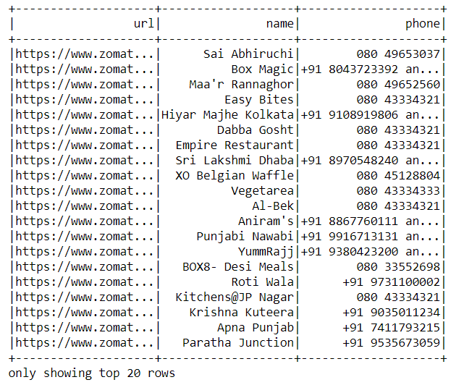

**Looking for good discount and restaurant type should be Drinks and Night Life.**

data.select("url","name", "address","phone","Discount", "listed_in_type").filter((data.Discount>=40) & (data.listed_in_type=='Drinks & nightlife')).show()

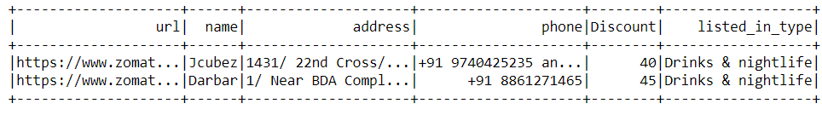

**Restaurant type should be dine out and dosa should be there in the menu item.**

data.select("url", "name", "address","phone", "menu_item").filter((data.menu_item.contains('Dosa')) & (data.listed_in_type=='Dine-out')).show()

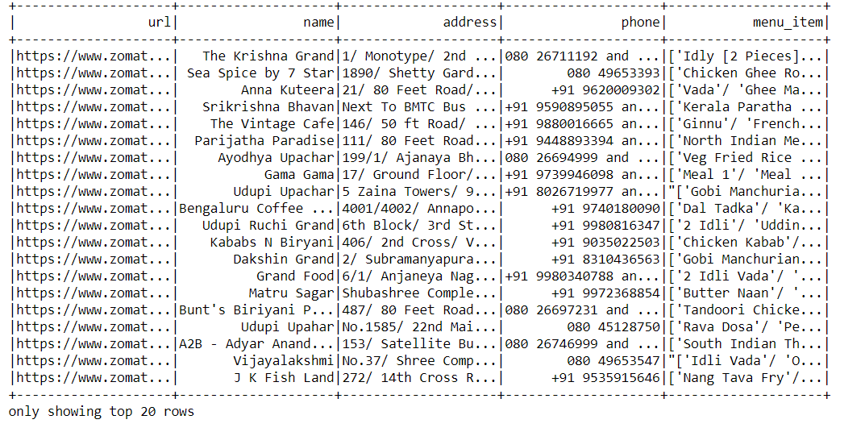

**Veg food in banashankari, budget is 800 max, please provide url, address, name, mobile Number of the restaurant and one more thing I only have Paytm to pay the bills.**

data.select("url", "name", "address", "phone").filter((data.menu_item.contains('Veg')) | (data.menu_item.contains('veg')) & (data.listed_in_city=='banashankari') & (data.payMode.contains('Paytm')) & (data.approx_cost_for_two_people<=800)).show()

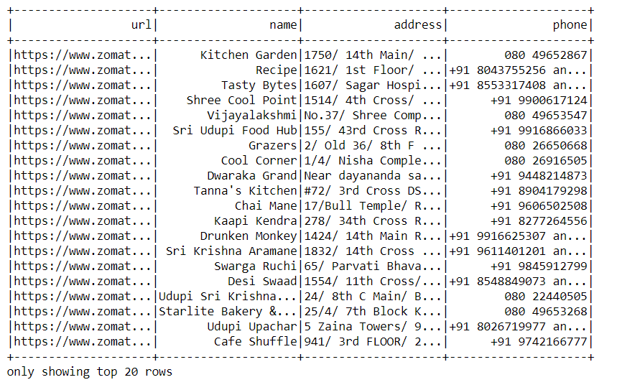

**Partitioning and bucketing**

**Partitioning the table based on Discounts of restaurant**

rest=s.sql('select * from restaurant2')

rest.write.partitionBy('Discount').saveAsTable("restaurant_part")

**We have performed bucketing on the type of restaurant with 20 buckets**

rest=s.sql('select * from restaurant2')

rest.write.bucketBy(20, "rest_type").saveAsTable("restaurant_bucketed")