SIMATS ENGINEERING
ASSESSMENT TOOL 3

COURSE NAME: INTERNET PROGRAMMING COURSE CODE: CSA43

COURSE OUTCOME COVERED

CO-1: Develop well-structured, standards-compliant web pages using HTML/XHTML and XML, and apply Internet protocols and HTTP communication mechanisms for web content delivery. (L2)

Assessment Tool: Code along exercise: Make your first HTML page together with CSS

Weightage: 10%

QUESTIONS: Total Marks: 10

Scenario: Web Development Standards Implementation
A start up is developing a modern web application. During development, the team encounters multiple issues related to HTML elements, HTTP methods, XML syntax, and web communication protocols.
The following observations are made:
- The team needs to embed a promotional video on the homepage.
- A registration form must securely send user data to the server.
- The navigation menu must follow semantic HTML standards.
- XML configuration files are being used but contain syntax errors.
- The application must communicate over the correct web protocol.

Data Snippets Provided

Snippet 1: Video Embedding Options
- <media src="video.mp4"></media>
- <video src="video.mp4" controls></video>
- <movie src="video.mp4"></movie>
- <vid src="video.mp4"></vid>

Snippet 2: Form Submission Methods

- GET
- POST
- PUT
- DELETE

Snippet 3: Navigation Elements

- <div>
- <nav>
- <section>
- <header>

Snippet 4: XML Syntax

- <note><to>User</to><from>Admin</from>
- <note><to>User</to><from>Admin</from></note>
- <note><to>User</from></note>
- <note to="User"></note

Snippet 5: Web Communication Protocols

- FTP
- HTTP C. SMTP
D. SNMP
Questions:
- Select the correct HTML tag for video embedding and justify your answer.
- Identify the appropriate HTTP method for form submission and explain why.
- Choose the proper semantic element for navigation and justify its usage.
- Identify the correct XML syntax and explain the error in other options.
- Choose the correct protocol for web communication and justify your choice.

Code of Conduct:

I Gurram Roshitha(19237207) (Name / Reg No) certify that this submission is my original work and that I have adhered to the guidelines specified for this assessment. I understand that any violation of academic integrity rules will result in disciplinary action.

Signature of the student: 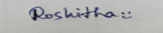
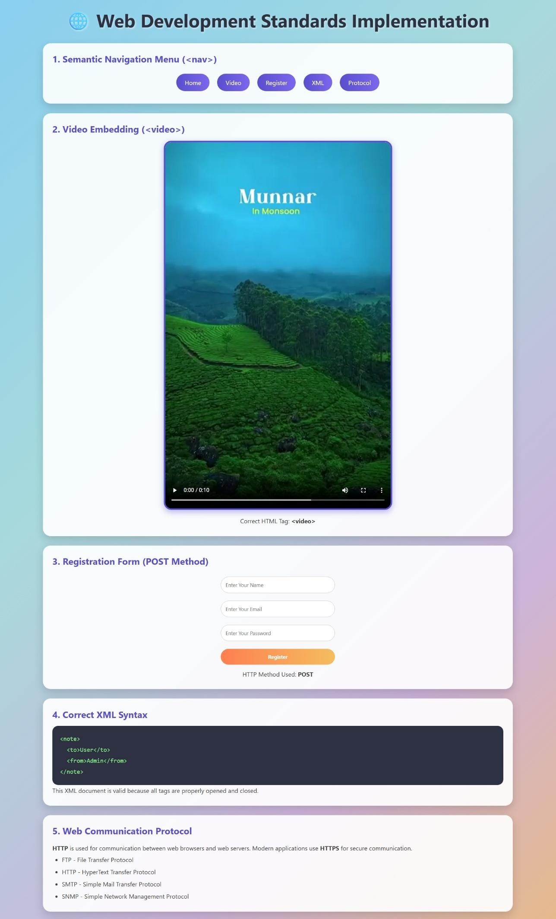
RUBRICS FOR CALCULATION:

Criteria | Weightage | Level 4 –  Exemplary | Level 3 –  Proficient | Level 2 –  Developing | Level 1 –  Beginning
Understanding  of Case | 25 | Thorough understanding;  clearly identifies all key issues | Good understanding with most issues identified | Basic understanding  ; some issues missed | Poor understanding;  problem not identified correctly
Application of Concepts | 25 | Effectively applies relevant concepts to  analyze the case deeply | Applies appropriate  concepts with minor gaps | Limited application of concepts | Fails to apply relevant concepts
Analysis | 20 | In-depth analysis with strong  reasoning and insights | Good analysis with logical reasoning | Basic analysis with limited depth | Weak or no analysis; lacks reasoning
Solution Design | 20 | Innovative, feasible  solutions with strong justification | Logical solutions with adequate justification | Basic solutions with weak justification | Incorrect or no solution provided
Clarity | 10 | Clear, wellstructured, and easy to understand | Organized and understandable presentation | Limited clarity and structure | Poor clarity; difficult to  understand

