Assertions in Jmeter

1. Response assertion:

Take the junit Sampler request again 🡪 right click on junit sampler and add 🡪 assertion 🡪 Response assertion

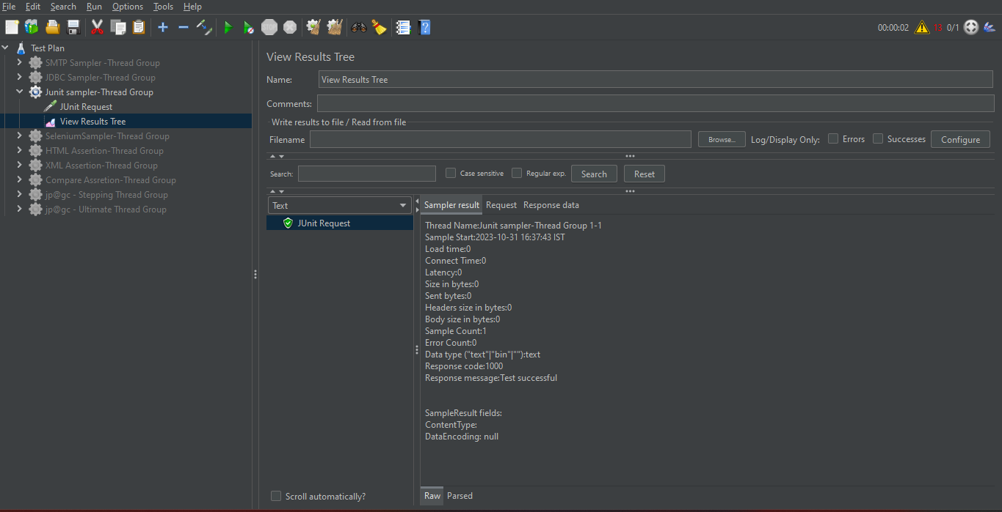

HTML Assertion

It captures errors and warnings on the HTML page that jmeter connects to

After which it can put those errors and warning in a file and save it.

Create a Thread group 🡪 add sampler HTTP request

Add HTMl assertion to http sampler

Create a new folder using browser button, also give the file name at the same time

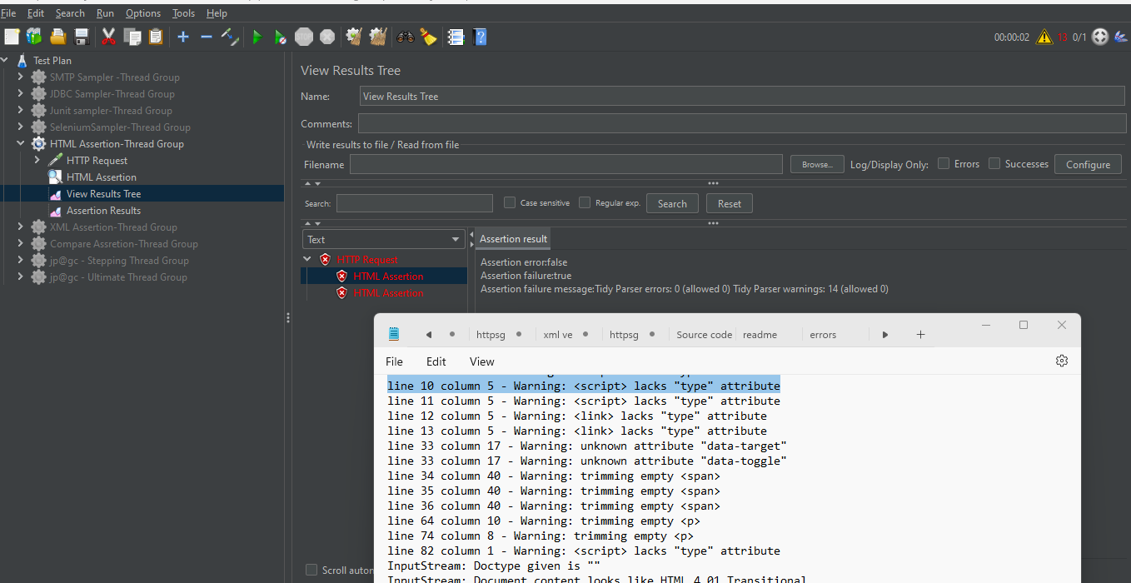

XML assertion

The assertion will just check if the response of the https request is an XML or not.

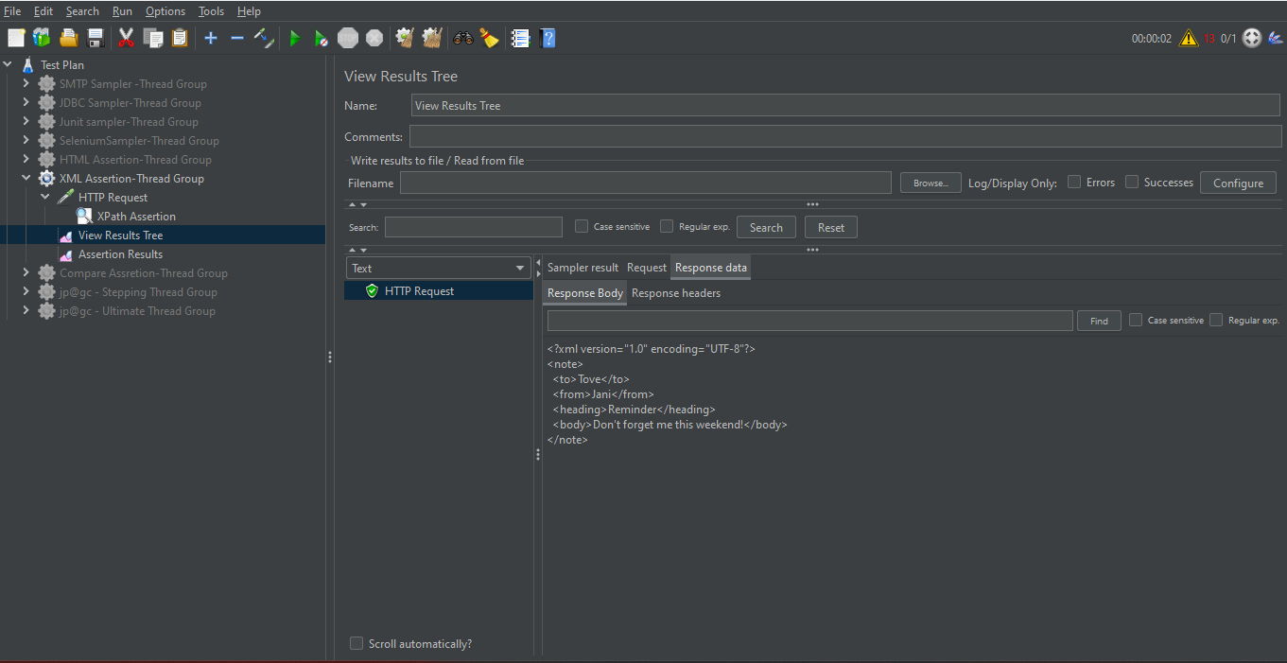

XPATH Assertion

XPATH assertion check for availability of XML path in the response from http request

<note>

<to>Tove</to>

<from>Jani</from>

<heading>Reminder</heading>

<body>Don't forget me this weekend!</body>

</note>

Here we can check and validate if we have xpath like : /not/to/from in the response

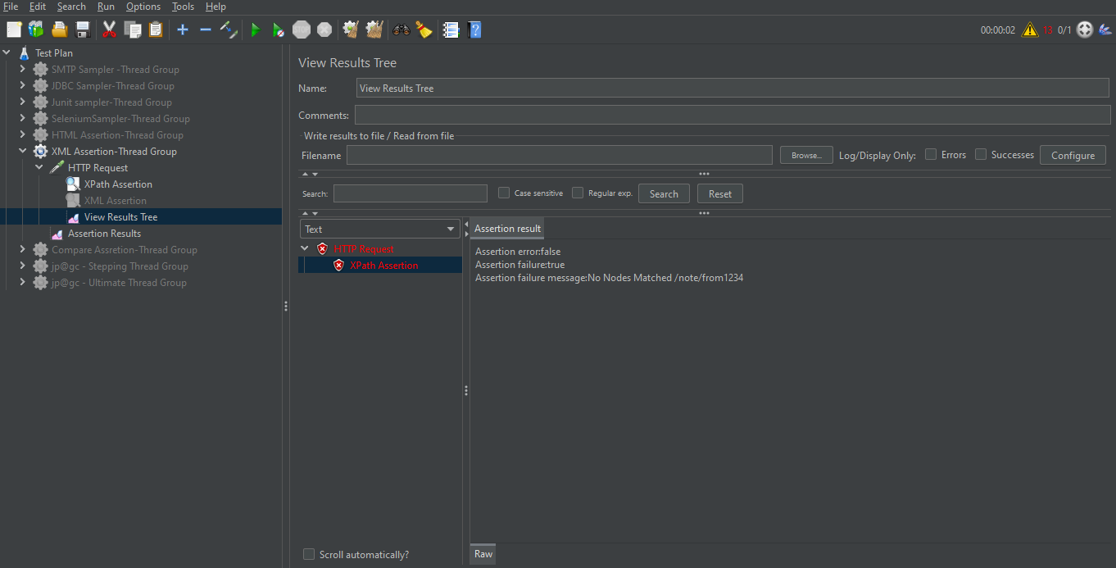

XML schema Assertion

It just check if xml response is having a schema or not

Take you XML file and generate the schema for it:

<note>

<to>Tove</to>

<from>Jani</from>

<heading>Reminder</heading>

<body>Don't forget me this weekend!</body>

</note>

<?xml version="1.0" encoding="utf-8"?>

<!-- Created with Liquid Technologies Online Tools 1.0 (https://www.liquid-technologies.com) -->

<xs:schema attributeFormDefault="unqualified" elementFormDefault="qualified" xmlns:xs="http://www.w3.org/2001/XMLSchema">

<xs:element name="note">

<xs:complexType>

<xs:sequence>

<xs:element name="to" type="xs:string" />

<xs:element name="from" type="xs:string" />

<xs:element name="heading" type="xs:string" />

<xs:element name="body" type="xs:string" />

</xs:sequence>

</xs:complexType>

</xs:element>

</xs:schema>

Save the XSD file in jmeter🡪bin🡪examples

