**(21)  check Abundant Number**

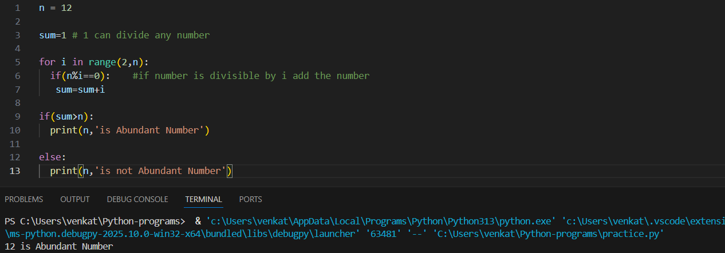

**(22) check whether two numbers are Friendly Pair**

**(23) find HCF of Two Numbers**

