**02-09-2025**

1. **Prime number**
2. **Palindrome**
3. **Armstrong**
4. **Strong**
5. **Fibonacci Series**
6. **Prime number**

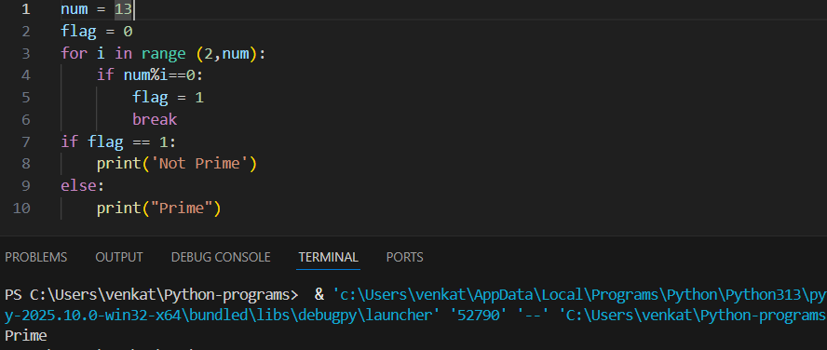

(2)**Palindrome**

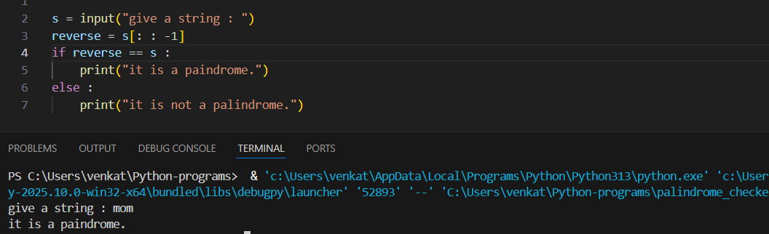

(3)**Armstrong** **number**

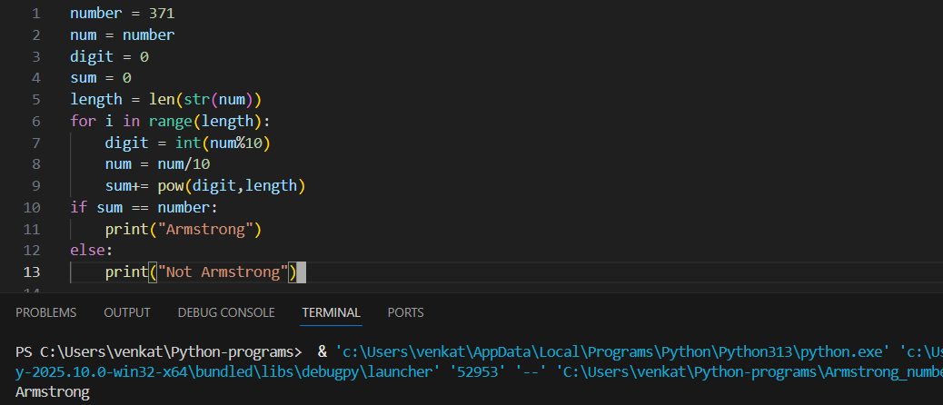

(4)**Strong** **number**

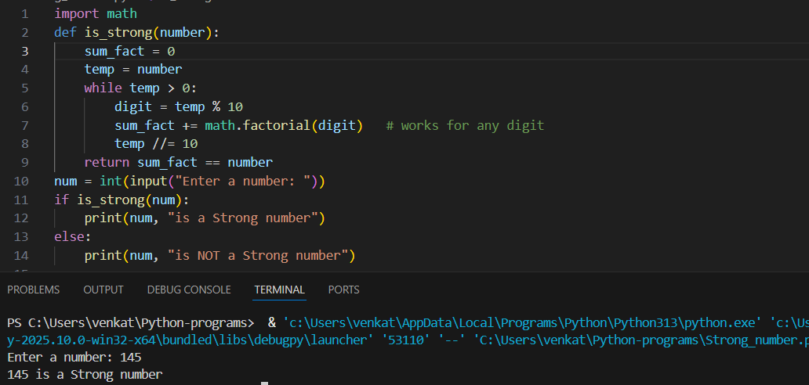

(5)**Fibonacci** **number**

