**(5)Harshad number**

**(6)Friendly pair**

**(7)Abundant number**

**(8)Strong number**

**(9)Automorphic number**

**\*Harshad number**

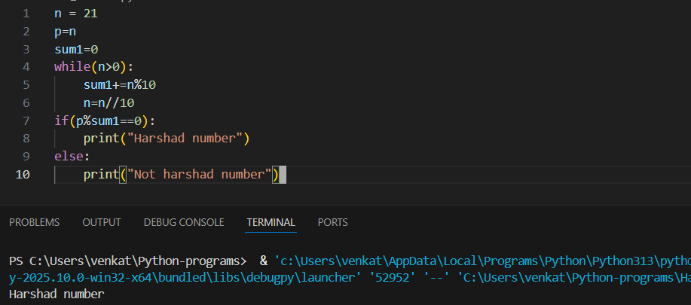

**\*Friendly pair**

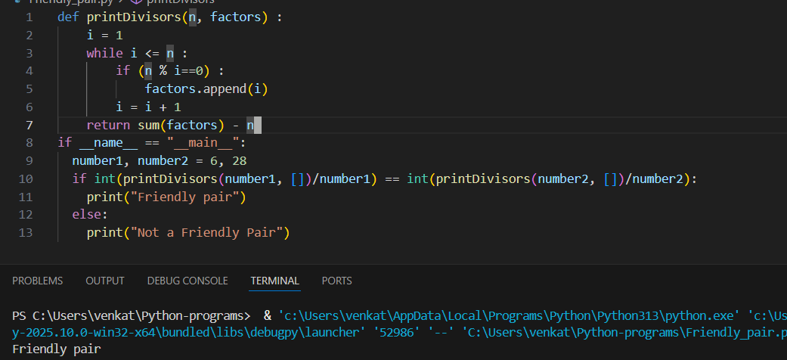

**\*Abundant number**

**\*Strong number**

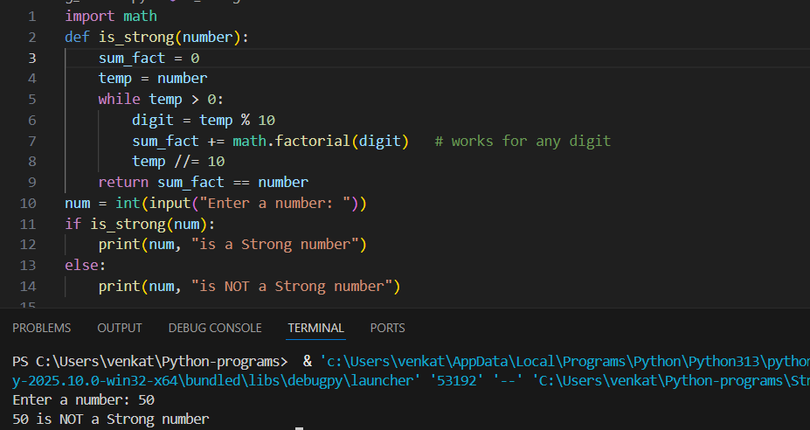

**\*Automorphic number**

