1. 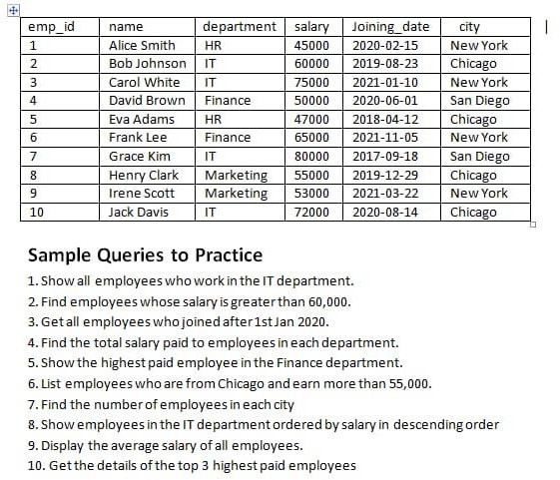Show all employees who work in the IT department.

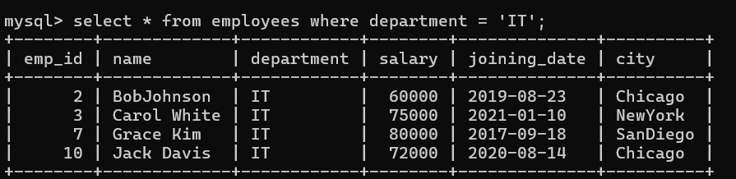

1. Find employees whose salary is greater than 60,000.

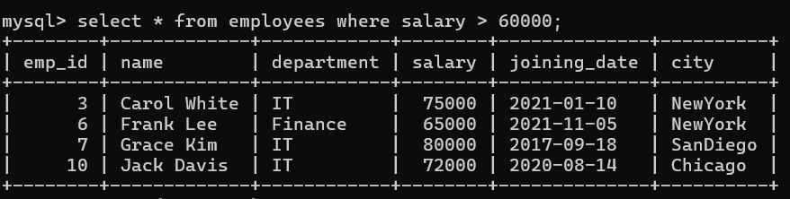

1. Get all employees who joined after 1st Jan 2020.

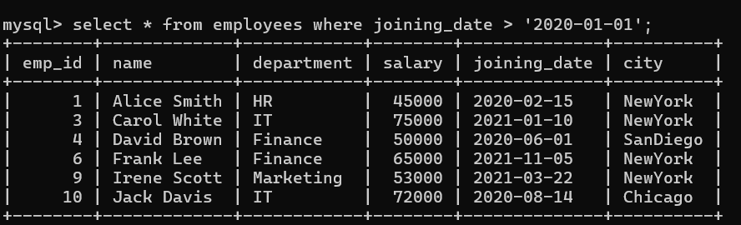

1. Find the total salary paid to employees in each department.

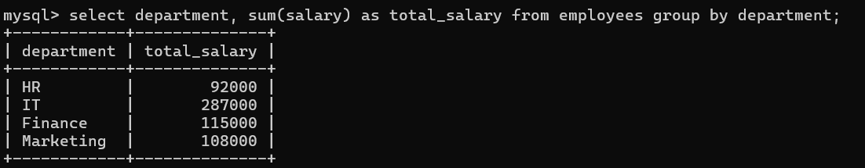

1. Show the highest paid employee in the Finance department.

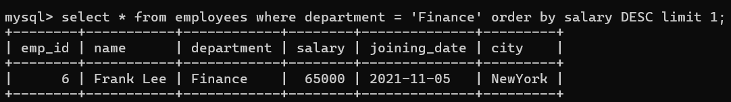

1. List employees who are from Chicago and earn more than 55,000.

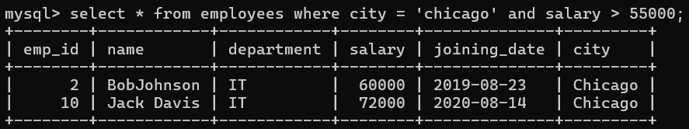

1. Find the number of employees in each city.

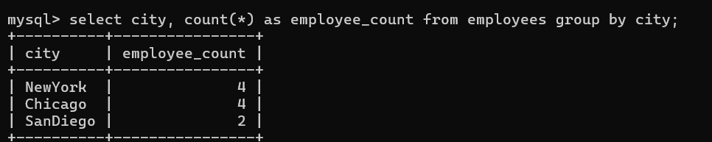

1. Show employees in the IT department ordered by salary in descending order.

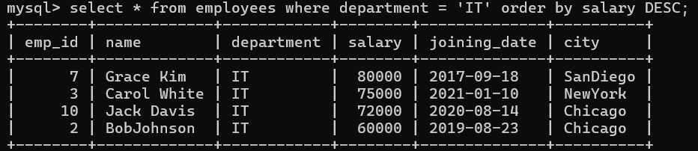

1. Display the average salary of all employees.

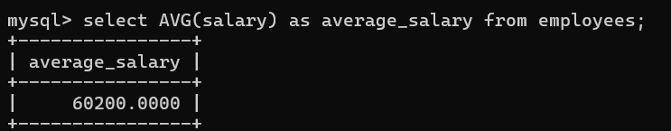

1. Get the details of the top 3 highest paid employees.

