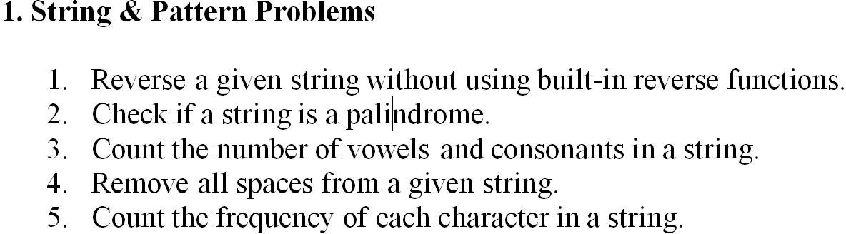

1. Reverse a given string without using built-in reverse functions.

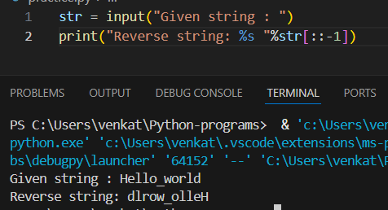

1. Check if a string is a Palindrome.

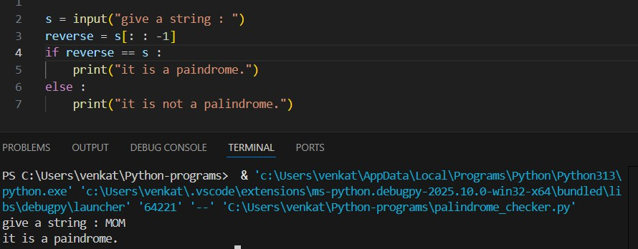

1. Count the number of vowels and consonants in a string.

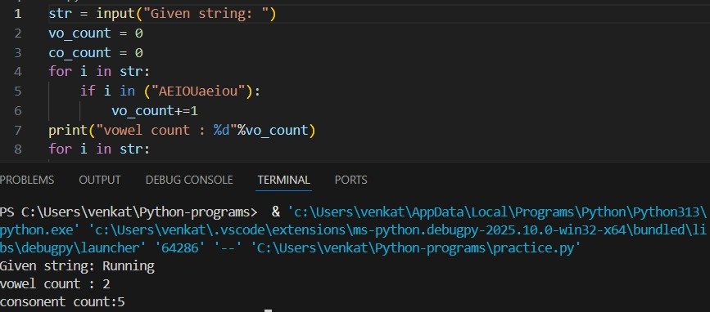

1. Remove all spaces from a given string.

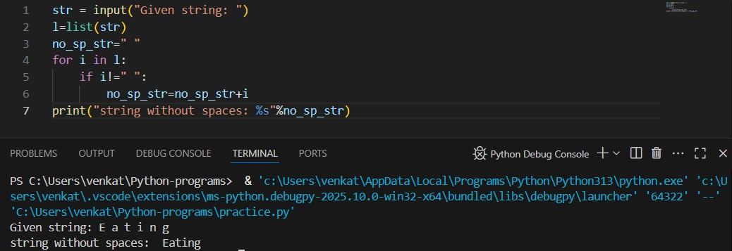

1. Count the frequency of each character in a string.

