python(prep insta)

\* Check a number is even or odd

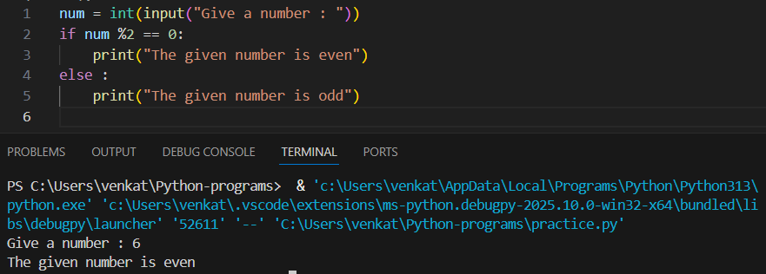

* The sum of first N natural numbers

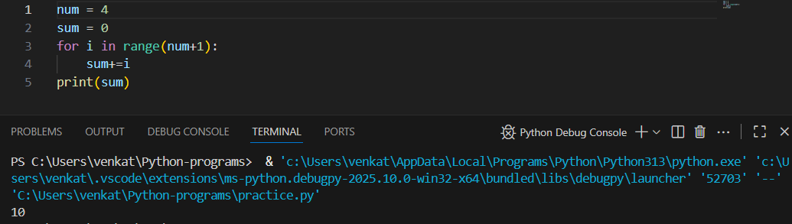

* Leap year program.

