(9) **Find the Sum of Numbers in a given Range**

(10) **Find the Greatest of Two Numbers**

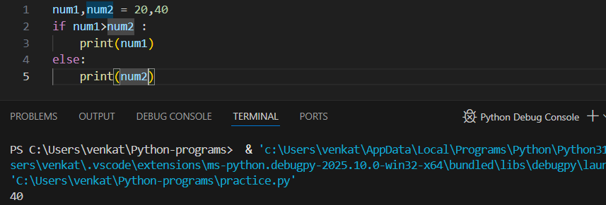

(11) **Find the Greatest of the Three Numbers**

