(12) **program to find factors of a number**

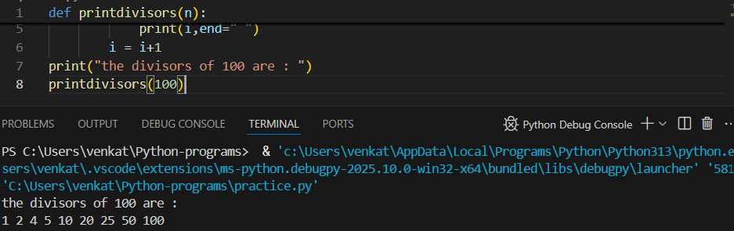

(13) **Program to Finding out the Prime Factors of a Number**

(14) **Perfect Number**

