(15) **Factorial of a Number**

**(16) Check for Perfect Square**

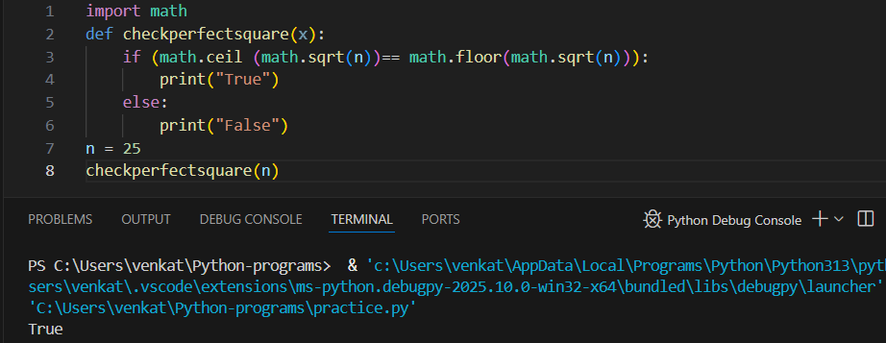

(17) **Automorphic number**

