(18) **Armstrong Number**

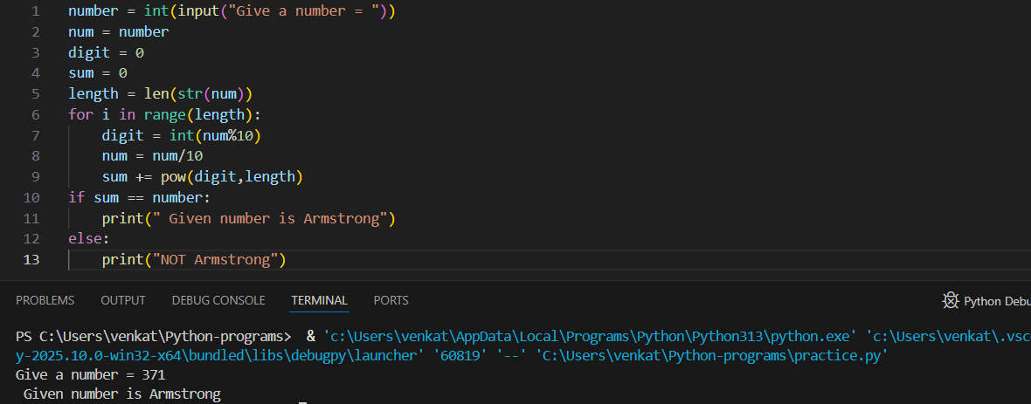

(19) **Find the Armstrong Numbers between Two Intervals**

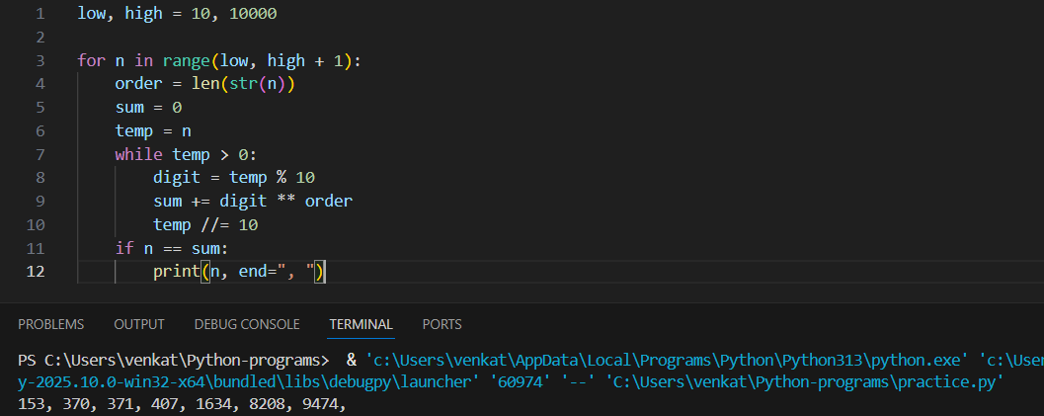

(20) **Checking Whether the Number is Harshad or not**

