BUSI after 38 epochs: Early stopping triggered with patience 30.
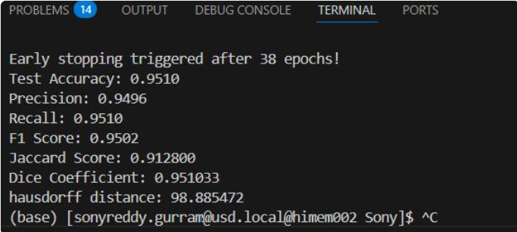
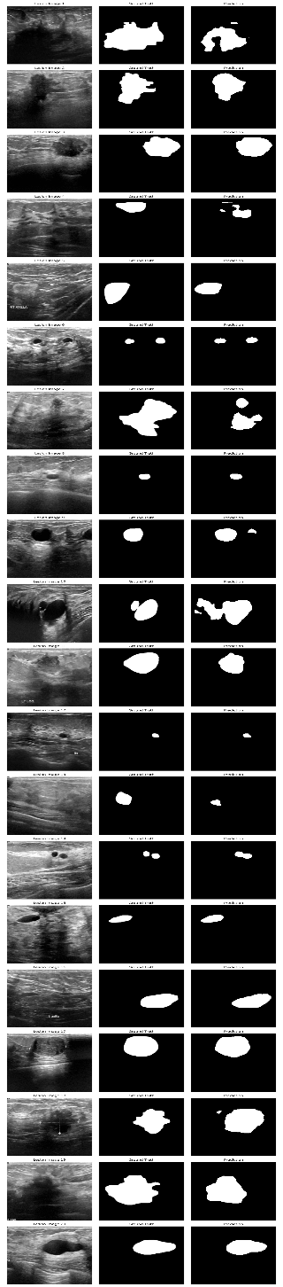
Kvasir-Seg after 39 epochs: Early stopping at 30
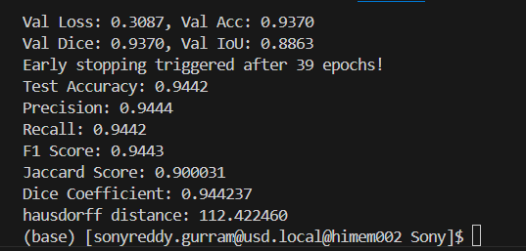
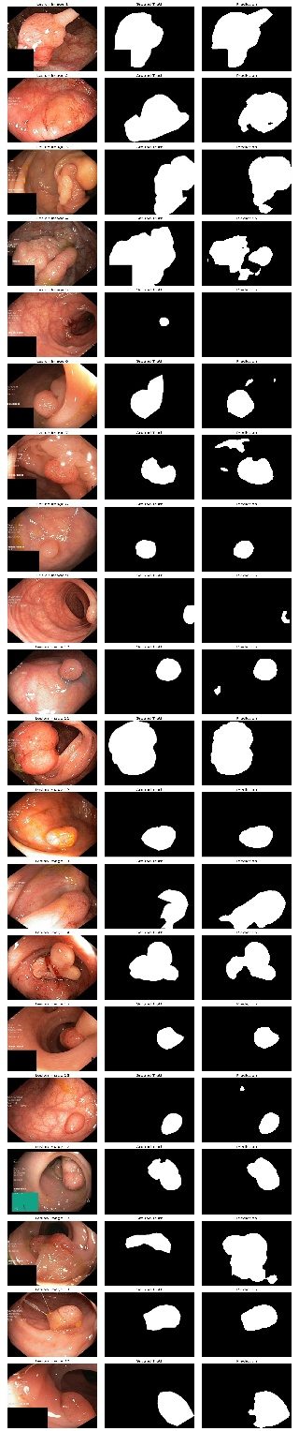
ISIC-2018 after 43 epochs: Early stopping patience 30
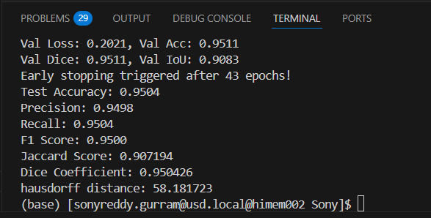
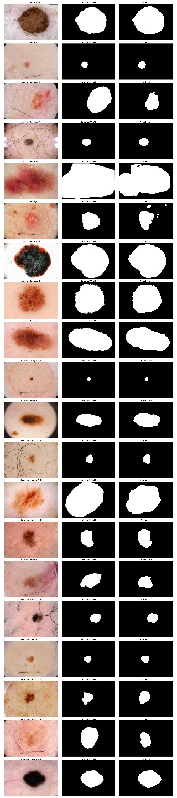
COVID-19 dataset X-ray after 39 epochs: Early stopping patience 30
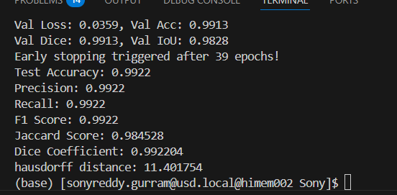
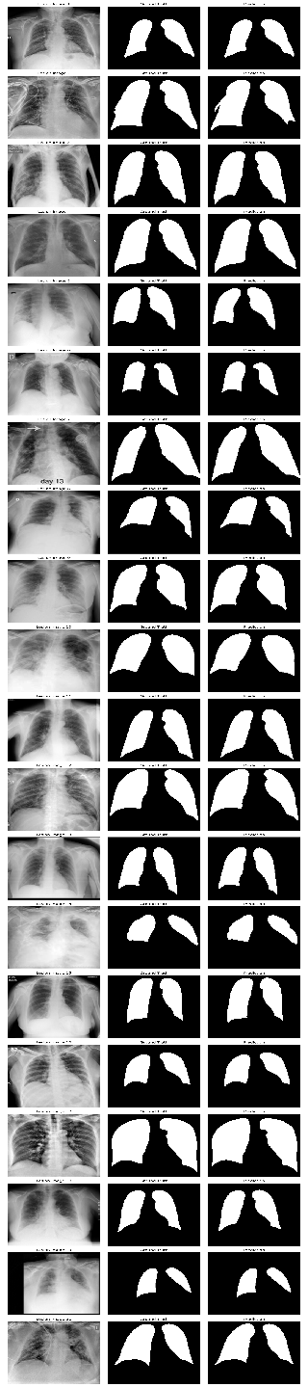

CVC-ClinicDB after 44 epochs: Early stopping patience 30
