**TRAINING REPORT (TR-102)**

**DAY: -21 (8 JULY 2024)**

**Install ReactJS on Windows**

**Steps to Install React JS on Windows**

**Step 1:** Install Node.js installer for Windows. Here, install the LTS version (the one present on the left). Once downloaded, open NodeJS without disturbing other settings, and click on the **Next** button until it’s completely installed.

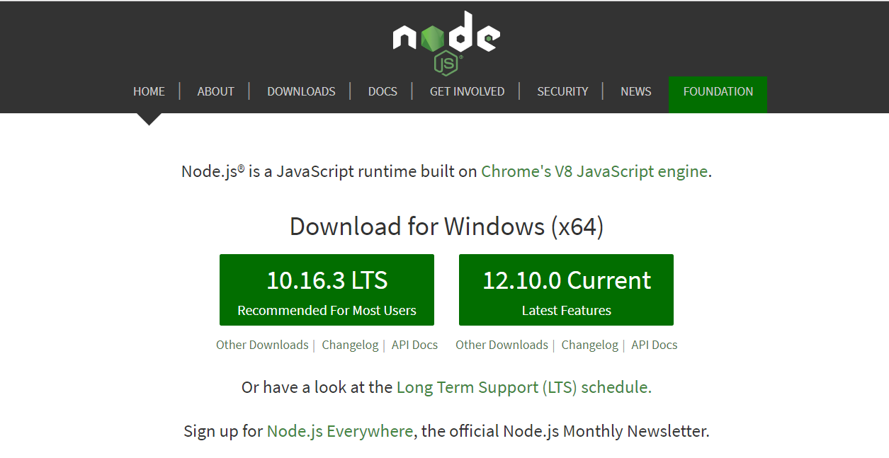

**Step 2**: Open the command prompt to check whether it is completely installed or not type the command –>

Node -v

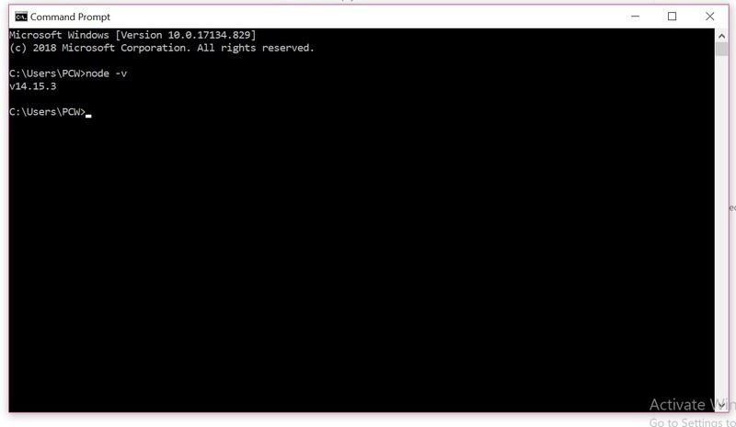

If the installation went well it will give you the version you have installed

**Step 3**: Now in the terminal run the below command:

npm install-g create-react-app

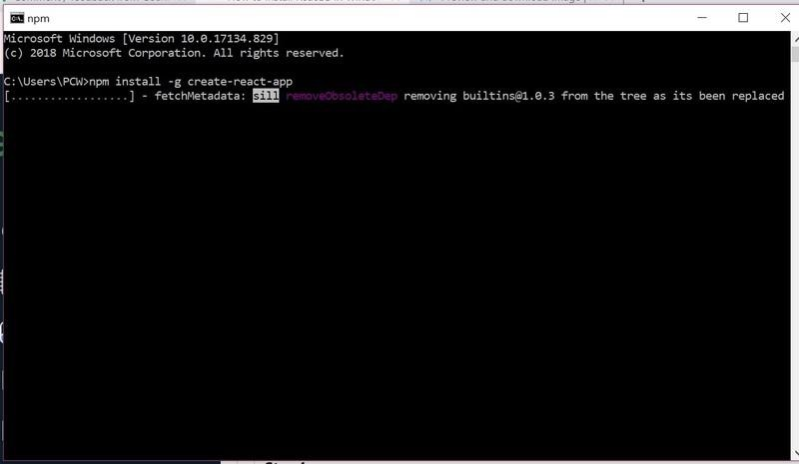

*Installation will take few seconds*

It will globally install react app for you. To check everything went well run the command

Create-react-app-version

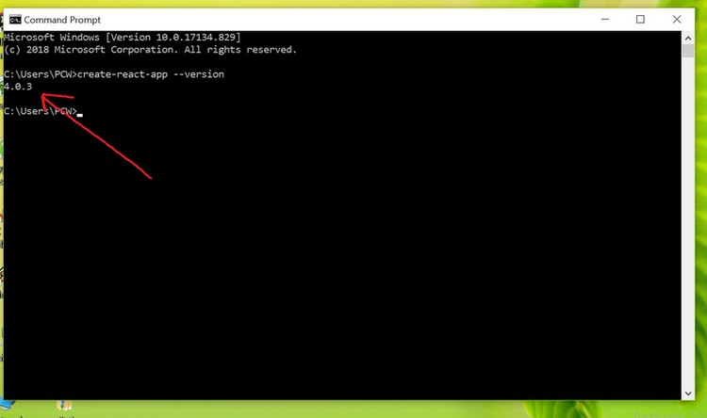

*version 4.0.3*

If everything went well it will give you the installed version of react app

**Step 4:**Now Create a new folder where you want to make your react app using the below command:

mkdir newfolder **Note:** The *newfolder* in the above command is the name of the folder and can be anything

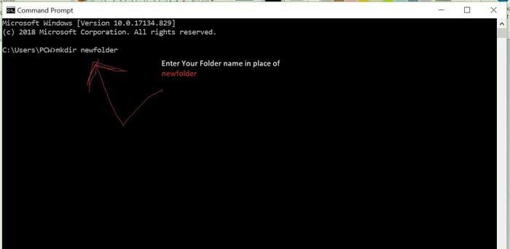

Move inside the same folder using the below command: cd newfolder (your folder name)

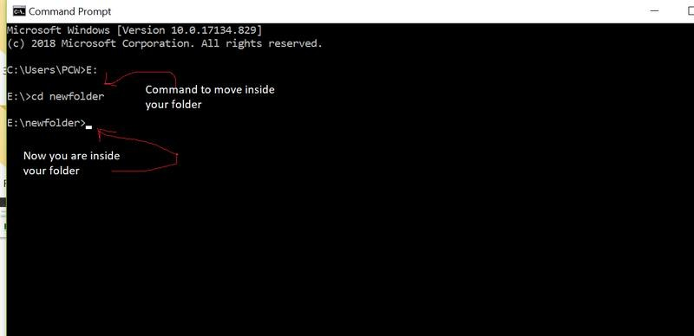

**Step 5**: Now inside this folder run the command –> create-react-app reactfile YOUR_FILE_NAME

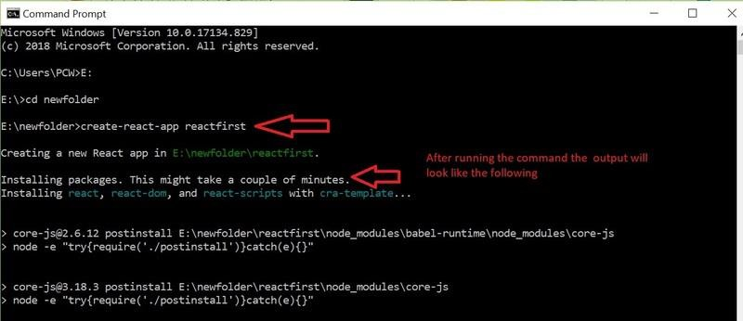

It will take some time to install the required dependencies

NOTE: Due to npm naming restrictions, names can no longer contain capital letters, thus type your app's name in lowercase.

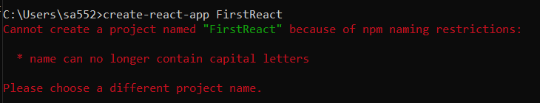

**Step 6**: Now open the IDE of your choice for eg. Visual studio code and open the folder where you have installed the react app **newfolder** (in the above example) inside the folder you will see your app’s name **reactapp** (In our example). Use the terminal and move inside your app name folder.Use command **cd reactapp** (your app name)

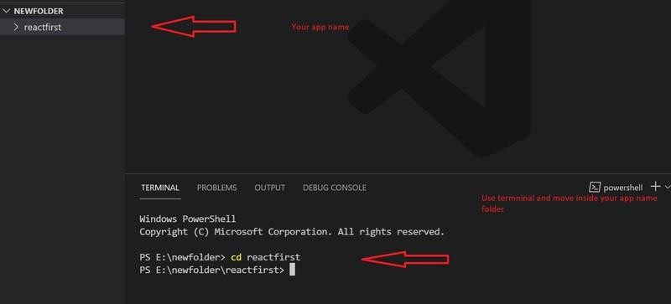

**Step 7:** To start your app run the below command: npm start

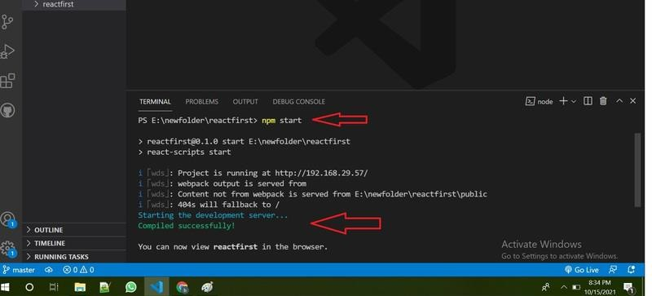

Once you run the above command a new tab will open in your browser showing React logo as shown below:

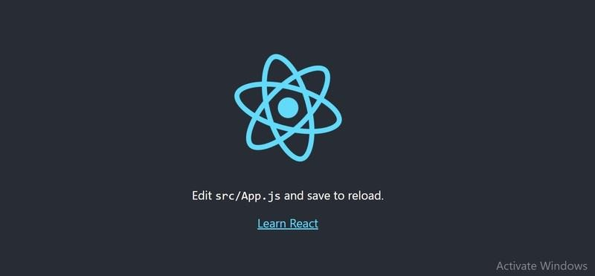

Congratulation you have successfully installed the react-app and are ready to build awesome websites and app.

Install React JS in Visual Studio Code

1. Install Visual Studio Code

Before you dive into React development, make sure you have Visual Studio Code installed on your machine. You can download it from the official website [here](https://code.visualstudio.com/).

1. Set Up Node.js and npm

React JS relies on Node.js and npm (Node Package Manager) for managing dependencies and building applications. If you don’t have Node.js installed, download it from the official website [here](https://nodejs.org/). Once installed, npm will be available in your command line.

1. Create a React App

Open your terminal and run the following command to create a new React app:

npx create-react-app my-react-app

1. Navigate to the App Directory

Move to the app directory using the following command:

cd my-react-app

1. Launch Visual Studio Code

Open the app in Visual Studio Code using the following command:

code .

1. Start the Development Server

In the terminal within Visual Studio Code, start the development server:

npm start

Your React app will now be running locally on a development server.

1. Begin Coding: You’re all set to start coding your React app! Open

the src directory and begin exploring and modifying the code to create your desired application.