

Student Name: Gursimran Singh

Student Number: 2042387

Module Code: 6CS007

Module Name: Project and Professionalism

Project Title: Web App or Native App

Module Leader Name: Alix Bergeret

Supervisor Name: Ingo Frommholz

Reader Name: Jeffrey Ting

Submission Date:
(The date you handed in the assessment)

Award Title: BSc (Hons) Computer Science
(Award Title for your project, if in doubt refer to your course/Module Registration)

Declaration Sheet

Presented in partial fulfilment of the assessment requirements for the above award.

This work or any part thereof has not previously been presented in any form to the University or to any other institutional body whether for assessment or for other purposes. Save for any express acknowledgements, references and/or bibliographies cited in the work. I confirm that the intellectual contents of the work are the result of my own efforts and of no other person.

It is acknowledged that the author of any project work shall own the copyright. However, by submitting such copyright work for assessment, the author grants to the University a perpetual royalty-free licence to do all or any of those things referred to in section 16(i) of the Copyright Designs and Patents Act 1988. (viz: to copy work; to issue copies to the public; to perform or show or play the work in public; to broadcast the work or to make an adaptation of the work).

Student Name (Print): Gursimran Singh

Student Number: 2042387


Signature: Date: 26/04/2023

(Must include the unedited statement above. Sign and date)

Please use an electronic signature (scan and insert)

Table of Contents
1 Project Proposal 6
1.1 Introduction 6
1.2 Initial Research 7
1.3 Aims and Objectives 8
1.3.1 Academic Question 8
1.3.2 Aims 8
1.3.3 Objectives 8
1.4 Scope and Limitations 8
1.5 Artefact 9
1.6 Summary 9
2 Literature Review 10
2.1 Introduction 10
2.1.1 Research Methodology 10
2.2 Performance 11
2.2.1 Introduction 11
2.2.2 Research 11
2.2.3 Conclusion 12
2.3 Usability 13
2.3.1 Introduction 13
2.3.2 Research 13
2.3.3 Conclusion 14
2.4 Testing 15
2.4.1 Introduction 15
2.4.2 Research 15
2.4.3 Conclusion 16
2.5 Security 17
2.5.1 Introduction 17
2.5.2 Research 17
2.5.3 Conclusion 17
2.6 Summary 17
3 Implementation and Development 18
3.1 Introduction 18
3.2 Design 18
3.2.1 UML Diagram 18
3.2.2 Screen Designs 19
3.2.3 Database Design 24
3.3 Test Plan 25
3.3.1 Native Application 25
3.3.2 Web Application 25
3.3.3 Usability 25
3.4 Implementation 27
3.4.1 Decisions on Developmental Tools 27
3.4.2 Development 28
3.4 Summary 30
4 Investigation and Comparison 31
4.1 Introduction 31
4.2 Performance 31
4.2.1 First Launch 33
4.2.2 Second Launch 34
4.2.3 RAM Stress 36
4.3 Usability 37
4.3.1 Introduction 37
4.3.2 Questionnaire 37
4.4 Summary 38
5 Overall Result and Discussion 39
5.1 Introduction 39
5.2 Performance 39
LOGIN 39
POSTS 41
POST UPLOAD 43
Chat 45
Account 46
5.3 Usability 47
5.4. Summary 47
6 Conclusion 48
6.1 Aims and Objectives 48
6.2 Conclusion 49
7 Critical Evaluation and Processes 51
7.1 Overall 51
7.3 Design 51
7.3.1 Positives 51
7.3.2 Areas of Improvement 51
7.4 Implementation 51
7.4.1 Positives 51
7.4.2 Areas of Improvement 51
7.5 Tests 52
7.5.1 Positives 52
7.5.2 Areas of Improvement 52
7.6 Time Management and Planning 52
7.6.1 Positives 52
7.6.2 Areas of Improvement 52
References 54
Appendices 56
1. Initial Gantt Chart 56
2. Final Gantt Chart 57
3. Meeting Logs 57

1 Project Proposal

Introduction
In a world where the technology is advancing rapidly, mobile devices have become part of the routine of the majority of the people. These devices that were used only to call or text thirty years ago, nowadays are used to access the Internet. The application that mobile devices has is wide, as these devices are nowadays used for entertaining, learning, communicating, navigating and for business purposes.
The purpose of this project is to see if a website developed for a mobile device (web app) can perform the same task that a native app can do and which of these offers the best experience to the user.
The project will start off by investigating the latest features of websites and native mobile apps. Following on, an investigation of any past research where the performances of the two applications are compared will create solid fundaments. The next step will be to investigate databases that will be used as backend for both the applications, the IDE that will be used to develop both the applications and therefore there will be a focus on the languages that these IDEs uses.
The next step of the project will be to design the web app, the native mobile app, and the database. In this phase all the results of the investigations done previously will be used to create a more detailed plan of all the features and all the applications that will be used in the implementation phase.
The first step of the implementation will be the creation of the database, this database will store all the data coming from and used by the native mobile app and the web app. The structure of the databases will be key as if done correctly it will make the following steps of the implementation much more easy-going.
The development of the two applications will be parallel, so if the login page has been implemented in the web app, it will be implemented in the native mobile app before any other work is done to the web app. This approach will allow me to focus on one feature at a time, and therefore concentrate all the resources to do it right. This approach will be adopted for the core features after which the optional feature’ implementation and the optimization will be done on one application and at the end on the other.
The tests of the applications will be done using tools and methodologies found during the investigation. These tests will be key as they will show the benefits, drawbacks and how both the applications performed.
The final step of this project will be to critically analyse the result of the tests and answer the academic question.

1.2 Initial Research
The “Android Studio Documentation” (Google, 2022) contains all the key information for developing an application for the Android Operating System. This documentation will be used to develop the application in case Android Studio is chosen as the IDE (Integrated Development Environment) for the native app. The language that will be used on this IDE will be Java, the “Java Programming for Mobile Applications” part of the “Practical Java programming for IoT, AI, and Blockchain” (Xiao P., 2019) will assist me with this language.
The “Clean Code: A Handbook of Agile Software Craftsmanship” (Martin, 2009) contains guidelines and standards for having a readable code. This book may be beneficial for the entire project as it will help me follow industry standards.
'A Tale of Two Fashions: An Empirical Study on the Performance of Native Apps and Web Apps on Android' (Ma et al., 2018) is an article that compare the performances of web apps and native apps. This article will give me a starting point to evaluate how, nowadays, the web app and the native app performance is compared to when the article was written.
The Oracle Cloud website (Oracle, 2022) provide useful information about cloud databases. With Autonomous Database on shared Exadata infrastructure, you do not need to configure or manage any hardware or install any software (Oracle, 2022). This type of databases could become part of the artefact as they will provide a place to store and access the data for the two applications. The type of the databases hosted on the Oracle Cloud is relational, a relational database is a type of database that stores and provides access to data points that are related to one another (Oracle 2022), and to link these databases together the SQL (Structured Query Language) is used.
As an alternative or as an addition to the Oracle Cloud Autonomous Database I have researched about the Google Cloud Firestore. Cloud Firestore is a NoSQL flexible, scalable database for mobile, web, and server development from Firebase and Google Cloud (Google, 2022). This type of cloud database is beneficial for my project as it could be used as an alternative or an addition to the Oracle Cloud Databases, as this service is based on a collections and documents system, which means it is not relational.
The website part of the project will be developed using HTML, CSS, JavaScript and possibly PHP. For the basics of these languages, the lecture notes and coursework of Internet Architecture (Alix Bergeret, 2021) will be used. The content of the article from M. M. “Essential JavaScript Libraries and Frameworks You Should Know About” will help me decide the right JavaScript frameworks and libraries.

Aims and Objectives

Academic Question
What application performs better and has better usability on a mobile device: native app or web app?

1.3.2 Aims
The Aims of the project I am planning to develop will be:
- To Investigate the differences between native and web app.
- To compare the advantages and disadvantages of native mobile app and web app.
- To Implement a complex native app and a web app.
- Test performance and usability of both the applications using appropriate tools and methodologies.
- Evaluate the result.

Objectives
The Objectives of the project I am planning to develop will be:
- Investigate the main features of a native mobile app.
- Investigate the main features of a web app.
- Investigate the advantages and disadvantages of native mobile app.
- Investigate the advantages and disadvantages of web app.
- Create and set-up a database to store data.
- Design a user Interface for the native app and for the web app.
- Develop the native app.
- Develop the web app.
- Test the native app and the web app.
- Compare the result of the testing.
- Answer the Academic Question.

1.4 Scope and Limitations
The scope of this project will be to compare the native app and the web app and see which of these two applications performs better and has a better usability. The project will begin with research to make the two applications as similar as possible and therefore comparable.

The limitations to this project are mainly time based as there will be the need to develop two complex applications using two different languages and therefore there will some time spent to get accustomed to the different software and languages.

1.5 Artefact
The two prototypes that will be created as the final artifact will be a web application and a native mobile application. The two prototypes will have the same features and will be tested in same environments. The key part of the two prototypes will be a database (or possibly two) which will be hosted on a cloud. This database will store all the key information of the user and the data that is uploaded on the two prototypes. One of the core features that both the prototypes will have will be a Sign Up and a Sign In process, this will allow the user to create a new account or login to an existing account. Another core features that will be in the prototypes will be the possibility to access the device camera to capture an image or a video and following on accessing the device hardware to get the device geolocation. The information that the user gathered in the previous part will be uploaded to the database in addition to the weather (fetched using an API and the geo location) and the time (UTC). The next feature that both the apps will have will be a search function that will allow the user to search for a location or/ and a weather condition and as a result get all the media that other users uploaded that matches those criteria. An optional feature that the prototypes will have will be the possibility to “star” a post that other users posted so this way the best will be displayed on top after a user search for that location/weather condition.
The final artefact will be a web app and a native mobile app that will allow a user to share a picture of a location in a certain weather condition and search for what other users shared.
The two prototypes will be tested in different mobile devices and different network condition to find out which of the two performs better. At the end of the testing a report will be created evaluating the advantages, disadvantages and how the web app and the native app performed and therefore, an answer to the Academic question will be given.

Summary
This section explained briefly the project proposed in the initial phases, defining the academic question, the aims and the objectives, the scope, and the limitation of this project.
The following section will be the literature review where past research done on the same topic will be explored and used to improve the project.

2 Literature Review

2.1 Introduction
In this section will be a literature review of the research done on web application and native applications.
Native applications are software programs developed for a specific system and released as a software package, usually published on, and downloaded from online app stores.
Web applications are developed using HTML, JavaScript, and CSS. These types of application can be accessed by all the devices that has a web browser and an Internet connection.
This Literature Review will focus on the papers that has been published regarding performance and usability of native mobile applications and of web applications. Other papers that will be looked to answer the question will be relative to testing web applications and native applications, these will be used to look at the possible ways to measure the performance of the applications and to make the application as efficient as possible. A little focus will also be made on the security part of native mobile applications and of web applications.

2.1.1 Research Methodology
This Literature Review has been done using popular online libraries, where the search has been made using key words and filtering the results by journals and/or conference papers. Following on the results have been skimmed furthermore to get only the latest papers, excluding some exceptions.
Research Libraries: IEEEXPLORE, Google Scholar.
Key terms
- Performance: (“Web Applications” OR “Web Apps” OR “Web-based Applications”) AND (“Native Applications” OR “Mobile Applications” OR “Android Application”) AND “performance”.
- Usability: (“Web Applications” OR “Web Apps” OR “Web-based Applications”) AND (“Security vulnerabilities” OR “Usability”), (“Native Applications” OR “Mobile Applications” OR “Android Application”) AND (“Security vulnerabilities” OR “Usability”).
- Testing: (“Web Applications” OR “Web Apps” OR “Web-based Applications”) AND (“Testing methodologies” OR “Testing”), (“Native Applications” OR “Mobile Applications” OR “Android Application”) AND (“Testing methodologies” OR “Testing”).
- Security: (“Web Applications” OR “Web Apps” OR “Web-based Applications”) AND (“Security vulnerabilities” OR “Security”), (“Native Applications” OR “Mobile Applications” OR “Android Application”) AND (“Security vulnerabilities” OR “Security”).

2.2 Performance

2.2.1 Introduction
This section of the Literature Review contains the result of the research done about the performance of native mobile applications and web applications.
The performance of an application defines the success or failure of a project. The papers found for this part of the Literature Review compares the native applications and web applications to see which of these has the best performance.

2.2.2 Research
The comparison of native and web application has always been explored by the developers (Ma et al., 2018). This is the most recent publication that compares the performance of a native mobile application and a web application. In this paper, the authors conduct an experiment evaluating the performance of several popular applications that has a web-based version and a native mobile version with the same features, and following the tests, they list their findings of how the performance of web applications and mobile applications could be improved.
This paper focuses on three questions, the first question is about the way native and web-based application access web services, the result of this question is that most of the applications they tested use RESTful Web services as they are more suitable due to the unstable mobile network and the limit of the mobile hardware compared to the SOAP-based Web services.
On the application, they tested the request URLs for the same features were different between the native and the web-based applications even if they were hosted on the same back-end database. Other discoveries were that the native application architecture for using Web Services was downloading only the requested response, as when the application was installed “the native code, including the data parsing, network management, and layout rendering, are maintained locally on the smartphone” as also some icons and images. However, the web-based application architecture for using Web Services was requesting all the information each time from the backend including the page structure and the layout, therefore it was taking longer to get the response.
The second question is about the way native applications and web-based applications perform differently while doing the same functionality. The performance test showed that both the native application and the web application were performing better with the cache, but the native app was performing slightly better as the web app was sending a greater number of requests to get the same object compared to the native app. In some cases, the web app was performing better than the native mobile application, this was caused by the meticulous cache mechanism that was implemented in the web application, so more data was stored locally, and fewer requests were made.
The third question is about the knowledge gained after the previous questions to optimize both applications. The answer to the question found after all the test is to improve the cache management of the applications, especially the web-based applications as this decreases the requests sent and therefore the response time, to do so “Some recent features such as HTML5 AppCache and localstorage” can be used. Other than this another way to optimize both applications is to limit the HTTPS requests overhead by “using lightweight SSL handshakes” this way the response will be faster. Avoiding unnecessary complexity and allowing developers “alternatives to programmatically filter the response data”, is another suggestion to optimize the applications. The last suggestion they made to optimize both applications is by unifying RESTful API semantics, so use the same URLs to get the same features in the native and the web application. The paper concludes that usually native applications perform better compared to web applications.

Other papers focus more on comparing progressive applications to native applications (Fortunato et al., 2018). This paper was only available in Portuguese and was translated using the translate document function of Google translate. Knowing a bit of Italian and being Portuguese similar it, the comparison proved that the translation was quite accurate. The purpose of this paper is to compare the features and functionalities of two applications (one native application and one progressive web application) and see if the progressive web application can perform better compared to the native application.
The paper starts by pointing out the main differences between the two applications and therefore focuses on the technical specification and the development framework of the progressive web applications.
Progressive web applications, as explained in one of the sections of this paper, can run on web browsers making them accessible from the majority of devices with only one single release. On the other hand, native applications, as the name suggests, are made only for a specific operating system, and have minimum hardware requirements that must be met to execute them. This difference, as the author says, is key for organizations as the cost and the time to produce a single progressive web application compared to the development of multiple native applications for different devices is significantly less. The paper continues by exploring and comparing popular frameworks used to develop progressive web applications, with the conclusion that the most popular and used framework is React.

2.2.3 Conclusion
These papers create a solid foundation to get near to answering part of the academic question, as the data that they gained throughout their research, and the techniques they used to test the performance of the two application could be used to efficiently build the artifact and therefore evaluate if the native application still performs better than the web application.
My research will add up to the research done in these paper as it will focus also on the usability of mobile applications and web applications. The artifacts of my research will also be used to verify if the declaration made by the authors, saying that the native application can use the hardware of the device more efficiently, is valid as one of the core features the artifacts that will be developed for this project will be the need to have access of the current location, the camera, and the storage of the device.

2.3 Usability

2.3.1 Introduction
This section of the Literature Review contains the result of the research done about the usability of native mobile applications and web applications.
The usability of an application is key to longevity and success of an application, as the application must guarantee to the user a great experience while using the software. The papers found for this part of the Literature Review compares the native applications and web applications to see if both offers the same usability.

2.3.2 Research
The usability of application as said above is the key for the longevity and success of an application, there are several ways to “measure” the usability (Jobe, 2013). In this paper the author conduct test to find out if the native application can be replaced by the web application. The author researched, built, and deployed native applications and web applications to a group of candidates and gathered the results.
The paper is divided into three parts: research and development of the applications, gathering data from the candidates, and analysing the data.
The first part of the paper explores several types of applications that can be developed for a mobile device. In this part, the author talks about native applications, dedicated web applications (developed using HTML5, CSS, and JavaScript), and generic mobile web applications (developed using mobile frameworks).
The author explains how the data will be gathered. Using the research of the previous section the author developed two web and native applications where one was tracking runs and the second was used for bookings. These applications were installed on devices and handed to 30 candidates, the data on these devices was collected, with the permission of the candidates, for an entire year. The candidates were runners that had to use the device to track their runs. The data retrieved was divided into two, one for the tracking apps and the other for the booking apps.
In the last part of the paper, the data gathered is analysed and further questions are asked of the participants of the study. The result of the data gathered shows that the candidates tried to use the web application for tracking initially, following which they only used the native tracking application, on the other hand, the booking web application was used as much as the native application for booking. The reason that the 30 runners preferred the native application for tracking was that the web application tracking was not accurate as the native application one. The conclusion of the paper states that for hardware-intensive apps native application is the choice, on the other hand, an application such as the booking one can be replaced by web applications.
The usability of mobile applications (Weichbroth, 2020), as said above is getting more and more attention from the developers. In this paper the author conducts research to find out how previous papers delt with usability of mobile applications. The purpose of this paper is to find out the best definition for usability and therefore, how to improve it.
The first part of the paper focuses on how the papers were researched and filtered; the result of the research showed that there is an increment in research done about the usability of mobile applications from 2001 to 2018.
Following on the author tries to answer to three questions. The first question is about the definition that could be given to the usability for mobile application, the second question is about the attributes that are used in for the usability for mobile applications and the last question is about the measures and evaluation methods used to define usability attributes for mobile applications.
In the conclusion of this paper the author answer to question by proving that the most used definition of usability is the ISO 9241-11 definition (“the extent to which a product can be used by specified users to achieve specified goals with effectiveness, efficiency and satisfaction in a specified context of use”), the most frequent attributes for usability are efficiency, satisfaction, and effectiveness.

To find out the most used usability methods, some papers focuses on evaluating them (Nugroho et al., 2022). In this paper, the authors conduct research to compare the result of past papers about the methods and techniques used to check the usability of mobile applications.
The first part of the paper focuses on the collection of data, explaining the criteria with which the papers used in this research were selected. Following on the authors use the papers selected to answer three questions.
The first question is about the techniques used to evaluate the usability of a mobile application, the findings show that the most used evaluation techniques are Usability testing and Heuristic Evaluation. The questionnaires are used to get efficiency, effectiveness, and user satisfaction for usability testing. For the second question, the authors look for how the evaluation of the usability is done, the answer to this question shows that most of the papers tested the usability by planning, selecting the participants, testing the user interface, conducting analysis, and then asking for a recommendation to improve the productivity. The last question is about finding out the characteristics of usability evaluation, the answer showed that efficiency, effectiveness, user satisfaction, and ease of use were the popular characteristics.

2.3.3 Conclusion
The research done in the first paper (Jobe, 2013) regarding the mobile application will be useful for my research, as also, the study done on using the tracking app will be a good comparison to the artifact that I will build, as my applications will need access to the hardware of the device to get the current location, to access the camera and the storage.
The other papers research creates a solid foundation for evaluating the usability of the artifacts that I will develop.

2.4 Testing

2.4.1 Introduction
This section of the Literature Review contains the result of the research done about the testing of native mobile applications and web applications.
Testing is a crucial part for the success of an application, the testing phase of an application is crucial to find any bugs and to improve the performance the applications. The papers found for this part of the Literature Review shows different testing methodologies or techniques for native applications and web applications.

2.4.2 Research
Testing is a key part of the development cycle and is also crucial to compare different applications. The are several testing methodologies of a native applications (Kong et al., 2019) that can be used to make sure that the application has no issues.
This paper is divided into three sections each with a question as a title. Before entering these three sections the authors describe how they researched and gathered data.
The first section looks at the concerns that the testing in the papers focuses on. The investigation in this part of the paper is done on test objectives and test targets. The main test objective listed in this section is Concurrency, Security, Performance, Energy, Compatibility, and Bus. The test targets that address testing approaches found in this investigation are categorized into GUI/Event, Infrastructure-as-code, and General which contains all the normal code testing.
The second section looks at the level at which the tests are addressed. The investigation shows that most of the android testing approaches are addressed to unit testing, regression testing, integration testing, and system testing. Unit testing is done by the developer at the beginning of the development of the application, this type of approach is used to check that all the internal structure of the application is working as intended (for example functions or components). Regression testing on the other hand consists of repeating tests that were done previously to check if the updates to the code caused issues with the initial program. Integration testing is done on a set of functionalities to check if they work as intended. System testing is used to assess if the whole application respects the requirement and the quality standards given by the developer.
The third section of the paper focuses on how the test approaches are built. The investigation in this section looks at the testing methodologies, test types, test environments, and at tool support.
The most used testing methodology found in this investigation is model-based testing, which consists in designing and building a model that later can be used to automate the testing of an application. Other testing methodologies were search-based testing, random testing, fuzzing testing A/B testing, and mutation testing.
The test type investigation looked at white-box testing, black-box testing, and grey-box testing. The white-box testing is generally performed by the developer as it is performed on the infrastructure of the application, while the black-box testing is generally assigned to a third-party tester as it focuses on the functionality of the application. The grey-box testing is a combination of the white-box and black-box testing as it requires a little knowledge of the code by the tester to evaluate the functionality.
The test environment investigation shows that generally the tests are run on an emulator, a real device, or both. The author's investigation shows that most of the application is generally tested on real devices which are not scalable therefore the results of the tests do not have full coverage, on the other hand, the test done on an emulator are scalable but does not test the security and require more work to test hardware functionalities. Ideally, the best solution will be to test the application using both environments.
In the tool support section, the authors investigate and list several tools that were more popular to automate tests on mobile applications.
A discussion about all the sections is made in the conclusion revealing how testing is becoming increasingly important for the success of an application or a reputation of a developer.

There are several testing tools and methodologies to test a web application (Pradeep et al., 2019) that can be used to make sure that the application has no issues. This paper explores different tools and technologies used to test web-based applications. This paper is divided into three sections. The first section lists the main tests that are done on a web application. The list has load testing, stress testing, security testing, smoke testing, unit testing, acceptance testing, GUI testing, gorilla testing, and performance testing.
The second section looks in dept at prominent tools for rigorous testing, explaining how to access the testing tools and what are the key features of these. The tools investigated in this section are Locust, Apache JMeter, and Hulk Automation. A particular focus is made on the Apache JMeter where is explained how a test plan can be created to load test an application.
The third section of this paper investigates the different points to evaluate the results gathered from the tests and concludes by pointing out how more tools and open-source libraries could increase the testing efficiency and therefore the performance of the applications.

2.4.3 Conclusion
The research done in these papers regarding the mobile application and web application testing will be useful for my project, as it gives a guideline that I can follow to achieve the best performance and usability from the web and the native applications.

2.5 Security

2.5.1 Introduction
This section of the Literature Review contains the result of the research done about the security of native mobile applications and web applications.
Even if the project does not focus on the security, it is a crucial part for the success of an application, the security ensures the reliability and gives to the user peace of mind. The papers found for this part of the Literature Review shows different security vulnerabilities and prevention methodologies of native applications and web applications.

2.5.2 Research
As said above the security is not a key factor in my project but it is essential to make understand the importance of it (Husainiamer et al., 2021). This paper looks at the security of mobile applications focusing on a way to find out the risk that an application has to be subject of malware attacks.
The first part of this paper starts by describing popular ways used to perform malware attacks, focusing especially on the calls made to the API to gather information from the GPS, Bluetooth and more. Following on, the author of this paper demonstrates the result of an application developed by them. This application is used to assess the risk level of an application, by looking at the API calls that are made by an application.

As it is also important for the web application (Kumar et al., 2017). This paper looks at the security of web application focusing on detecting vulnerabilities.
The paper starts by describing the importance of security on web applications, as they are usually subject to security breaches. The authors look at three popular attacks that are made to web applications, starting from SQL Injections, URL Injection and Cross Site Scripting Attack. The papers continue by giving possible solutions to prevent these types of attacks, as for SQL Injection the suggestion made is never pass input from the user directly into a query but to filter it and verify if it is not harming first or, for the Cross-site scripting attacks they suggest to “convert what is written between two tags”.

2.5.3 Conclusion
The research done in these papers will be used to improve the security of the native application and the web application that will be created to test web application and native application performance and usability.

2.6 Summary
In this section present all the key element in the literature review, that will be useful to design, build and test the artefacts.

3 Implementation and Development

3.1 Introduction

In this section there will be the design of the databases and of the screens of the native and web application. As also the test plan where will be discussed how the artefact will be tested after implementation. To conclude there will be the implementation phase where will be discussed the main phases of the implementation and any issues encountered.

3.2 Design

3.2.1 UML Diagram
The artefact will have two applications therefore there will be two UML Diagrams. Both the application will fetch data from the OpenWeatherMap API to get the current weather and therefore the data will be uploaded to Firebase, the picture will be uploaded on the Cloud Storage, the link of the image will be added to the Firestore database in Posts collection and therefore added to the User Collection.
The main difference between the two applications will be the language used to fetch data and the place where the data will be stored locally. The Native app will store the data in the SQLite, on the other hand the web app will store the data in the browser local Storage.

Native App
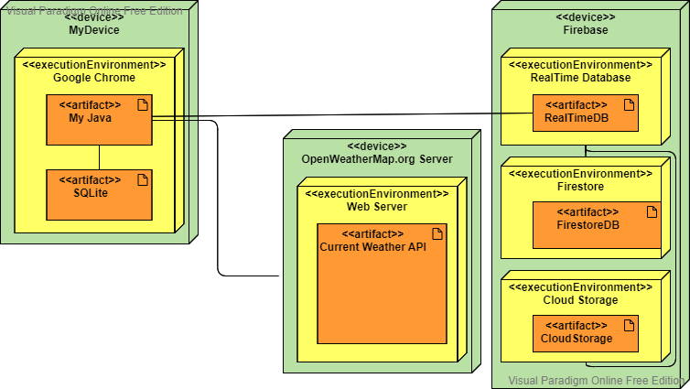

Web App
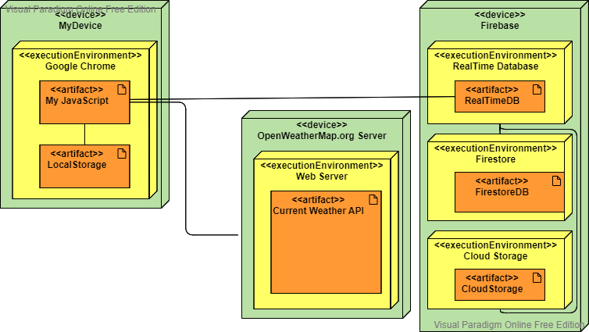

3.2.2 Screen Designs
The artefacts that will be built for this project will be used to compare web application and native application, therefore, the design of the two applications will be the same (if permitted).

Sign In
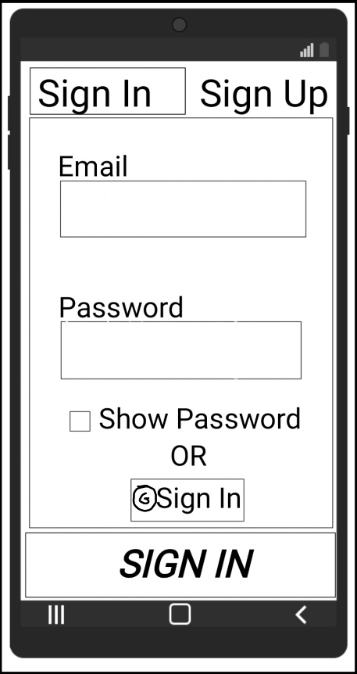
The Sign in Screen will allow the user to log in either using email and password or using the google account.

Sign-Up
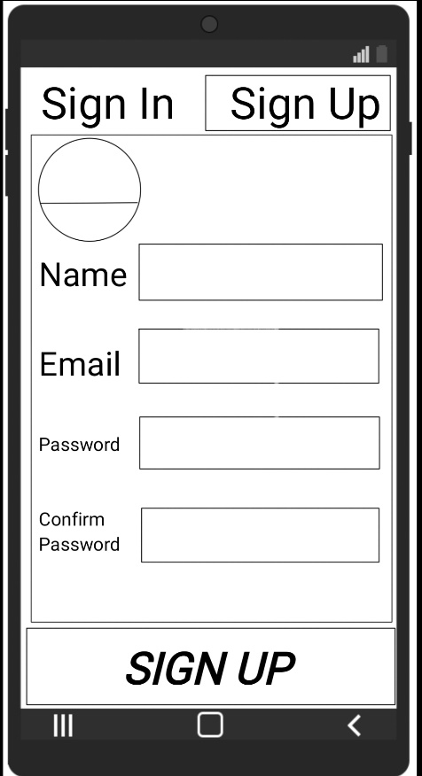
The Sign-Up Screen will allow the user to register to the application using email and password.

Post Template
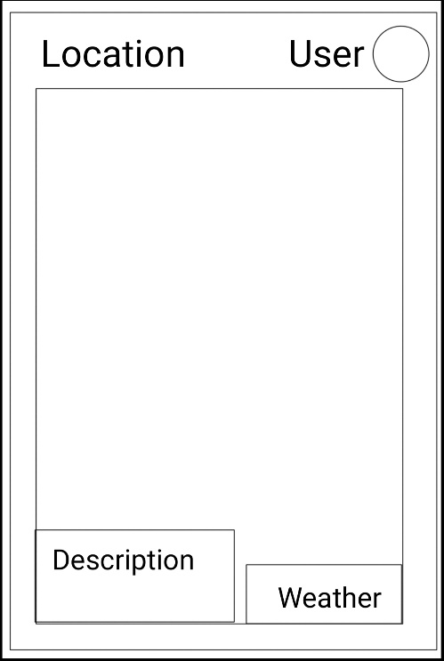
The Post shows how the posts will be displayed in the applications. The picture or the video will have an overlay with a description, and on the bottom right corner there will be the weather conditions in which the picture or video was captured.
Picture/Video

Homepage
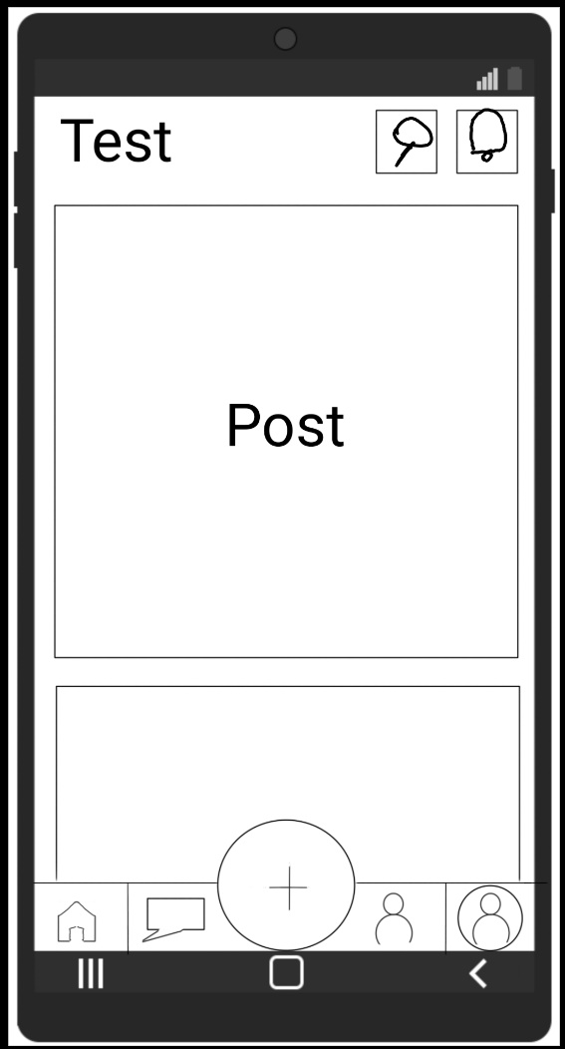
TITLE
The Homepage will display recent posts from other users prioritizing any posts uploaded by users in the contact list.

The Navigation on the bottom will be displayed in most of the screens of the application with the exception of Sign In, Sign Up, Upload and Chat Screens.

Account
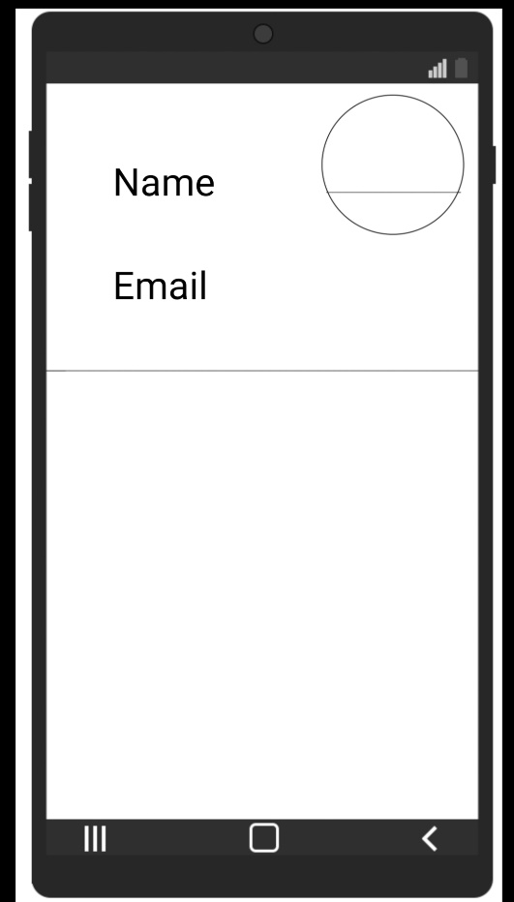
The Account Page will display key information of the user such as Name Email and Picture. The bottom part will display all posts uploaded by the user.

Contacts
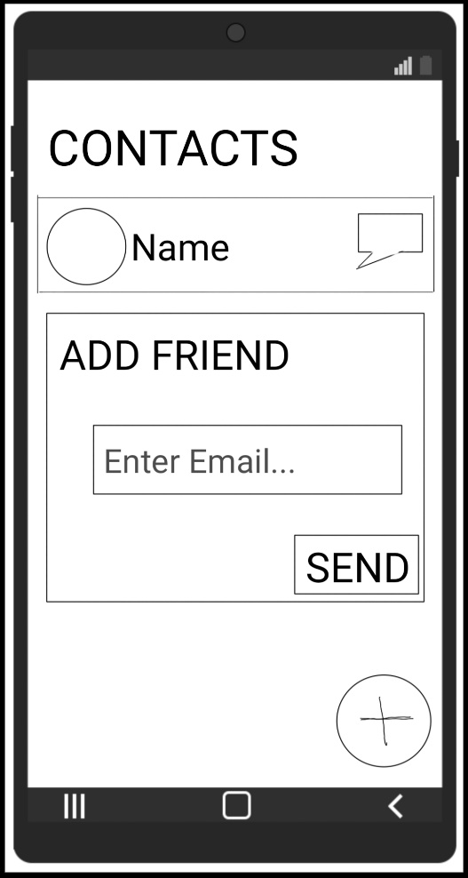
The Contact Page will display all the friends of the user and will allow the user to start a chat with the friend by clicking on the message logo. The user will also be able to send friend request using the email address.

Chat
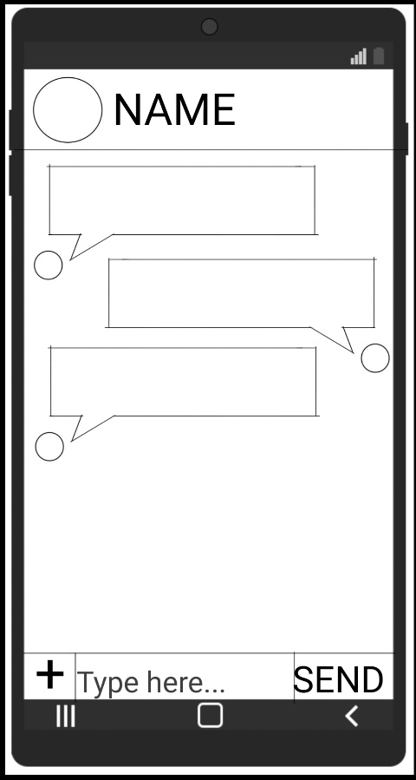
The Chat Screen will display the friend’s name and image on the top part, the messages in the middle and the bottom part will allow the user to type messages or/attach images to messages and send messages.

Upload
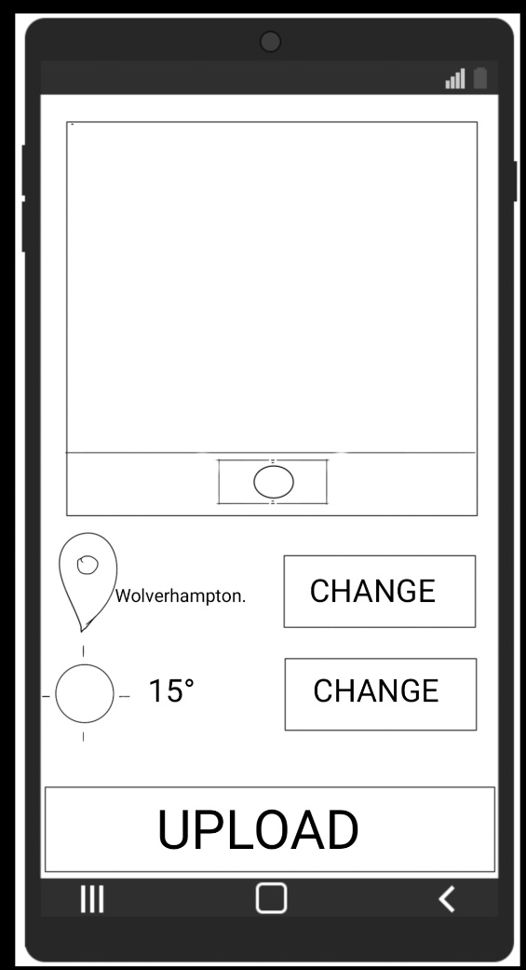
This Screen will be displayed by clicking on the plus sign in the middle of the bottom navigation.
Here the user will be able to upload an Image Following on the application will fetch the location and the weather automatically, in case any of these information are wrong the user will be able to modify them and finally upload them.

Search
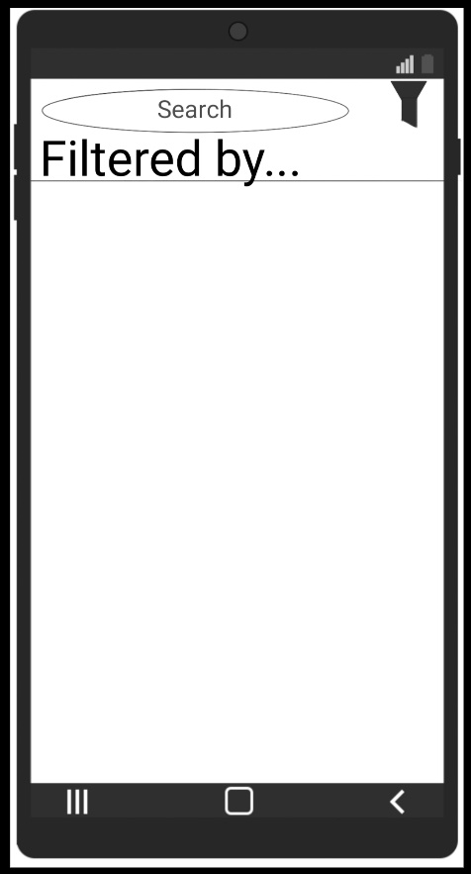
This Screen will be displayed by clicking on the Search Logo in the Homepage Screen.
Here the user will be able to upload search for an image/video by typing the location and also filter the result to order them by date or only show images taken in certain weather conditions.

Notifications
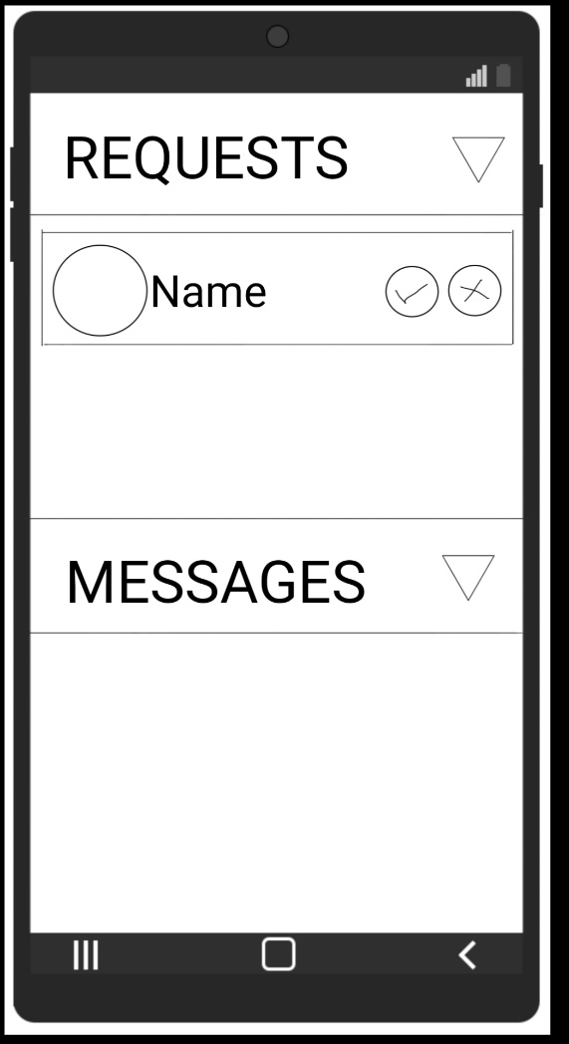
This Screen will be displayed by clicking on the notification logo in Homepage Screen.
Here the user will be able to see friend requests sent or received and also see recent messages. The user will have the possibility to collapse the requests and messages.

3.2.3 Database Design
The Artefacts that will be built for this project will rely mainly on the Firebase database, this will be used to store data of the user, of the conversations and of the Posts.
This data will be accessible in the same way by both the applications.

Firebase ERD
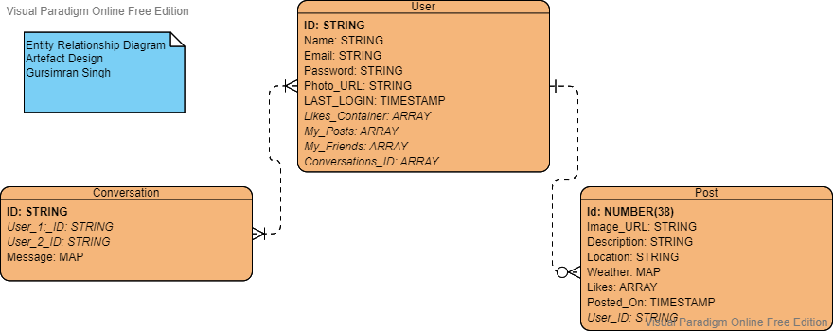

3.3 Test Plan

3.3.1 Native Application

Performance
The performance of the Native application will be tested using the tools offered by Android Studio. The main tools that will be used for testing this application will be CPU Profiler, Network Profiler and Energy Profiler.
Other than using these tools further testing will be done to catch the response time for fetching the location using the GPS of the device, loading the camera application, and uploading/fetching data from firebase. Most of the test listed previously will be run by declaring and printing a variable during the debug and noting the results on a separate document. The tests will be run using different emulators and using physical devices.

3.3.2 Web Application

Performance
The Performance of Web Application will be tested using tools offered by Google Chrome, such as Performance Insights and Lighthouse.
Other data will be collected by using the Network tool, where I will test and note the response time for fetching the location using the GPS of the device, loading the camera application, and uploading/fetching data from firebase. The tests will be run in different conditions and on different devices.

3.3.3 Usability
The usability of the artefacts will be tested using a questionnaire, which will be given to different peoples. The questionnaire will ask direct questions with choices that will be Native Application, Web Application and No Preferences.

Questions Examples
- What application would you use on a daily basis?
  - Native Application
  - Web Application
  - No Preferences
- What application is easy to Use?
  - Native Application
  - Web Application
  - No Preferences
- From what application would you upload a post?
  - Native Application
  - Web Application
  - No Preferences
- What application loads the posts quickly?
  - Native Application
  - Web Application
  - No Preferences
- From what application would you chat?
  - Native Application
  - Web Application
  - No Preferences
- What application has a more accurate location?
  - Native Application
  - Web Application
  - No Preferences
- What application has better camera quality?
  - Native Application
  - Web Application
  - No Preferences

3.4 Implementation

3.4.1 Decisions on Developmental Tools
For the development of the two artefacts there were several decisions to be taken, starting from the languages in which the applications were going to be developed and therefore the relevant development environment, following with the database that was going to store the data of the applications, and the API from which the information was going to be fetched by the native and the web apps.

The decision of the language for the native application came down to Java with Android Studio as development environment. This choice was made to save some time with the throughout the native application development as I had a little experience with Android Studio.

The time saved from the decision for the native application will be used to develop the web application. The choice for the web application came down to React, the idea was to build an application that was using the standard version of react and compare it to the native application.

After the languages and the development environment were chosen, the next decision was about the core part of the application: the database. As stated in the project proposal the choice of the database was between the Oracle database and Firebase. After doing a bit of research and looking at the compatibility of both the databases to the native and web application, the final decision was to base the application on Firebase. Firebase was chosen at the end because the documentation was covering the native application part and the web application part.

The last major decision made before beginning the development was about the API that were going to be used to fetch the data required by the application (Weather data and Location Data). The choice of these APIs was quite straightforward as I had used API that were needed to fetch the data requested by the two applications.
For the Weather API the selected API was offered by OpenWeather, this API was essential as it was allowing me to fetch the weather data of a location and allowing me to store it in my database. Another reason for which the OpenWeather service was chosen was that it was allowing me to display icons of the weather condition into my applications, as OpenWeather was hosting logos and adding the name of the logo in the data that was fetched by the API.
For the Location API the selected API was offered by Google Maps, this API was essential as it was allowing me to fetch the information about a location by the city name of by the latitude and longitude that was fetched by the device GPS. The final choice for which this API was chosen was that it was using the same database that Google Maps uses, therefore it was going to be the most complete.

3.4.2 Development
The project is based on two applications, therefore the plan, as stated in the project proposal was to develop the native application and the web application in parallel, which means that when a feature is implemented in one application is going to be added to the other one before proceeding with the development of the first.
The start of the development phase went flowless as thanks to the detailed documentation provided by Google (Google, 2022) the native application and the web application were connected to Firebase without issues. After connecting both the application to Firebase the next step was to allow the user to login and sign-up. The development of the sign-up and login page on the native application went by without any issues, on the other hand the first issue was encountered while implementing these pages in the web application. The issue was that the user was able to sign-up and login just fine using the email and password Firebase Authentication system but when the user was logging in using the sign in with google Firebase Authentication, the service was display an unique user id different from when the user was logging in using the google sign in Firebase Authentication on the native application, after several attempts and researches I just decided to remove the sign in with google from both the application, as it was an extra login way that was offered to the user.

After the end of the implementation of the login and sign-up pages in both the application, I
started developing the navigation bar that was going to be at the bottom of most of the pages of the applications, allowing the user to navigate to different pages. The implementation of the navigation bar on the native application was quick, on the other hand the implementation of the navigation bar on the web application took several longer than expected as the navigation had an unique shape, as it is possible to see in the designs, which was pretty easy to reproduce on the native application while on the web application with the fact that the application was going to be available on the internet and therefore accessible from different types of devices with different screen size, it was more difficult.

After finishing off implementing the navigation bar in the application I decided to concentrate on implementing all the main features in the native application first. This choice was made because the logic that was used in the native application was very similar to the web application, and therefore was pretty easy to implement the same feature in the web app, but recreating a layout similar to the native application , and the designs, in the web application was on the other hand taking longer, as I had to do several tries to have it as similar as possible to the native application.

As said above I started implementing all the key features in the native application, starting with “creating a post” in this part of the implementation, all the key features of the app were going to be implemented, starting from capturing an image, accessing an image from the device, getting the user latitude and longitude, using the latitude and longitude to fetch the city name and country using the Google Maps API, following on using the city fetched to get the weather conditions of the location, and to conclude upload the post created to Firebase. The implementation of all the features went without any issue in the native application as at the end of this implementation I was able to capture or get an Image from the user’s phone and get the current location with the current weather and upload all these data in Firebase.

After the it was possible to upload posts, I started implementing a way to display the uploaded posts with all the details. This part was pretty straight forward in theory as I had to order the posts by the time they were uploaded and fetch the last ten of them uploaded by all the users except the one’s uploaded by the logged user and display them stating with the most recent in the home page. The implementation of this feature had a little issue as Firebase was not allowing me to only order the posts by the time they were uploaded, but as I was filtering all users except one, I had to order the posts first by the users and then by the time. Therefore the end result was that the post displayed in the home were first ordered by the user and therefore all posts of a user were coming first, and then by the time they were uploaded ,and so they were ordered by the post time..

The next step was to implement the chat in the native application, to do so I had to add the possibility to send and receive friend requests, approve, or deny friend requests, start conversation, and send or receive images or text messages. The implementation of all the features went without any issue in the native application as I create an chat application with similar features in the past, therefore at the end I was able to send or receive friend requests, accept or refuse them and if the user was a friend start a conversation with him were text messages and images could be sent and received by each other’s.

After implementing all the key features in the native application, I started working on the web application. The first implementation that was made was for creating and uploading a post, as said before most of the logic that was implemented in the native application worked fine in the web application such as the getting the current location and the weather. The only feature that had to be changed a bit was about capturing an image, as to capture an image using the hardware camera of the device, I had to use the react webcam package. This package allowed me to access the camera of the device by streaming it inside a webpage and to capture an image by taking a screenshot of the stream. This screenshot was therefore sent back to the upload page and the current location and weather were fetched. The implementation of the camera took from me some time as I had to understand the package and create a layout the browser camera. At the end of this phase I was able to upload the post in the same way as the native application.

Displaying in the home page the posts uploaded by the users in the web application had the same issues as the native application, so the posts shown were ordered by the users first and the time after.
The implementation of all the other key feature went smoothly, as said above I had was able to use the same logic I used in the native application and therefore the only time-consuming factor was to make the layout of all the web application pages look as similar as possible to the native application.

3.4 Summary
This section talked about the design of the native and web application that will be developed for this project as also the design of the database that will be used for these application , following on I talked about the way in which the performance of these application will be tested and displayed the questionnaire that will be given to other user to get data on the usability of the two applications.
Afterward I talked about the implementation phase in which I discussed the decision I had to make before stating the development and how the development of the two application went.

4 Investigation and Comparison

4.1 Introduction
In this section there will be the performance tests performed on the native application and the web application. The tests will be run on different features of the applications, the native application will run on an API 30 Android emulator device, while the web application will be run on the Google Chrome browser of Dell XPS 13 laptop. The tools that will be used to test the web application will be from the Dev Tool of Google Chrome. The Network tool and the Performance tool will help me get the precise time that takes for an event to run in the application. The tools used to get the precise time that takes for an event to run in the native application will be provide by Android Studio, the main tools used will be the Profiler and the App Inspection tool. Other than the tools said above some of the testing will be done printing a message in the console.
This section will also include the questionnaire that will be used to evaluate the usability of the two applications. The questionnaire will have the questions and answers provided in the Implementation and Design section.
At the end of this section I will have data to compare the native application and the web application, so I will be able to analyse the data and answer to the academic question.

4.2 Performance
The performance of an application, whether native or web, is crucial for the success of a project. In this project I will use the tools described before to see how long some of the key features of the application takes to load and be displayed simulating events that may occur when the product is made available to other users.

The features that will be evaluated are:
Log In – Time elapsed from when the user presses the sign in button to when the home screen is displayed on screen.
User Image – Time elapsed to load and display the User picture.
Update User Image – Time elapsed to upload the new User picture to the database.
Camera – Time elapsed from when the user click the “Capture” picture button to when the camera launches.
Location – Time elapsed to fetch the city and the country of the current location, using the latitude and longitude.
Weather – Time elapsed to fetch the weather of the current location, using the city fetched precedingly.
Home Posts – Time elapsed to fetch and display the image inside the first post in the home page (where the most recent posts uploaded by any user will be fetched).
My Posts – Time elapsed to fetch and display the image inside the first post in the account page (where all the posts uploaded by the logged user will be fetched and ordered by upload time from the most recent to the oldest).
Chat: Receive Image – Time elapsed to fetch and display the first image received by the user in the chat with another user.
Chat: Send Image – Time elapsed to upload and send an image to another user via the application chat.
The performance test will be made simulating some events that may occur when the product will be released, such as different network speeds. The speeds used in this test will be:
Wi-Fi – This event will simulate a stable, strong and fast connection that is usually present in the houses or in the buildings. The download speed of the connection used is 67 Mbps and the upload speed is 37 Mbps.
4G – This event will simulate a strong connection that is available in most of the populated areas, this type of connection is often in open spaces. The download speed of the connection used is 0.9 Mbps and the upload speed is 0.5 Mbps. This specific value has been selected as they are the one used by the Android Studio Emulator.
3G – This event will simulate a slow connection that is available in rural areas. The download speed of the connection used is 0.2 Mbps and the upload speed is 0.15 Mbps. This specific values has been selected as they are the one used by the Android Studio Emulator.

4.2.1 First Launch

Introduction
The first launch of an application is most often the most time-consuming part of an application life cycle. In this phase most of the key elements are loaded and/or created for first time in the device. For example, in the first launch of a native application the local database is created for the first time, this database will be used by the application in the future to decrease the loading time of some items and therefore improve the performance of the native application. On the other web application side, the data fetched in the first launch is often stored in the cache of the browser, so to decrease the loading time of some items and therefore improve the performance of the web application.

In this section, as explained above, I have collected the loading time on the first launch of some of the key features of the web application (Table 1) and of the native application (Table 2).
 | Wi-Fi | 4G | 3G
Log In | 307 | 727 | 874
User Image | 458 | 682 | 3547
Update User Image | 1290 | 1690 | 5999
Camera | 709 | 1234 | 841
Location | 69 | 161 | 247
Weather | 234 | 273 | 357
Home Posts | 357 | 1150 | 10801
My Posts | 436 | 1620 | 4231
Chat: Receive Image | 758 | 868 | 5111
Chat: Send Image | 1110 | 1420 | 5984
Table 1 Web Application
 | Wi-Fi | 4G | 3G
Log In | 510 | 611 | 907
User Image | 791 | 819 | 2130
Update User Image | 1143 | 1316 | 3506
Camera | 3 | 8 | 15
Location | 111 | 272 | 6185
Weather | 296 | 362 | 438
Home Posts | 942 | 819 | 2376
My Posts | 898 | 1350 | 2164
Chat: Receive Image | 759 | 598 | 2981
Chat: Send Image | 1265 | 1316 | 4552
Table 2 Native Application

4.2.2 Second Launch

Introduction
The second launch of an application often has similar loading times to the all the next launches. The cause of this, is that the application has already created solid foundations in the first launch and therefore so there is no need to rebuild them again. In the second launch and after the native application will have a local database built and ready to be used to store or retrieve data, this cut off a lot loading time, improving the performance of the native application.
As for the native app the web application also created a solid foundation in the first launch, storing some of the key elements in the cache of the browser, cutting loading time and improving therefore the performance.

In this section I have tested and collected the loading times of a web application with the cache active (Table 3) and without the cache (Table 4), this has been made possible thanks to a simple checkbox in the Google Chrome that allows to disable or enable the cache on the website. On the native application side (Table 5), there was no tool that allowed to perform this type of testing so easily, therefore the native app has some parts that are stored in the local database such as the posts uploaded by the logged user (My Posts) and others that are not such as the posts shown in the home page (Home Posts).

 | Wi-Fi | 4G | 3G
Log In | 488 | 526 | 609
User Image | 539 | 312 | 1760
Update User Image | 1210 | 144- | 6200
Camera | 589 | 915 | 766
Location | 107 | 167 | 609
Weather | 225 | 196 | 300
Home Posts | 300 | 308 | 393
My Posts | 297 | 271 | 316
Chat: Receive Image | 346 | 440 | 367
Chat: Send Image | 1150 | 1400 | 6000
Table 3 Web Application with cache
 | Wi-Fi | 4G | 3G
Log In | 389 | 557 | 713
User Image | 462 | 475 | 1642
Update User Image | 1150 | 1330 | 1300
Camera | 765 | 740 | 980
Location | 105 | 121 | 239
Weather | 253 | 192 | 226
Home Posts | 677 | 892 | 2907
My Posts | 505 | 1160 | 2627
Chat: Receive Image | 408 | 1210 | 753
Chat: Send Image | 1150 | 1430 | 1300
Table 4 Web Application without cache

 | Wi-Fi | 4G | 3G
Log In | 309 | 347 | 231
User Image | 710 | 892 | 1802
Update User Image | 792 | 1269 | 4420
Camera | 3 | 3 | 13
Location | 202 | 213 | 366
Weather | 357 | 372 | 289
Home Posts | 792 | 1140 | 2008
My Posts | 2 | 2 | 6
Chat: Receive Image | 691 | 590 | 2938
Chat: Send Image | 1195 | 1680 | 5073
Table 5 Native Application

4.2.3 RAM Stress

Introduction
The RAM on a mobile device is often limited, and more than often users have several applications opened. The RAM stress test will get the loading times of the key features in an environment where the device has several tasks running in the background or in parallel.

In this section as said above both the application will be tested in an environment where most of the RAM of the device will be used. For the web application (Table 6), the test has been done with 93+ % of RAM used by application (Android Emulator, Android Studio, several chrome tabs, 5 virtual desktops). For the native application(Table 7) 90+ % of RAM has been achieved by reducing the emulated device RAM from 1.532 GB to 512 GB and open applications in the background (Google Chrome, Gmail and YouTube).

 | Wi-Fi | 4G | 3G
Log In | 583 | 713 | 783
User Image | 458 | 1642 | 3123
Update User Image | 1300 | 1300 | 6200
Camera | 1004 | 980 | 789
Location | 467 | 239 | 323
Weather | 154 | 226 | 327
Home Posts | 375 | 1907 | 2060
My Posts | 549 | 1627 | 2015
Chat: Receive Image | 821 | 753 | 4967
Chat: Send Image | 1300 | 1300 | 5987
Table 6 Web Application

 | Wi-Fi | 4G | 3G
Log In | 402 | 265 | 402
User Image | 896 | 968 | 2028
Update User Image | 1195 | 1240 | 5203
Camera | 4 | 7 | 12
Location | 236 | 224 | 435
Weather | 389 | 236 | 321
Home Posts | 953 | 778 | 953
My Posts | 2 | 3 | 13
Chat: Receive Image | 793 | 514 | 2972
Chat: Send Image | 1187 | 1169 | 4932
Table 7 Native Application

4.3 Usability

4.3.1 Introduction
The usability of an application, whether native or web, is crucial for the success of a project. The usability of an application can be evaluated through interviews, feedback sessions or questionnaires. The latter will be used for this project. The purpose of the questionnaire will be to get from the user the application that in their opinion is best at doing a certain task. The questions asked in the questionnaire will be simple as the questionnaire will be given peoples with different ages.

The subjects for this questionnaire had the possibility to chat, upload a post, explore posts uploaded by the other users and add remove friends. The test of has been done on an emulator for the native application and on my laptop browser for the web application.

Subject 1 – the subject is under 18, daily uses native applications and web applications.
Subject 2 – under 25, daily uses native applications and web applications.
Subject 3 – under 30, daily uses native applications and web applications.
Subject 4 – under 50, daily uses native applications rarely uses web applications.
Subject 5 – over 50, sometimes uses native applications does not use web applications.

4.3.2 Questionnaire

 | 1 | 2 | 3 | 4 | 5
What application would you use on a daily basis? | Native Application | Native Application | Native Application | Native Application | Native Application
What application is easy to Use? | No Preferences | Native Application | Native Application | Native Application | Native Application
From what application would you upload a post? | Native Application | Web Application | Native Application | Native Application | Native Application
What application loads the posts quickly? | Web Application | Native Application | Native Application | Native Application | Native Application
From what application would you chat? | No Preferences | Native Application | Native Application | Native Application | Native Application
What application has a more accurate location? | No Preferences | Native Application | No Preferences | No Preferences | No Preferences
What application has better camera quality? | Native Application | Native Application | Native Application | Native Application | Native Application

4.4 Summary
This section talked about the tests that were done on the web application and the native application, focusing most of the attention on the performance and the usability. The data collected in these tests will be used in the next section to compare the two application and later to answer the academic question.

5 Overall Result and Discussion

5.1 Introduction
This section will focus on analysing the data collected in the tests done previously, comparing the performance of the native application and the web application. The results will get me closer to answering the academic question. This section will also have a discussion about the data collected from the questionnaire, the conclusion of which will provide the answer to the usability part of the academic question.

5.2 Performance
The data collected in the tests performed on the native application and the web application will be used to compare the two application and identify which of these has a better performance.
In this I will compare the login times, the posts loading times, the post upload times, the time it takes to send a message with an image and the time it takes to update the user profile picture in native application and the web application.

LOGIN
The Login of all the application is often the most visited pages of an application, as in some applications, such as mine, the user must be logged in to access the features of the application.
The first login is one that takes the most time as the application will have to create the foundations in the device, for example the web application will create cache that will improve the performance the next time the user logs in, on the native application side, it will create the SQL database that will be used to store some of the data locally on the which will make the next log in quicker.

Figure 1 First Login
The graph above (Figure 1) displays the data collected in the tests in different network conditions. With the strong connection (WIFI) it is possible to see that the web application logs the user in 203ms before the native application, the cause the longer loading time is due to the SQL Lite database, which has said above is built for the first time in this occasion and will stay there until the data of the application is deleted or a newer version is implemented. On a slightly slower connection (4G) it is possible to see that the web application takes longer to log the user in, this is because the web application needs to fetch more data from the internet compared to the native application. On the slowest connection (3G) both the application spent roughly the same time before the user was logged in.

Figure 2 Second Login
The graph above (Figure 2) displays the data collected in the tests in different network conditions on the second login. The second login as expected took in most cases less time to allow the user in the application. As it is possible to see in the graph the native application performed much better compared to the web application, as the items that were fetched in this occasion where the ser details, weather in the web application other items were fetched such as the CSS and the JavaScript files. The login times on a slower connection demonstrates how the native application logs the user in nearly 3 times quicker than the web application.

Figure 3 RAM Stress Login
The graph above (Figure 3) displays the data collected in the tests in different network conditions while using over than 90% of the device RAM. The test was run after on the application that had already built/created their foundations in the device or in the browser. The test demonstrates that the RAM does affect the performance of the two application in most of the cases, there are some exceptions such as in the 4G connection test the native application was able to log the user in even quickly compared to when the ram was not stress tested, this is because, in this occasion the device used all the resources in this application, ignoring all the applications that were running in the background.

POSTS
The posts are key elements of the application as they store information for which the user opened the application (Images of a location, location name, weather condition, description, likes, and buttons to interact with the user that uploaded the post). The data for this section has been collected by noting the time that takes to the image, of the first post in the page, to be displayed on screen.

Figure 4 Post Load Time (First Launch)
The graph above (Figure 4) displays the data collected in the tests in different network conditions on the first launch of the application. The data collected shows that the web application loads the first post nearly 3 times quicker that the native application, as the application is also using some of the device resources to get add the data in the SQL database. From the data collected is possible to see how the native application loads the first post image quickly under the 4G and 3G network compared to the web application. In the last network condition, a huge time difference is displayed from the web application and the native application loading time, the cause of this huge difference is that the web application loads all ten posts in the pare in parallel by displaying a piece by piece the image in the post, weather the native application loads the post visible in the screen first. To conclude all the posts in the home page are loaded much quickly compared to the native application were only the visible one are loaded.

Figure 5 Post Load Time (cache)
The graph above (Figure 5) displays the data collected in the tests in different network conditions on the second launch of the application with the cache enable for the web application and the SQL database populated in the native application. As it is possible to see from the data collected the loading time of the first post drastically decreased from the first launch, in all the three network conditions the loading time is similar. For the native application the posts are stored in the SQL database that can be accessed locally, therefore the posts loads instantly. This method nearly removes the loading time but uses the storage of the device.

Figure 6 Posts Load Time (without cache)
The graph above (Figure 6) displays the data collected in the tests in different network conditions on the second launch of the application without the cache enable for the web application and without populating the SQL database in the native application. The data collected in this tests demonstrates how the loading times for the web application, especially of the native application are similar to the loading times on the first launch (Figure 5). For the web application the times are slightly different as the sometime in the test the image in the first post was loaded after other posts.

POST UPLOAD
As said above the posts are the elements of the application for which a user log in. In this section I will explore the data collected while testing the native application and the web application, comparing how long would take to an user to fill out the Post upload page, so that it is ready to be uploaded. The key elements of this task is the loading time of the camera, the time to get the current location, and to conclude get the current weather.

Figure 7 Wi-Fi Post Upload (First Launch)
The graph above (Figure 7) displays the data collected in the tests on a strong connection (Wi-Fi) conditions on the first launch of the application. One key elements that is immediately seen in the graph is that the native application has nearly no camera loading time, this is because the native application access the device camera application which loads instantly. On the other hand the web application is able to access the camera of the device through a stream, which is loaded in a different page in the browser from where the user can switch the cameras and capture the picture (this is done by taking a screen shot of the stream, which will be then sent back to the Post Upload page). In this graph it is also possible to note that the web application takes less time to fetch the current location and the current weather compared to the native application.

Figure 8 Post Upload (WIFI, 4G, 3G)
The graphs above (Figure 8) displays the data collected in the tests in different network conditions on the second launch of the web application and the native application. The graphs above shows how the native application loading time to fill up all the information in the post upload is similar throughout the different network conditions. On the other hand the loading time increases in web application , as it has to fetch more data compared to the native application.

Chat
The chat in the application allows the user to send and receive messages in real time to users that are “friends”. The chat allow the user to send or receive text message, images, text and images to other user as it also allows to edit and delete messages sent by the logged user. The data regarding the loading of the text messages sent or received was not collected during the testing, as the loading time of these type of message was close to none. On the hand data has been collected on the loading time of sending and receiving images in the chat.

Figure 9 Chat: Send Image
The graphs above (Figure 9) displays the data collected in the tests in different network conditions on the first launch of the chat in the web application and in the native application. The data collected shows how the amount of time passed to send the image is similar in the native application compared to the web application. The only exception is in the slow connection (3G) where the native application was able to send an image via the chat 2 seconds before the web application.

Figure 10 Chat: Receive Image
The graphs above (Figure 10) displays the data collected in the tests in different network conditions on the first launch of the chat in the web application and in the native application. The data collected shows how the amount of time passed to display the received image in the chat is similar in the native application compared to the web application. The only exception is in the slow connection (3G) where the native application was able to receive the image via the chat 2 seconds before the web application.

Account
The account page of the application allows the user to see the account details, such as the name, email, the profile picture, and the posts uploaded. From this page the user can update the profile picture by just clicking on the current profile picture, from there the user will be able to navigate in the device files and select an image.

Figure 11 Account: Update Profile Picture
The graphs above (Figure 11) displays the data collected in the tests in different network conditions on the first launch of the time passed by to update the user profile picture. The data collected shows how the amount of time passed to update the user profile image is similar in the native application compared to the web application. The only exception is in the slow connection (3G) where the native application was able to send an image via the chat 2 seconds before the web application. This data is similar to the data collected when sending an image in the chat (Figure 9), the reason is due to the upload speed of the connection and the size of the image uploaded (the same image was used when testing).

5.3 Usability
The data collected in the questionnaire regarding the usability of the native application and the web application will demonstrate weather a web application can outclass the native application.

The data collected in the questionnaire (section 4.3.2), shows how the native application is preferred by most of the users that took part in the questionnaire. The reason of this choice that I was given during the questionnaire was that the native application was easy to access as the users only had to click on the application icon, on the other hand for the web application they had to open a browser, type the URL, and then navigate the application.
In today’s world where time has gained more value compared to the past, most users look for the quickest way to perform a task, which therefore leaded to the selection of the native application.

5.4. Summary
This section talked about results of the tests that were done on the web application and the native application, analysing the performance of different key elements of the application, and comparing them. The comparisons will be used to find out what application performs better, by doing so I will be able to answer the academic question, using also the data retrieved from the questionnaire.

6 Conclusion

6.1 Aims and Objectives

The Literature Review helped me to investigate and understand better the differences between a native application and a web application. Reading the papers used in the literature, I was able to understand better advantages and disadvantages of native application and web application, which allowed me to work well during the design phase.
As said above, the research done for the literature review, gave me a clear idea of what I was going to develop, and therefore a clear idea of what was going to be tested and compared at the end.

Android Studio was selected as development environment for the native application as I had experience with this environment. On the side I went with something completely new for me by choosing React to develop the web application. The choice of known environment freed up some time that was spent on learning React. Due to the details added during the design phase the implementation phase went smoothly with little or no issue, as I was able to implement immediately the database, following the ERD done in the design phase. The implementation of the application started by adding a feature in the native application and following on implementing the same feature in the web application. After following this process for two or three key feature I decided to implement all the main features in the native application first, as the most challenging part on the web application was to recreate a layout that was as similar as possible to the native application one, using React for the first time having to wait a week or more before using it again was taking away a lot of time. By the implementing all the main features in the native application I was able to focus entirely on React.

At the end of the implementation phase several performance tests were run on both application simulating the same conditions and issues, as also a questionnaire was given to some people to get their feedback and evaluate the usability of the two applications

6.2 Conclusion
From the analysis using the data collected during the tests and the data collected from the questionnaire it is possible to compare the performance and the usability of the native and the web application.
Starting with the performance, as said before several tests were run emulating the same scenarios in both the application, to get the loading times of the key elements of the application. As It is possible to see from the data collected in the tests (4.2) and in the analysis of the data (5.2) the native application is often quicker than the web application, this is caused by the data stored in the SQL database, as also by the possibility to access the devices camera without having to stream it in a browser.
The native application as, studied during the literature review research, has several advantages compared to the web application, starting with the possibility of using the application without Internet connection, (Posts uploaded by the user logged in and the chat is available offline in the native application if the user has launched these activity while there was an Internet connection, as they are stored in the SQL database), this “little” advantage is quite important on a mobile device, as the name says the device is used while moving, and so the Internet connection will not be always available.
On the other hand the advantage of the web application is that it can be accessed from any device or operating system with an Internet connection, where the native application can only be accessed on the operating system for which it has been developed (Android in this case) and must be downloaded and installed on the device.
The performance of the web application without using the cache and the native application , without the data in the SQL database, is similar as it can be seen from the Post load time (without cache) graph (5.1 Figure 6), these shows how the both the applications has similar performance on fetching data from the database and displaying it on the screen.
The key element that took some performance away from the web application is the camera used when creating a new post in the “Post Upload” page, the data collected from the tests done on this page shows how the camera drastically increases the loading time on the web application. The cause of this is the that the web application was unable to access directly the device camera, therefore I had to create a web page where the devices camera is streamed and from where the user can change between the front and the rear and capture the picture. On the other hand the native application was able to access the integrated camera app without any issues. Another issue of the streamed camera in the web application was that the quality was quite poor compared to the native camera app as the picture captured was actually a screenshot.
Overall the native application had a better performance compared to the web application, although the web application was able to access and use the device hardware without any issues, the only downside of the web app was caused by the SQL database of the native application which allowed it to run offline and store and therefore load some data quickly.

The data collected in the questionnaire gave some elements to evaluate the usability of the two application. The result of the questionnaire saw the native application selected instead of the web application in the majority of cases. Starting from the first question of the questionnaire, that was asking what application the user was most likely to use on a daily basis, in here the answer was native application by all the users that compiled the questionnaire. The cause of this is, as said above, the possibility to quickly access the device instead on the web application the user had to open the browser and type the correct URL to get to the login page, this caused some issues to users that were not used to use the web browser on the device, and during the testing made mistakes while typing the URL. On the other hand all the user had no issues accessing the native application as they only had to click on native app icon to get to the login page. The most intriguing data was collected when in the questionnaire was asked what application was fetching the location quickly, as the majority of the user answered with native application, but in performance tests that were run on the same application in the same circumstances the web application was fetching the location before the native application. The cause of this choice, in my opinion, is related to the perception of the user while using an native application compared to a web application.
Overall there was no competition for the web application as the majority of users preferred the native application, the reason of this response is in my opinion caused by the more “effort” that the user needs to put in to access the web application.

7 Critical Evaluation and Processes

7.1 Overall
The project was concluded in time and al the aims and objectives set in the beginning were met, although there were several challenges during this project either caused by the tolls or by external factors that forced me to limit the number of tests. Other factors such as time management also impacted the amount of test I was able to do.

7.3 Design

7.3.1 Positives
The time spent creating the layouts of the different screens of the application helped me a lot during the implementation phase as I had an image to follow, that was detailed and did not required any adjustment, rather than some quality-of-life implementation in the web application (the back button in some pages).
Another big help was given by the ERD diagram that was created in the design as it helped me to create an effective database for the web application and the native application, that I did not had to touch during the entire implementation.
Overall the design gave me a strict route to follow to create two applications that has similar if not identical layouts.

7.3.2 Areas of Improvement
One of the area that should have been more detailed was the test plan, this section had only general testing techniques without any information on how the test were going to be run. The time that was spent to research the testing methods in the testing part of the project took some time away from the testing itself, this resulted in less data to be analysed at the end to answer the academic question. During the design some testing tables should have been created with the elements to be tested the condition in which it was going to be tested and the how the test was going to be performed, this would have allowed me to run more tests in the testing phase.

7.4 Implementation

7.4.1 Positives
The tools selected at the start of the development phase gave a clear idea of how the two applications were going to be developed. The implementation went smoothly for most of the development of the native application as the design created earlier gave solid foundation from where to begin. The use of comments and clear variable and function name helped to understand and fix issues quickly and also to recycle some code in other pages of the native application. As stated above the project started by implementing a feature in the native application first and following on implementing the same feature in the web application. The fact of having a working logic in one application developed in an environment in which I have experience, and having to replicate it in React, that I was using for the first time, saved me from doing several trials and errors in the web application, as the only thing I had to do was to “translate” the working code on the native application to React for the web application. The decision made throughout the implementation of focusing fully on the native application before starting to implement the features in the web application also saved me a lot of time, for the same reason written above.

7.4.2 Areas of Improvement
One aspect that could have been improved in the implementation was amount of resources used to implement features that were discarded throughout the implementation phase, such as the possibility to sign in with Google, this feature was one of the first feature to be added in both application, the purpose of this was to allow an easy method of login to the user. The reason for which this feature was discarded was that the native application and the web application were using different unique ids and therefore the user on the native application had items that the web application did not. I spent several days trying to identify this issue until I discovered it by looking at the tables in the Firebase database. This feature was an extra feature that was not essential for the application, but I wanted to have so that I only had to click a button to log in to test the application rather than entering the email and password. At the end this feature was discarded and the time spent working on it was lost.

Another aspect that could be improved was the development environment updates. Several times during the development I updated the development environment (especially Android Studio) and I had to fix some issues that were not there in the older version. At the start of the project I should have selected a stable version of Android Studio and kept it until the end of the implementation.

7.5 Tests

7.5.1 Positives
Several tests were done, using the same condition on the web application and on the native application. It was possible to run tests and comparable data between the application thanks to the condition that was possible to set in Google Chrome for the web application and in the Android Emulator for the native application. The conditions and the defined items to be tested made the testing phase simple.

7.5.2 Areas of Improvement
On of the aspect that could have been improved in the testing was the testing device. The tests were run on an emulator, for the native application, and on Google Chrome, for the web application, other than trying to emulate as much the tools was making possible the same conditions in both the application the results were not always respecting the prevision, as in one case a process running in the background (Windows Update) took resources from the web application that was being tested, making the test null. In my situation the test was run 3-4 times and were only collected where they were producing similar results. On the native application, the procedure was adapted as some times the emulator was using the strong connection instead of the set slow connection voiding the tests.

7.6 Time Management and Planning

7.6.1 Positives
The initial Gantt Chart (Appendix 1) and the upload assessment created a path to follow throughout the project, making me prioritize on some elements first rather than on others. The time spent in the design phase helped in the development phase as it gave me guidelines on how a certain element was supposed to look like. Some of the time spent implementing a feature was much lower that the time allocate for it in the Gantt Chat this allowed me to experiment and learning more about React and Android Studio.

7.6.2 Areas of Improvement
Throughout the project there were several factors, that were not initially been calculated in the first Gantt Chart (Appendix 1). For example the time spent learning React, or holidays. Looking back I should have created a Gantt Chart taking in consideration only the so called working days, so excluding the weekends and the holidays. This way I would have used that time for the written part of the project rather than using an entire week to do so.
Another aspect that could have been improved was the fact of developing a feature at a time in each application, as it is possible to see in the final Gantt Chart (Appendix 2) at the end I ended up implementing all the main features in the native application first to then fully focus on implementing the feature in the web application and making it look as similar as possible to the native application. As said above I should have thought this in the planning phase as it was going to be my first time developing a web application.

References
Abdullah, H. and Zeebaree, S.R.M. (Dec 28, 2021) Android Mobile Applications Vulnerabilities and Prevention Methods: A Review. Piscataway: IEEE, pp. 148.
Alix Bergeret, 4CS071 Internet Architecture, University of Wolverhampton. 2021.
Banks, A. and Porcello, E. (2020) Learning React. Sebastopol: O'Reilly Media, Incorporated.
Fortunato, D. and Bernardino, J. (Jan 1, 2018) Progressive web apps: An alternative to the native mobile Apps. Piscataway: The Institute of Electrical and Electronics Engineers, Inc. (IEEE), pp. 1.
Google Android Studio Documentation.
Available at: https://developer.android.com/docs
(Accessed: Oct 10,2022).
Google and Firebase Cloud Firestore.
Available at: https://firebase.google.com/docs/firestore
(Accessed: 13/11/2022).
Jobe, W. (2013) 'Native Apps Vs. Mobile Web Apps', International journal of interactive mobile technologies, 7(4), pp. 27. Doi: 10.3991/ijim.v7i4.3226.
Kong, P., Li, L., Gao, J., Liu, K., Bissyande, T.F. and Klein, J. (2019) 'Automated Testing of Android Apps: A Systematic Literature Review', IEEE transactions on reliability, 68(1), pp. 45-66. Doi: 10.1109/TR.2018.2865733.
M, M. (2022) Essential JavaScript Libraries and Frameworks You Should Know About.
Available at: https://code.tutsplus.com/articles/essential-javascript-libraries-and-frameworks-you-should-know-about--cms-29540
(Accessed: 11/10/2022).
M. A. Husainiamer, M. Mohd Saudi, and M. Yusof (2021) Securing Mobile Applications Against Mobile Malware Attacks: A Case Study. pp. 433.
Ma, Y., Liu, X., Liu, Y., Liu, Y. and Huang, G. (2018) 'A Tale of Two Fashions: An Empirical Study on the Performance of Native Apps and Web Apps on Android', (5, 17), 990-1003. 10.1109/TMC.2017.2756633.
Martin, R.C. (2008) Clean Code: A Handbook of Agile Software Craftsmanship. Pearson.

Nugroho, A., Santosa, P.I. and Hartanto, R. (Jan 1, 2022) Usability Evaluation Methods of Mobile Applications: A Systematic Literature Review. Piscataway: The Institute of Electrical and Electronics Engineers, Inc. (IEEE).
Oracle, Oracle Cloud Autonomous Database.
Available at: https://docs.oracle.com/en-us/iaas/autonomous-database-shared/index.html
(Accessed: 11/10/2022).
Oracle, Relational Databases.
Available at: https://www.oracle.com/uk/database/what-is-a-relational-database/
(Accessed: 11/10/2022).
Pradeep, S., and Sharma, Y.K. (Jan 1, 2019) A Pragmatic Evaluation of Stress and Performance Testing Technologies for Web Based Applications. Piscataway: The Institute of Electrical and Electronics Engineers, Inc. (IEEE), pp. 399.
S. Kumar, R. Mahajan, N. Kumar, and S. K. Khatri (2017) A study on web application security and detecting security vulnerabilities. pp. 451.
w3Schools React Tutorial.
Available at: https://www.w3schools.com/react/default.asp
(Accessed: 11/10/2022).
Weichbroth, P. (2020) 'Usability of Mobile Applications: A Systematic Literature Study ', IEEE access, 8, pp. 55563-55577. Doi: 10.1109/ACCESS.2020.2981892.
Xiao, P. (2019) Java Programming for Mobile Applications part of Practical Java programming for IoT, AI, and Blockchain. Indianapolis: Wiley.

Appendices

Initial Gantt Chart
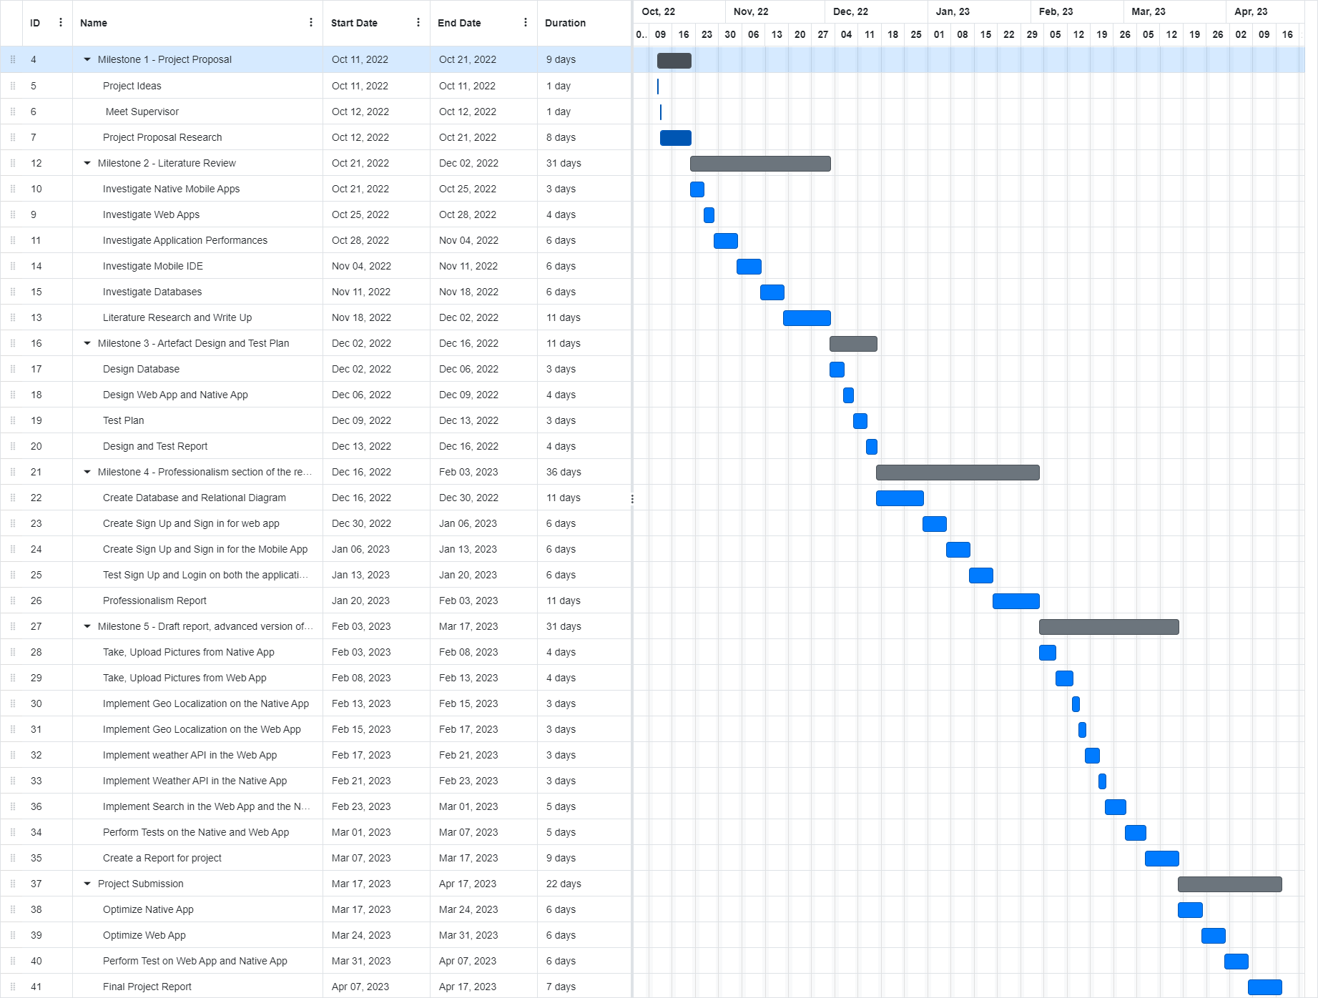

Final Gantt Chart
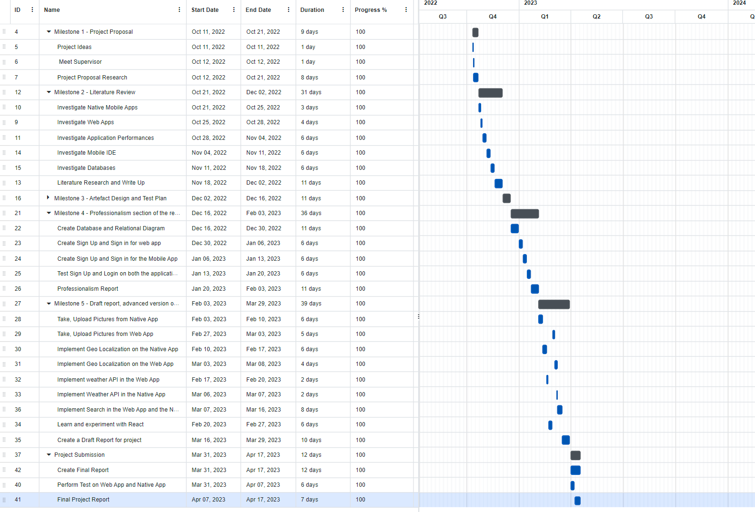

Meeting Logs

PROJECT MANAGEMENT LOG
First Name: Gursimran Surname: Singh
Student Number: 2042387 Supervisor: Frommholz, Ingo
Project Title: Native vs Web App | Date:12/10/2022
What have you done since the last meeting
First Meeting with the supervisor.

What do you aim to complete before the next meeting
Complete and submit the project proposal

Supervisor comments
Proposed some project ideas.

PROJECT MANAGEMENT LOG
First Name: Gursimran Surname: Singh
Student Number: 2042387 Supervisor: Frommholz, Ingo
Project Title: Native vs Web App | Date:04/11/2022
What have you done since the last meeting
Completed and submitted the proposal, started researching articles for the literature review.

What do you aim to complete before the next meeting
Search and read more papers for the literature review.

Supervisor comments
Proposed some website to research papers and articles for the literature review.

PROJECT MANAGEMENT LOG
First Name: Gursimran Surname: Singh
Student Number: 2042387 Supervisor: Frommholz, Ingo
Project Title: Native vs Web App | Date:25/11/2022
What have you done since the last meeting
Researched several articles and worked on the literature review.

What do you aim to complete before the next meeting
Submit Literature Review and start working on the design of the artefacts and on the test plan.

Supervisor comments
Suggested improvements to be made to the literature review.

PROJECT MANAGEMENT LOG
First Name: Gursimran Surname: Singh
Student Number: 2042387 Supervisor: Frommholz, Ingo
Project Title: Native vs Web App | Date:14/12/2022
What have you done since the last meeting
Started working on the design of the artefacts and on the test plan

What do you aim to complete before the next meeting
Finish off and upload the Design of the artefacts and the Test Plan, start developing the artefact.

Supervisor comments
Suggested some design ideas and testing methods.

PROJECT MANAGEMENT LOG
First Name: Gursimran Surname: Singh
Student Number: 2042387 Supervisor: Frommholz, Ingo
Project Title: Native vs Web App | Date:16/02/2023
What have you done since the last meeting
Uploaded Design of the Artefacts and Test Plan.
Completed Professionalism Report and created a prototype of the artefacts

What do you aim to complete before the next meeting
Fix the professionalism report and have an advance version of the artefact as well as a draft of the report.

Supervisor comments
Suggested some fixes to be made to the professionalism report.

PROJECT MANAGEMENT LOG
First Name: Gursimran Surname: Singh
Student Number: 2042387 Supervisor: Frommholz, Ingo
Project Title: Native vs Web App | Date:17/04/2023
What have you done since the last meeting
Completed Artefacts
Completed Reports

What do you aim to complete before the next meeting
This is the final meeting, the next steps will be to demonstrate the work to the reader and upload all the files.

Supervisor comments
Asked questions about the features of the artefacts.

