**GAME DESIGN DOCUMENT**

Educational Game**:** Eating Healthy

TABLE OF CONTENTS ...................................................................................1

1. Overview…………………………………………………………………………………..2
   1. **Target audience and benefits**
   2. **Summary**
2. Core Gameplay………………………………………………………………………..2-3
   1. **Game View**
   2. **Player Activity**
   3. **Game Controls**
3. Game GUI………………………………………………………………………………...3
4. Game Flow Diagram…………………………………………………………………..3
5. Game Elements and Mechanics…………………………………………….....4-5
   1. **Protagonist**
   2. **Food Types**
      1. ***Healthy***
         1. **Salad**
         2. **Vegetables**
         3. **Pulses**
      2. ***Unhealthy***
   3. **User Loses**
   4. **User Wins**
   5. **Level Select**
6. Unity Scenes……………………………………………………………………………..5
7. Music………………………………………………………………………………………..5

Overview

**Target audience and benefits**

The educational game is meant for young toddlers so as to introduce them to healthy eating habits from a young age. The game aims at teaching children to eat health and stay healthy.

**Summary**

The user will play as a young kid named Jeff. Jeff is a young toddler who is hungry, your task is to feed him healthy food while saving him from the harmful junk food thereby saving him from obesity and a ton of diseases.

Core Gameplay

**Game View**

It is a 2D game where the user has a restricted control over the protagonist. The user can only move the character up or down. A variety of different food will be making their way to him. The main objective will be to feed Jeff fruits and vegetables and save him from the junk food. If Jeff eats junk food he will lose a life. The user will have save Jeff for a two minutes after which they will complete the level and move on to the next one. The user will also get scored on the basis of the number of healthy items which are fed to Jeff. To achieve this the user will have to move Jeff up or down the three lanes accordingly.

**Player Activity**

The player can move Jeff up or down in the three lanes. First the player cans select the level of difficulty in accordance to his skill at the game. While controlling Jeff if it gets in contact with another game object and that object will be destroyed. Now three things can happen:

1. If the food is healthy the player will gets some points or a power up in accordance with the food.
2. If the food is healthy Jeff will lose a life.
3. If the food is missed no points will be awarded.

**Game controls**

Keeping in mind that the target audience is toddlers, the controls are as simple as possible. Just two controls:

1. Upward Key: For moving up.
2. Downward Key: For moving down.

|  |  |
| --- | --- |
| KEY | MOVEMENT |
| C:\Users\Predator\AppData\Local\Microsoft\Windows\INetCache\Content.Word\download.jpg | MOVE UP |
| C:\Users\Predator\AppData\Local\Microsoft\Windows\INetCache\Content.Word\download.jpg | MOVE DOWN |

Game GUI

The GUI will feature the following information:

1) Number of remaining lives

2) Time bar (Count down from 2 minutes)

3) Score and Level Difficulty

As Jeff hits unhealthy food the number of lives decrease. The GUI elements will appear at the top of the game in separate panel / window.

Game flow Diagram

Game Elements and Mechanics

**Protagonist (Jeff)**

He is our main hero and is hungry. He is the only game object which the player can control and any other object that collides with him gets destroyed.

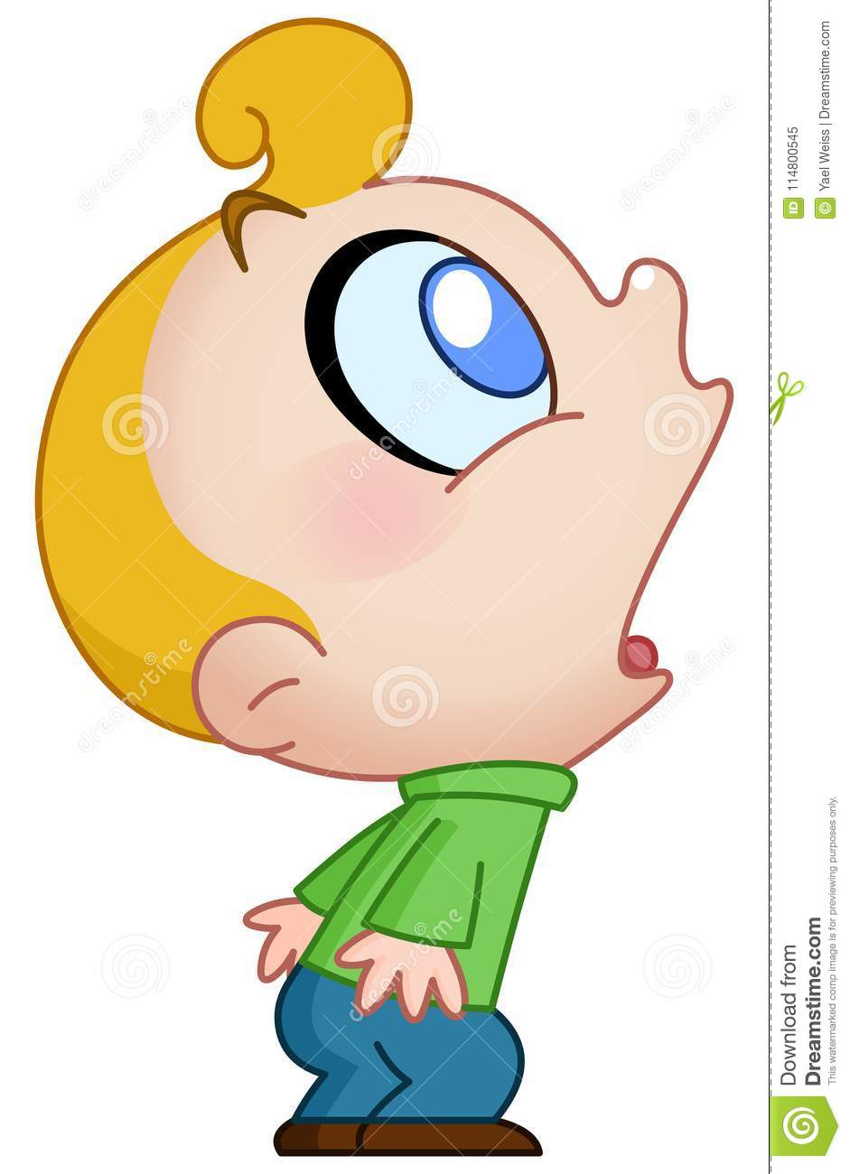

**Food Types**

**Healthy**

***Salad***

Eating salad will give 30 points to the user. It will move via Transfrom.translate towards Jeff and on collision will destroy itself. 

***Vegetables***

Eating vegetables will give 50 points to the user. They will move via Transfrom.translate towards Jeff and on collision will destroy itself. 

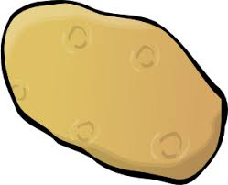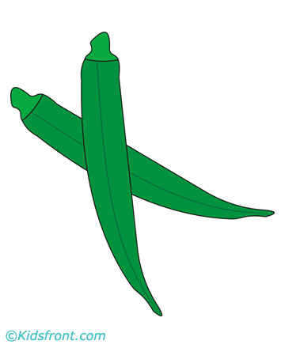

***Pulses***

Eating pulses will give 20 points to the user. They will move via Transfrom.translate towards Jeff and on collision will destroy itself.

**Unhealthy**

Eating Junk food like burger and pizza will take away user’s life. It will move via Transfrom.translate towards Jeff and on collision will destroy itself.

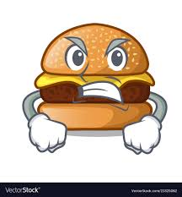

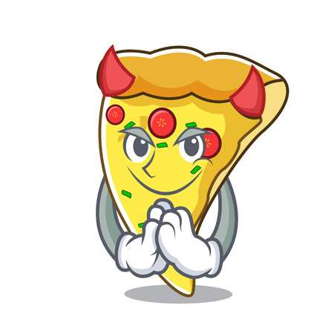

**User Loses**

If Jeff loses 3 lives the game ends.

**User Wins**

If Jeff survives for 2 minutes the user wins and is taken to the winner’s page with his score being displayed.

**Level Select**

Each Level gets tougher and tougher as the speed of the food items increase.

Unity Scenes

There will be 4 different scenes. First scene will be the main menu with Start, Instructions and Exit buttons. Exit button will close the game. Instruction button will lead to instructions page and start will take to level select which will eventually take user to the actual game.

Music

The music will be simple loops taken from the cartoon series. They should include: Menu Loop, Standard Game Loop and Sound Effects like Cry on losing the game, winning sound and a sound for losing a life.