1, pwd

2, mkdir

3, ls

4, ls-a

5,ls -l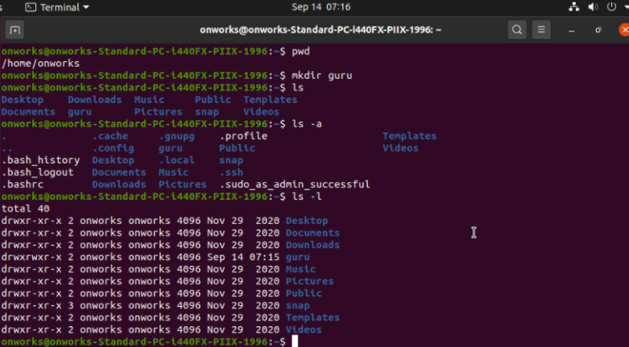

6, cd guru

7, cd ..

8, df

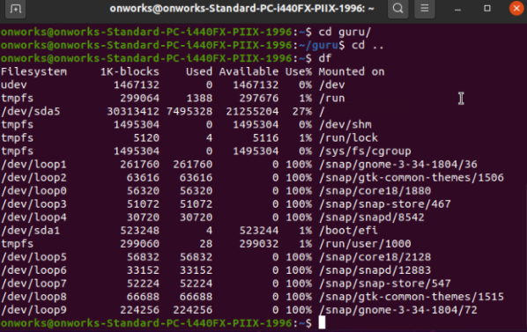

7, df -h

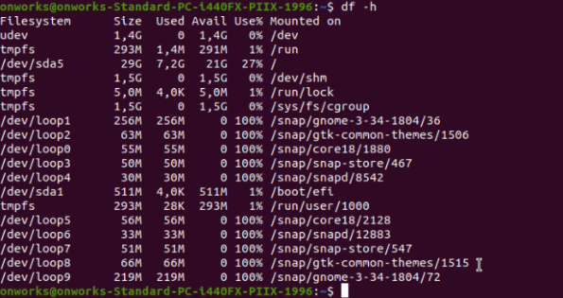

8, ps

9, ps -d

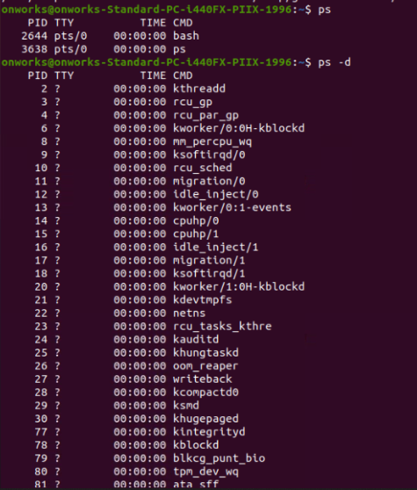

10, getid example.txt

11, getid example.txt &

12,cat example.txt

13,ps

14,kill 2644

15, free

16, free -h

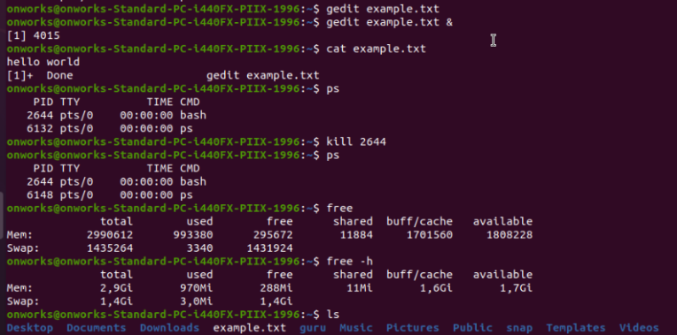

17,lscpu

