Hands-On 1:

1. Creating resource group-
2. Click on the resource groups and then add(+).

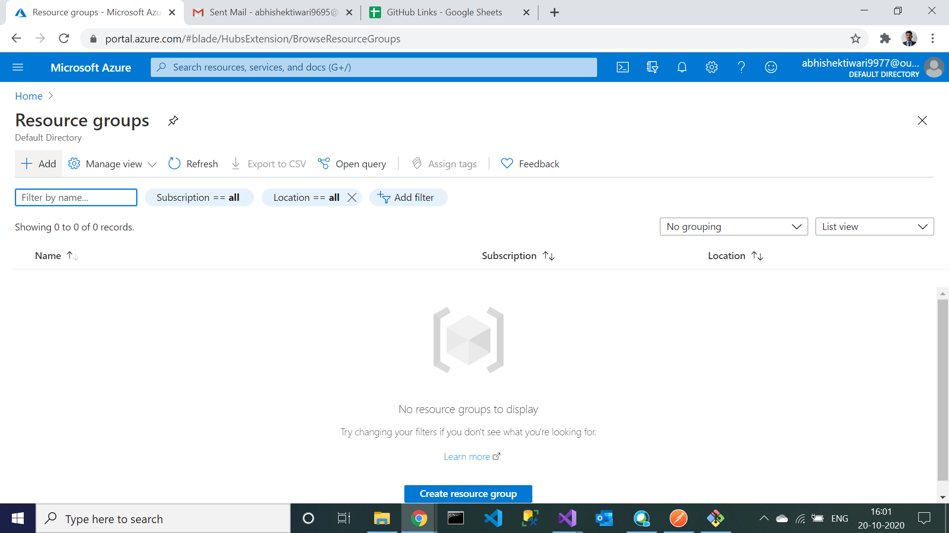

1. Enter this ‘DNAzure_ResGrp’ as a resource group name and click on create and review it.

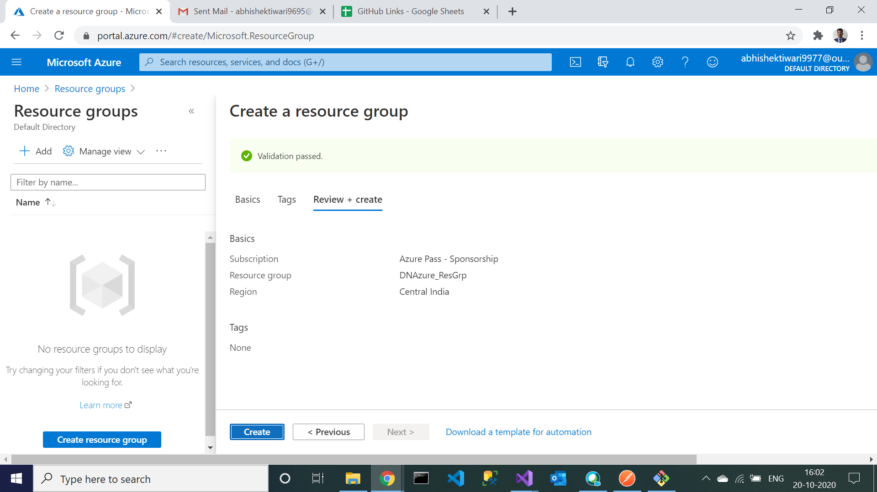

1. Resource group created. Check in notification tab.

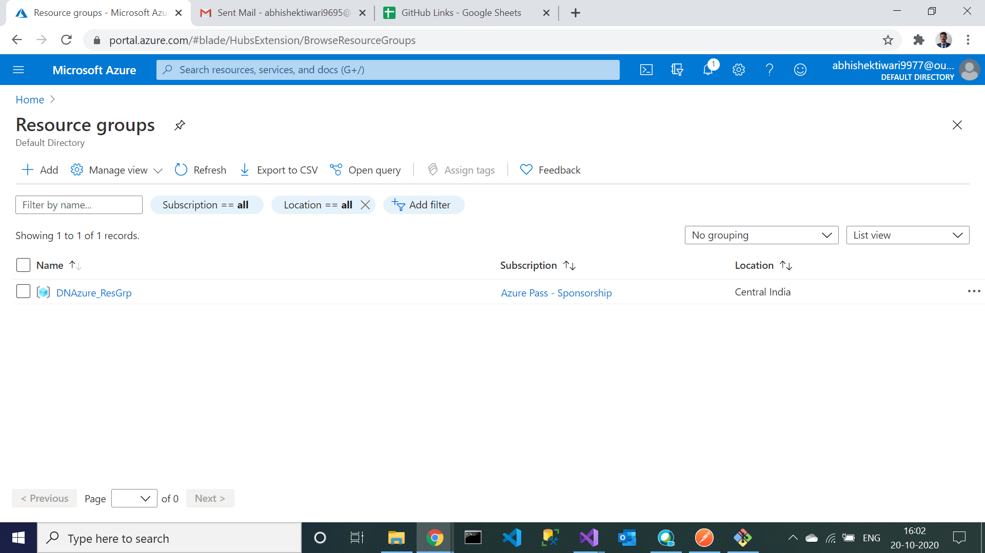

2. Navigation to Container Registry

1. Click on ‘Create a resource’ and search for container.

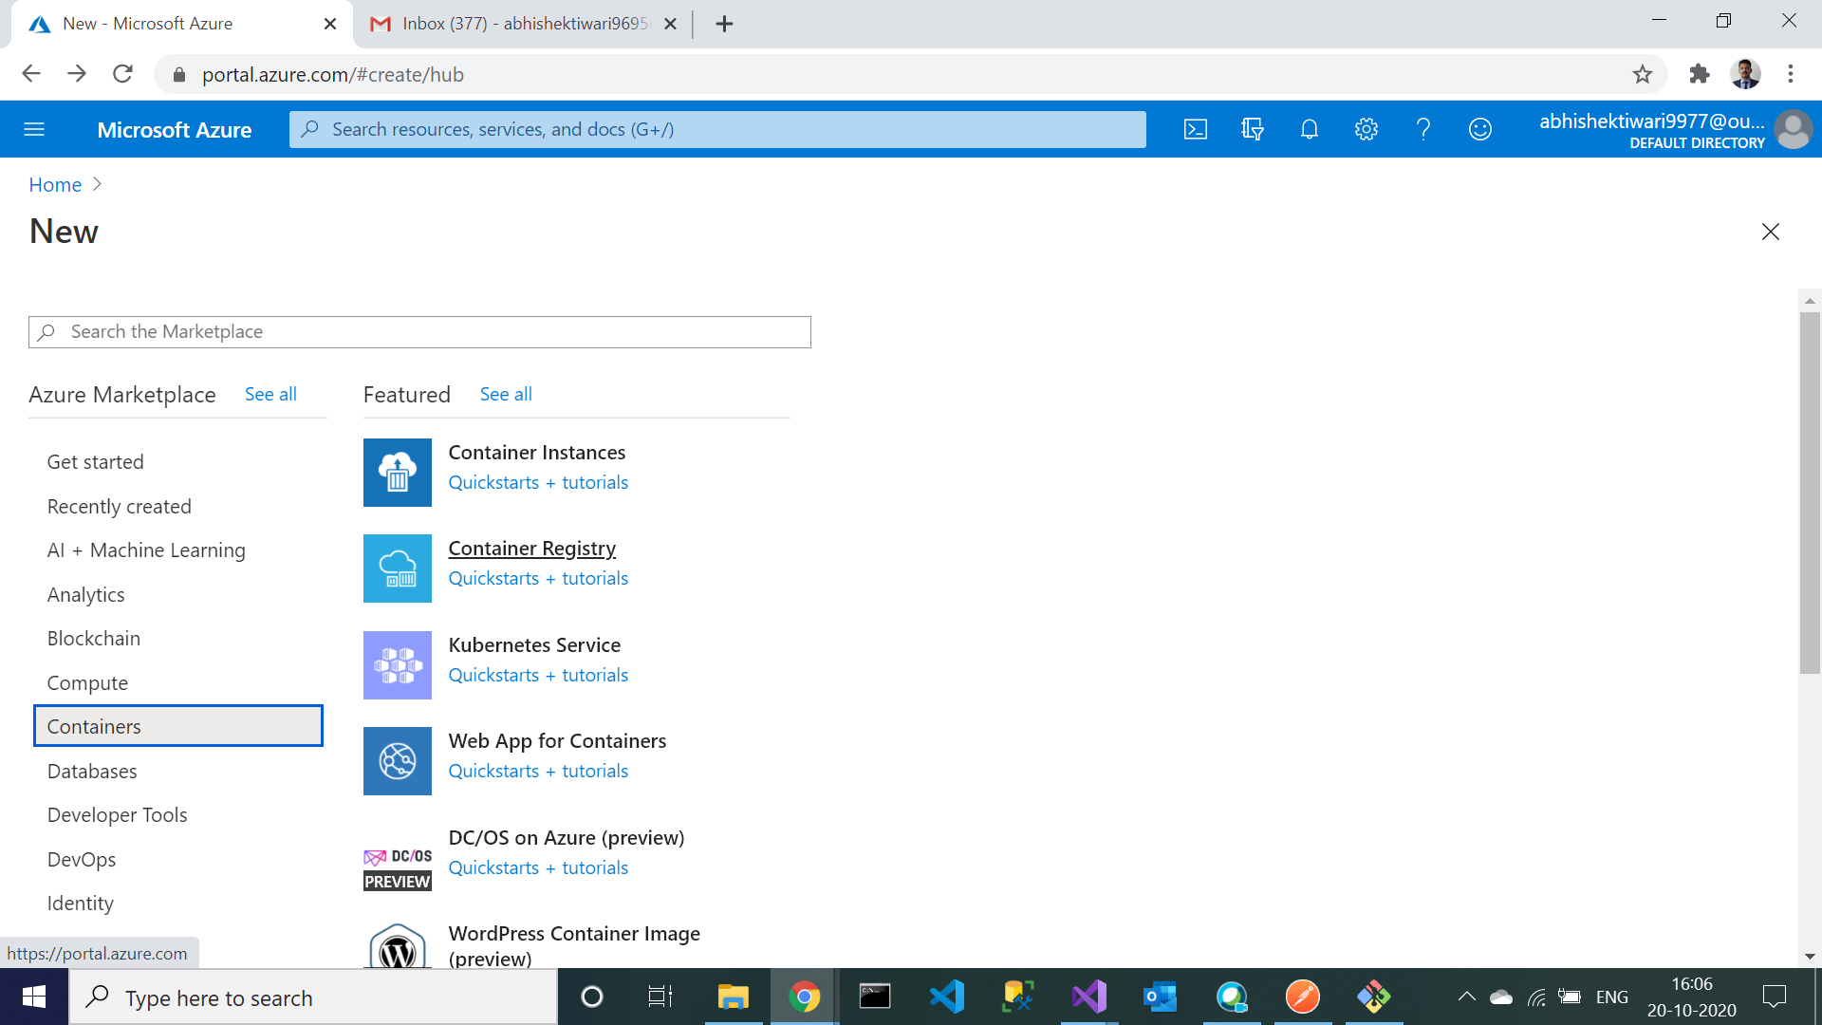

1. Enter “DNAzureRegistry” as a registry name and click on review and create.

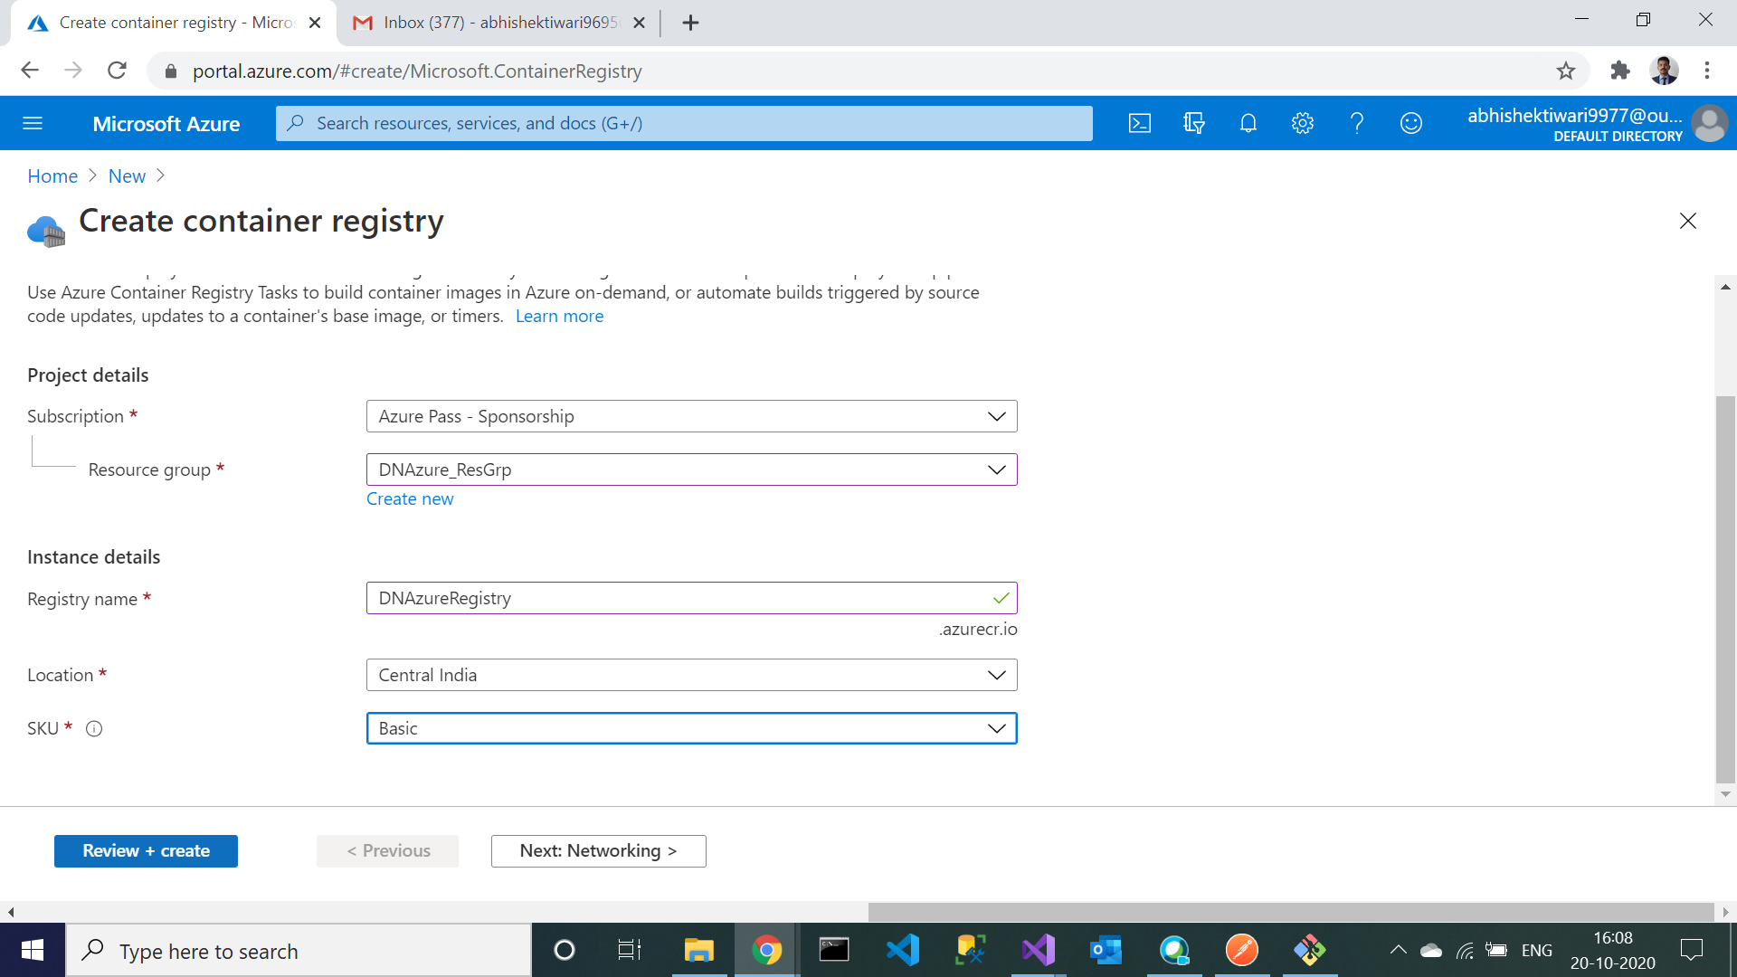

1. Container registry created, you can see in the notification tab.

