Hands-on 2:

Create Logic App and Add RSS feed trigger.

1. Search for Logic App in resources.

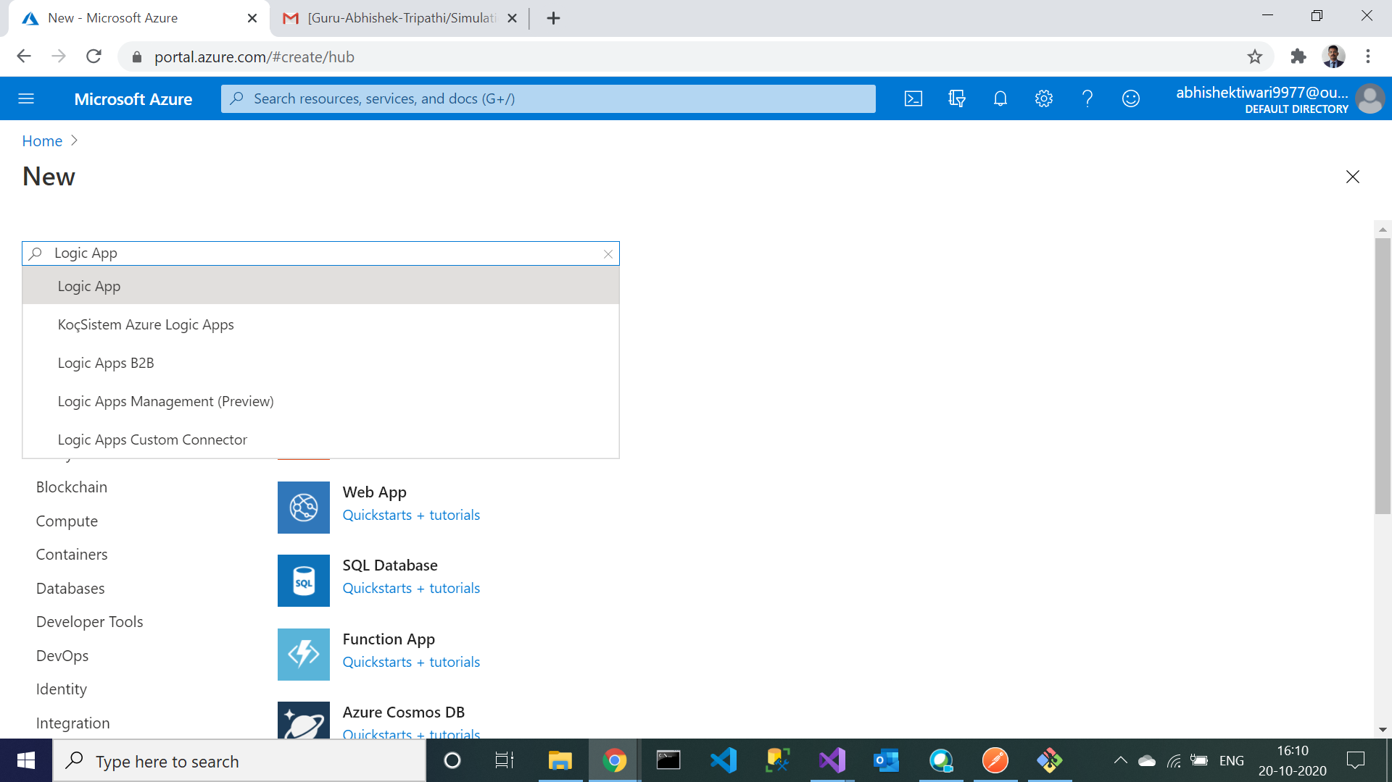

1. Click on create to add logic app in resource group

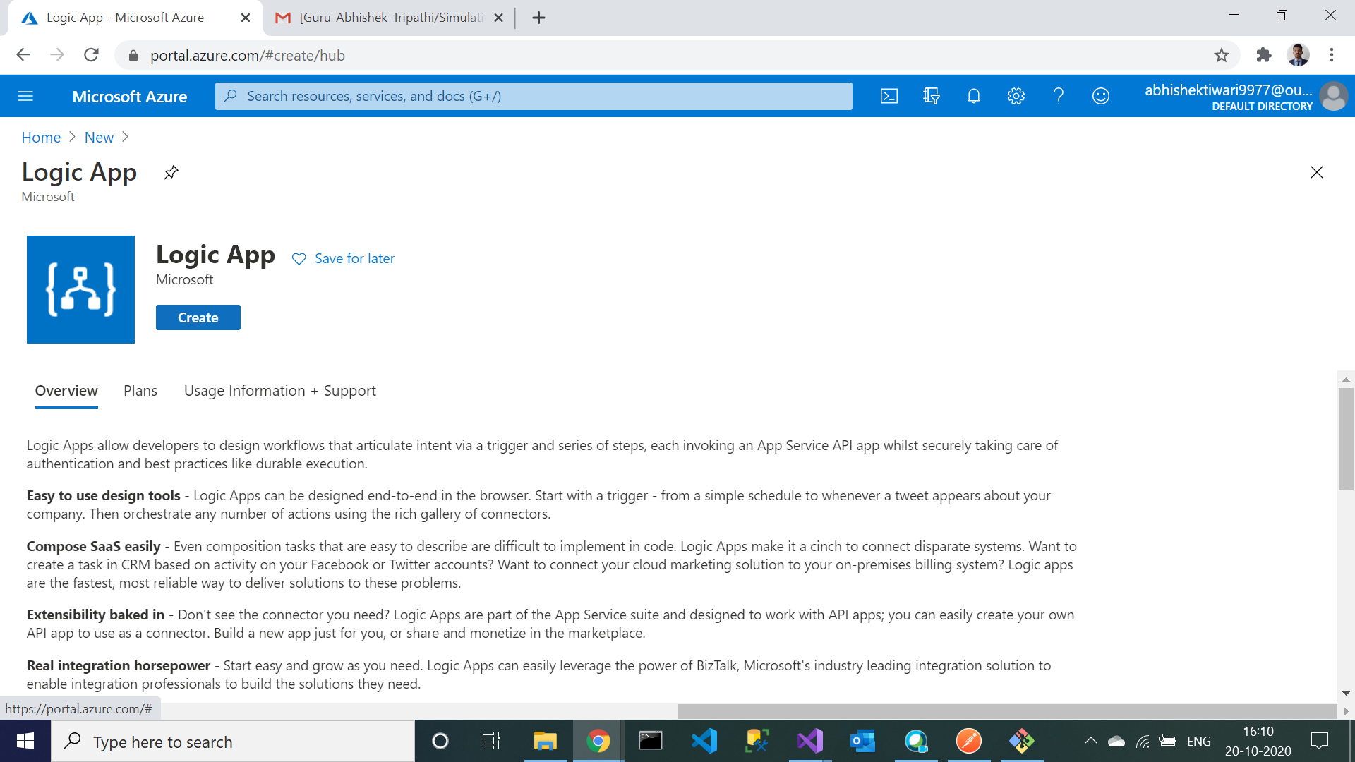

1. Select the resource group previously made and enter “DNAzure_RssFeedLogicApp” as the name of the logic app. Then click on review and create.

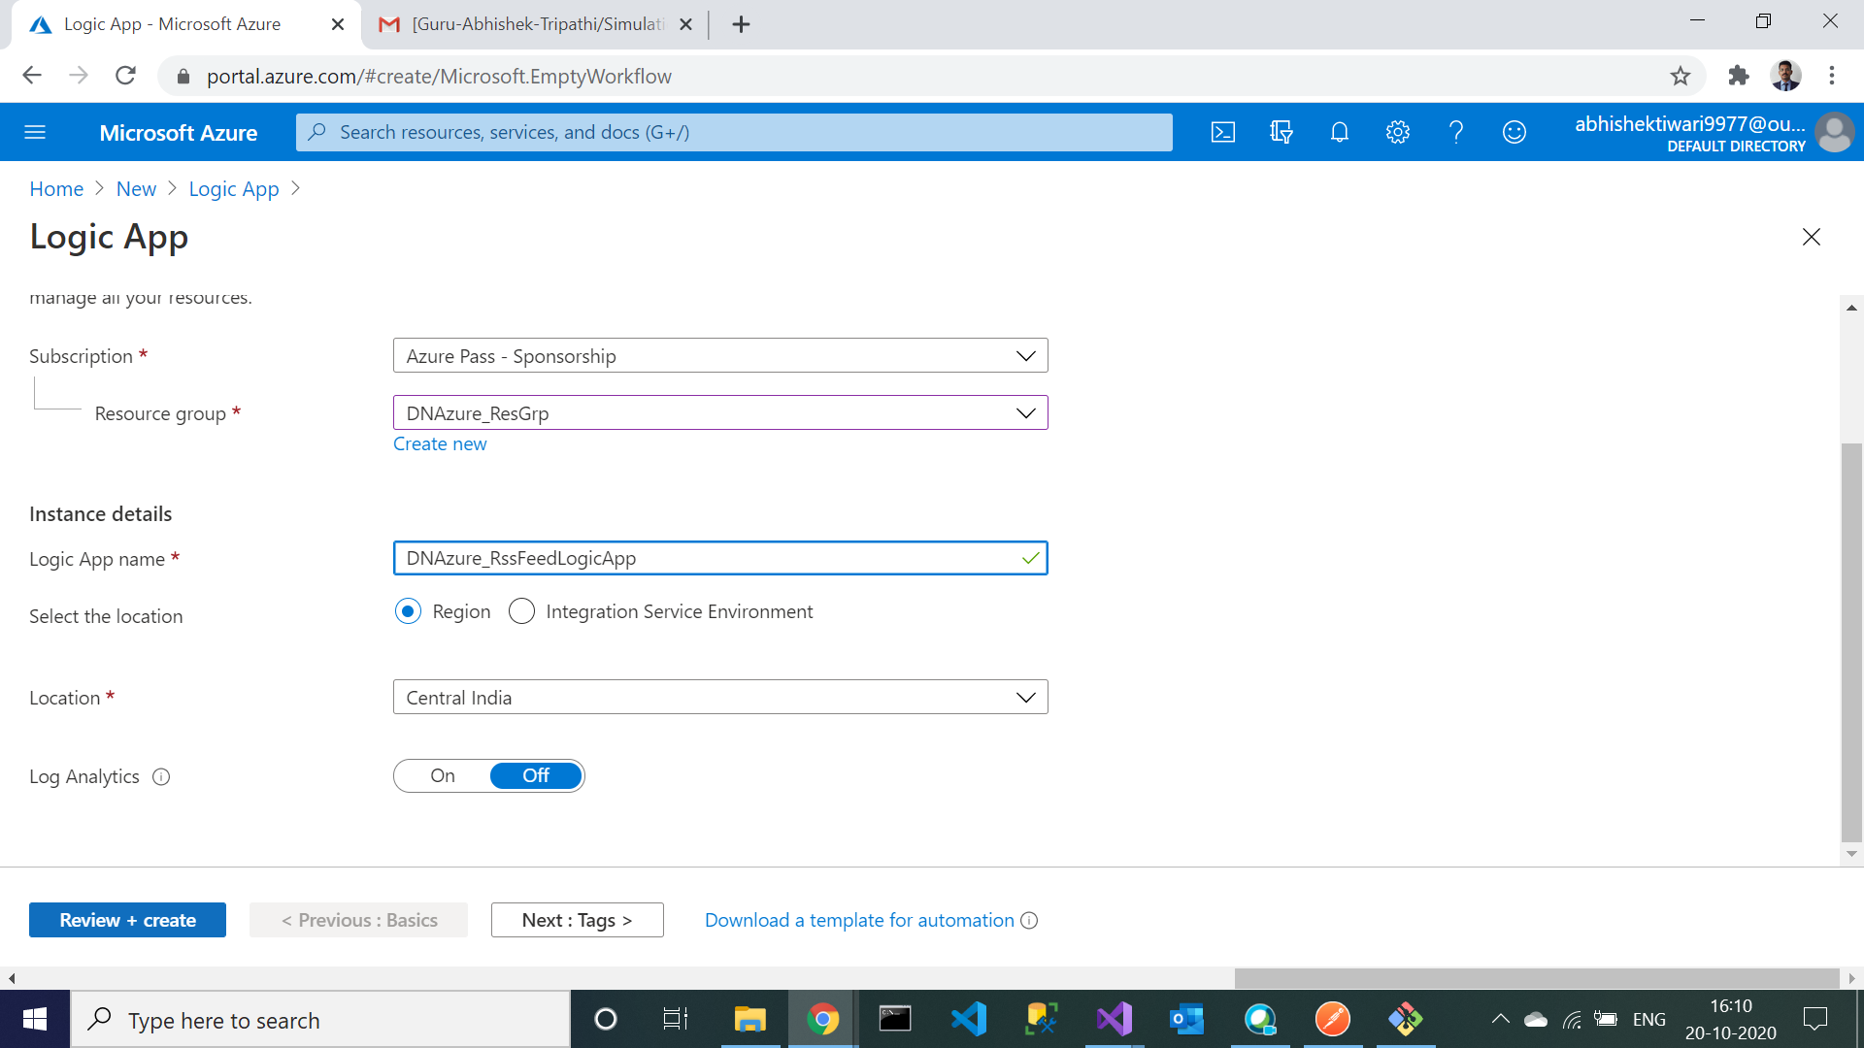

1. Logic app created. Check in notification.

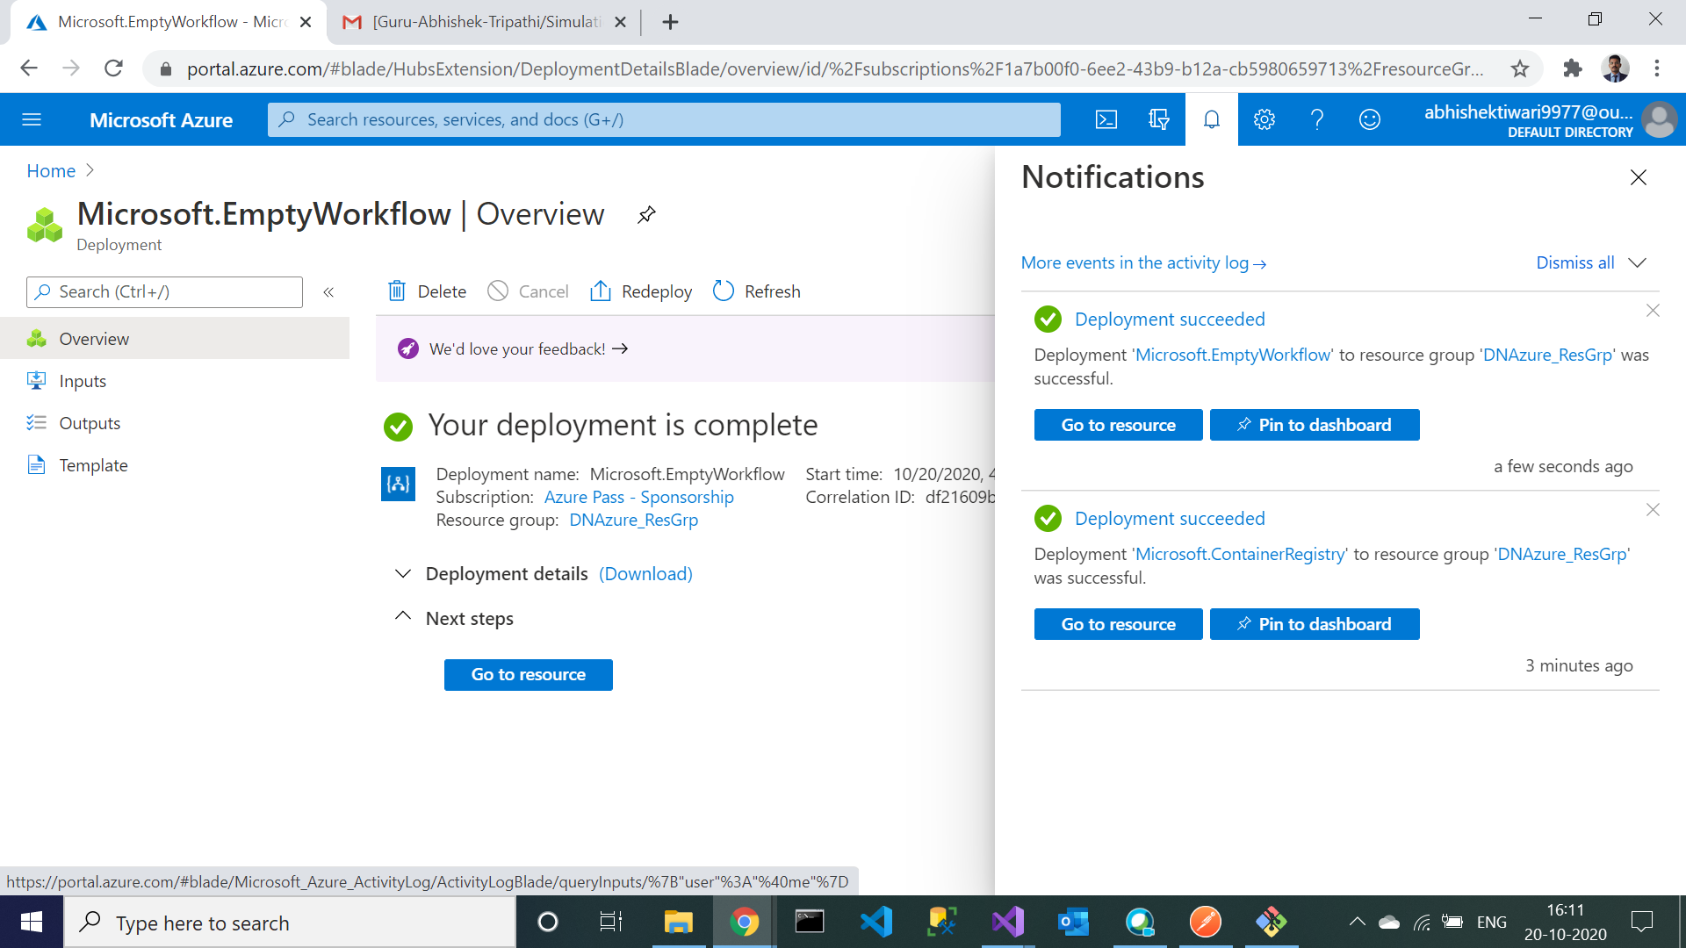

1. Go to Logic app designer and search for RSS to add an RSS feed trigger.

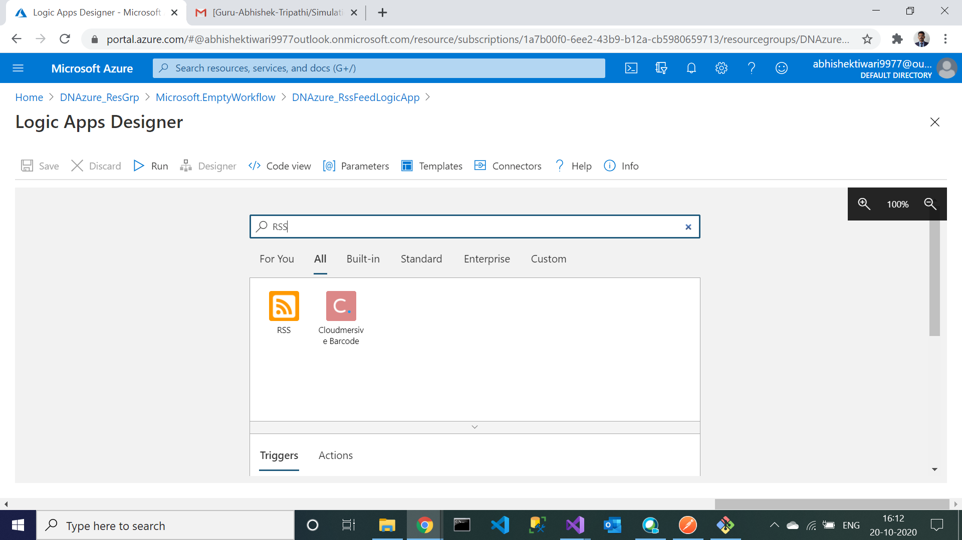

1. Copy this link - ‘<https://timesofindia.indiatimes.com/rssfeedstopstories.cms>’ in your RSS feed url. Click on the newstep and add gmail.

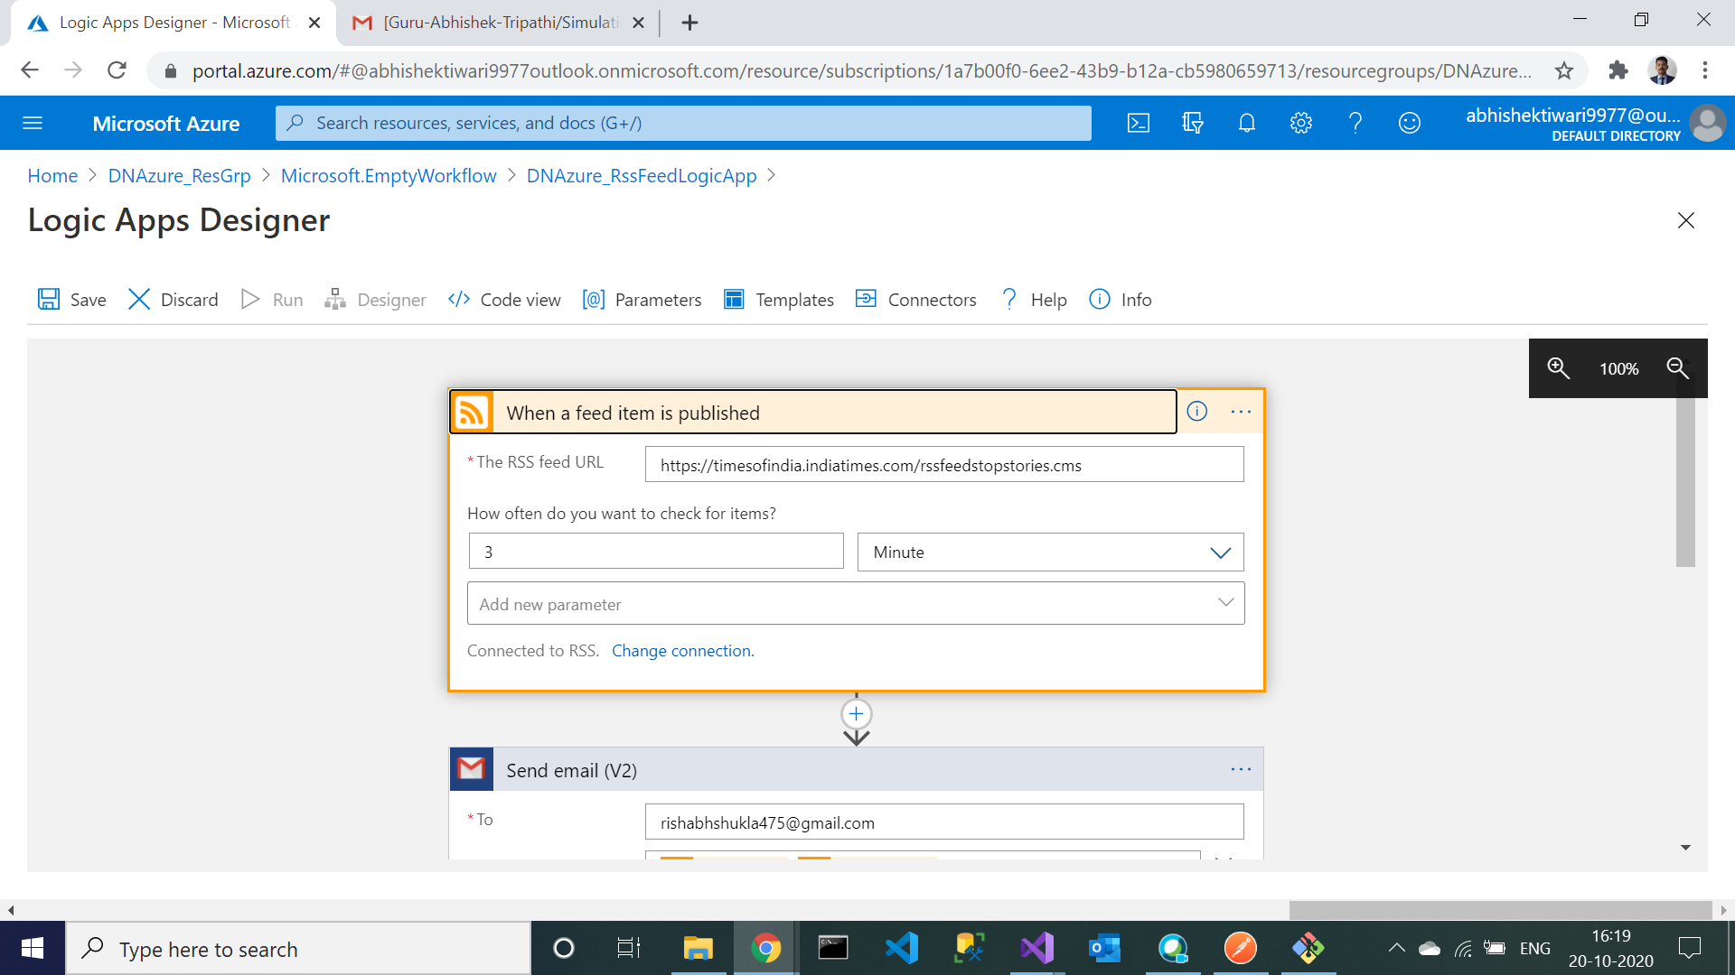

1. Enter the destination email id. In the subject and body add the dynamic content.

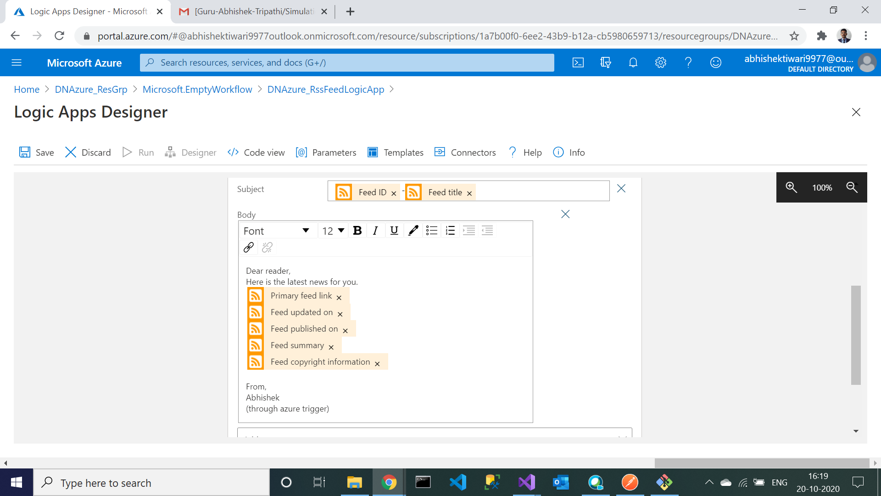

1. Logic app created successfully and RSS feed trigger implemented successfully.



