Hands on - 3

Devops project creation.

1. Create a resource. Developer tools => Devops Starter

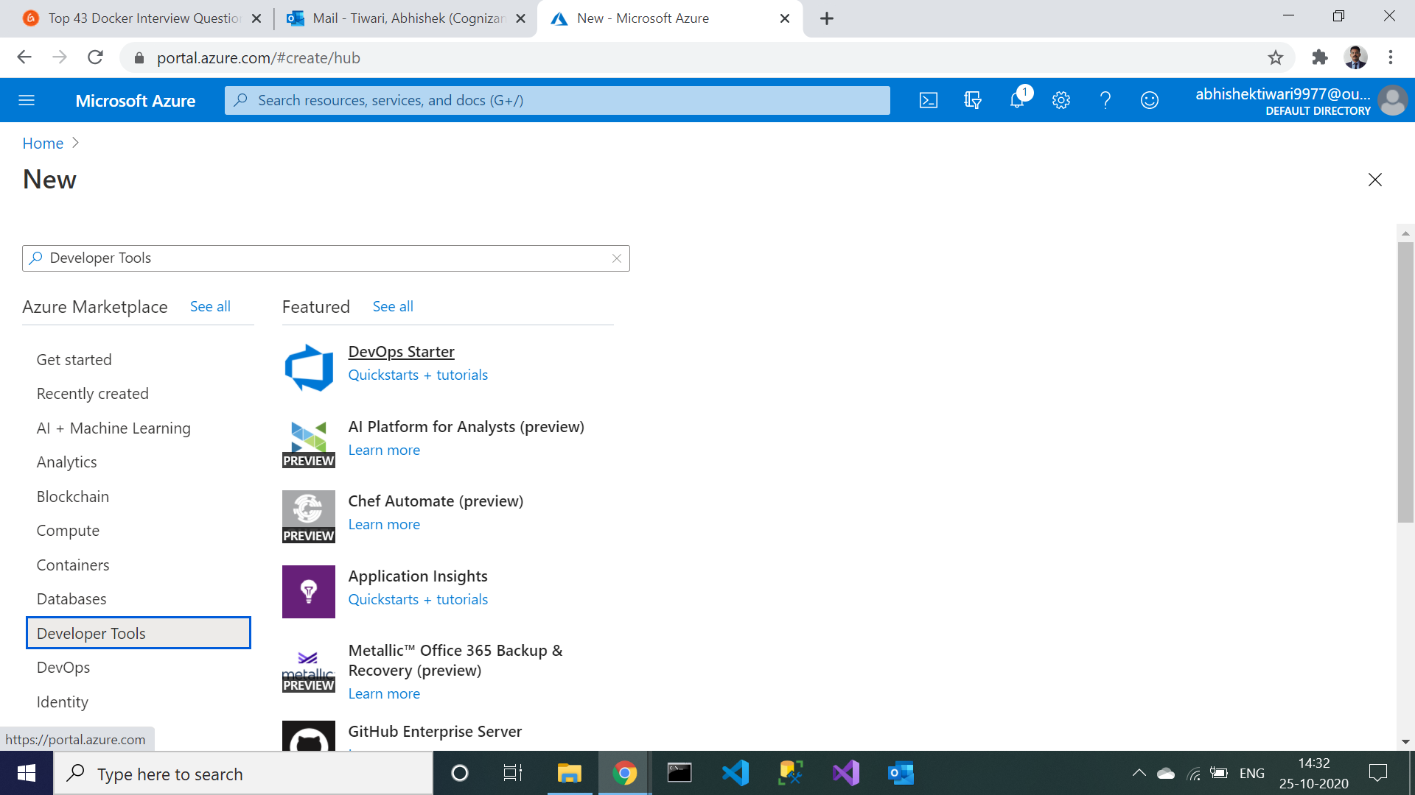

1. .NET will be selected by default, click on next and choose framework.

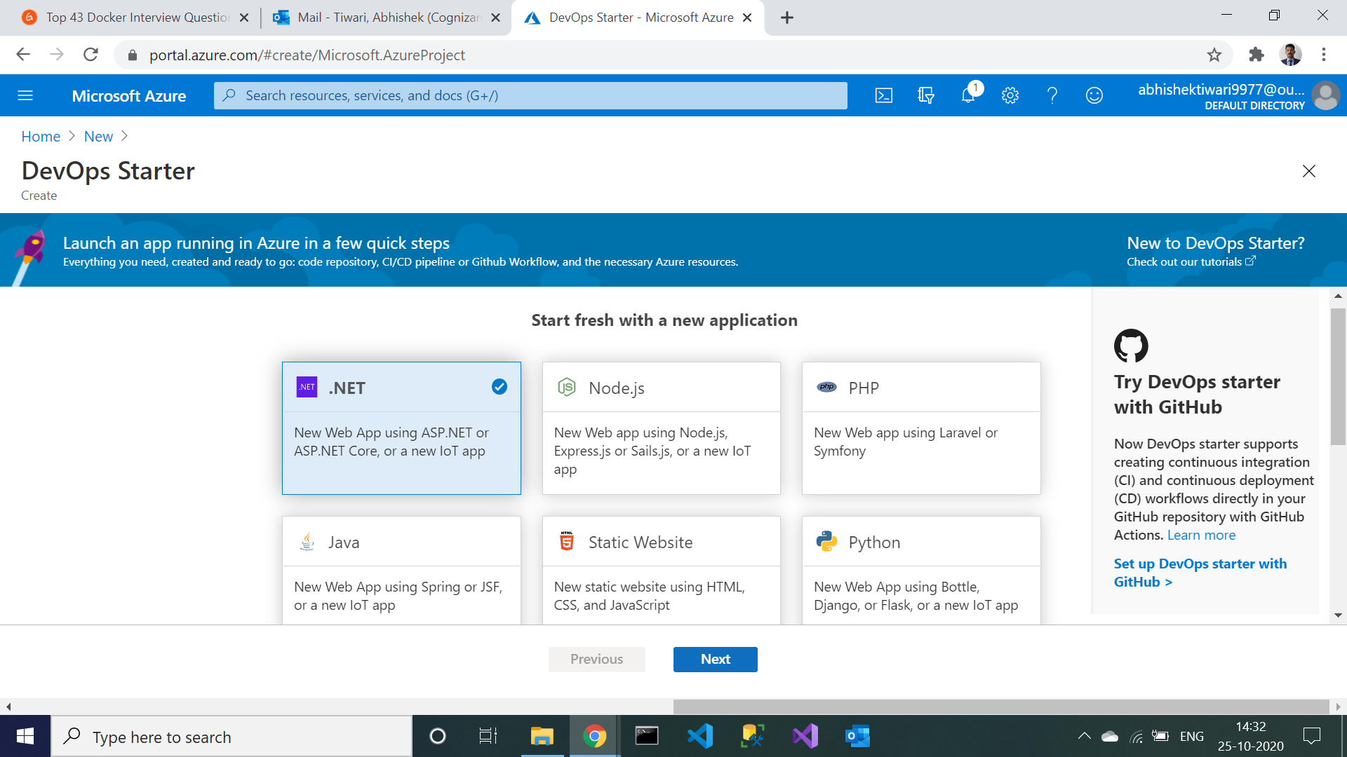

1. Choose the service and click on next. It will ask for the project name and organization name.

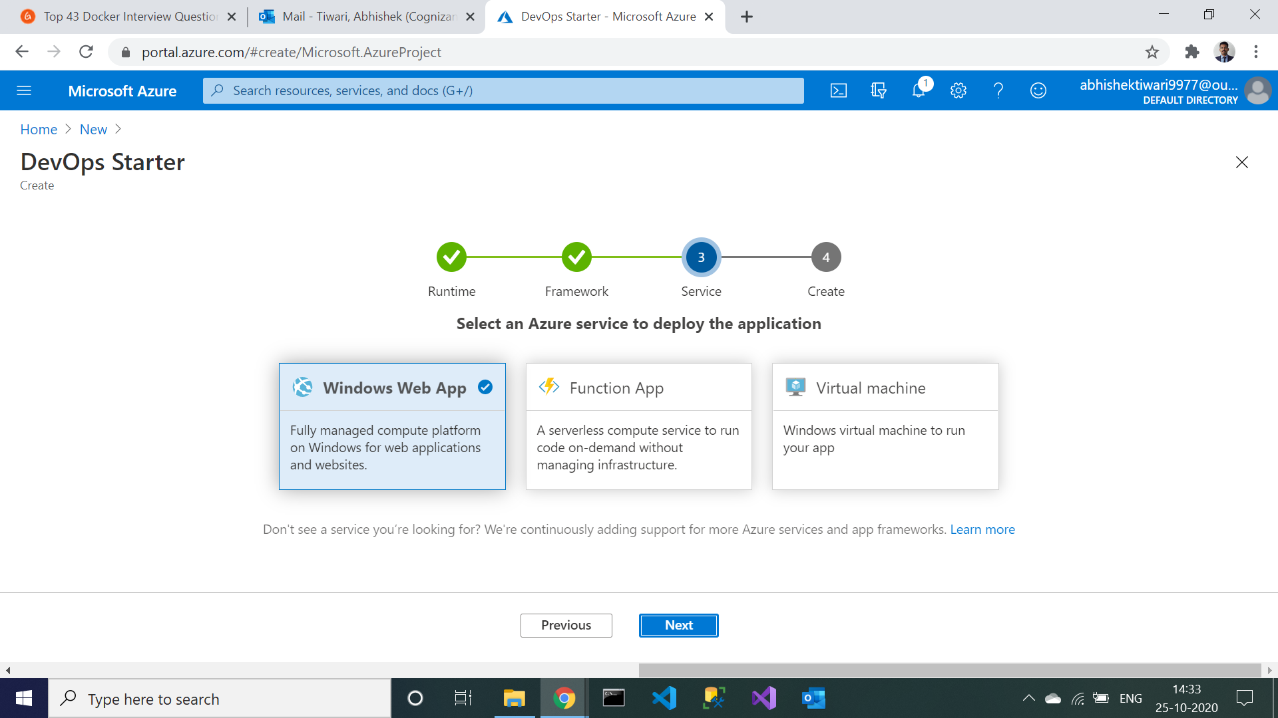

1. Fill all the attributes and change the pricing tier to basic. Click on done.

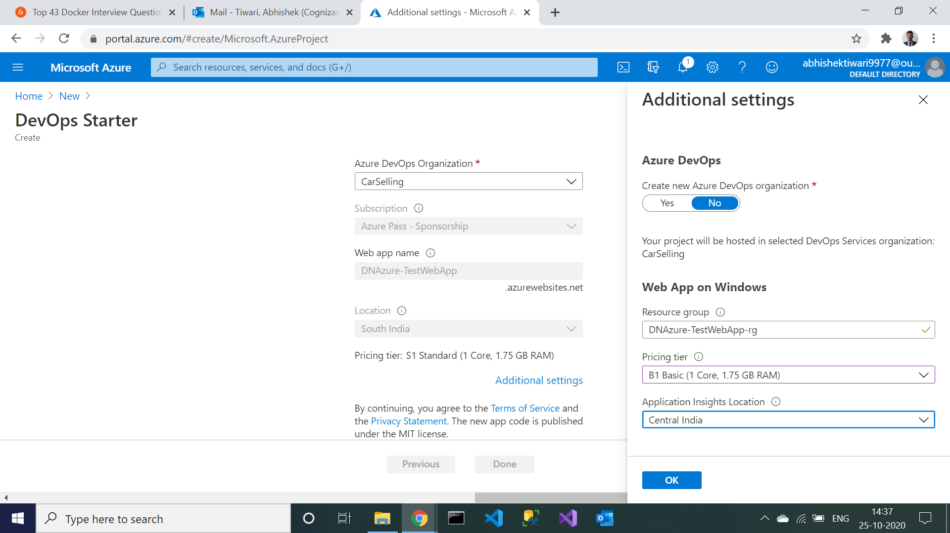

1. Check on the notification tab, deployment will be in progress.

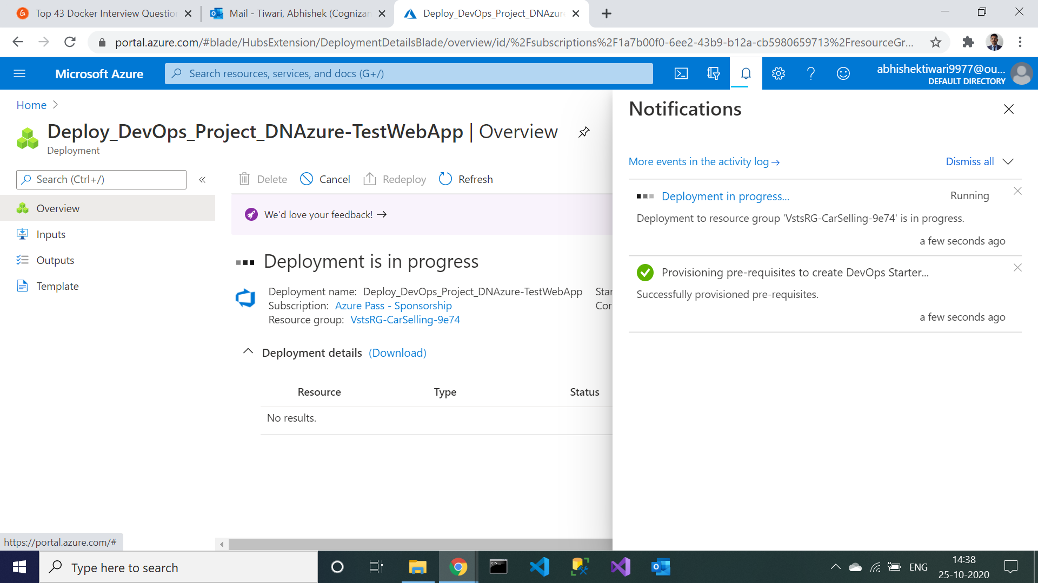

1. After deployment gets succeeded, click on Go to resources.

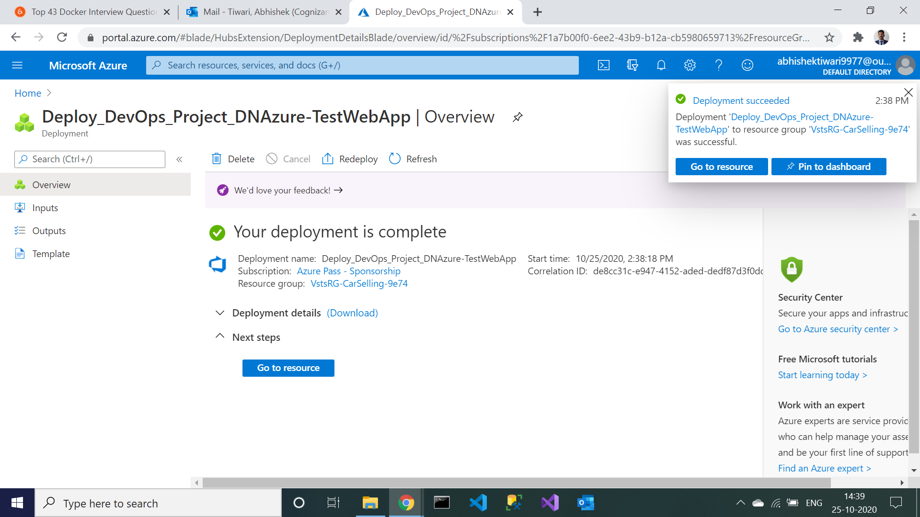

1. In the resources Build will be in progress. When build is succeeded, click on refresh tab. Release will be in progress.

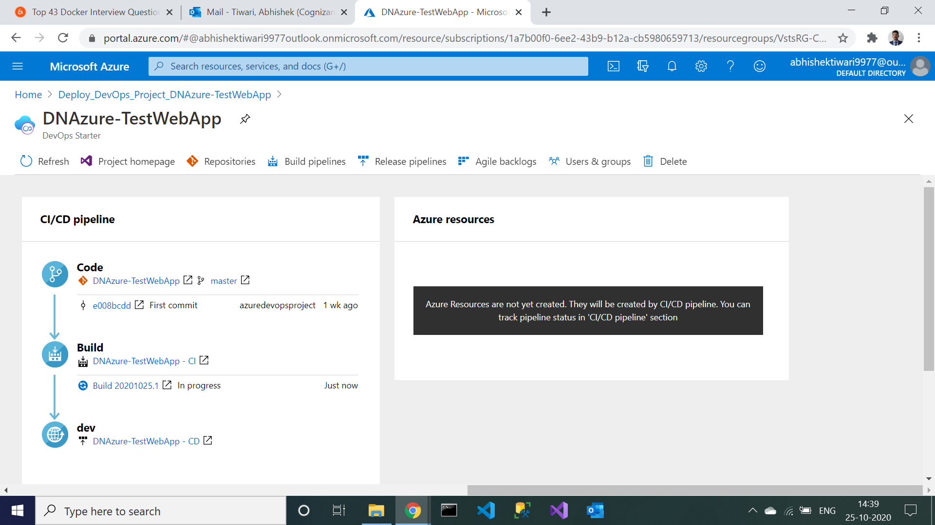

1. When release gets succeeded, click on browse to see if your application is running or not.

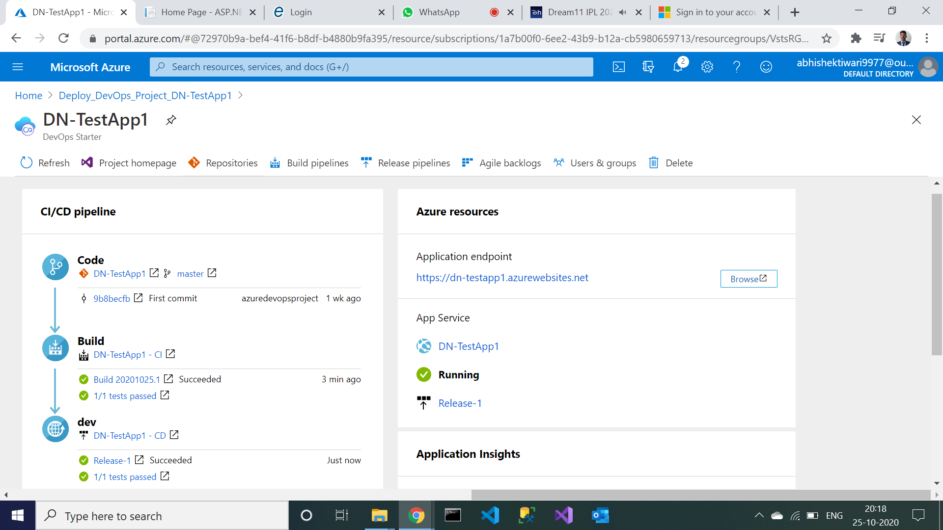

1. If in your browser this type of page gets opened means all successfully done.

