Hands on - 4

DevOps project code modification and automatic CI and CD deployment.

1. Click on the resource group in which your project is there.

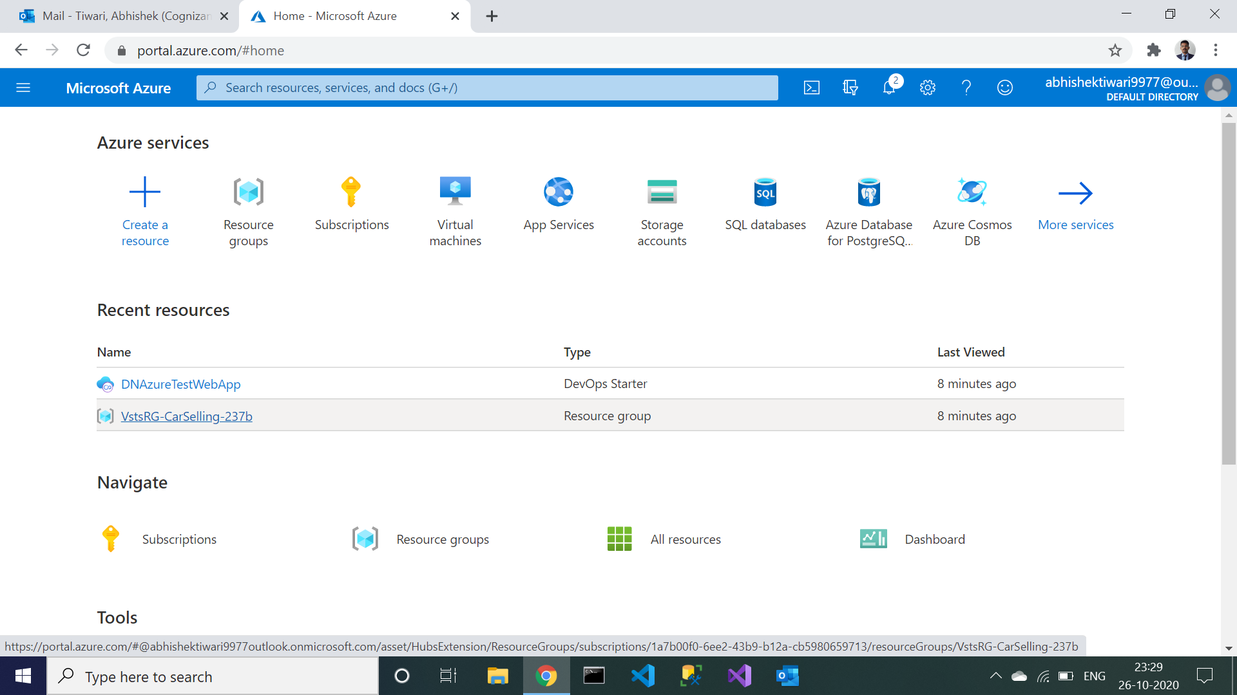

1. Next choose your project from a resource group.

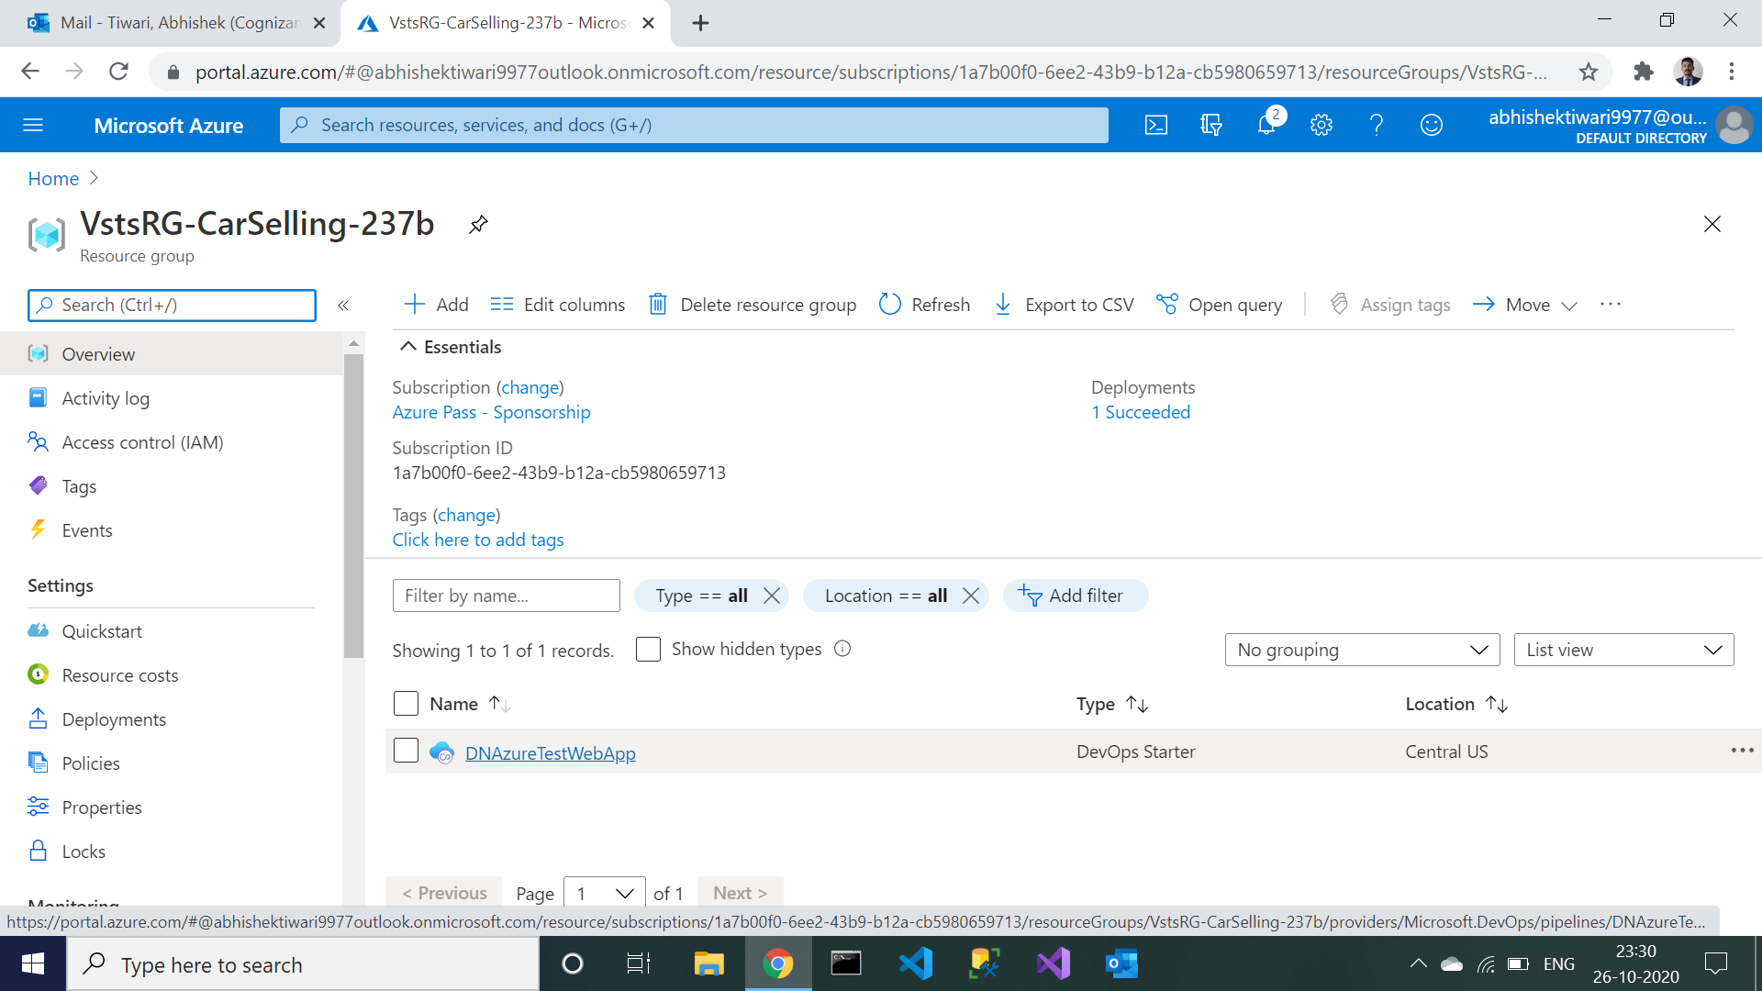

1. Open the repositories tab by clicking on repositories.

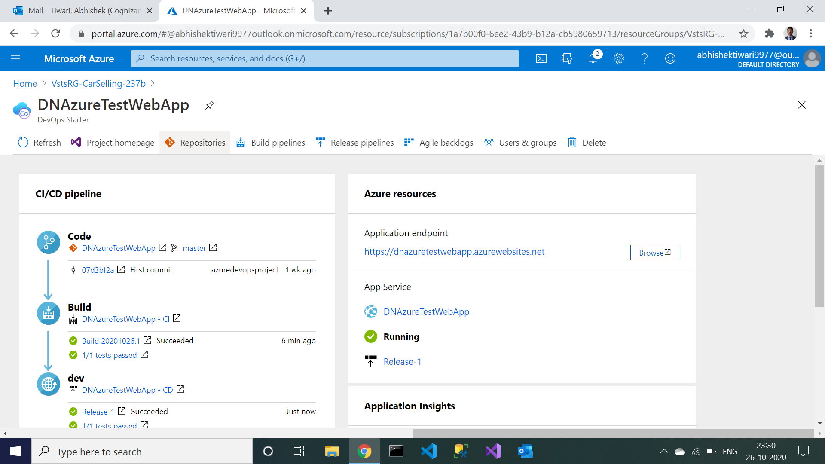

1. In the repository, open the application folder and go to index.cshtml file and change something in it.

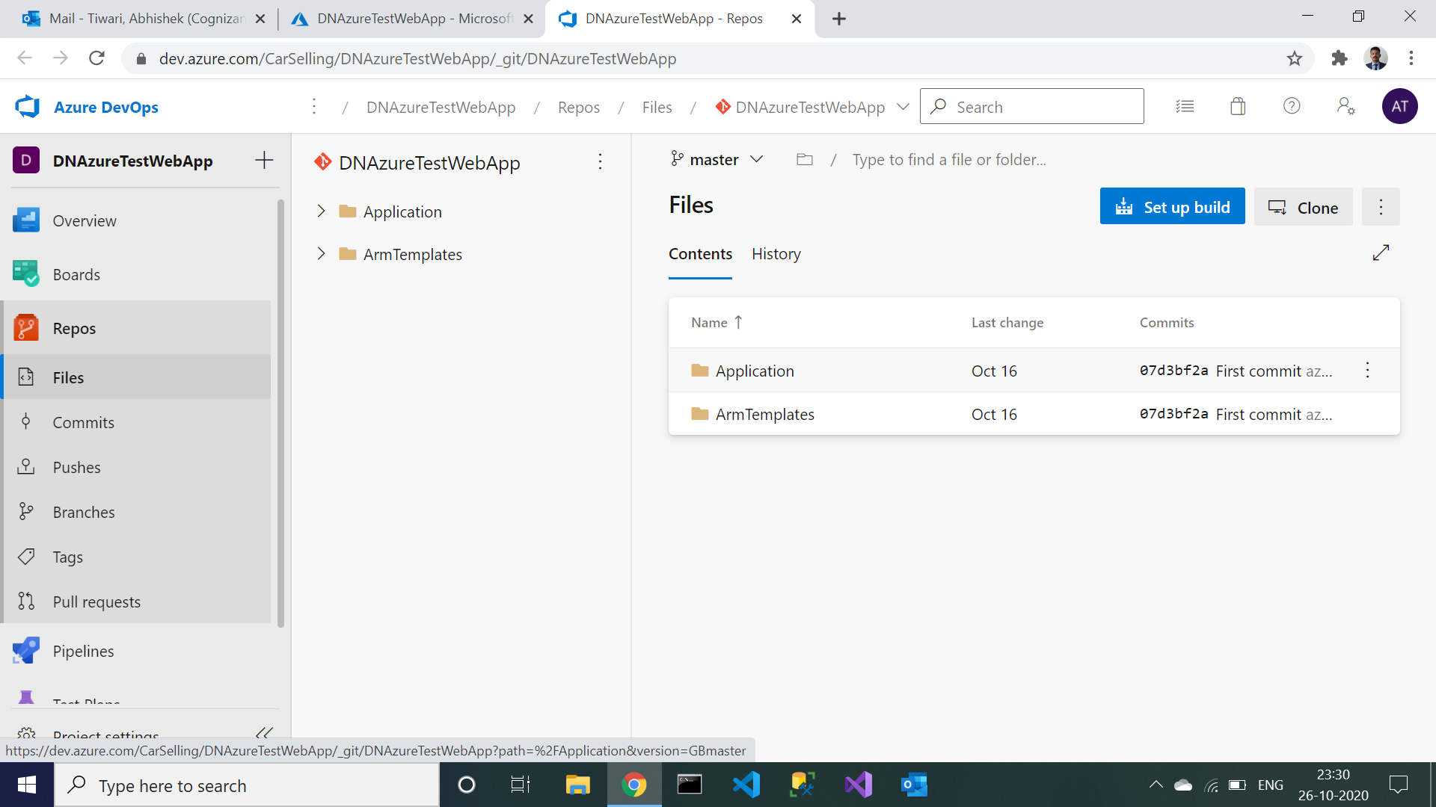

1. I have changed on line no 18 **“I have edited this”**. And go to the pipeline.

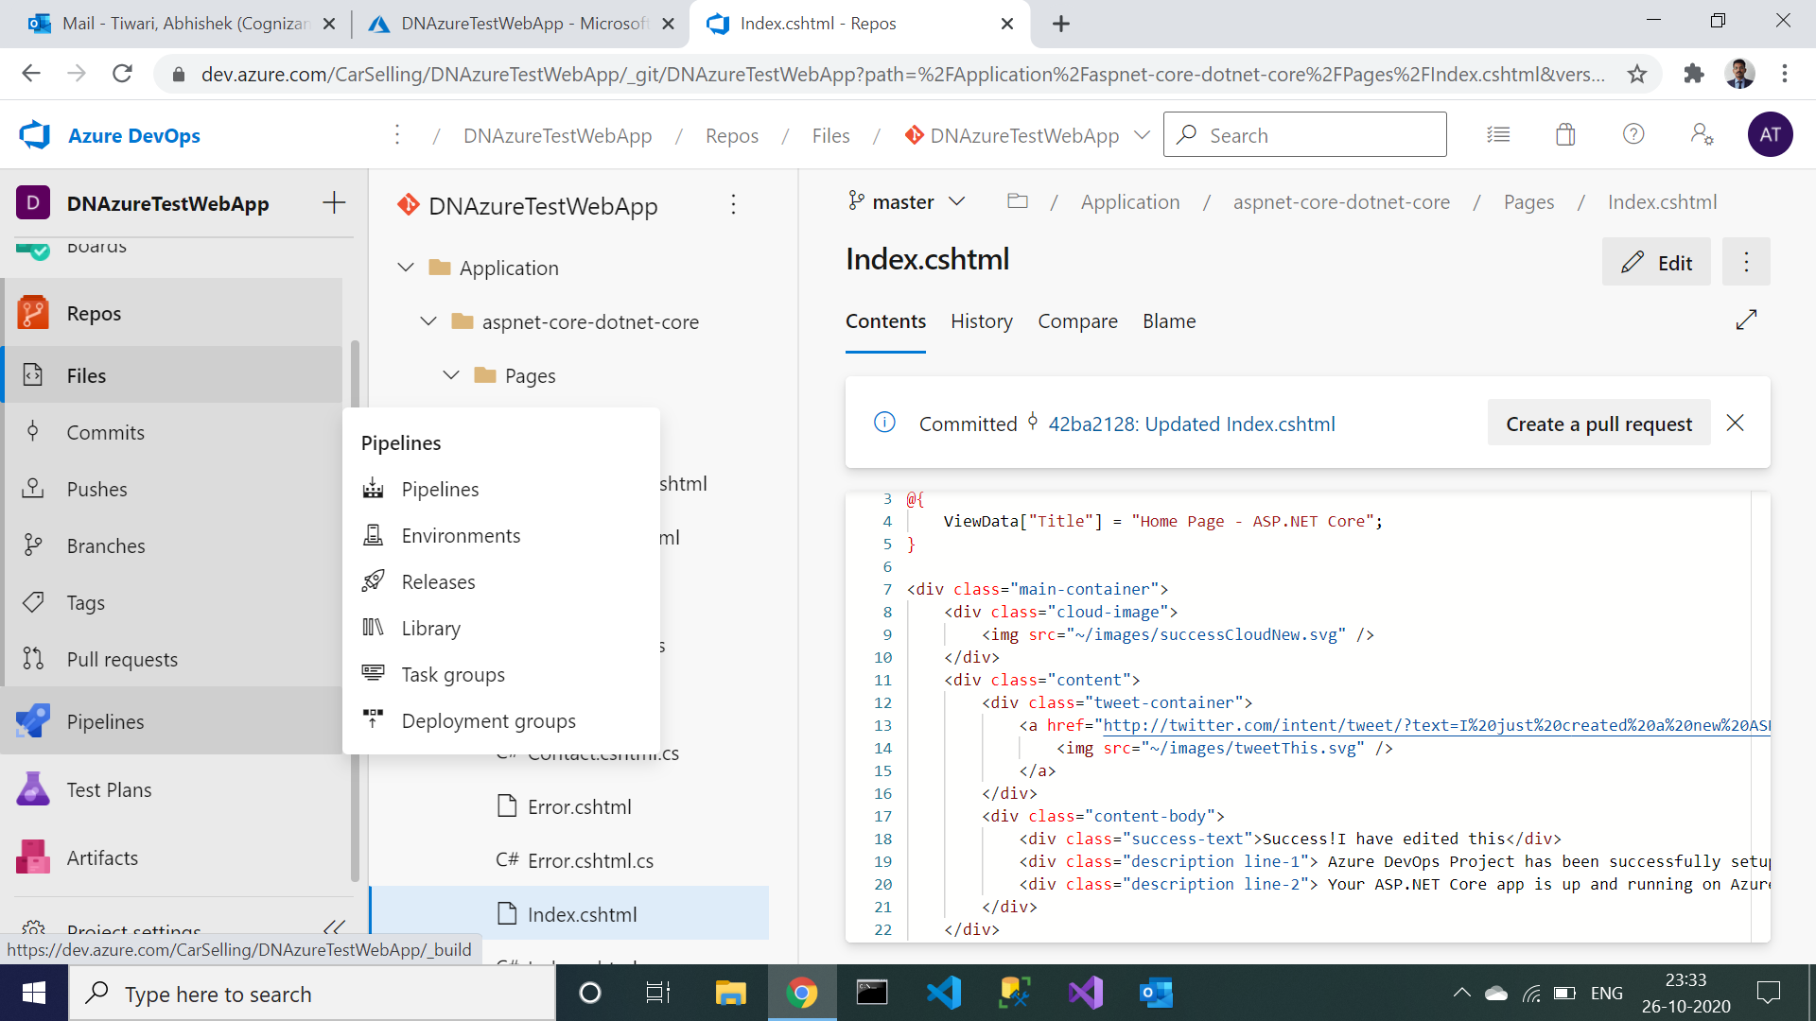

1. After opening the pipeline, open CI pipeline.

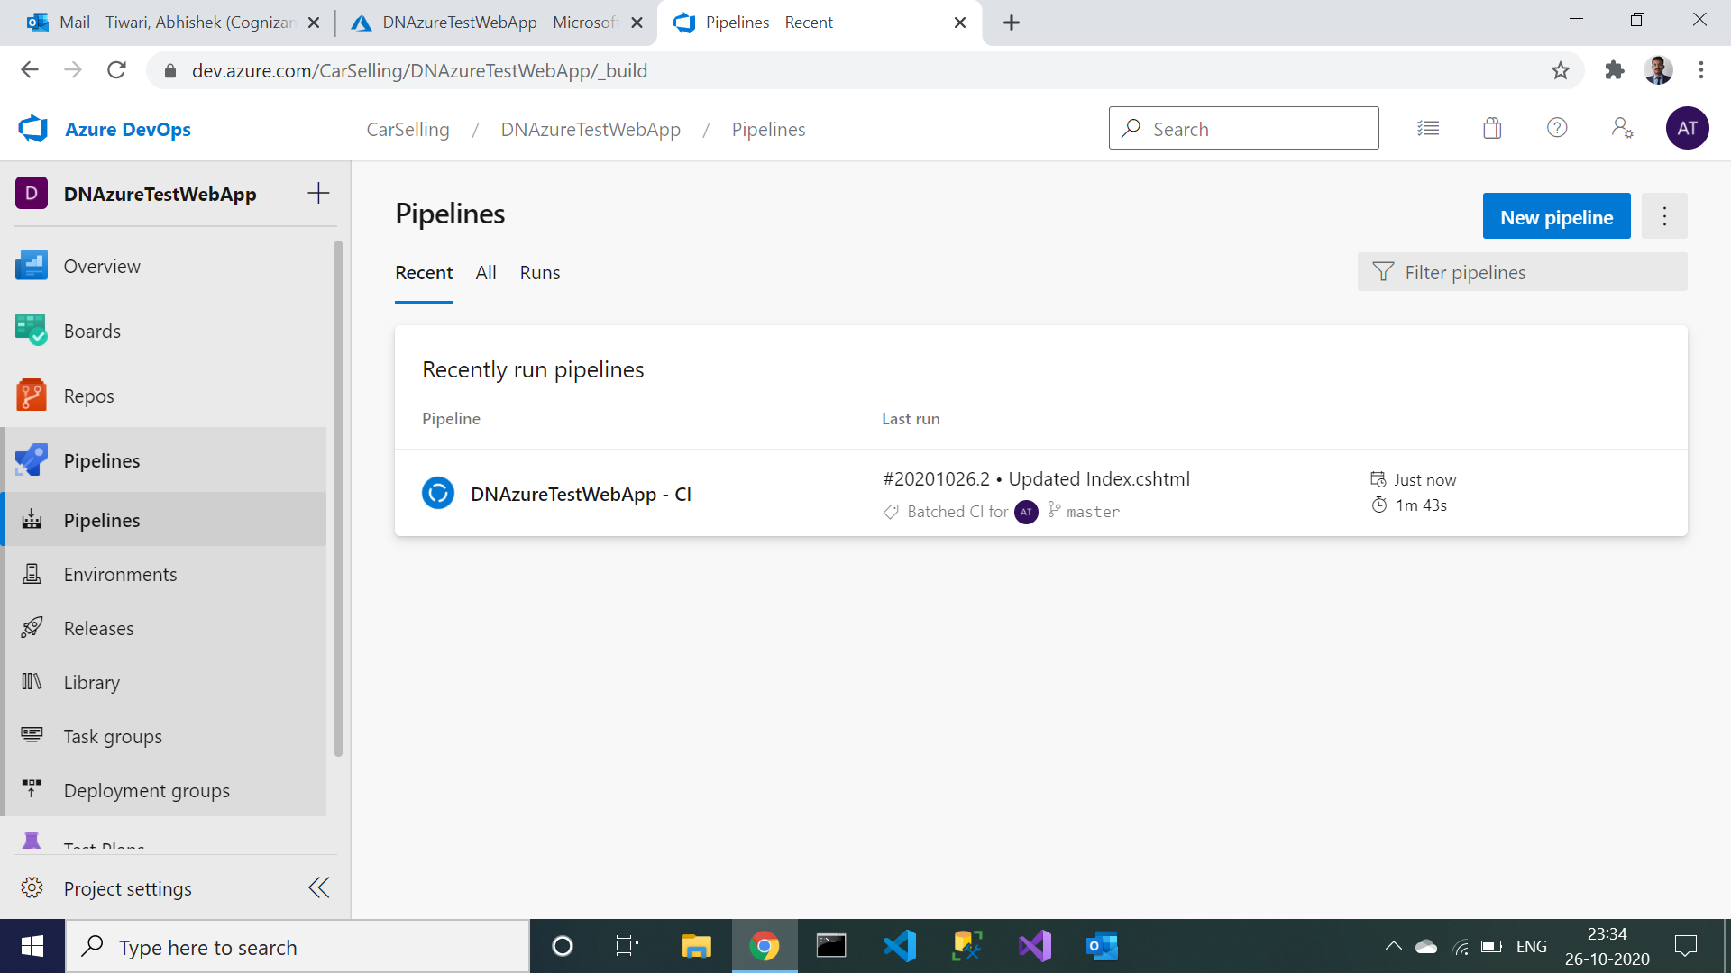

1. You will find that build is in progress automatically. After this CD will be automatically triggered.

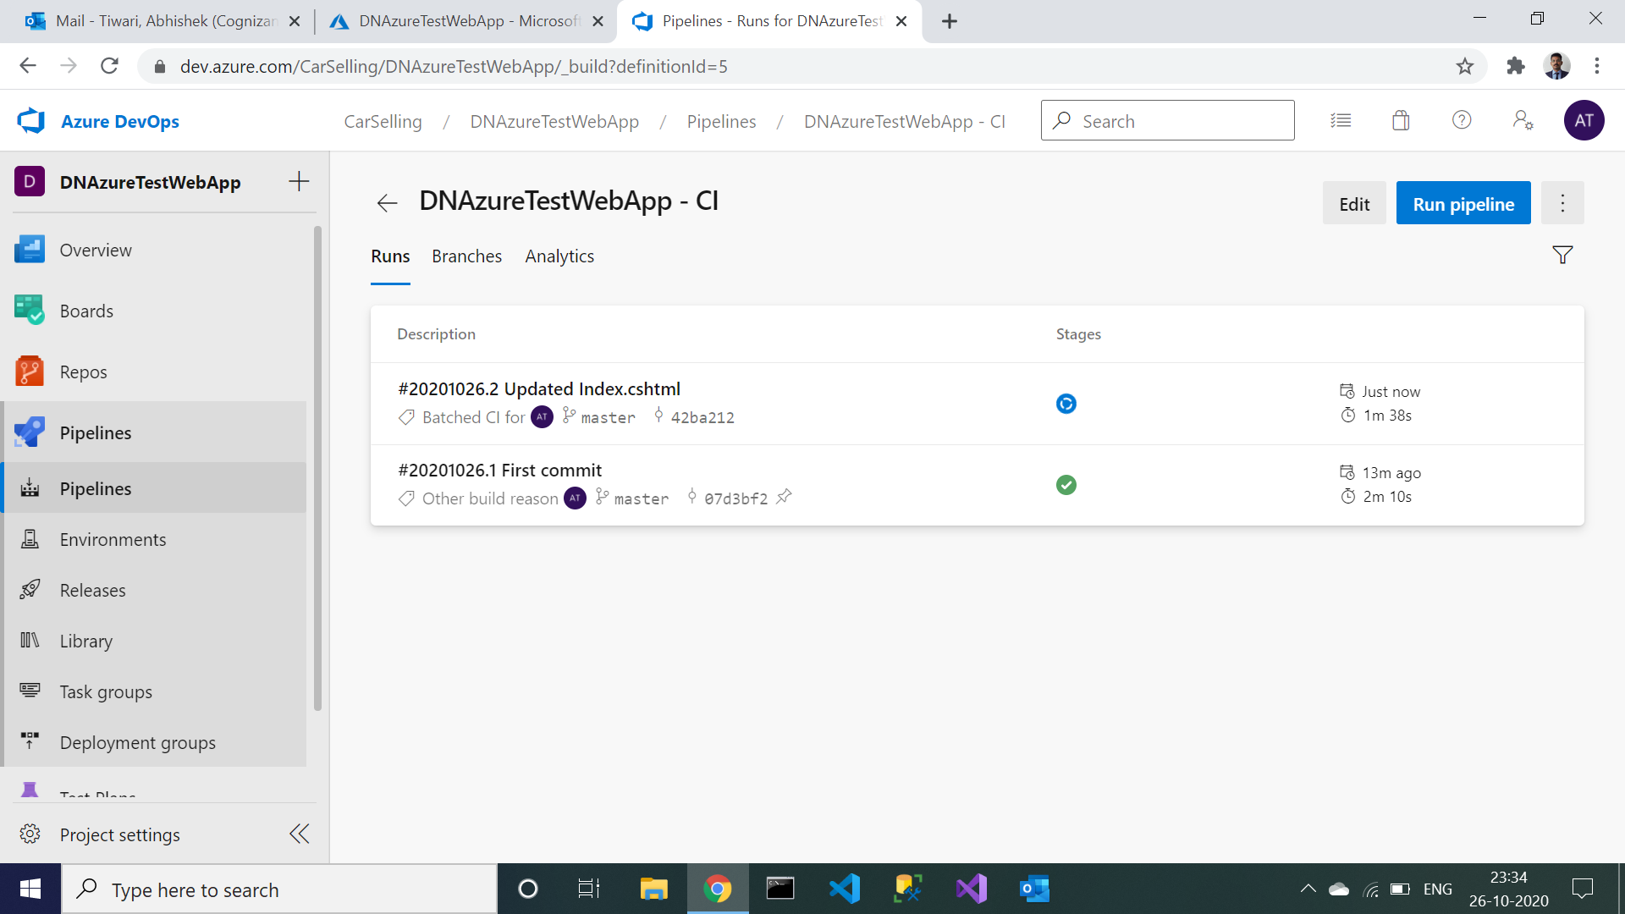

1. Now go to release you will find that releases will be listed in descending order of trigger.By default, the deployment will be on the ‘Dev’ stage.

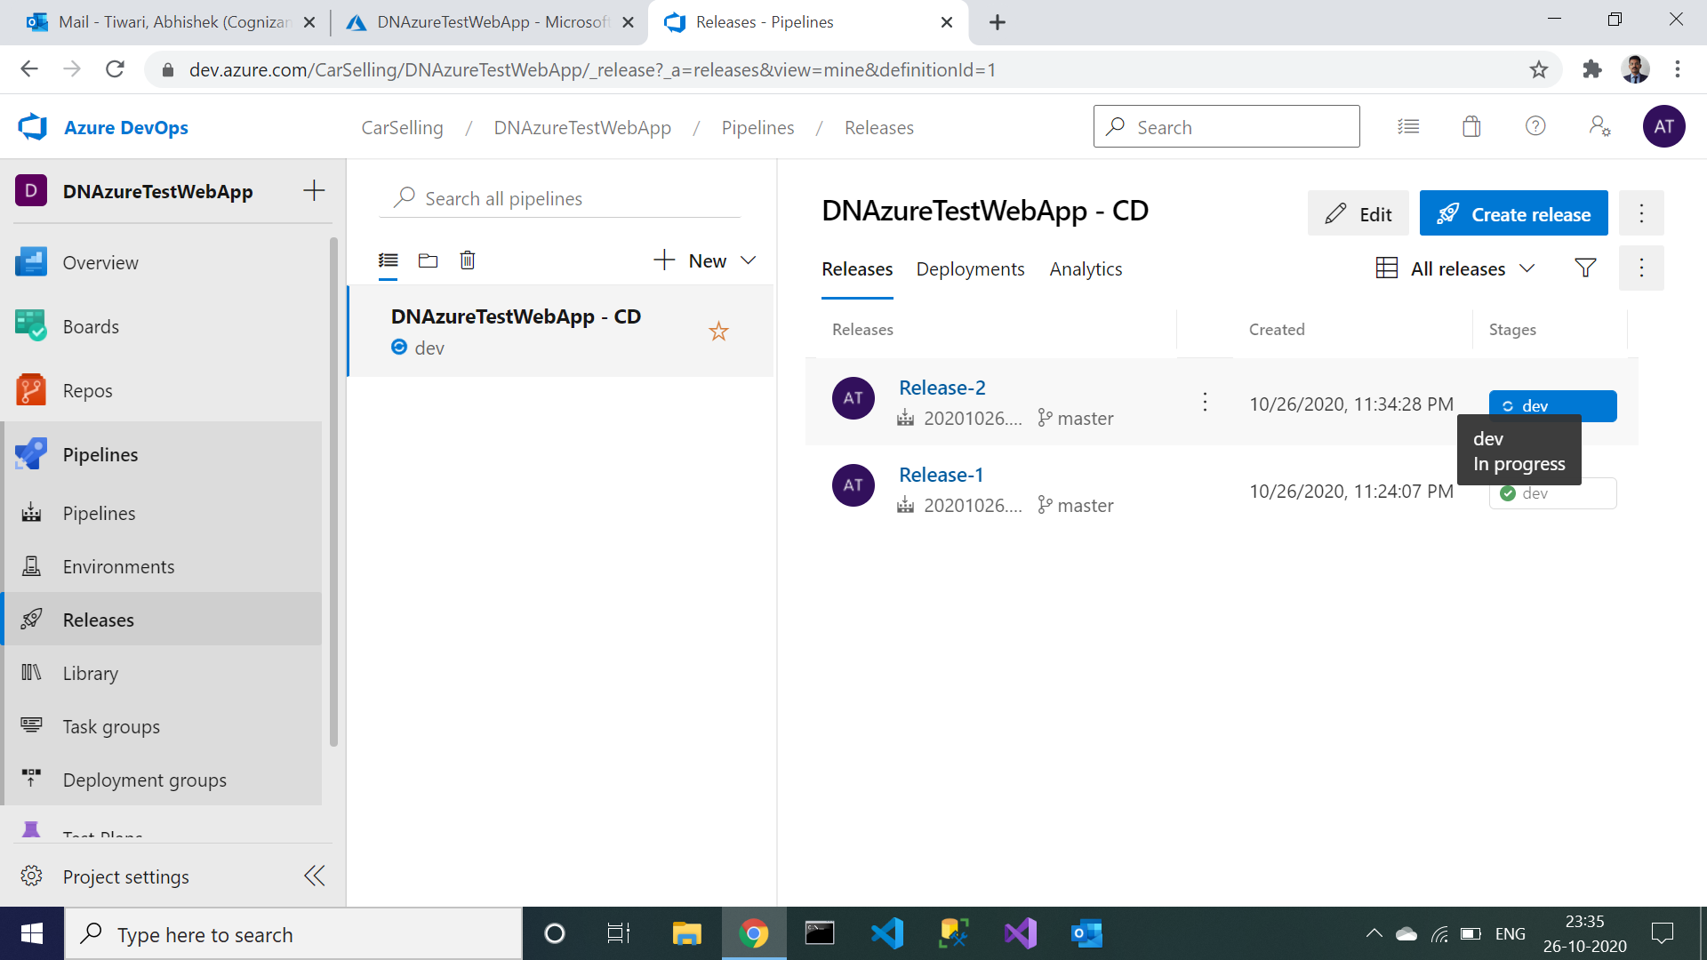

1. Click the ‘dev’ button to view the deployment logs.

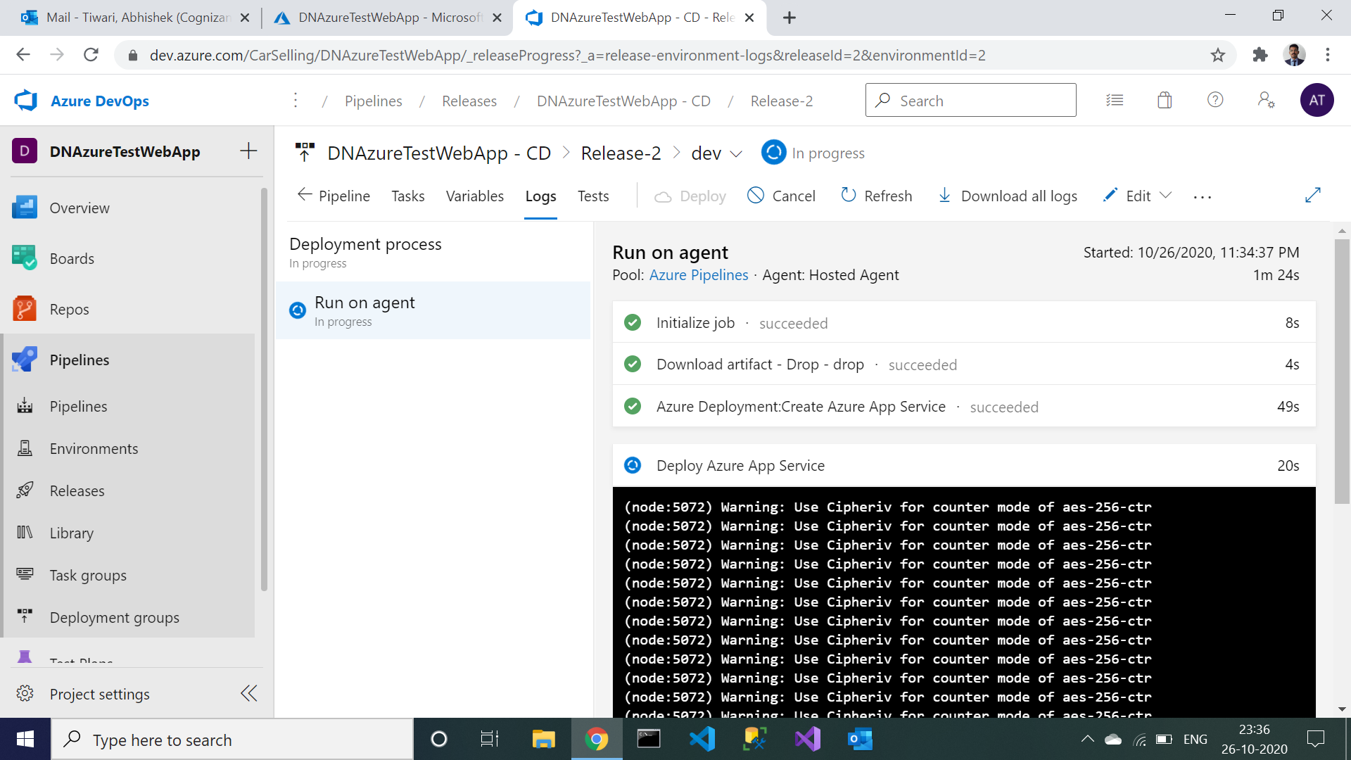

1. After some time dev succeeded.

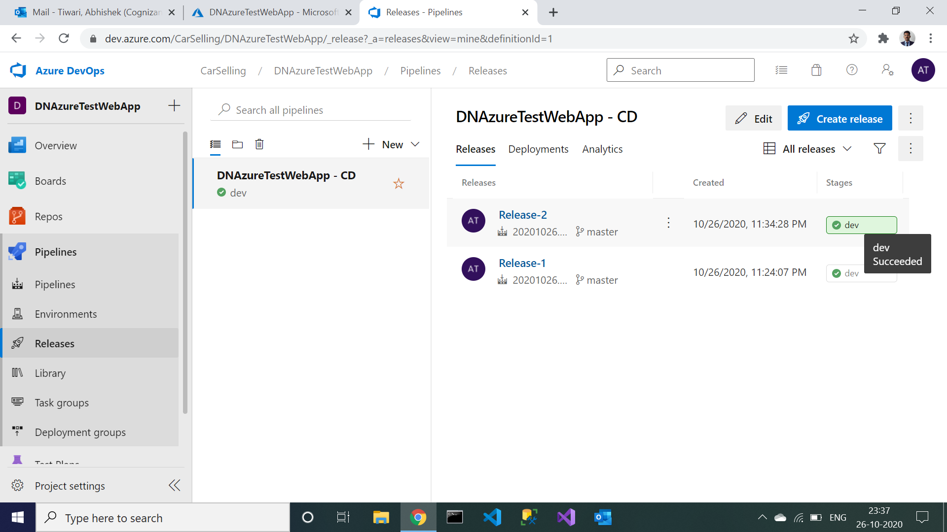

1. Now go to your project you will find that release 2 has been succeeded.

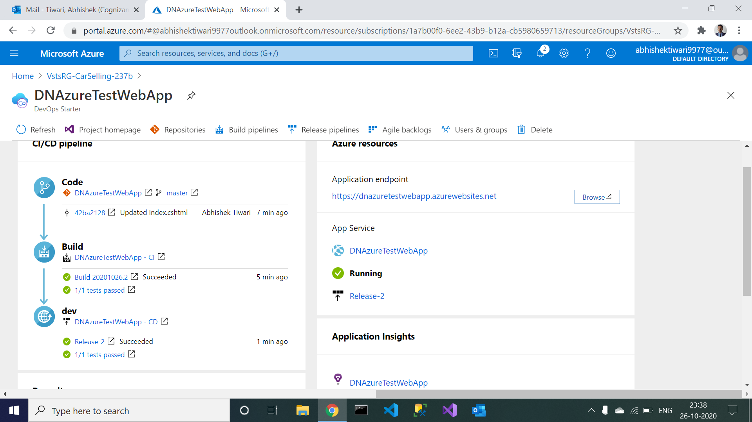

1. Now click on browse you will get that updated page.

