Hands on 5

Simple WebApi deployment on IIS.

1. First of all install “Hosting Bundle”.

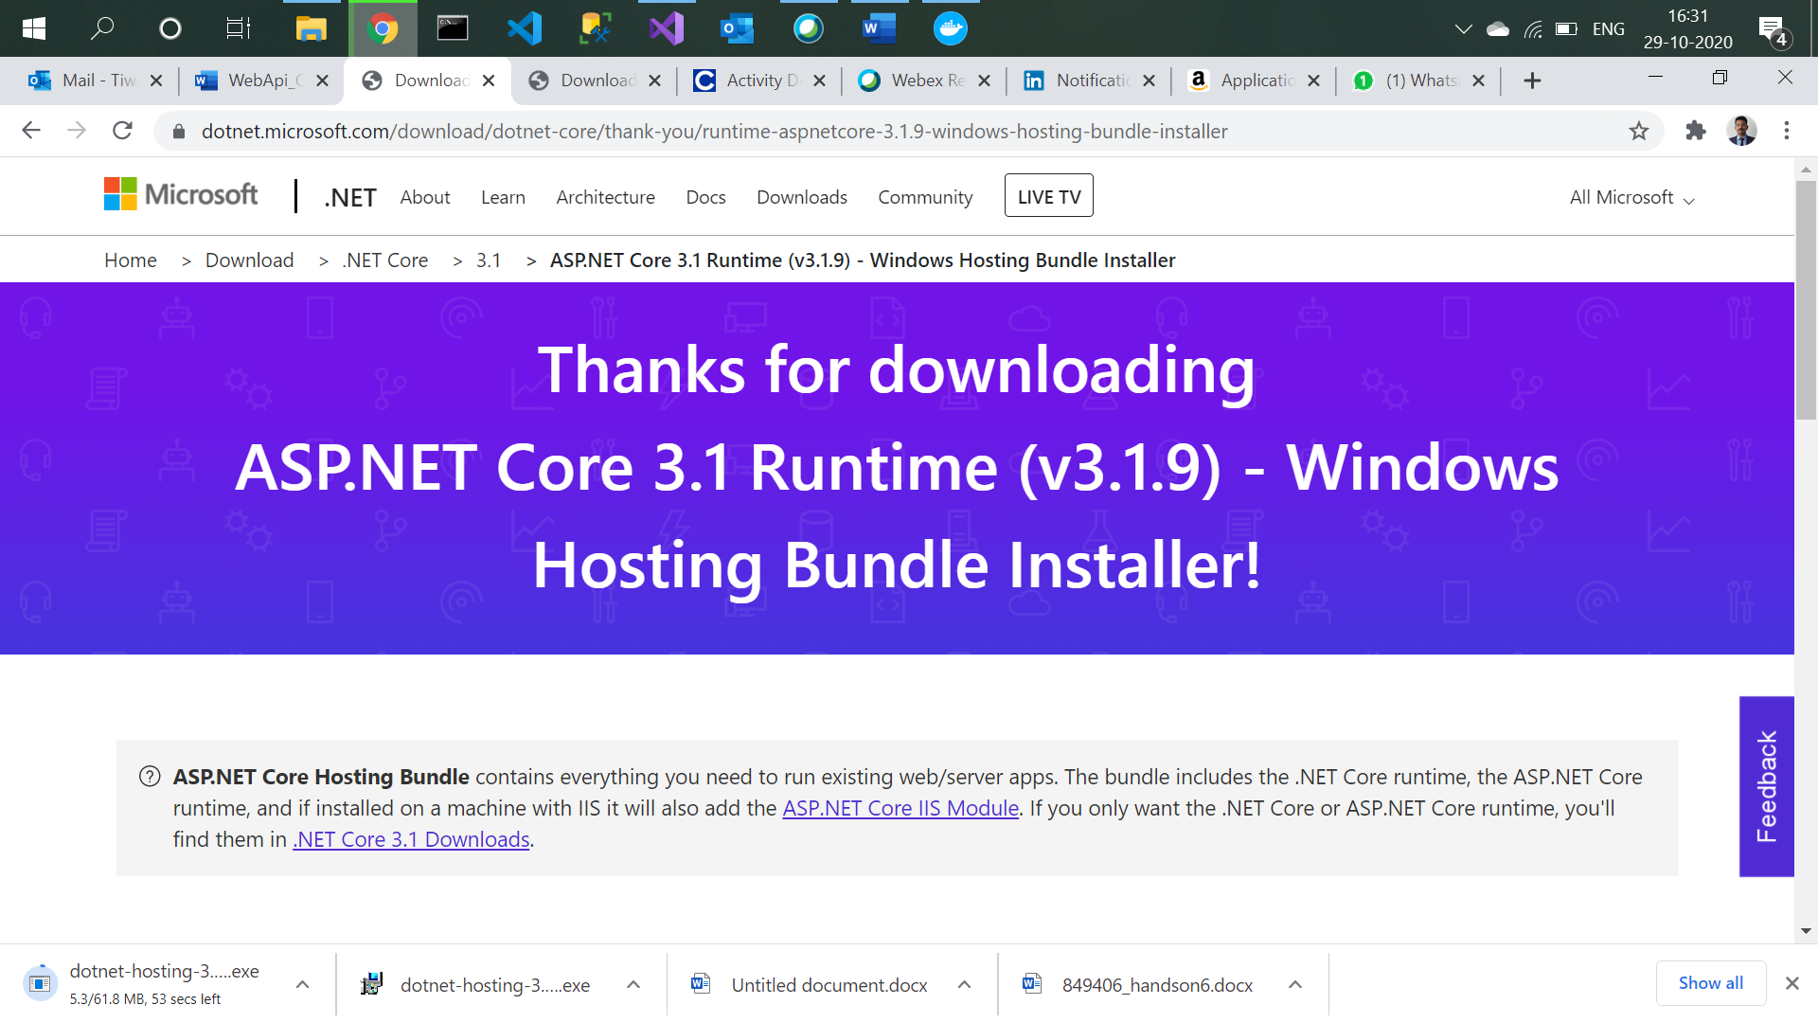

1. Create a docker enabled project.

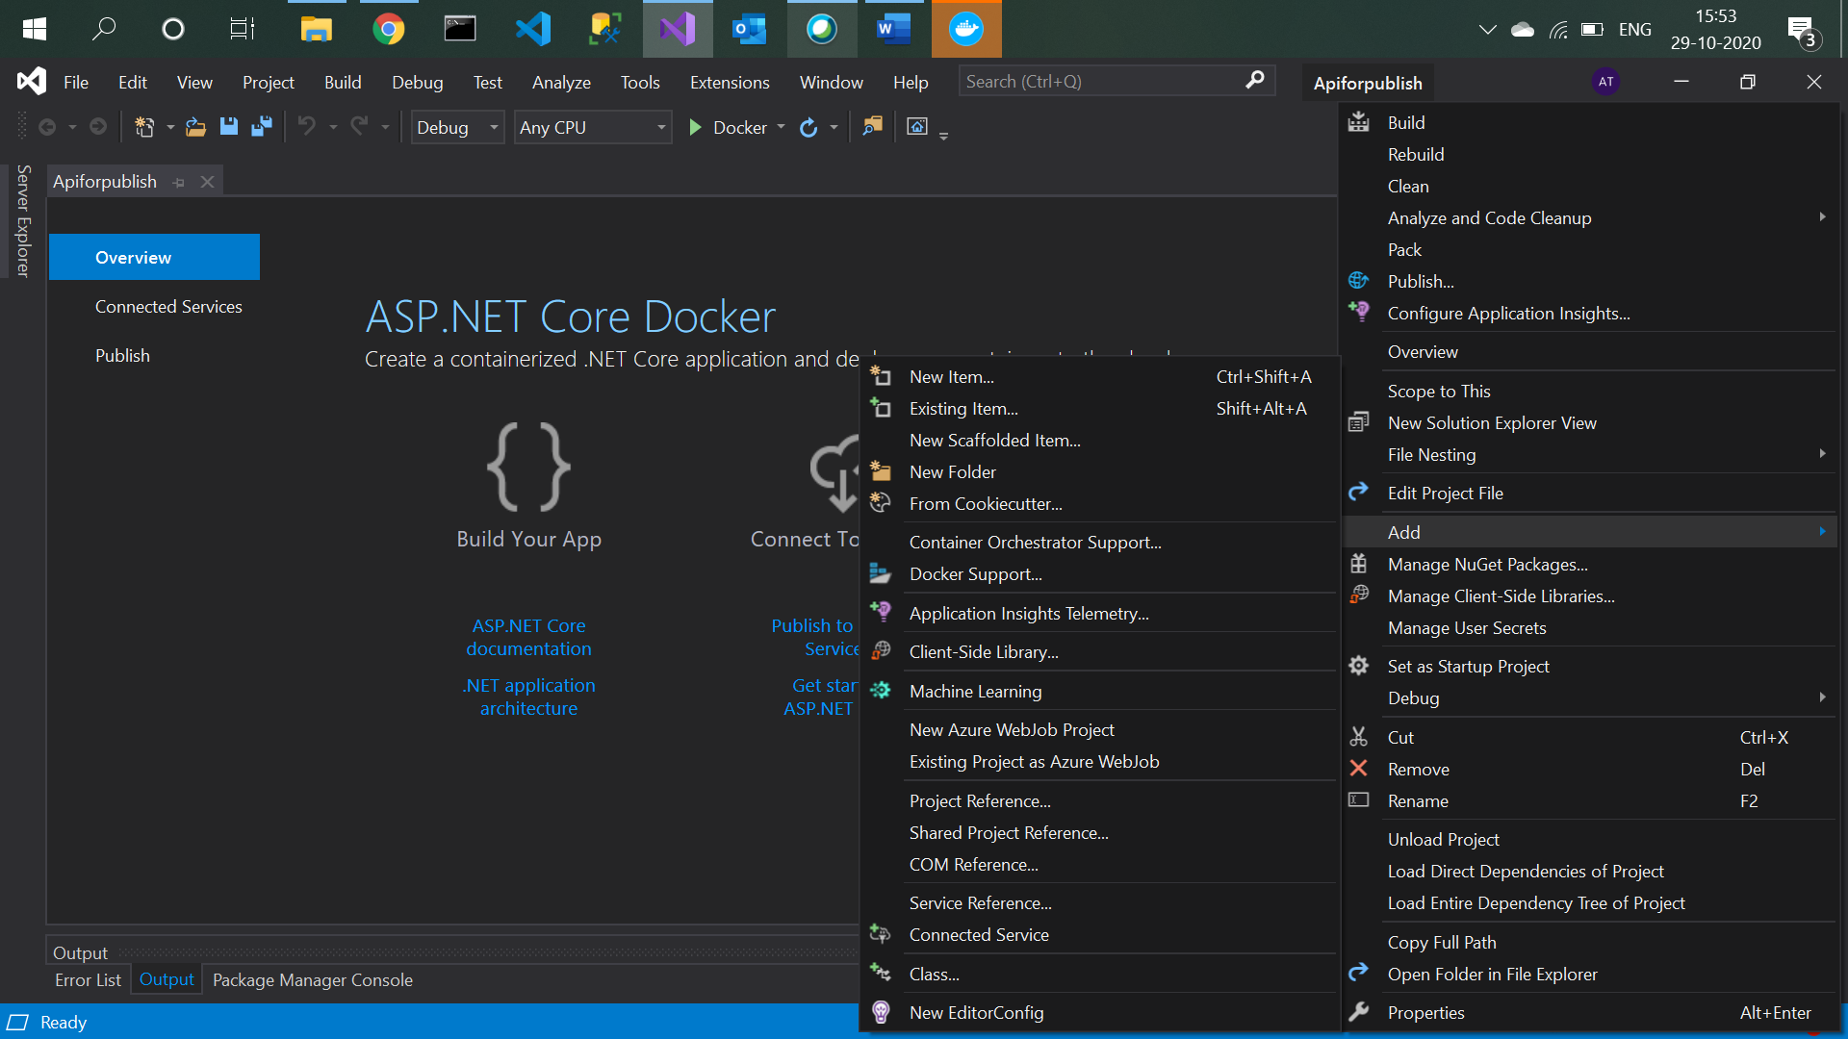

1. Add docker support

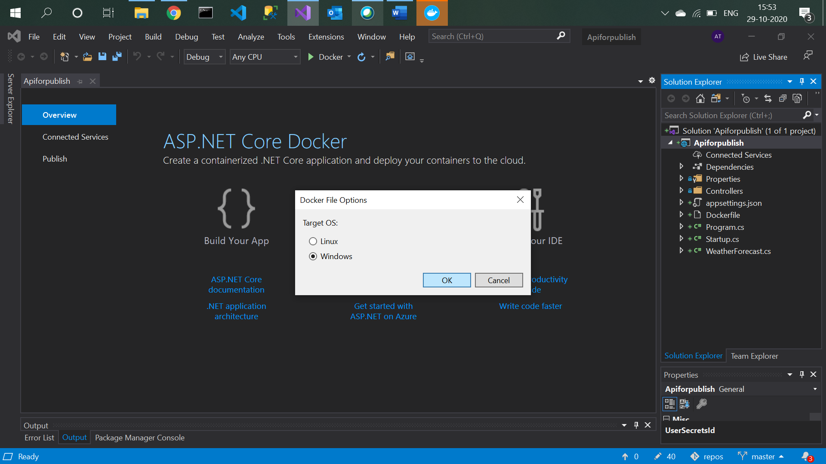

1. Add container orchestrator support

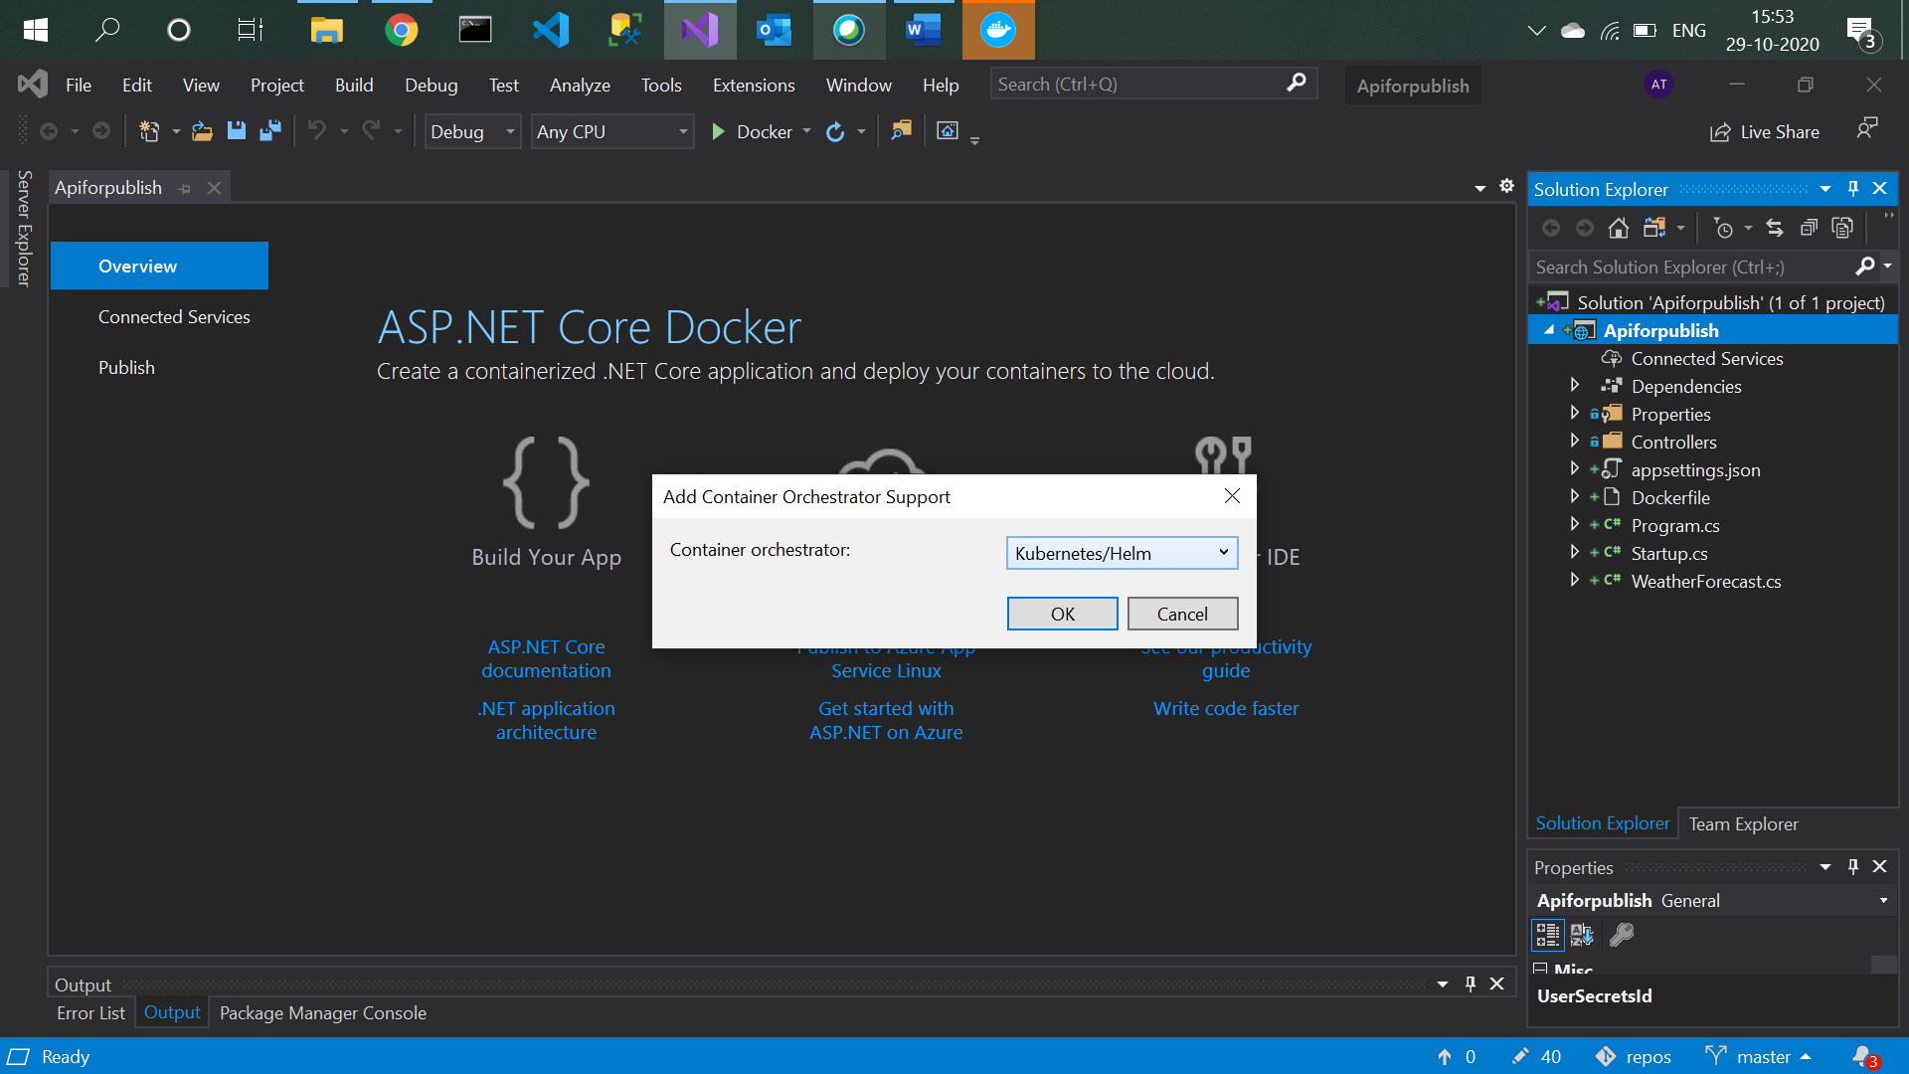

1. Now go to Control panel → Program and features → Turn windows feature on or off → check IIS and click on OK.

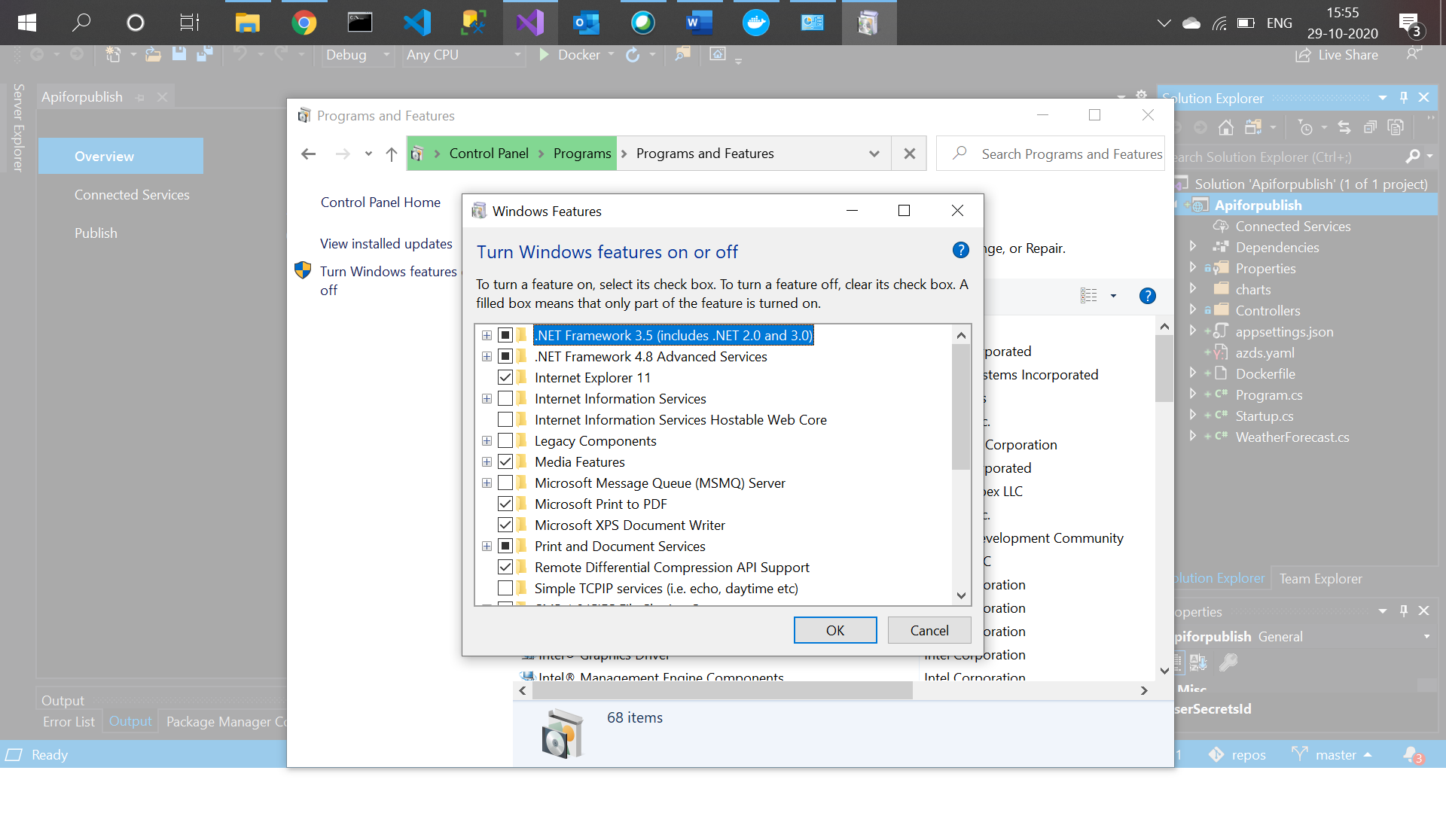

1. Right click on project → Publish → Folder → Next

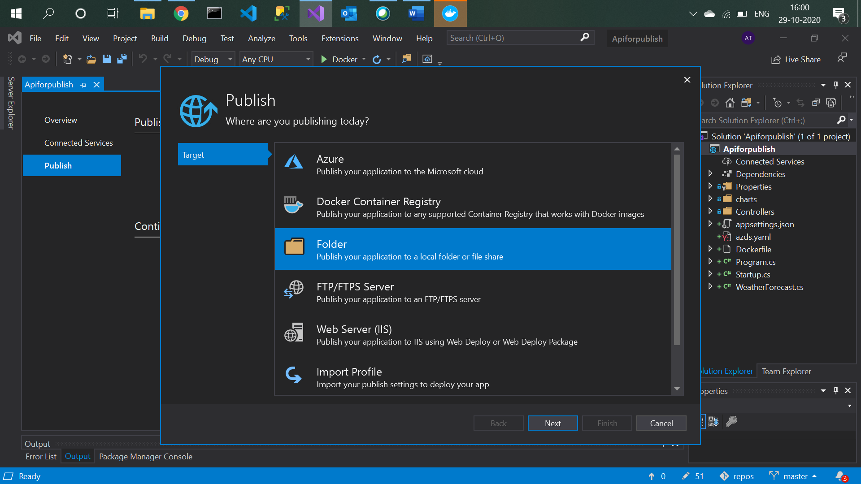

1. Click on finish.

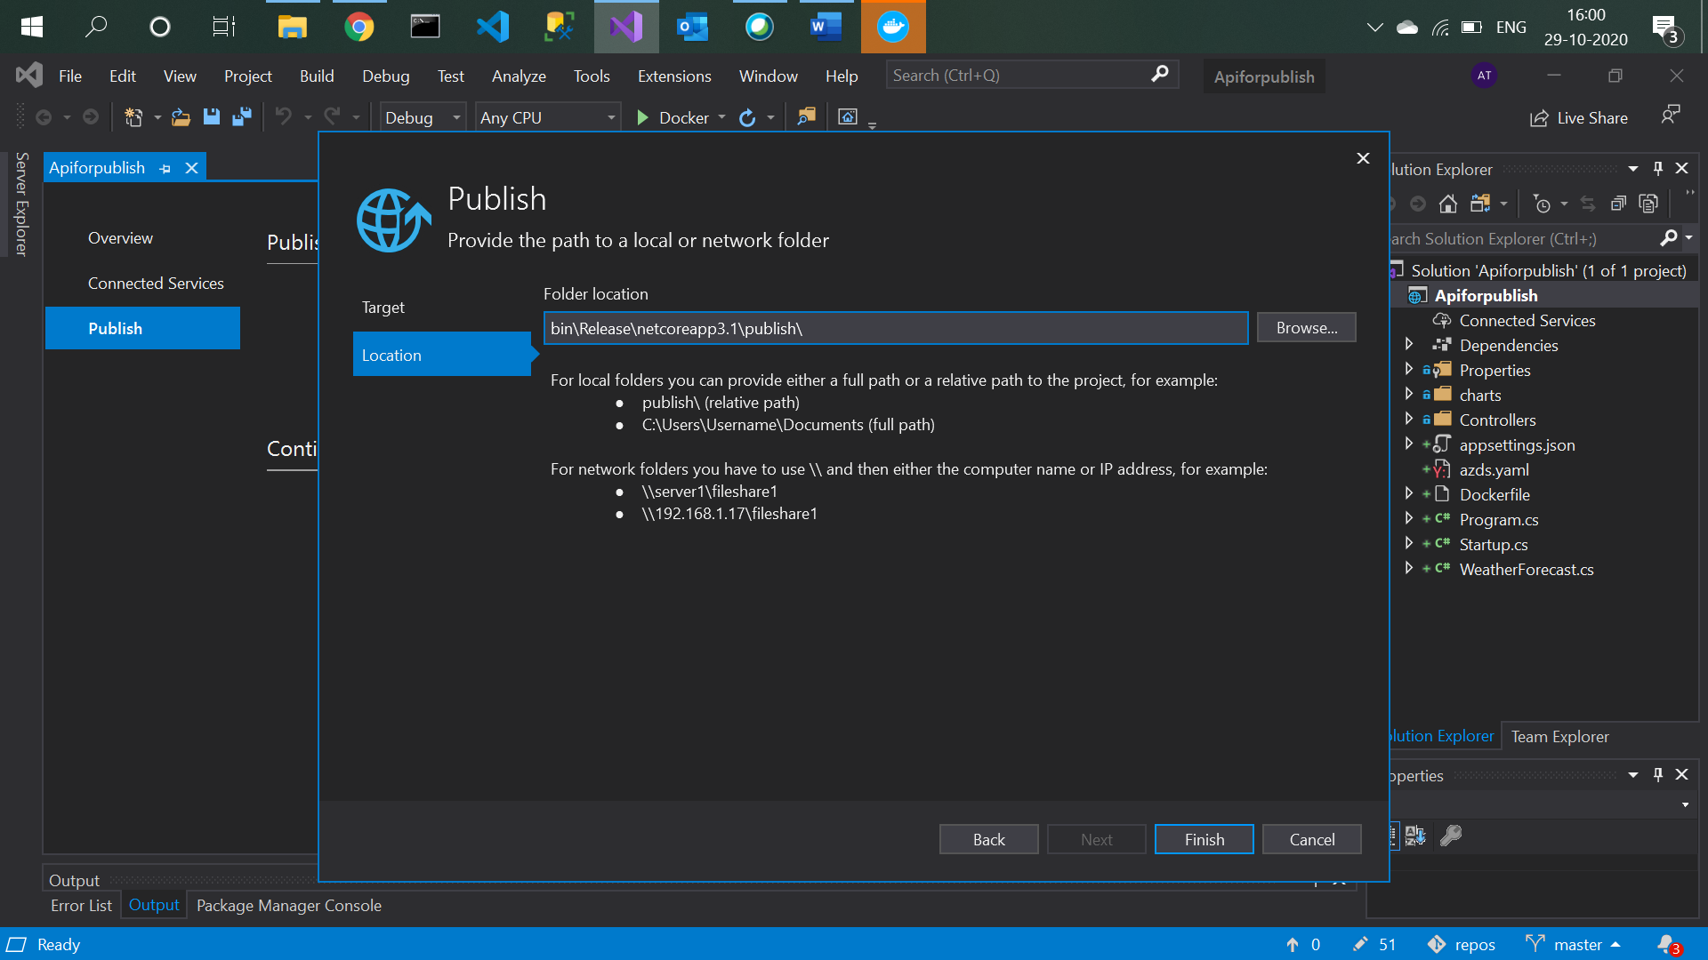

1. Go to bin → release → netcoreapp3.1 → Copy publish folder.

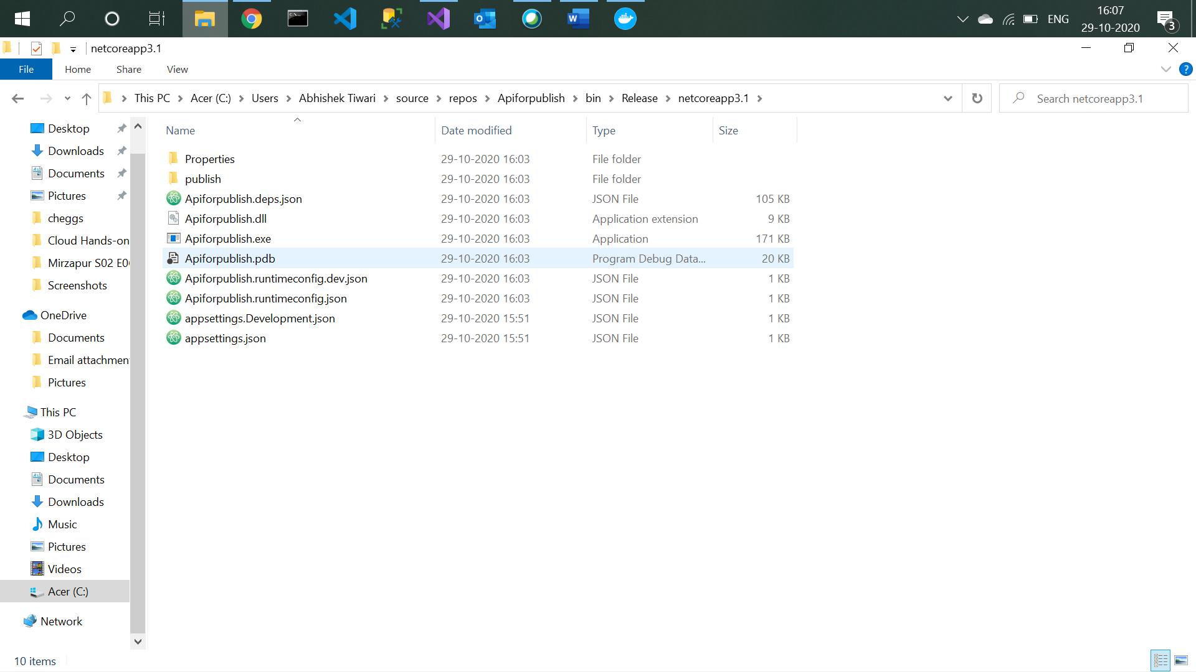

1. Paste publish in C → inetpub → wwwroot.

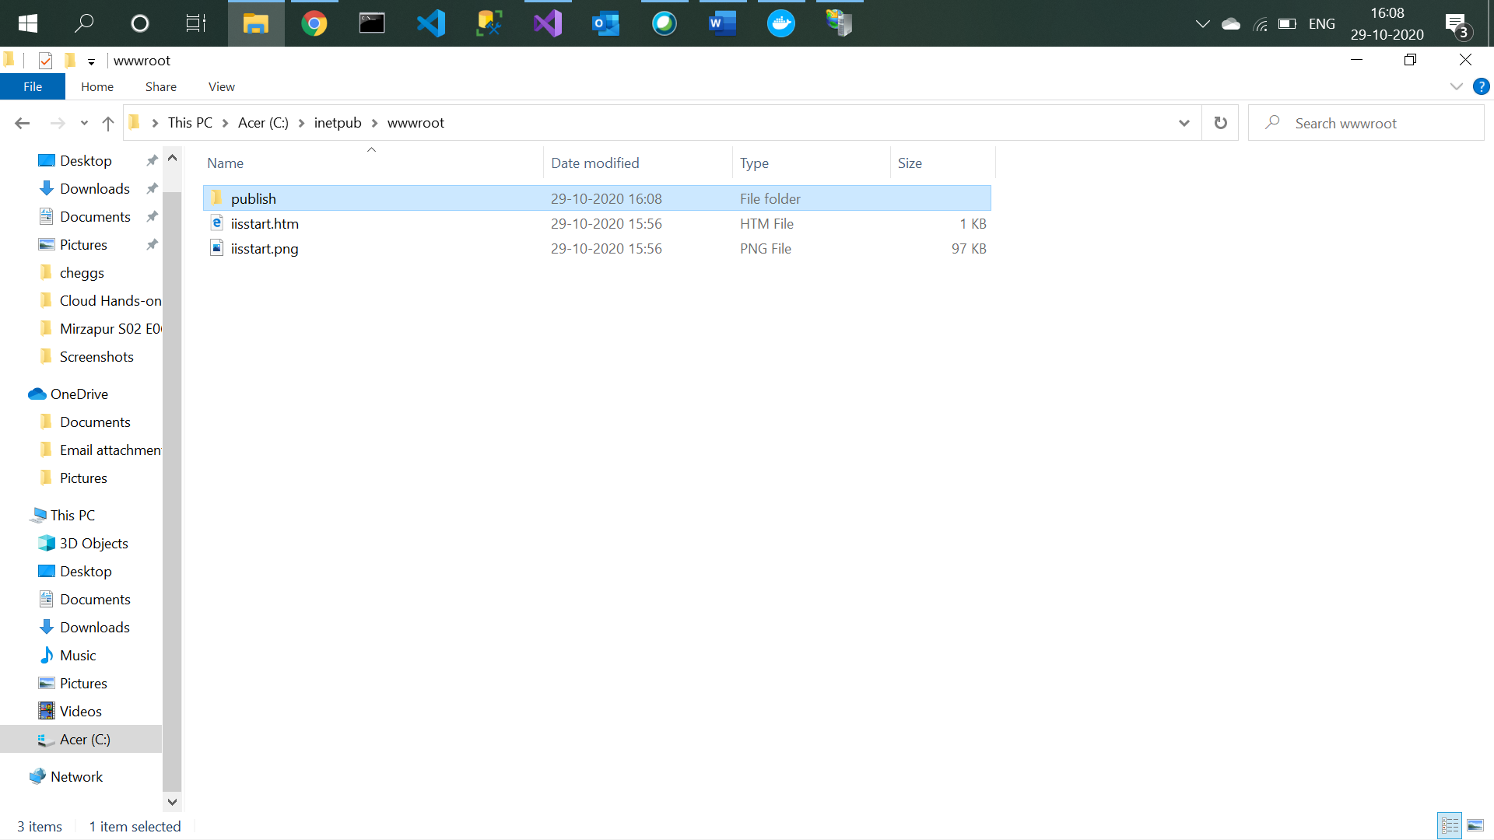

1. Open IIS manager and add application pool.

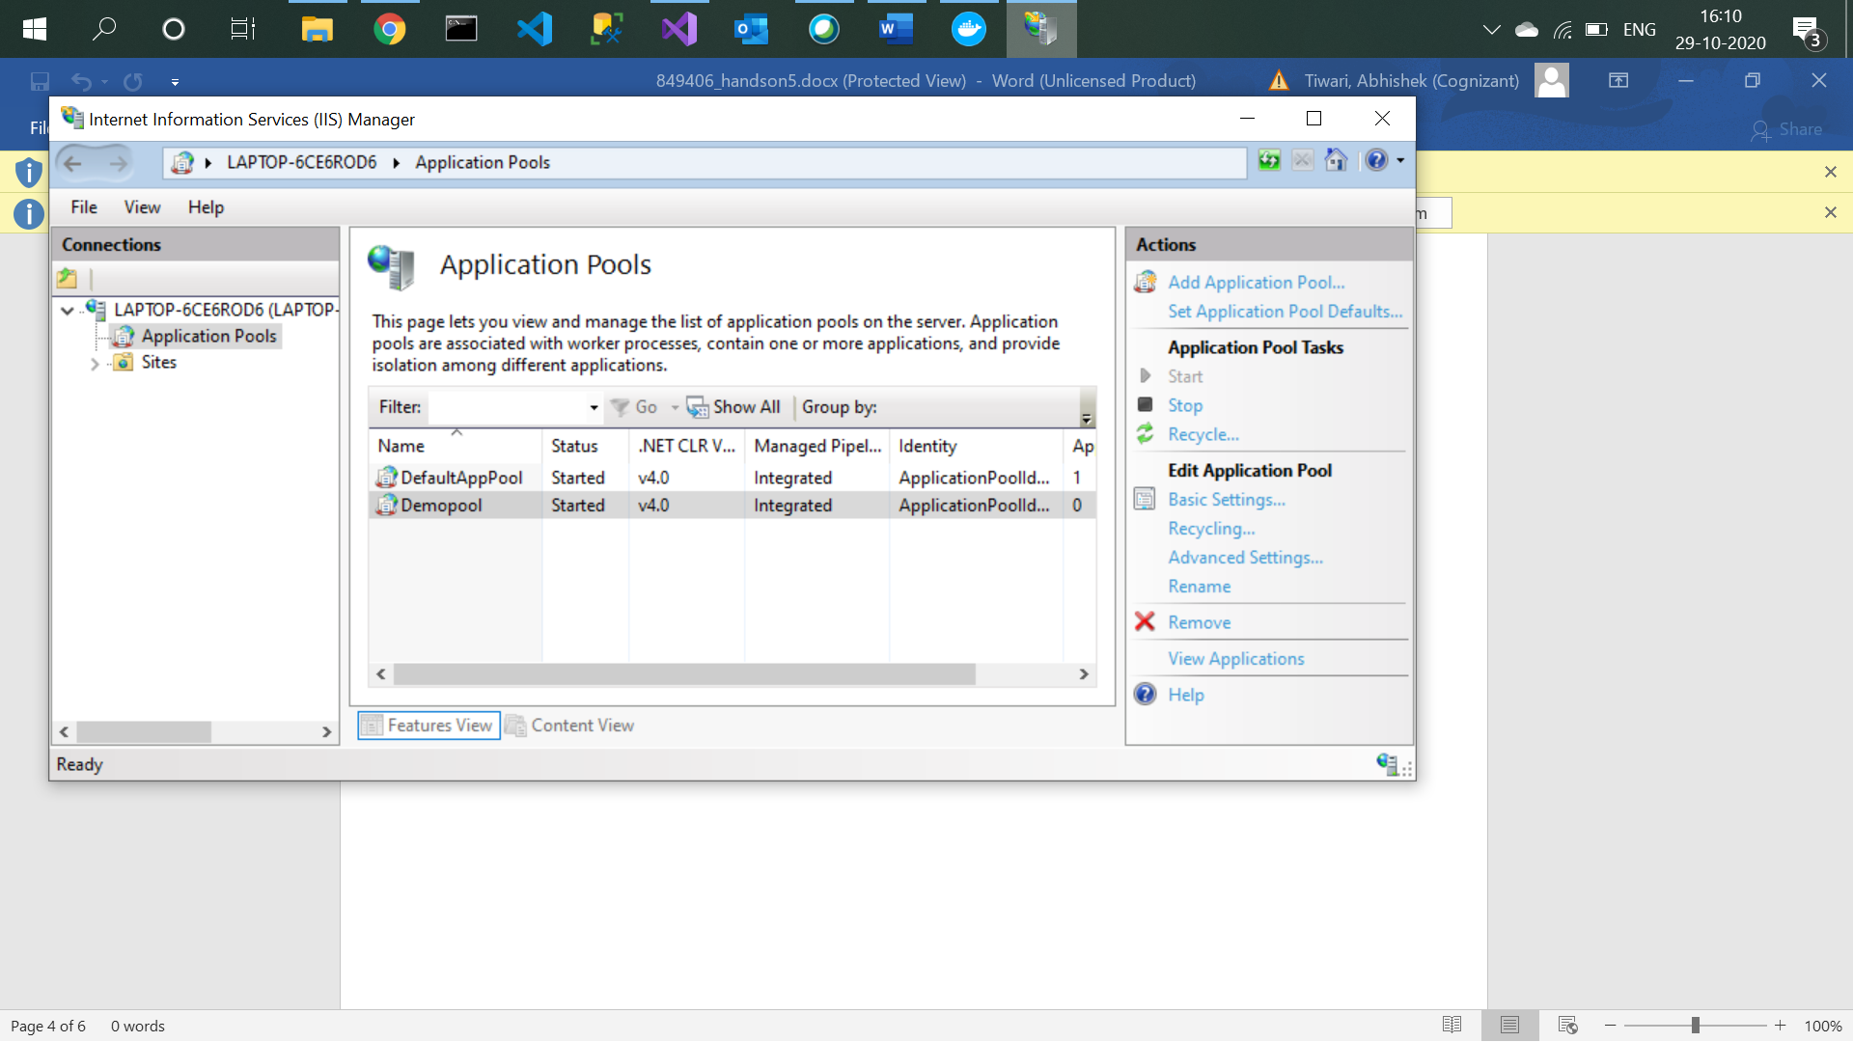

1. Add new website and pass the address of the publish folder.

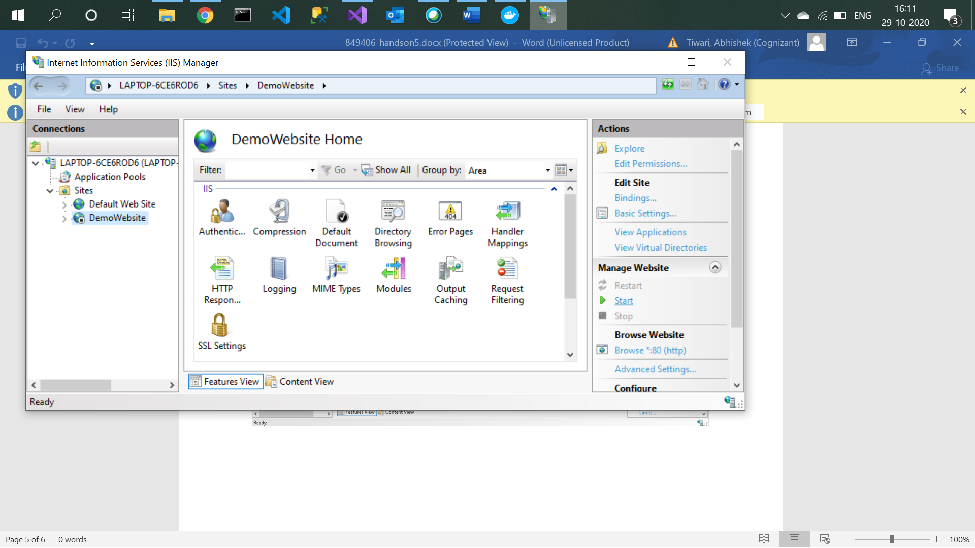

1. Now browse the site and append “weatherforecast” in URL to see output.

